ASSIGNMENT-16
Name: Azra Farheen
Enrollment Number: 2505B04211
Course: M. Tech (Embedded Systems)

SCHOOLOFCOMPUTER SCIENCE AND ARTIFICIAL INTELLIGENCE |  |  |  |  | DEPARTMENTOFCOMPUTER SCIENCE ENGINEERING
ProgramName:M.Tech/MCA/MSC |  |  |  | AssignmentType: Lab |  |  | AcademicYear:2025-2026
CourseCoordinatorName |  |  |  | Venkataramana Veeramsetty
CourseCode |  |  |  | CourseTitle |  | AI Assisted Problem Solving Using Python
Year/Sem |  |  | I/I | Regulation |  | R25
DateandDay  of Assignment |  |  |  | Time(s)
Duration |  |  | 2 Hours | Applicableto  Batches
AssignmentNumber:16.3(Presentassignmentnumber)/24(Totalnumberofassignments)
 | Q.No. | Question |  |  |  |  |  | ExpectedTime  to complete
 | 1 | Lab 16 – Database Design and Queries: Schema Design and SQL Generation  Lab Objectives  - To practice basic SQL query generation with AI assistance.  - To analyze AI-suggested queries for correctness and efficiency.  - To understand how AI can help in documenting and improving database logic.  Learning Outcomes  After completing this lab, students will be able to:  - Use AI tools to design a simple ER diagram / schema for a given scenario.  - Generate CREATE TABLE statements using AI.  - Write and refine basic SQL queries (SELECT, INSERT, UPDATE, DELETE).  - Validate correctness and efficiency of AI-generated SQL.  - Compare AI-generated vs manually written queries.  Task Description #1 – Schema Generation  Task: Ask AI to design a schema for a Library Management System (Tables: Books, Members, Loans).  SQL Code  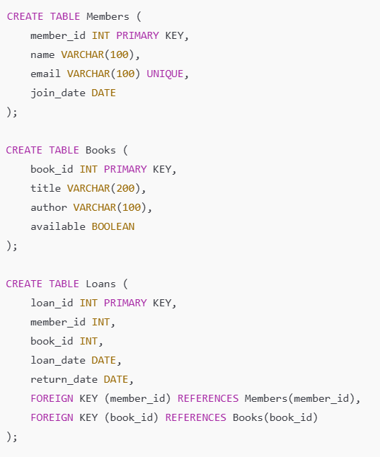  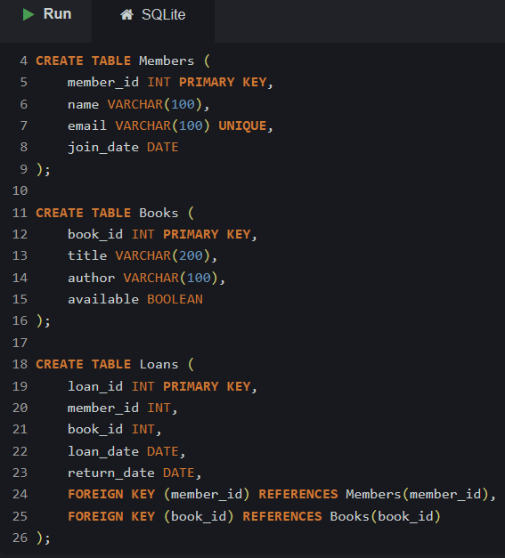  Fig 16.1(a) Creation of database tables for a Library Management System using SQL (Members, Books, Loans).  CODE EXPLANATION:  - Members Table  - member_id INT PRIMARY KEY  Each member has a unique numerical ID. The PRIMARY KEY ensures this value cannot repeat.  - name VARCHAR(100)  Stores the member’s name with a maximum of 100 characters.  - email VARCHAR(100) UNIQUE  The email must be unique for each member (no duplicate emails allowed).  - join_date DATE  The date when the member joined the library.  Purpose: This table stores all library members’ details.  - Books Table  - book_id INT PRIMARY KEY  Unique ID for every book.  - title VARCHAR(200)  Title of the book (up to 200 characters).  - author VARCHAR(100)  Author of the book.  - available BOOLEAN  Shows whether the book is available (TRUE) or borrowed (FALSE).  Purpose: This table stores information about books in the library.  - Loans Table  - loan_id INT PRIMARY KEY  Unique ID for each loan transaction.  - member_id INT  ID of the member who borrowed the book.  - book_id INT  ID of the borrowed book.  - loan_date DATE  Date when the book was borrowed.  - return_date DATE  Date when the book was returned (NULL if not yet returned).  - FOREIGN KEY (member_id) REFERENCES Members(member_id)  Ensures the member exists in the Members table.  - FOREIGN KEY (book_id) REFERENCES Books(book_id)  Ensures the book exists in the Books table.  Purpose: This table records which member borrowed which book and when.  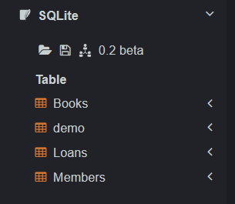  Fig 16.1(b) The tables Members, Books, and Loans were successfully created in the database.  Task Description #2 – Error Insert Data  Task: Ask AI to generate INSERT INTO queries for the schema above (3 sample records per table).  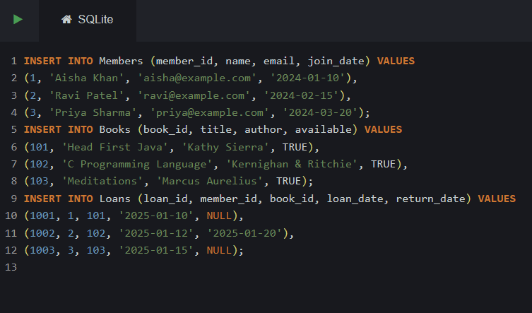  Fig 16.2(a) SQL code for creating the database schema (Members, Books, and Loans tables) for the Library Management System.  CODE EXPLANATION:  Each table stores different information and they are connected using foreign keys.  1. Members Table Explanation  CREATE TABLE Members (  member_id INT PRIMARY KEY,  name VARCHAR(100),  email VARCHAR(100) UNIQUE,  join_date DATE  );  Explanation:  - member_id INT PRIMARY KEY  A unique number for each member. The PRIMARY KEY ensures no duplicates.  - name VARCHAR(100)  Stores the member’s name (up to 100 characters).  - email VARCHAR(100) UNIQUE  Email must be unique, meaning two members cannot use the same email.  - join_date DATE  The date the member joined the library.  Purpose: This table stores all details of library members.  2. Books Table Explanation  CREATE TABLE Books (  book_id INT PRIMARY KEY,  title VARCHAR(200),  author VARCHAR(100),  available BOOLEAN  );  Explanation:  - book_id INT PRIMARY KEY  Unique ID assigned to every book.  - title VARCHAR(200)  The name of the book with a maximum length of 200 characters.  - author VARCHAR(100)  Stores the author’s name.  - available BOOLEAN  Indicates whether the book is available (TRUE) or borrowed (FALSE).  Purpose: This table stores information about all books in the library.  3. Loans Table Explanation  CREATE TABLE Loans (  loan_id INT PRIMARY KEY,  member_id INT,  book_id INT,  loan_date DATE,  return_date DATE,  FOREIGN KEY (member_id) REFERENCES Members(member_id),  FOREIGN KEY (book_id) REFERENCES Books(book_id)  );  Explanation:  - loan_id INT PRIMARY KEY  Unique ID for each borrowing transaction.  - member_id INT  Refers to the member who borrowed the book.  - book_id INT  Refers to the book that was borrowed.  - loan_date DATE  The date the book was issued to the member.  - return_date DATE  The date the book was returned (NULL means not yet returned).  - FOREIGN KEY (member_id)  Ensures that only valid members can borrow books.  - FOREIGN KEY (book_id)  Ensures that only valid books can be borrowed.  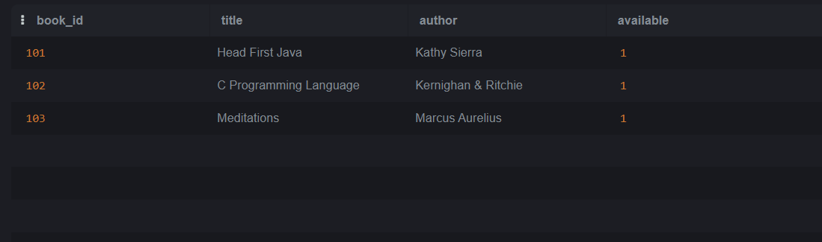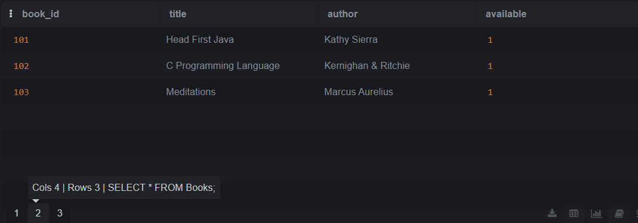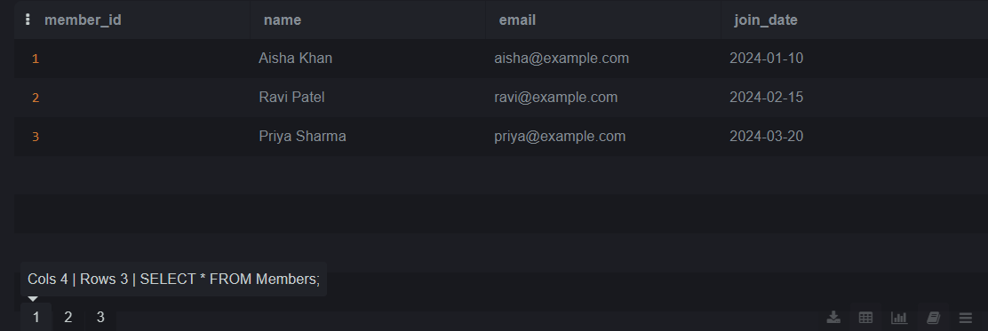Fig 16.2(b) Output  Task Description #3 – Basic Queries  Task: Use AI to generate a query to list all books borrowed by a specific member  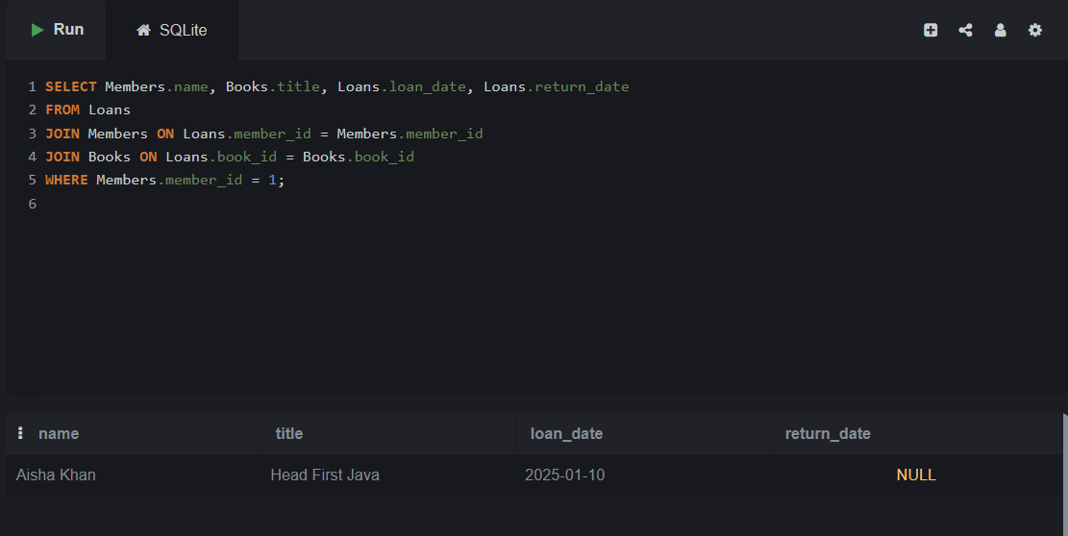  Fig 16.3 Code and Output of the SQL query showing the list of books borrowed by the member with Member_ID = 1.  CODE EXPLANATION:  - FROM Loans  The query starts from the Loans table because it holds borrowing records.  - JOIN Members ON Loans.member_id = Members.member_id  Joins loan data with member data to show who borrowed the book.  - JOIN Books ON Loans.book_id = Books.book_id  Joins loan data with book details so we can display the book title.  - WHERE Members.member_id = 1  Filters the results to show only the books borrowed by member ID 1.  - SELECT Members.name, Books.title, Loans.loan_date, Loans.return_date  Displays:  - the member’s name  - the title of the borrowed book  - the loan date  - the return date (NULL means not yet returned)  This query gives a complete list of all books borrowed by a particular member.  Task Description #4 – Update and Delete Queries  Task: Generate queries with AI for:  - Updating a book’s availability to FALSE when borrowed.  - Deleting a member record safely.  UPDATE QUERY:  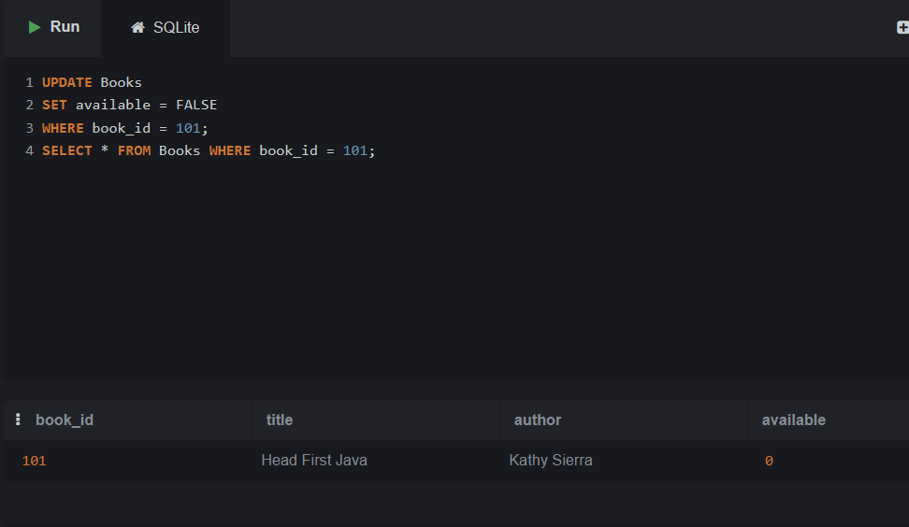  Fig 16.4(a) Output showing that the availability status of the book with Book_ID = 101 has been successfully updated to FALSE (0), indicating the book is now marked as unavailable.  Output Explanation:  The SELECT statement confirms the update operation.  The available column for book 101 now shows 0, meaning the book is currently borrowed and not available.  DELETE QUERY:  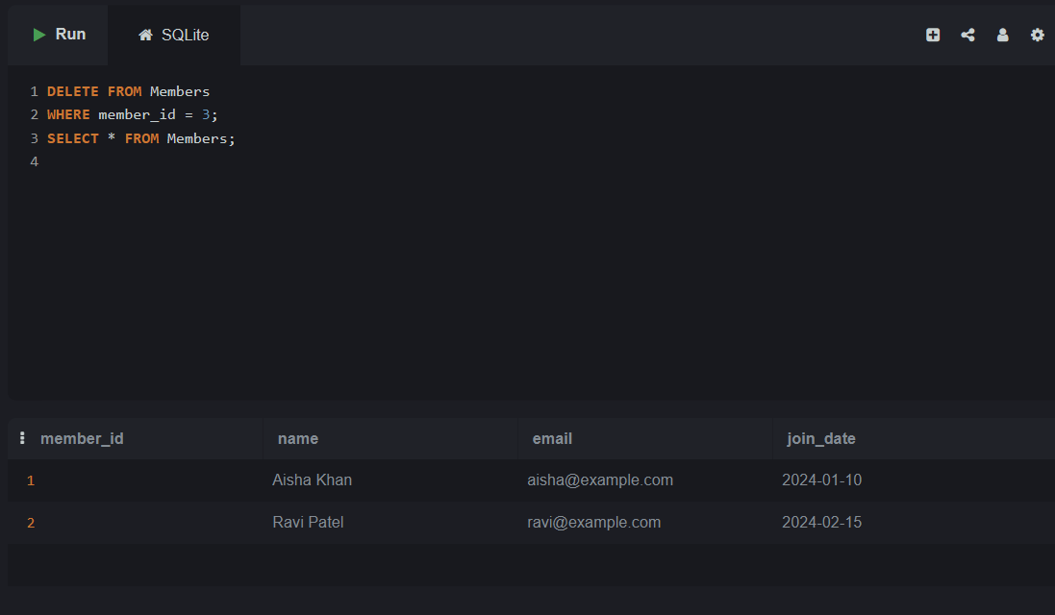  Fig 16.4(b) Output showing that the member with Member_ID = 3 has been successfully deleted from the Members table. The SELECT query confirms that only the remaining members (IDs 1 and 2) are present.  CODE EXPLANATION:  1. DELETE Query  DELETE FROM Members  WHERE member_id = 3;  - This statement removes the member whose member_id is 3.  - The WHERE clause ensures only that specific member is deleted.  - No other records are affected.  2. SELECT Query  SELECT * FROM Members;  - This retrieves all remaining members from the Members table.  - The output shows only:  - Aisha Khan (ID 1)  - Ravi Patel (ID 2)  - Since member 3 is missing, it confirms that the DELETE operation worked correctly.

