ASSIGNMENT-7
Name: Azra Farheen
Enrollment Number: 2505B04211
Course: M. Tech (Embedded Systems)
SCHOOL OF COMPUTER SCIENCE AND ARTIFICIAL INTELLIGENCE |  |  |  |  | DEPARTMENT OF COMPUTER SCIENCE ENGINEERING
ProgramName:B. Tech |  |  |  | Assignment Type: Lab |  |  | AcademicYear:2025-2026
CourseCoordinatorName |  |  |  | Venkataramana Veeramsetty
Instructor(s)Name |  |  |  | Dr. V. Venkataramana (Co-ordinator)  Dr. T. Sampath Kumar  Dr. Pramoda Patro  Dr. Brij Kishor Tiwari  Dr.J.Ravichander  Dr. Mohammand Ali Shaik  Dr. Anirodh Kumar  Mr. S.Naresh Kumar  Dr. RAJESH VELPULA  Mr. Kundhan Kumar  Ms. Ch.Rajitha  Mr. M Prakash  Mr. B.Raju  Intern 1 (Dharma teja)  Intern 2 (Sai Prasad)  Intern 3 (Sowmya)  NS_2 ( Mounika)
CourseCode |  |  | 24CS002PC215 | CourseTitle |  | AI Assisted Coding
Year/Sem |  |  | II/I | Regulation |  | R24
Date and Day  of Assignment |  |  | Week4 - Wednesday | Time(s)
Duration |  |  | 2 Hours | Applicableto  Batches
AssignmentNumber:7.3(Present assignment number)/24(Total number of assignments)
 | Q.No. | Question |  |  |  |  |  | ExpectedTime  to complete
 | 1 | Lab 7: AI-Error Debugging with AI: Systematic approaches to finding and fixing bugs  Lab Objectives:  - To identify and correct syntax, logic, and runtime errors in Python programs using AI tools.  - To understand common programming bugs and AI-assisted debugging suggestions.  - To evaluate how AI explains, detects, and fixes different types of coding errors.  - To build confidence in using AI to perform structured debugging practices.  Lab Outcomes (LOs):  After completing this lab, students will be able to:  - Use AI tools to detect and correct syntax, logic, and runtime errors.  - Interpret AI-suggested bug fixes and explanations.  - Apply systematic debugging strategies supported by AI-generated insights.  - Refactor buggy code using responsible and reliable programming patterns.  Task Description#1  - Paste a function with a missing colon (add(a, b)), and let AI fix the syntax error.  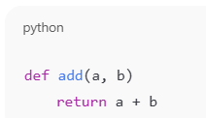  Expected Output#1  - Corrected function with syntax fix  Prompt:  Fix the syntax error in this function and correct the code:  def add(a, b)  return a + b  RESULT:  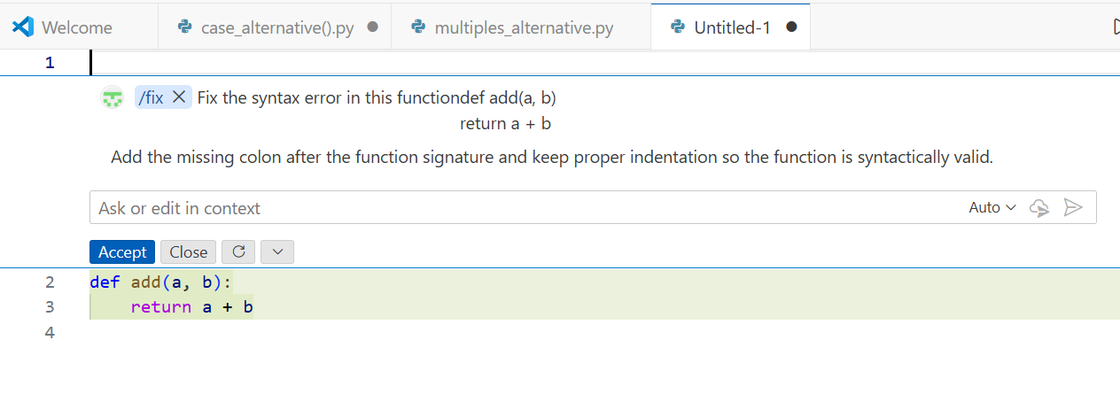  Fig 7.1(a) AI fix showing corrected add(a, b) function with colon added.  EXPLANATION:  - The colon (:) after the function header was missing, which caused a SyntaxError.  - Adding the colon fixes the function definition and makes the code valid.  - The return statement now correctly returns the sum of a and b.  Task Description#2 (Loops)  - Identify and fix a logic error in a loop that causes infinite iteration.  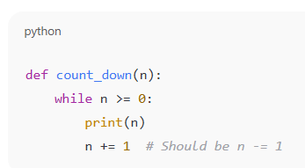  Expected Output#2  - AI fixes increment/decrement error  Prompt:  Fix the logic error in this loop that is causing infinite iteration.  def count_down(n):  while n >= 0:  print(n)  n += 1 # wrong increment  RESULT:  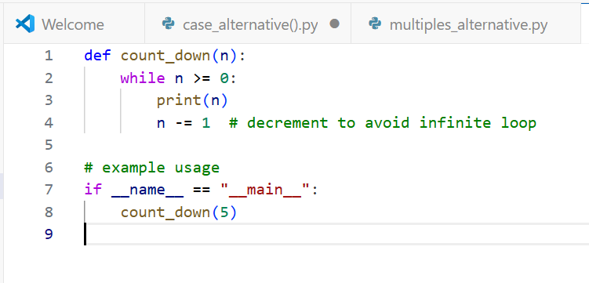  Fig 7.2(a) Final corrected countdown function with proper decrement and example usage.  EXPLANATION:  - The loop condition while n >= 0 means n must decrease to eventually stop.  - The original code used n += 1, which increases n and makes the loop run forever.  - Changing it to n -= 1 correctly counts downward and prevents infinite iteration.  OUTPUT:  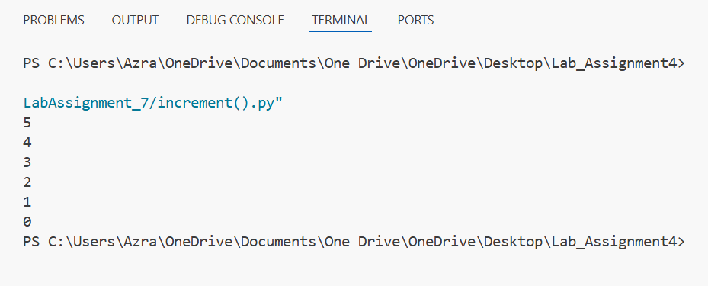  Fig 7.2(b) Correct countdown output after loop fix.  Task Description#3  - Debug a runtime error caused by division by zero. Let AI insert try-except.  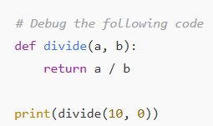  Expected Output#3  - Corrected function with safe error handling  Prompt:  Debug this function and fix the division-by-zero error using try-except. Show only the corrected code:  def divide(a, b):  return a / b  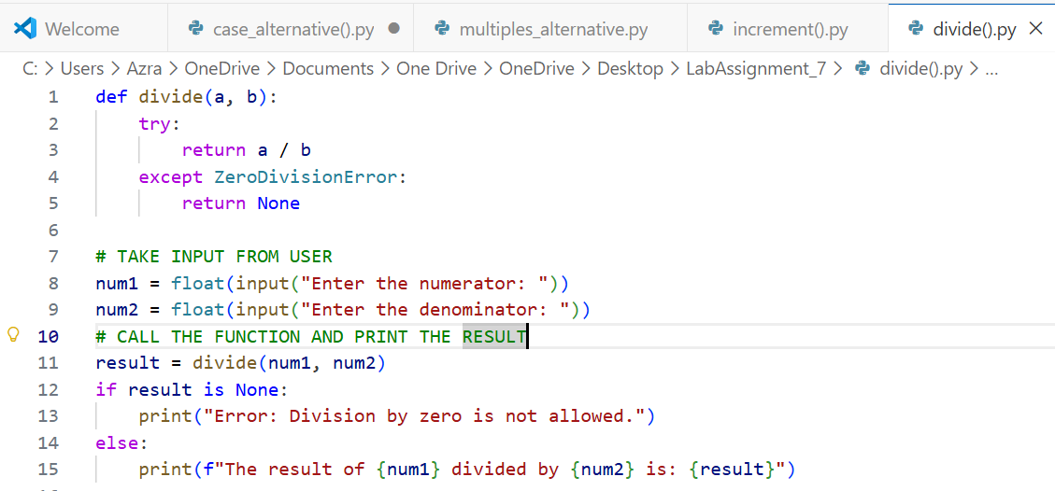  Fig 7.3(a) Program output after fixing the runtime error, showing correct division result when valid inputs are provided.  EXPLANATION:  - The original function divide(a, b) caused a runtime error when the value of b was zero.  - This error happens because dividing a number by zero is not allowed in Python (ZeroDivisionError).  - To prevent the program from crashing, the division operation was placed inside a try block.  - If b is zero, the except ZeroDivisionError block executes and returns None (or an error message).  - This makes the function safer because it now handles invalid inputs without stopping the program.  - The calling code checks whether the result is None and prints a friendly error message.  - When valid numbers are entered, the program correctly performs the division and prints the result.  OUTPUT:  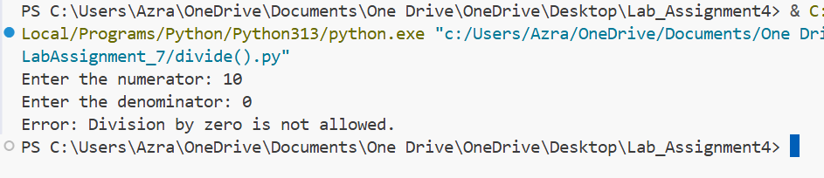  Fig 7.3(b) Figure: Successful division output after adding try-except.  Task Description#4  - Provide a faulty class definition (missing self in parameters). Let AI fix it  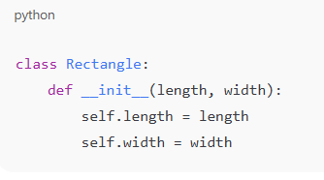  Expected Output#4  - Correct __init__() method and explanation  Prompt:  Fix this class constructor which is missing self in the __init__ method.  class Rectangle:  def __init__(length, width):  self.length = length  self.width = width  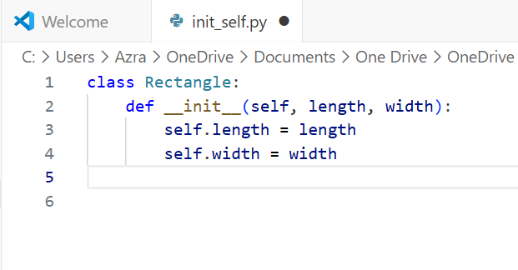  Fig 7.4(a) Figure: AI correcting the Rectangle class by adding 'self' to the __init__ method parameters.  EXPLANATION:  - The original __init__ method was missing the required self parameter.  - In Python classes, self must always be the first parameter to access instance attributes.  - Without self, the code raises errors because Python cannot map values to the object.  - Adding self makes the constructor valid and allows length and width to be stored as object attributes.  Task Description#5  - Access an invalid list index and use AI to resolve the Index Error.  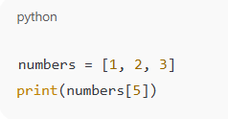  Expected Output#5  - AI suggests checking length or using safe access logic  Prompt:  Fix this IndexError by adding safe list access logic. Show only the corrected code:  numbers = [1, 2, 3]  print(numbers[5])  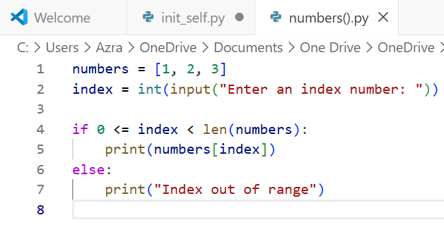  Fig 7.5(a) Figure: Safe index check before accessing list elements.  EXPLANATION:  - The list has only 3 elements, so index 5 does not exist and causes an IndexError.  - To avoid this error, we must check if the index is within the valid range before accessing it.  - Alternatively, a try-except block can be used to catch the IndexError and prevent the program from crashing.  OUTPUT:  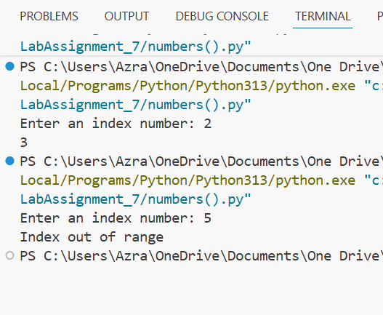  Fig 7.5(b) Output showing correct handling of index-out-of-range case  Note: Report should be submitted a word document for all tasks in a single document with prompts, comments & code explanation, and output and if required, screenshots  Evaluation Criteria:  Criteria Max Marks  Identification of bugs 0.5  Application of AI-suggested fixes 0.5  Explanation and understanding of errors 0.5  Corrected code functionality 0.5  Report structure and reflection 0.5  Total 2.5 Marks |  |  |  |  |  | Week4 - Wednesday

