3.4.2--Practice the beginners commands for HDFS .

### ****1. Put Command****

### C:\Users\612971\Desktop\4.1.PNG

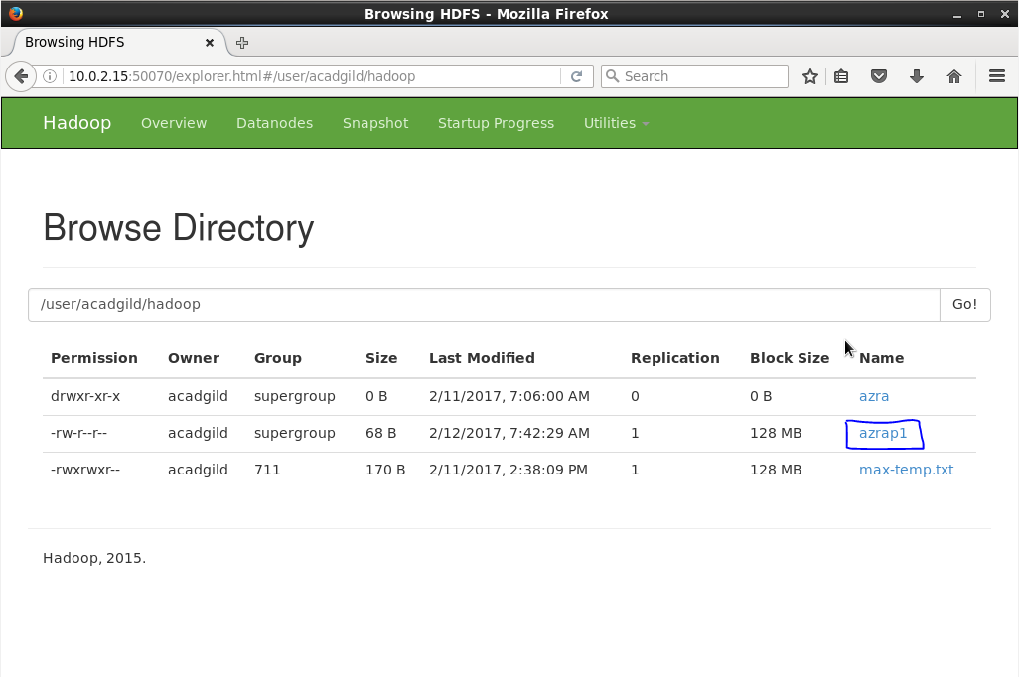

### ****2. List Command****

### C:\Users\612971\Desktop\4.3.PNG

### ****3.Get Command****

### C:\Users\612971\Desktop\4.4.PNG

### ****4. Make Directory Command****

### C:\Users\612971\Desktop\4.5.PNG

### ****5. View contents of particular file****

### C:\Users\612971\Desktop\4.6.PNG

### ****6.Duplicating a Complete File inside the HDFS.****

### C:\Users\612971\Desktop\4.7.PNG

### ****7.Duplicating a File from HDFS to the Local File System.****

### C:\Users\612971\Desktop\4.8.PNG

### ****8.Removing the File****

### C:\Users\612971\Desktop\4.9.PNG

### ****9.Run a DFS Filesystem to Check Utility****

### C:\Users\612971\Desktop\4.10.PNG

### ****10.Run a Cluster Balancing Utility****

### C:\Users\612971\Desktop\4.11.PNG

### ****11.Check Directory Space in HDFS****

### C:\Users\612971\Desktop\4.12.PNG

### 12. List all the Hadoop File System Shell Commands

### C:\Users\612971\Desktop\4.13.PNG

### ****13.Asking for Help****

### C:\Users\612971\Desktop\4.14.PNG