Assignment 26.1 – Problem 1

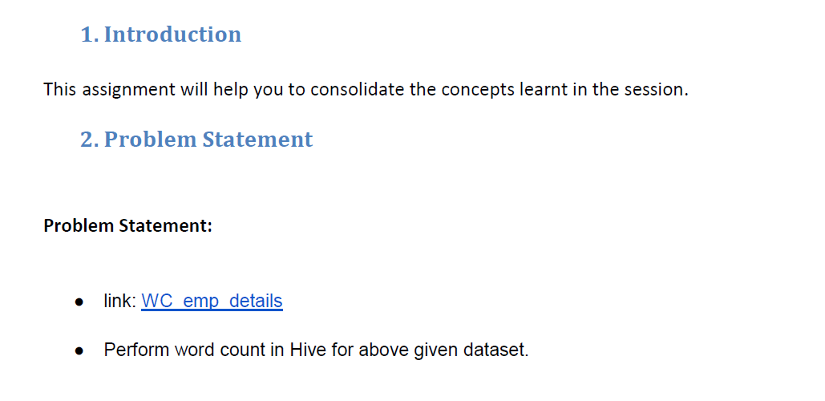

* **Our input emp_detail.txt file is**

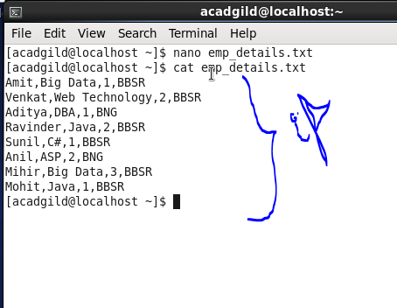

* **So first we will create table named word_count using CREATE command using line as a column name with string as datatype as we will split our line using “,” as delimiter then we will count the words.**



* **After creating table we will load our dataset that is emp_details.txt file to our table**

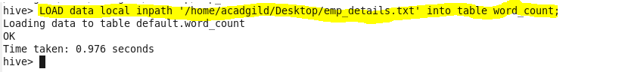

* **Now, we will split each line in our dataset using split command taking “,” as delimiter**

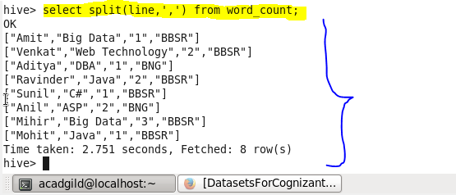

* **After splitting we will take each word separately or we will explode each word using explode command**

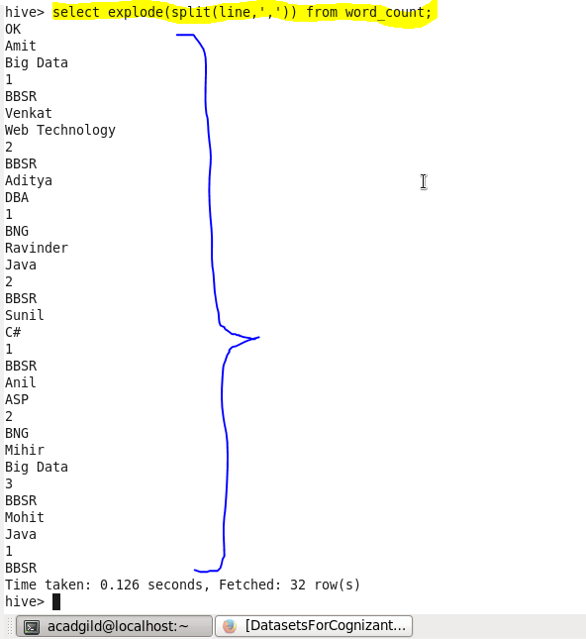

* **Now using above result we can count each word , taking above query as subquery and using COUNT command for counting we can count the number of words.for everyword count will be one and if word repeats it will automatically increase the count by 1 .**

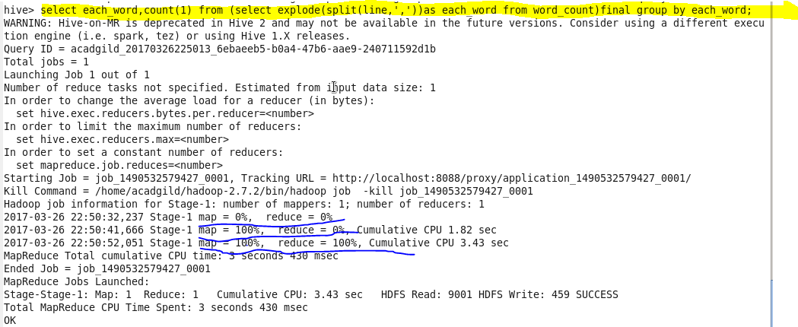

* **So the result of above hive query is :**

