**Assignment 17.5**

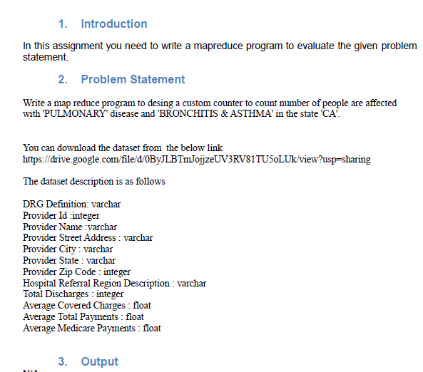

**Driver Class**

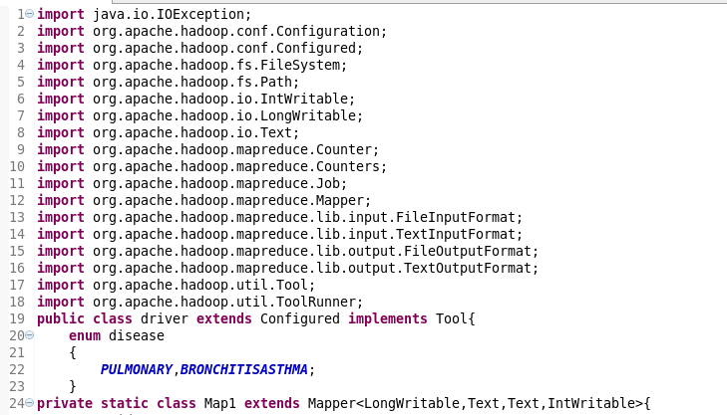

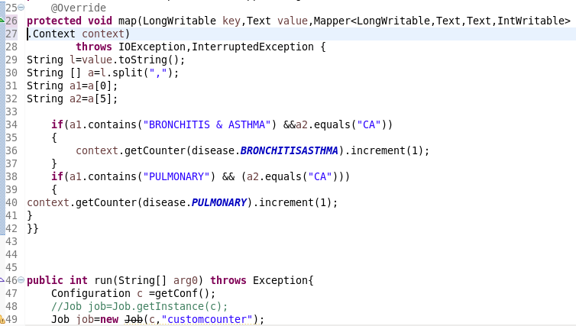

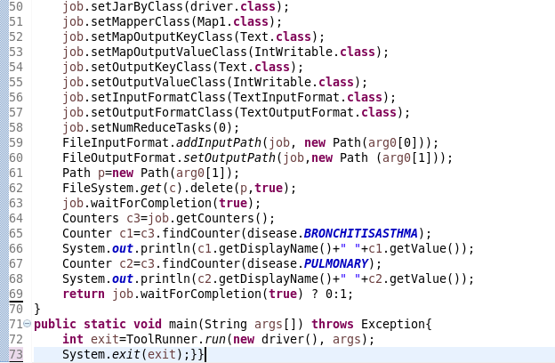

The custom counter BRONCHITIS and PULMONARY has been created and incremented.

**Running JAR**

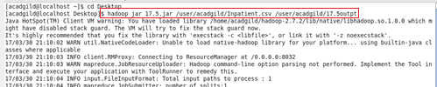

**Output:**

Here, it is showing the count.

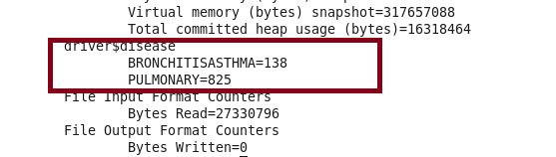

**JOBHISTORY SERVER**

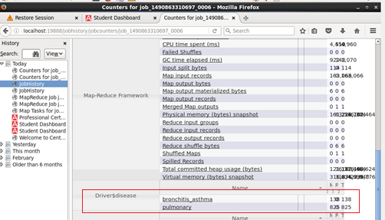

* **Hence Verified**