**Assignment 10.1**

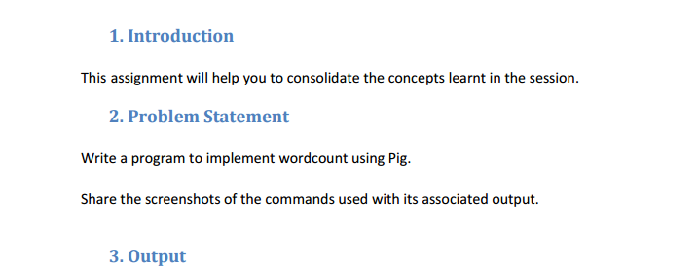

**Input text file:**

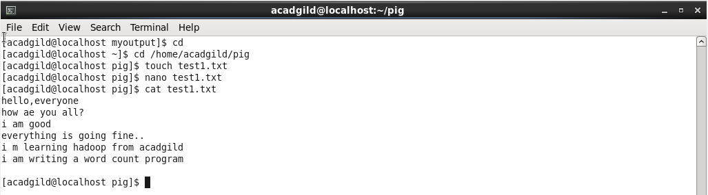

* **Load the data from Local**

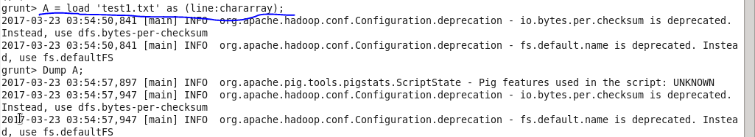

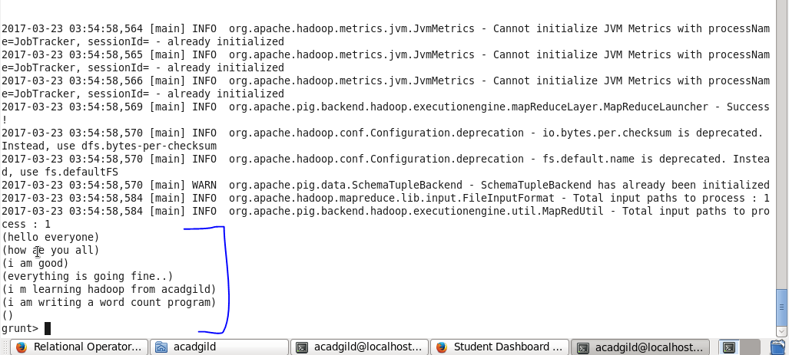

**Convert the sentence into words**

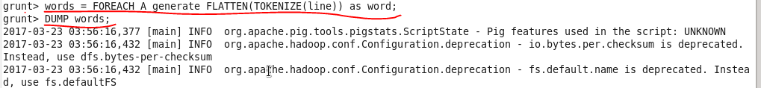

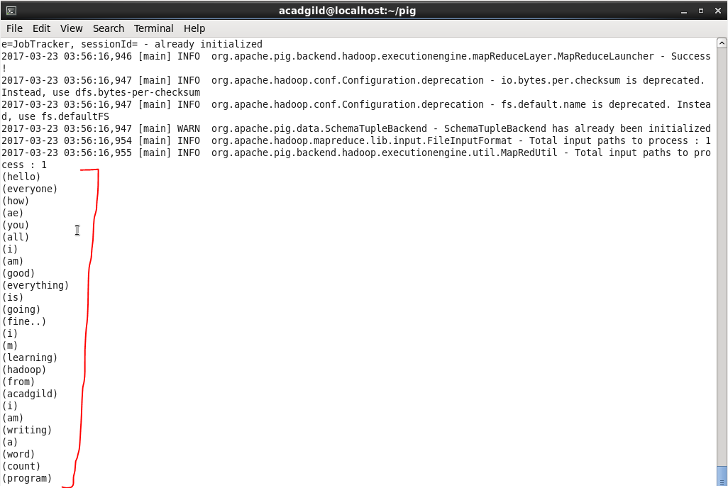

**Apply group by to group same words :**

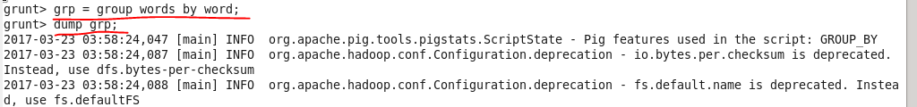

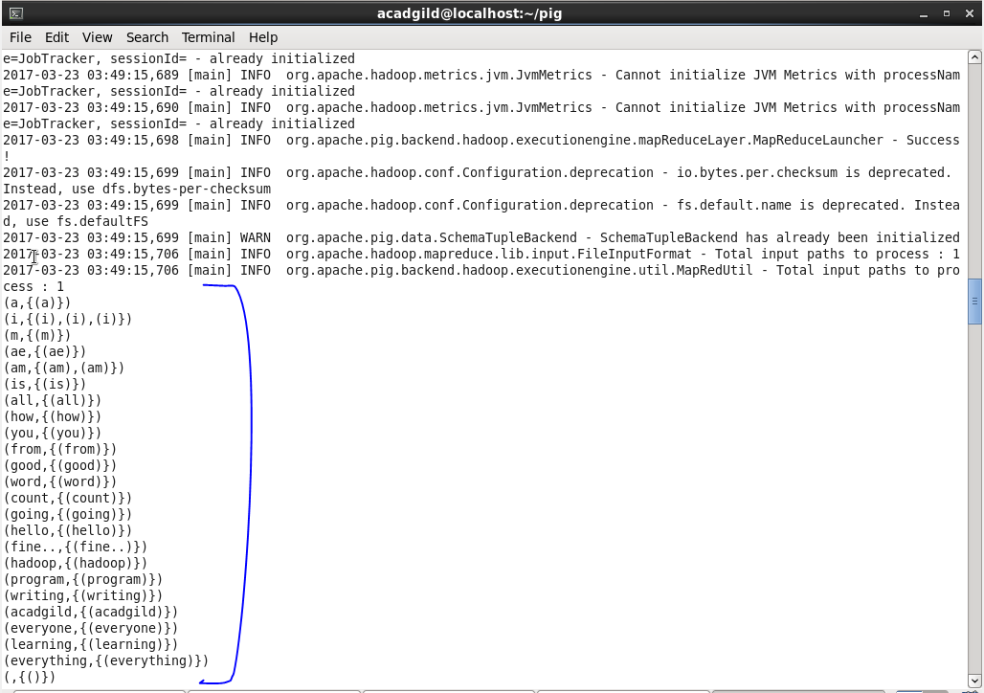

**Generate word count**

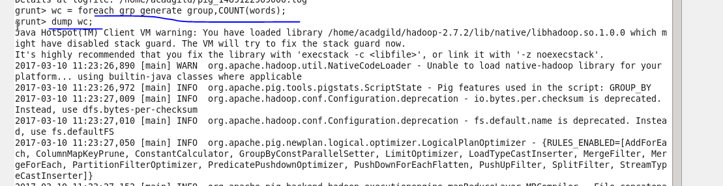

**Output**

