**Assignment 11.1**

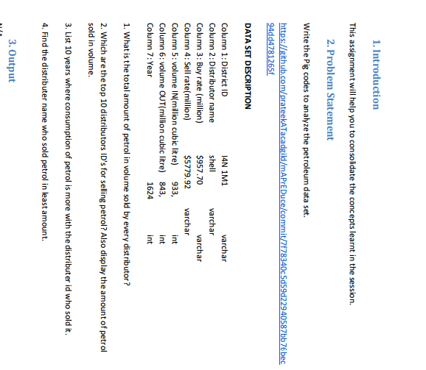

**1 > total amount of petrol sold –**

* For this first we need to load the data set i.e petrol_dataset.txt as we want to display the distributer’s name so we will group the data by the distributer name and will generate the sum that is total amount of sold volume that is vout.

**Pig command :**

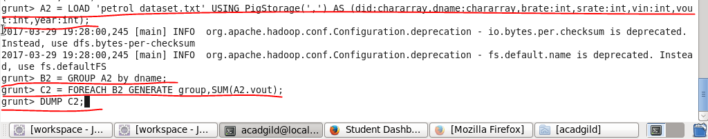

**Output**

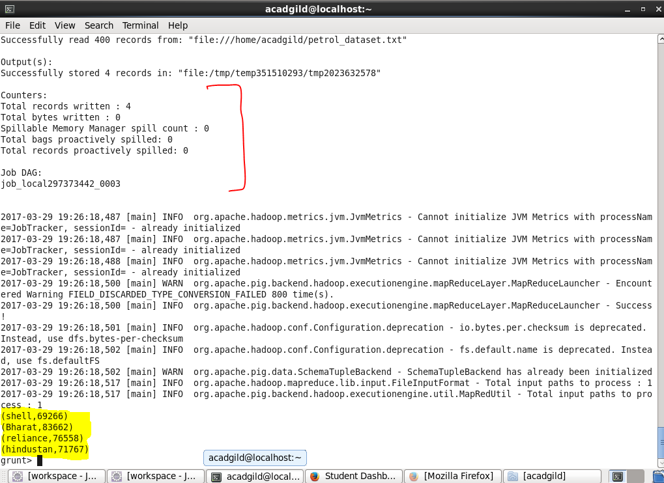

**2 > top 10 distributers ID’s with amount sold –**

* For this first we need to load the data set i.e petrol_dataset.txt as we want to display the distributer’s id and amount of petrol sold so we will group the data by the distributer id first then we will generate the sum that is total amount of sold volume that is vout and then we will order the resulting data in descending order and as we want only top 10 names so we will limit our result to 10 numbers using LIMIT command and will display.

**PIG COMMAND –**

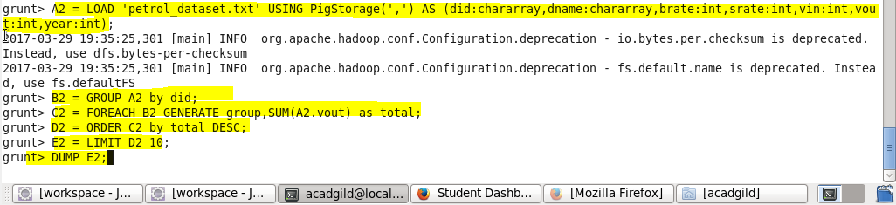

**OUTPUT -**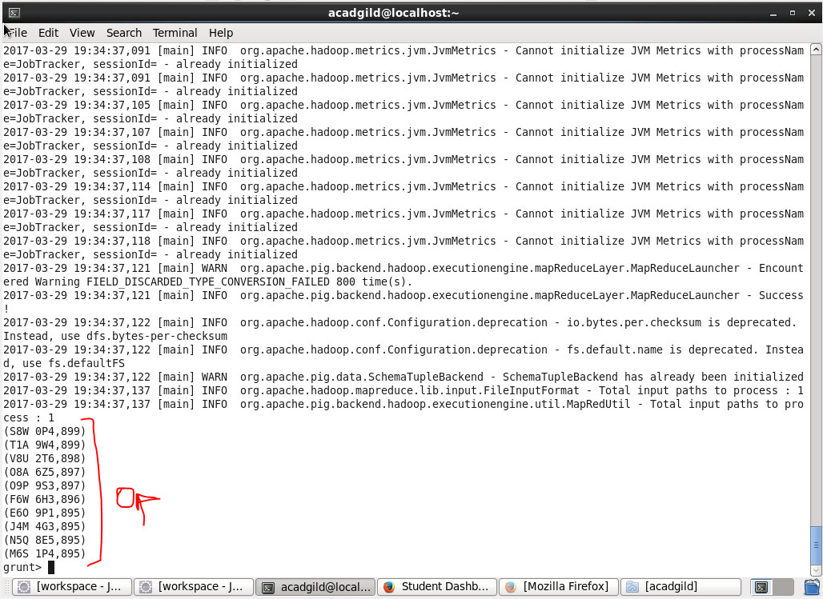

**3 – List the 10 years where consumption of petrol is more with id.**

* For this first we need to load the data set i.e petrol_dataset.txt as we want to display the year and distributer’s id where consumption is more so we will group the data by the distributer id ad year first the we will generate the difference of volume in ad out so as to get the consumption then we will generate year and resultant consumption and as we want top 10 so we will limit our data by 10 and then will show the result.

**Pig commands :**

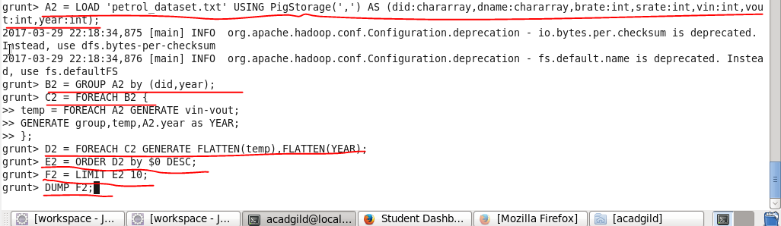

**Output :**

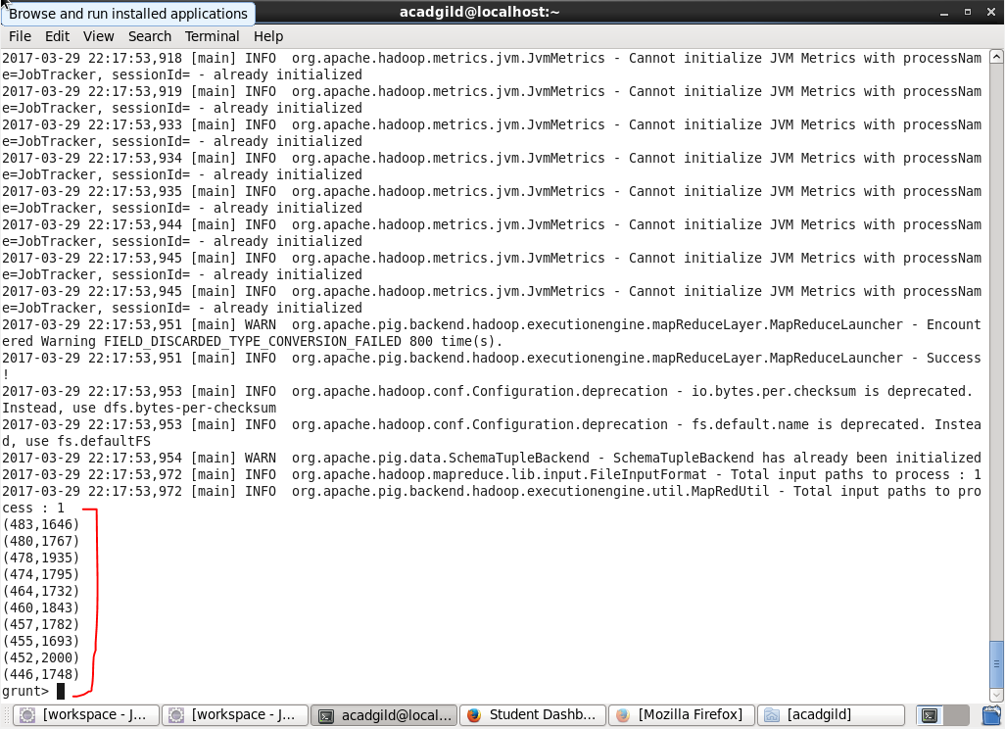

**4 > distributers name who sold least amount :**

As we need to find out the distributers name who sold the least amount for this first we will find out the amount of volume sold and then we will check the least amount and we will display the corresponding distributers name.

**Pig command**

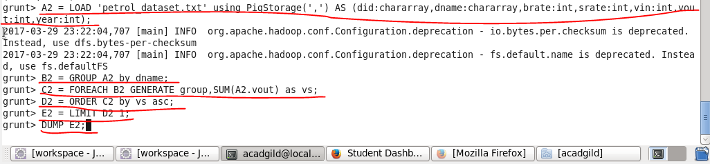

**Output :**

