ASSIGNMENT 23.1

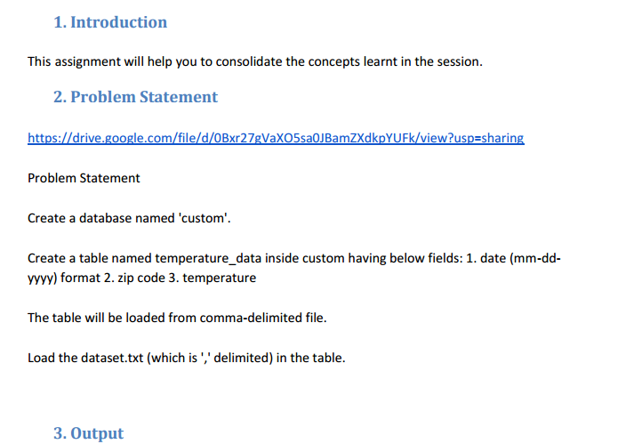

**Input data for inserting into the table**

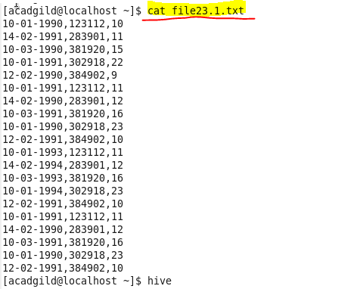

**First we will create database named custom**

* **We can use show databases command to show the databases we created**

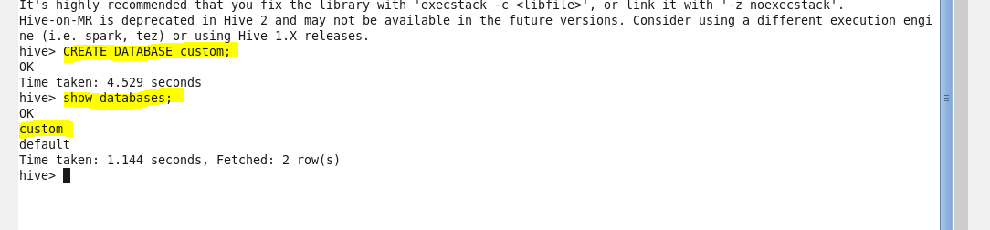

**Then to use database custom so as to create table temperature_data inside custom we will use**

**‘use custom’ command.**

C:\Users\612971\Desktop\23.13.PNG

**Create table temperature_data**

* Now using create table command we will create table temperature_data with comma delimited



**Show table**

* **Show tables will be the command which will show all the tables inside the current database that is custom.**

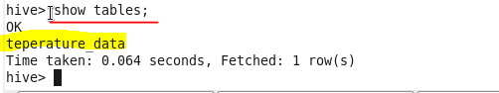

**Load the data into the table**



**Display the content of the table**

* Using following hive query we can display the contents of table teperature_data

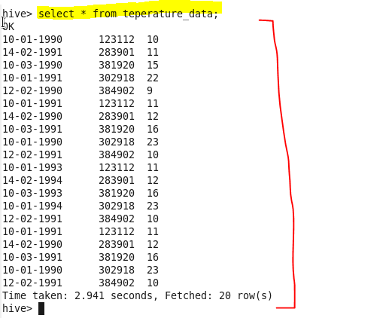

So we get exactly the same data as that of input dataset after removing the delimiter which is comma.