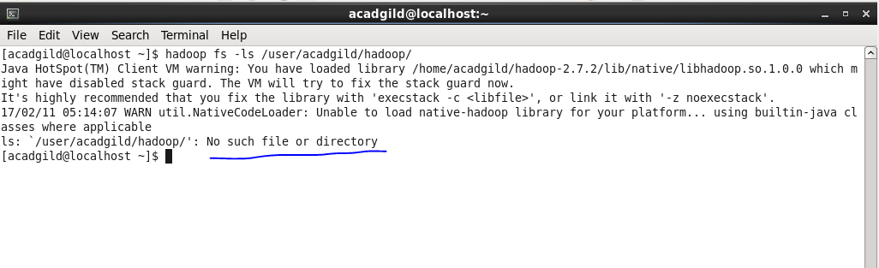

Initially no /user/acadgild/hadoop directory was there ,now we will create that directory…

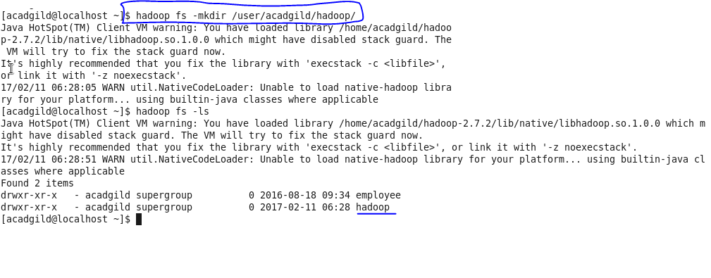

Now we will check again that the give directory exists or not.The below screenshot shows the existance of that directory.

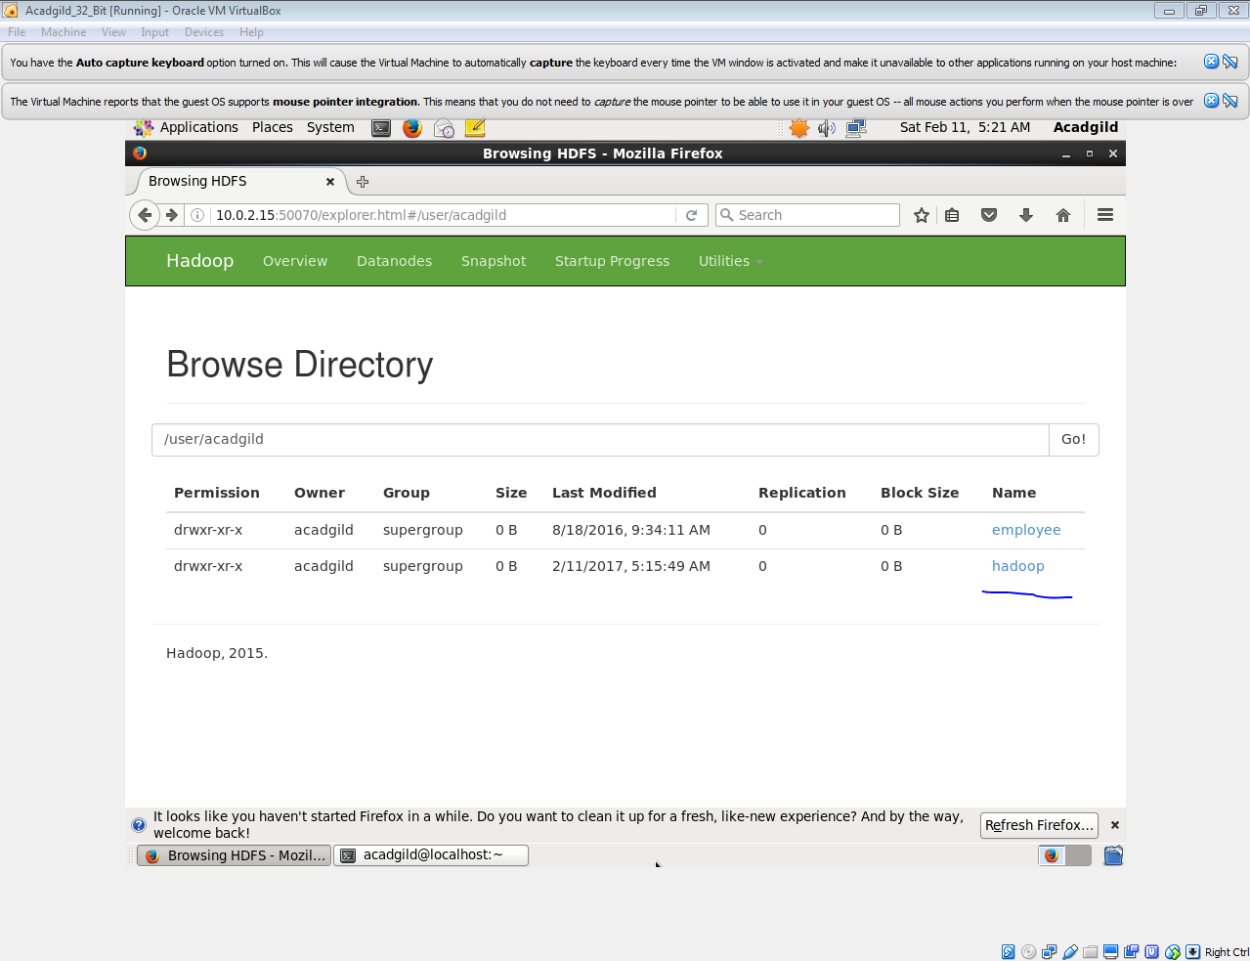

Now we will create new sub directory named azra in our directory-

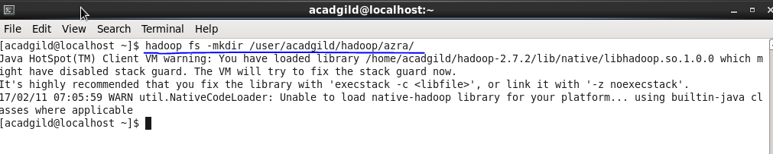

Now we will check that our new subdirectory azra exists or not:

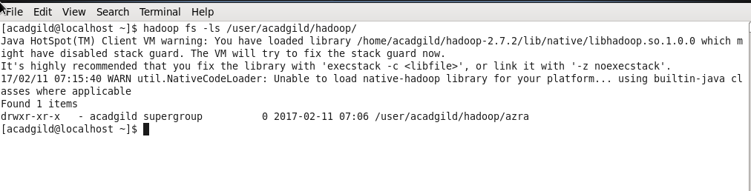

Now,we can see that azra is subdirectory in user/acadgild/hadoop directory.

