**Assignment 7.1**

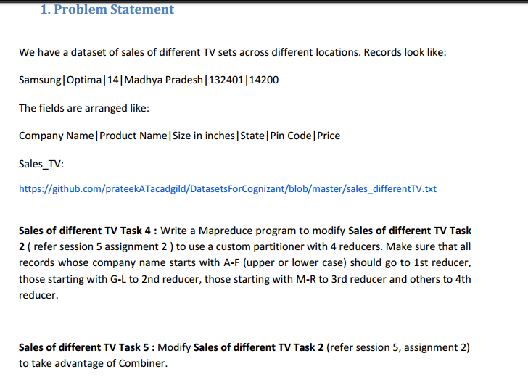

**DRIVER CLASS**

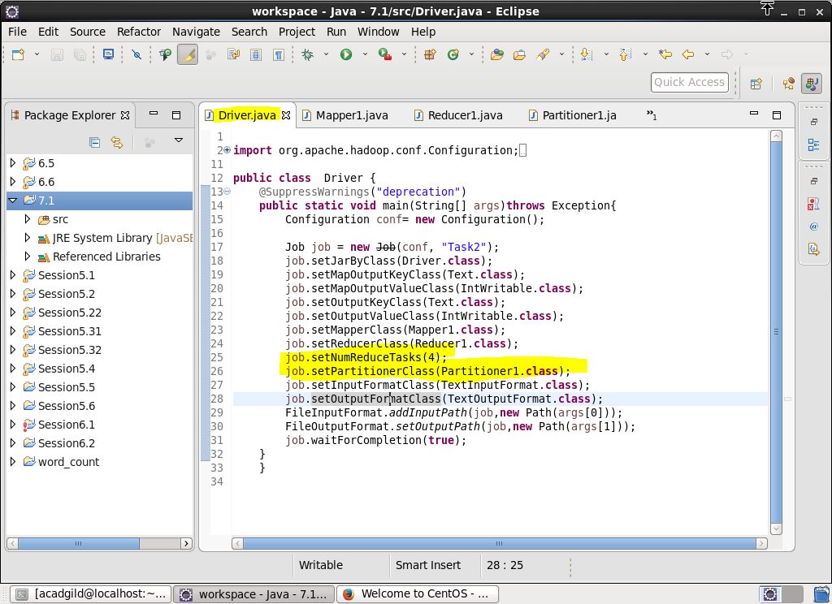

We will use one partitioner class and will set number of reduce task to 4.

**MAPPER CLASS**

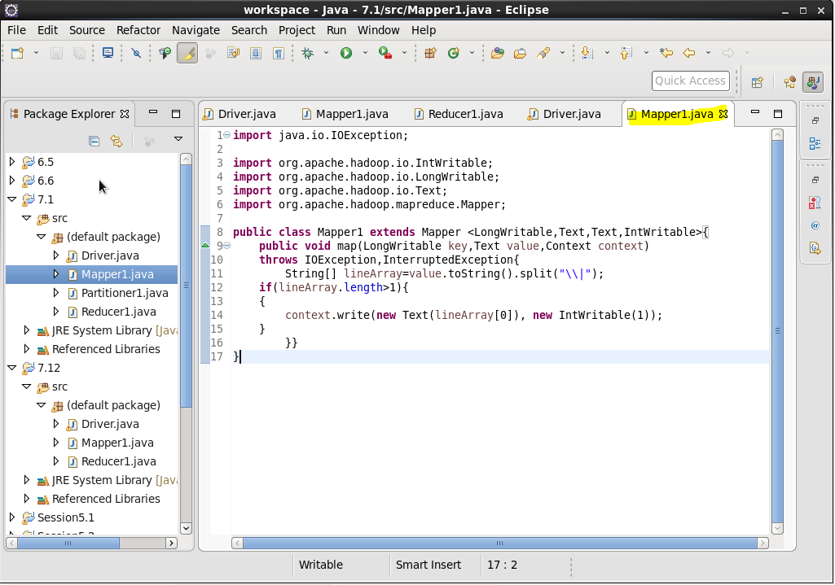

We used mapper splitting using “|” as delimiter and we will check if record is their or not and sent the company name as key and for each company we sent 1 as value usig context.write.

**REDUCER CLASS**

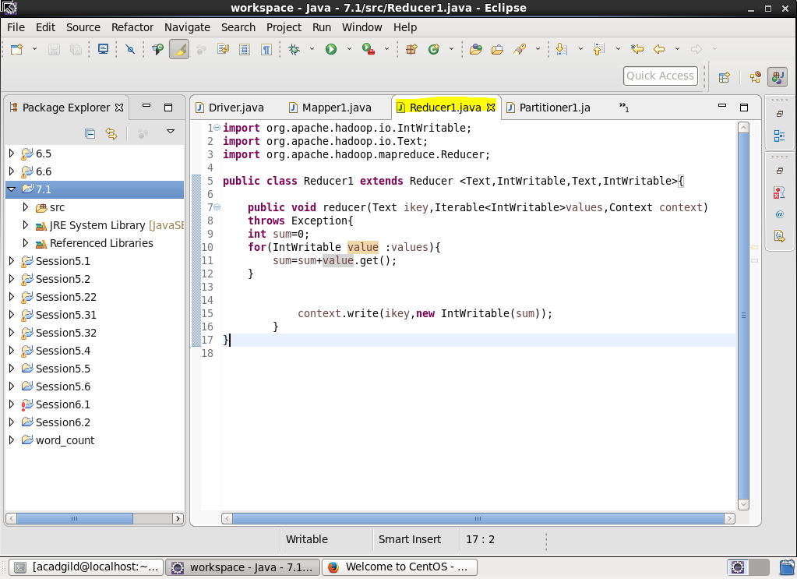

Using reducer class we will COUNT the no of units for each company by iterating .

**PARTITIONRER CLASS**

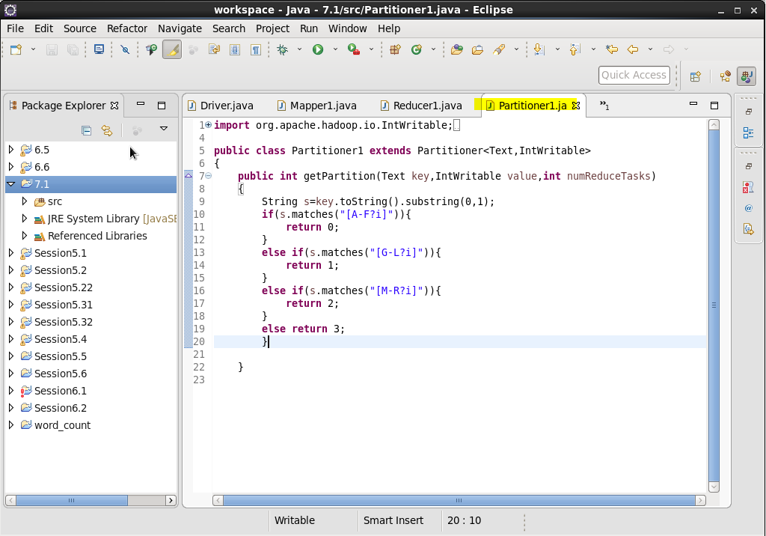

USED MATCHES FUNCTION AND COMPARE KEY NAME AND SEND IT TO CORRESPONDING REDUCER

**RUNNING JAR**

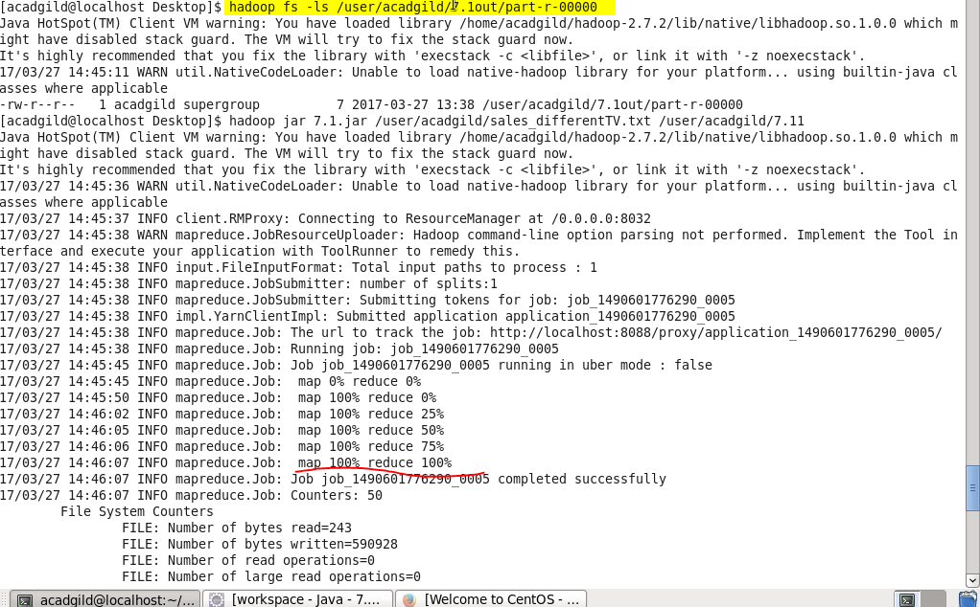

**output**

**Reducer 0 output :**

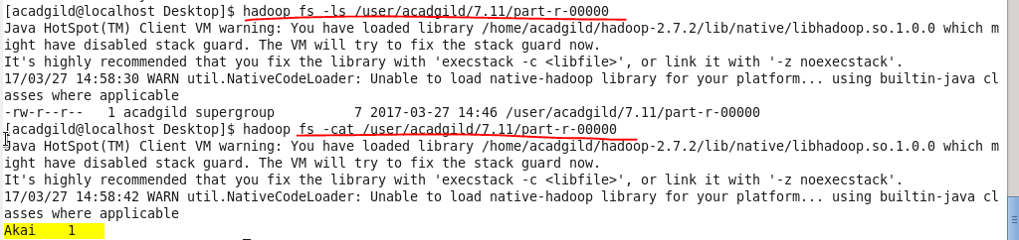

**Reducer 1 output :**



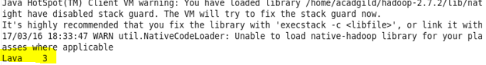

**Reducer 2 output :**



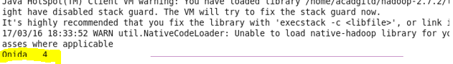

**Reducer 3 output :**



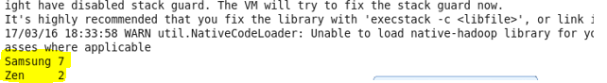

*Prb 2 : Modify Sales of different TV Task 2 (refer session 5, assignment 2) to take advantage of Combiner.*

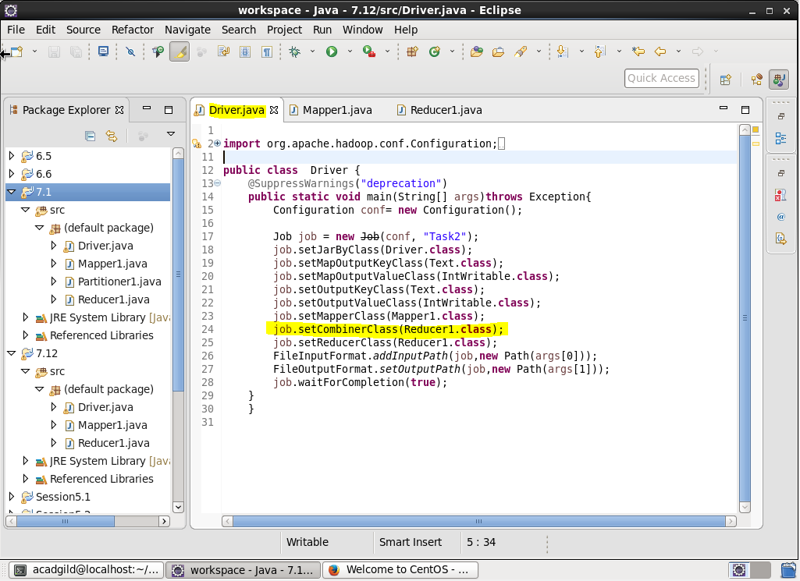

Set combiner class and give the reducer class as combiner as the logic for combiner and reducer is the same

**Mapper class**

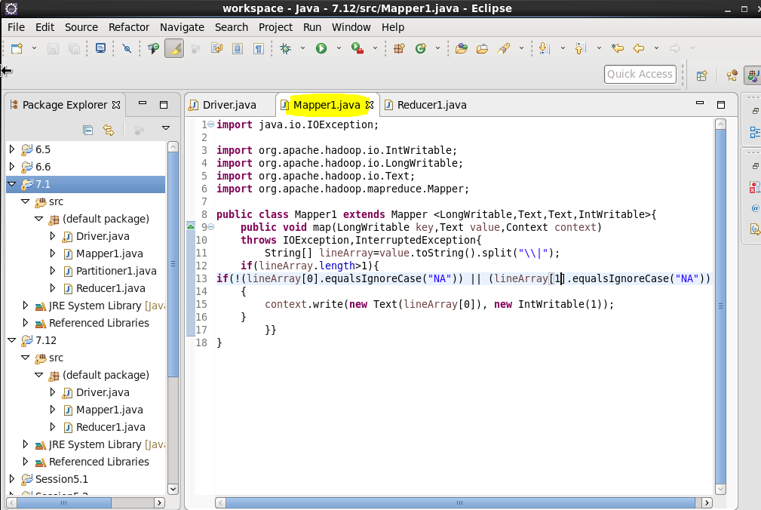

**REDUCER**

COUNT the no of units for each company by iterating

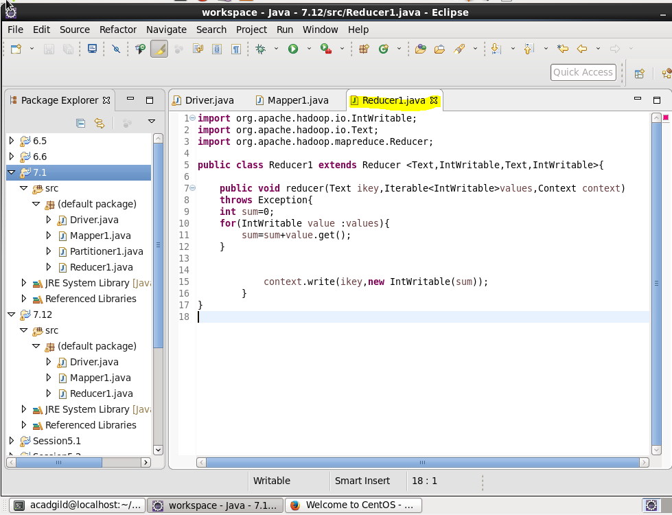

**RUNNING JAR**

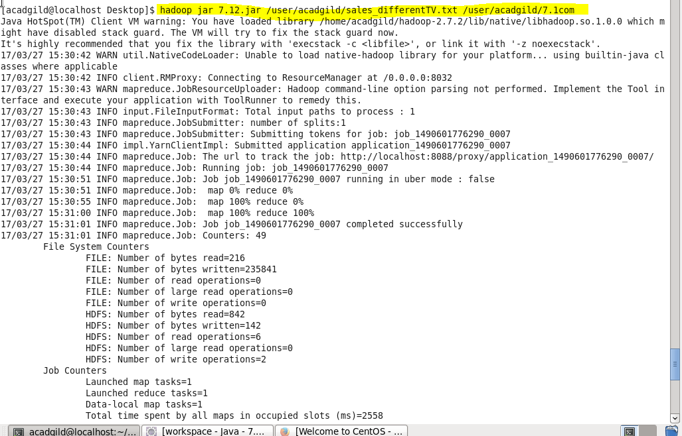

**Output**



