4.1.1. Java program to take a HDFS Path as input and display all the files and sub-directories in that HDFS path

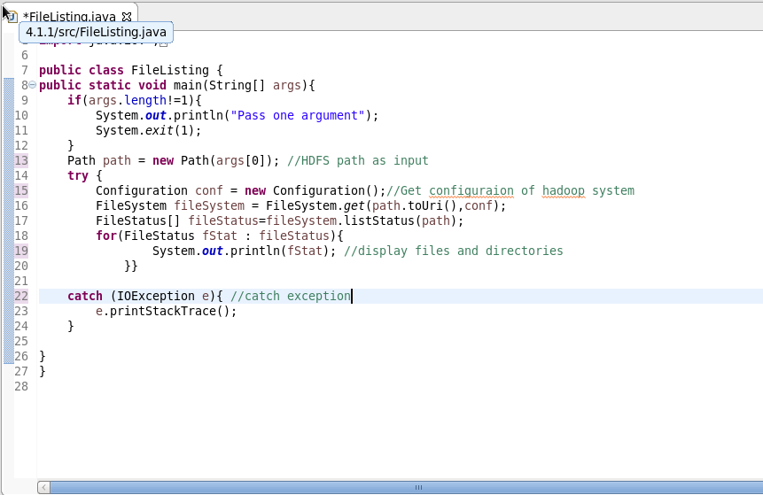

Output:

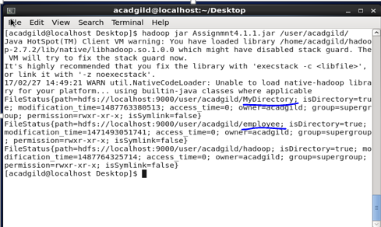

4.1.2. Program to list all the files and sub-directories in the HDFS path recursively.

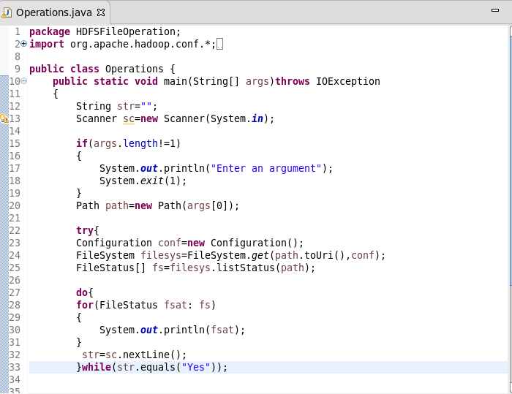

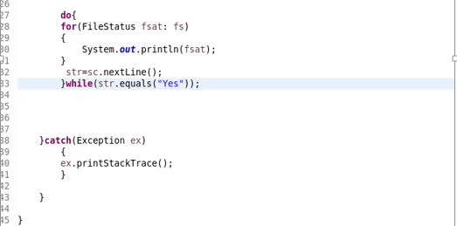

Output:

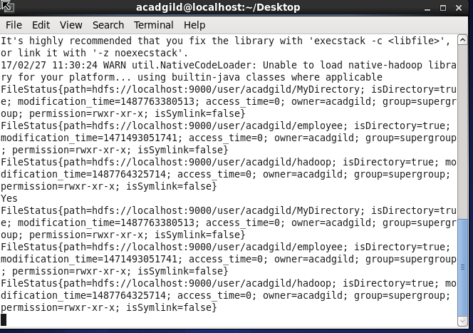

4.1.3. Program to take multiple HDFS paths (separated by space) and list all the files and sub-directories in those HDFS paths recursively.

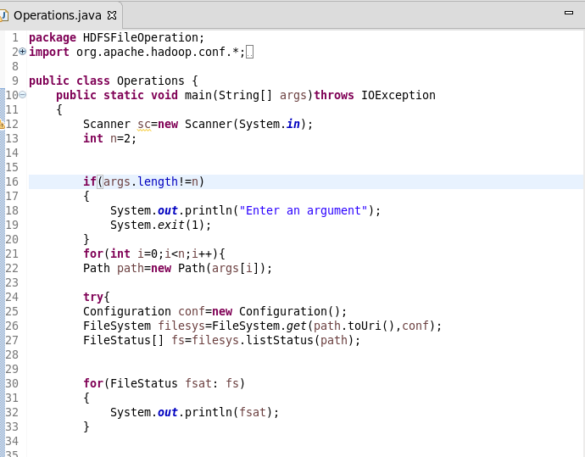

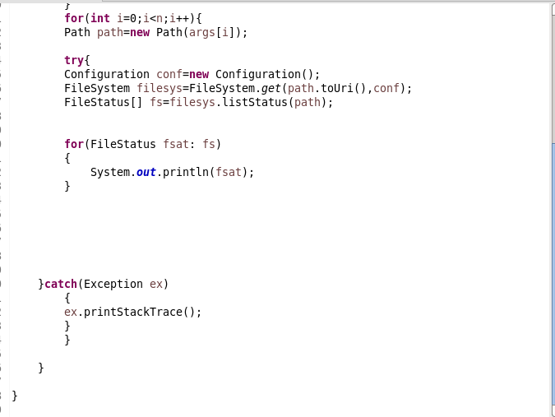

Output:

