**Assignment 5.2 >**

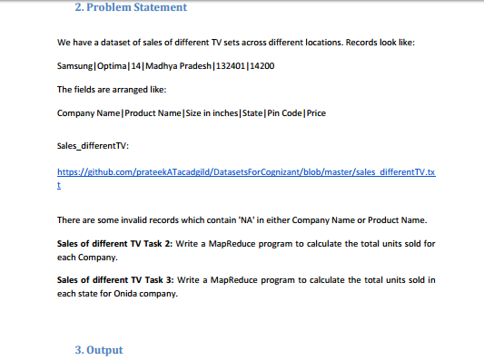

DataBase for above problem is :

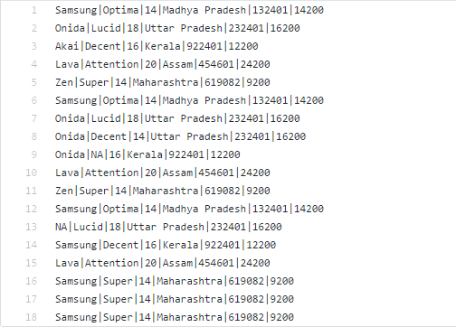

**Task 2** *>*

1. Create file sales_differentTV.txt >

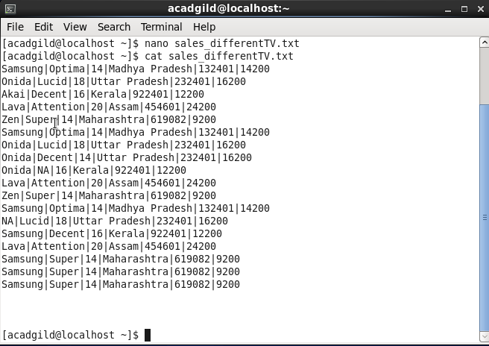

**Code :**

***Driver class* :** following shows the driver class for task2

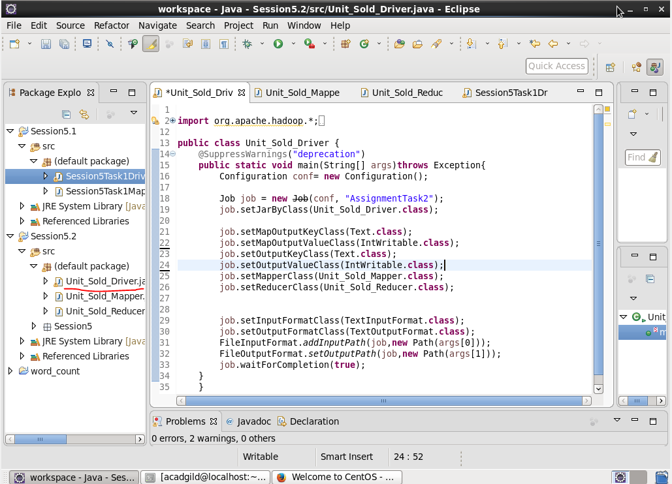

***Mapper class :*** following shows the mapper class for task2

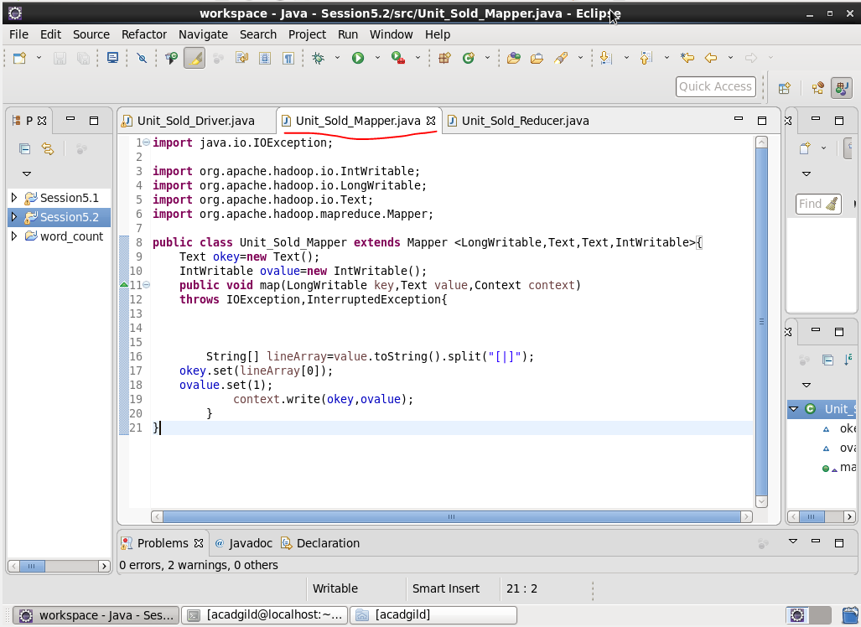

***Reducer class:***

following shows the Reducer class for task2

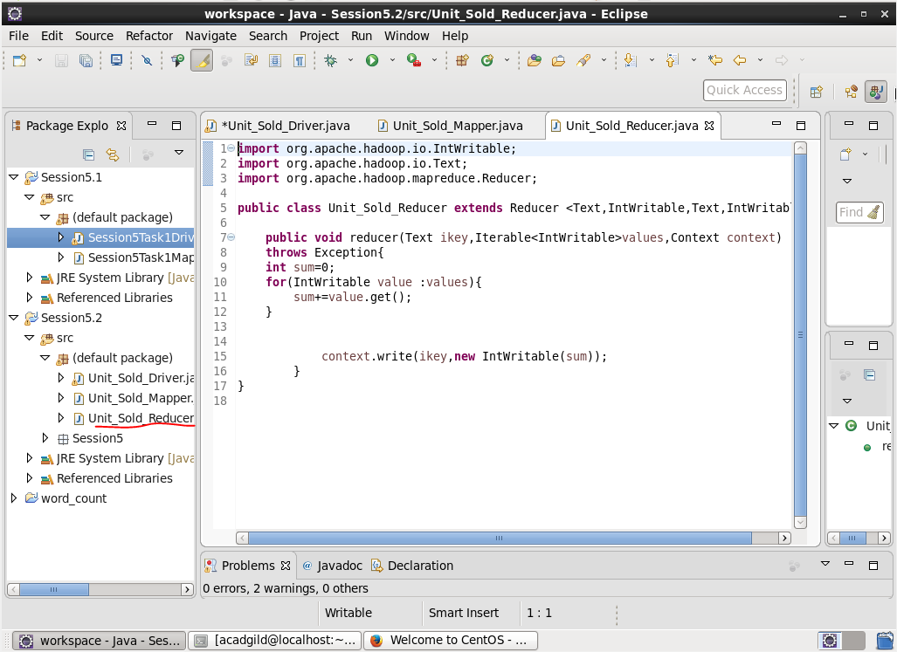

**Output :**

Following are the output screenshots we got after performing task 2:

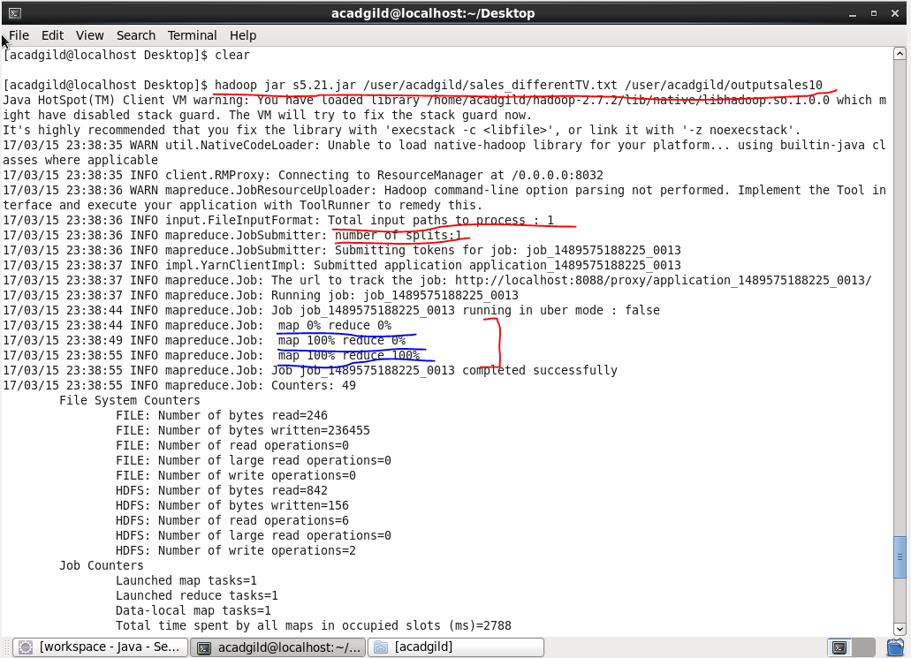

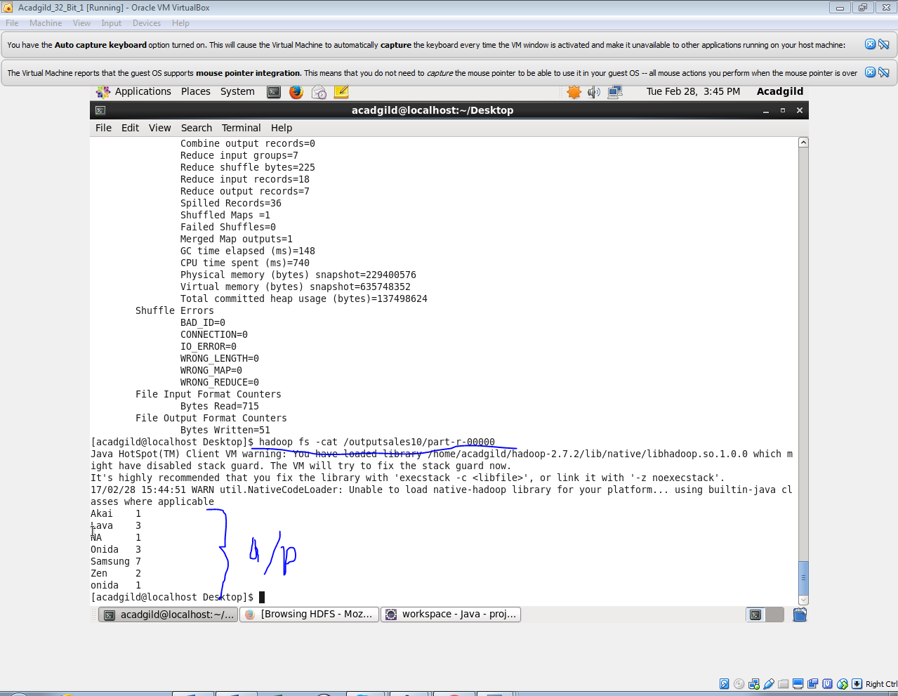

**Task 3 :**

***Input file***

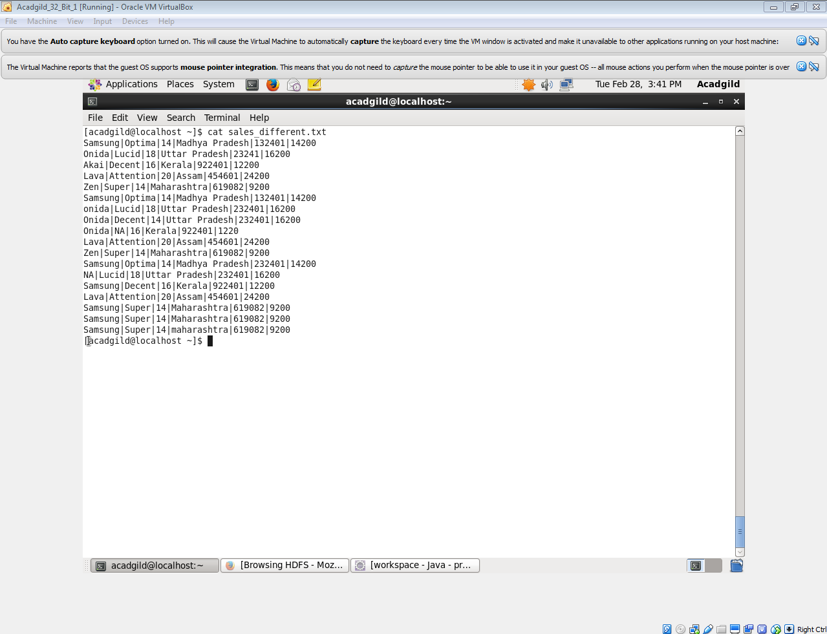

**Code :**

**Driver >**

following shows the Driver class for task3

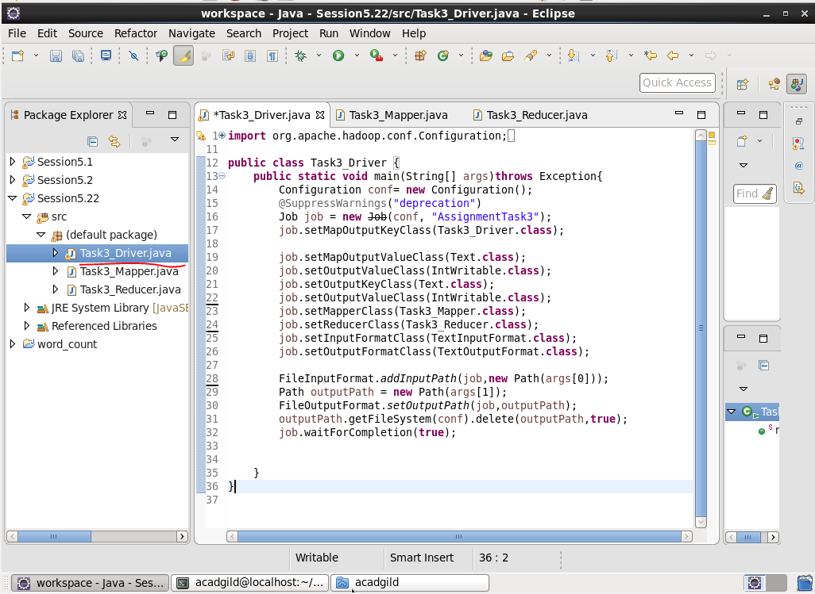

**Mapper >**

Following shows the Mapper class for task3

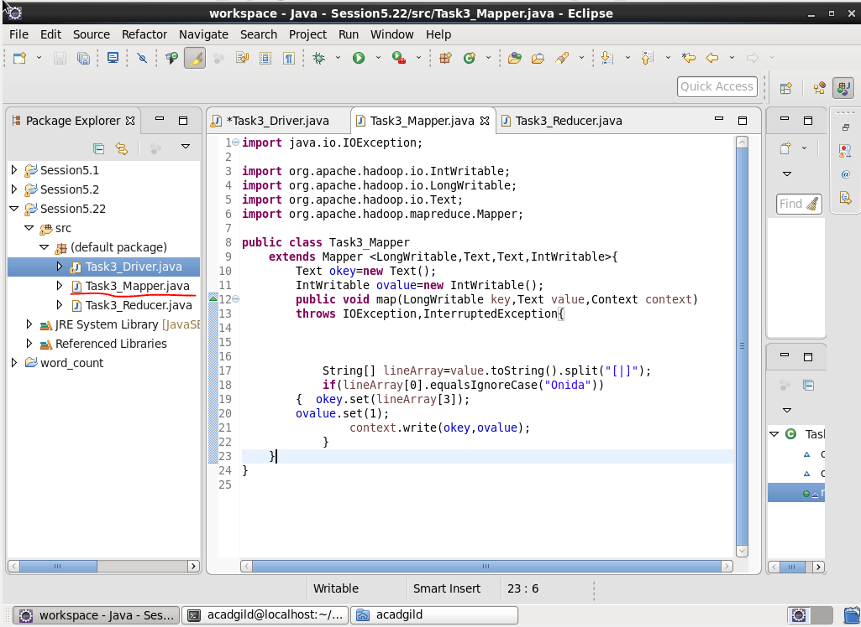

**Reducer >**

following shows the Reducer class for task3

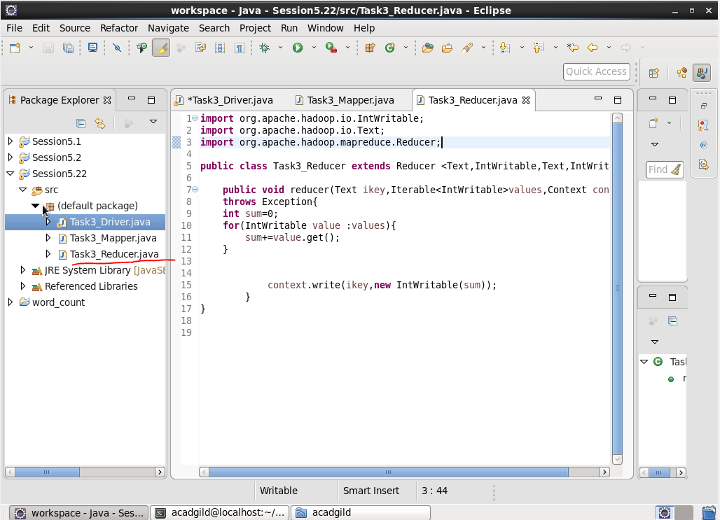

**Output**

Following are the output screenshots we got after performing task 3:

