* First we have to create a file named max-temp.txt and add records to that
* Using touch command we created file
* Using nano command we inserted data into that(save that(ctrl+x followed by y))
* To check our file we used cat command.

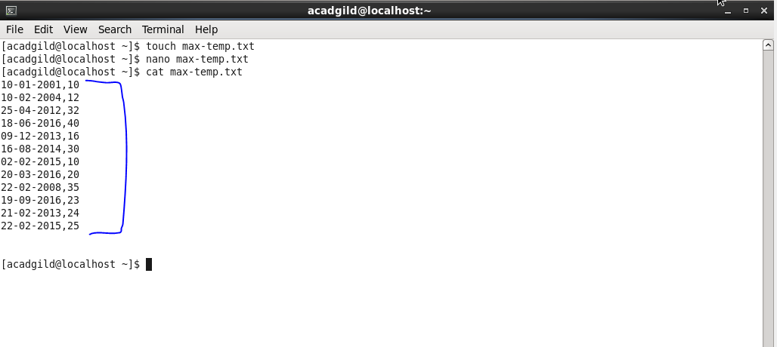

To edit and insert data in nano editor :

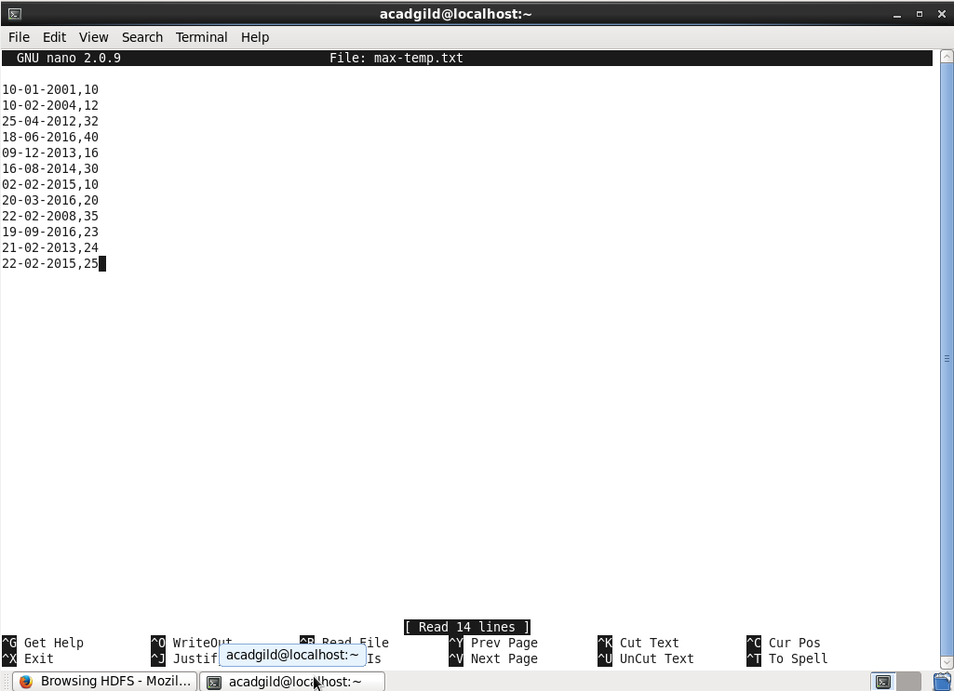

* Now we have to copy the above max-temp.txt file from the local file system to HDFS in the /user/acadgild/hadoop path for that we used put command

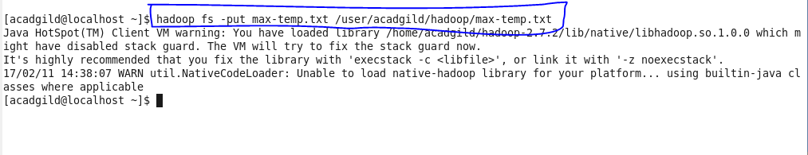

Now we will check in browser if our file is copied or not :

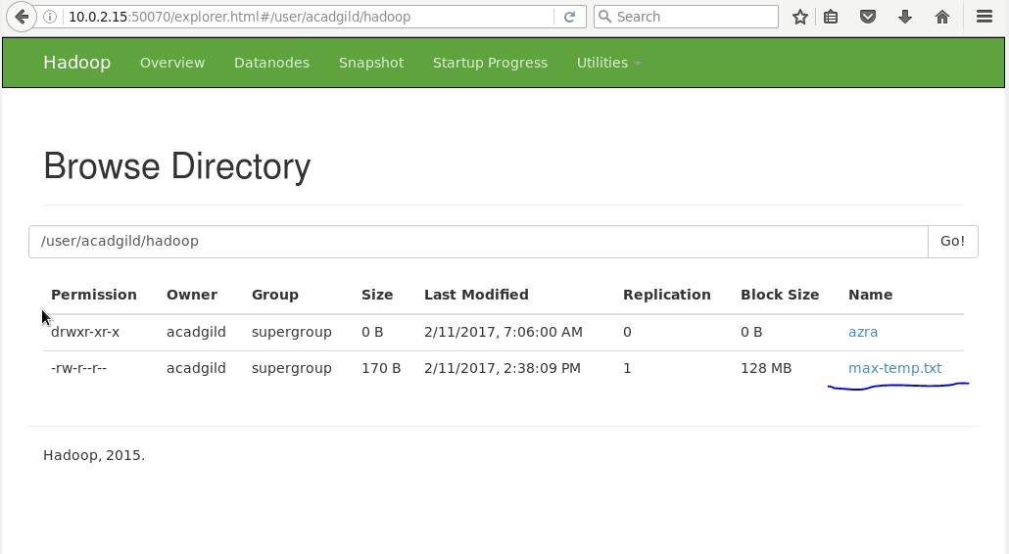

Below diagram shows the information of our file:

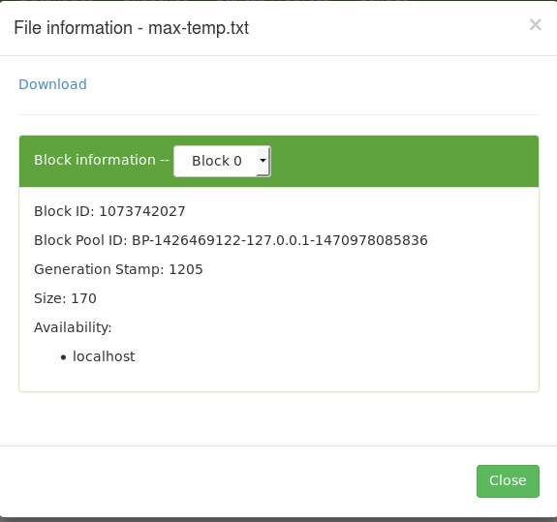

Now, we have to change the permission of the file such that only the owner and the group members should have the read,write,execute permissions. Others should have only read the permission on the above file.

First lets check the current permissions :

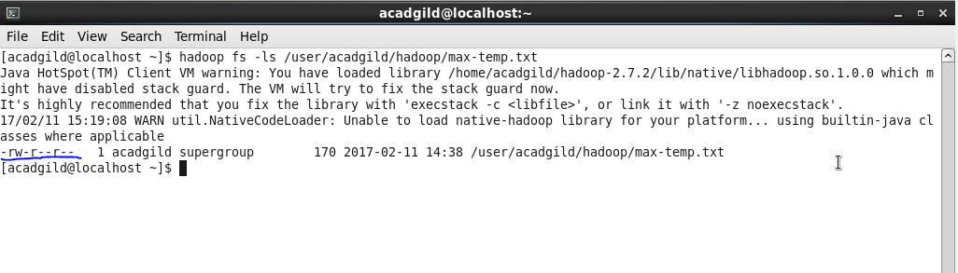

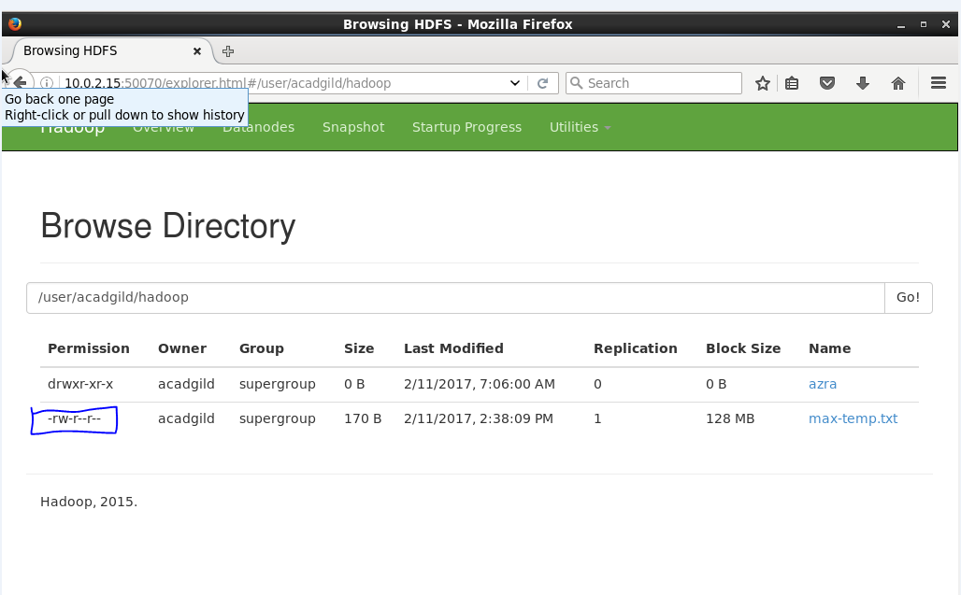

Here we can see only read and write permission is given to user and only read permission to groups and others.

Now ,to change the permissions we will use chmod command as follows:

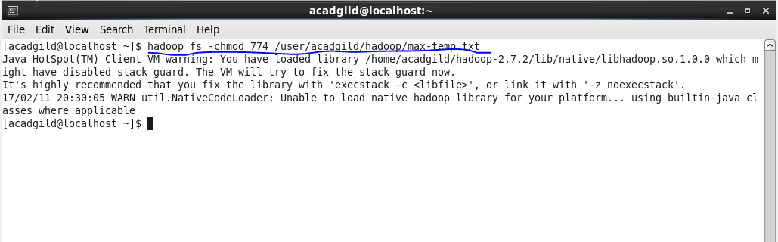

Now we can check the changed permissions:

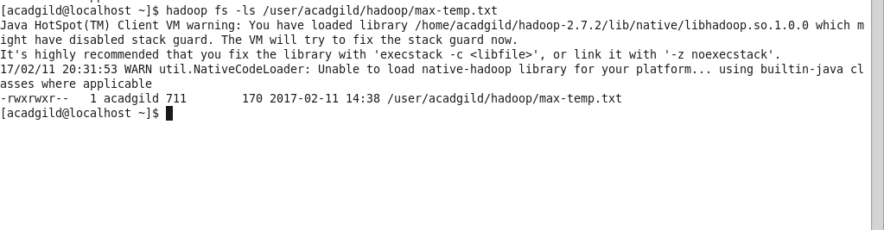

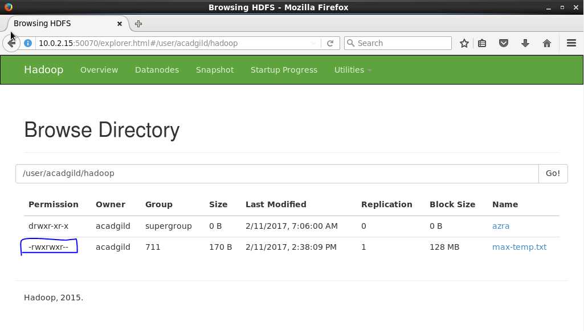

Above screeshot show that we have changed the permissions successfully.