**Assignment 9.2 :**

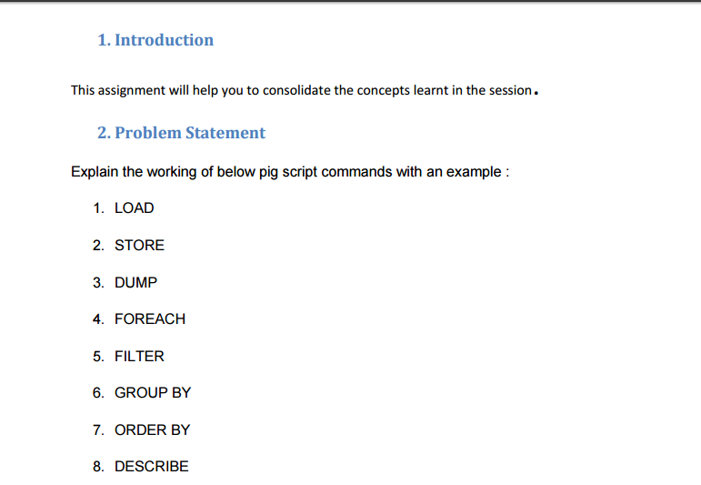

**Let say a particular database is there named employee_details.txt with data:**

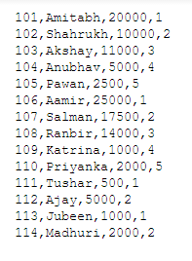

* **LOAD**
* LOAD command is used to load the data from the file system (local/HDFS) into a relation.

Eg.

emp = LOAD 'employee_details' USING PigStorage(',') AS (emp_id:int, emp_name:chararray, emp_salary:int);

* **STORE**
* STORE command is used to save a relation to the file system (local/HDFS).

Eg.

STORE sorted_emp_annual_salary into 'sorted_emp_annual_salary';

* **DUMP**

To print the contents of a relation on the console we use DUMP command.

Eg.

Dump emp_salary ;

* **FOREACH**

To generate data transformations based on columns of data we use FOREACH command.

Eg.

emp_salary = FOREACH emp generate emp_name, emp_salary*12;

* **FILTER**

To remove unwanted rows from a relation FILTER command is used.

Eg.

filtered_emp_id = FILTER emp by emp_id<110;

* **GROUP BY**

Group by command group the data in a single relation.

Eg.

grouped_emp_with_rating = group emp_with_rating by emp_rating;

* **ORDER BY**

Order by command arrange a relation in a sorted order based on one or more fields (ascending or descending).

Eg.

sorted_emp_annual_salary = ORDER emp_annual_salary by annual_salary desc; (arranging in descending order)

* **DESCRIBE**

To describe the schema of a relation we use describe command.

Eg.

describe emp_salary;