4.3.1. Write a Java program to display the content of a file in HDFS on screen.

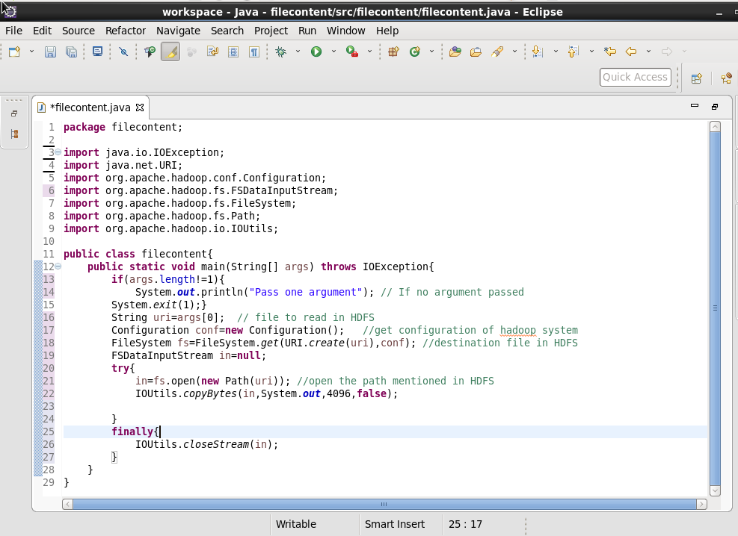

Output :

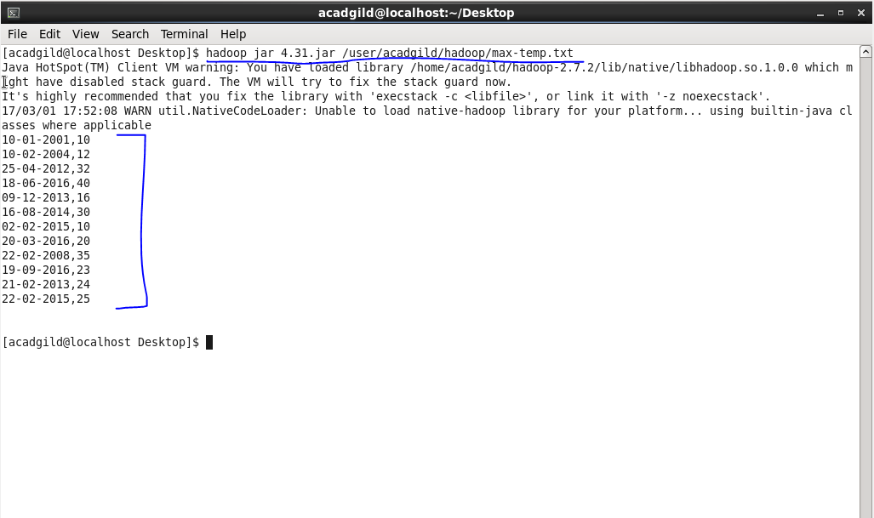

4.3.2. Write a Java program to copy a file from local file system to HDFS.

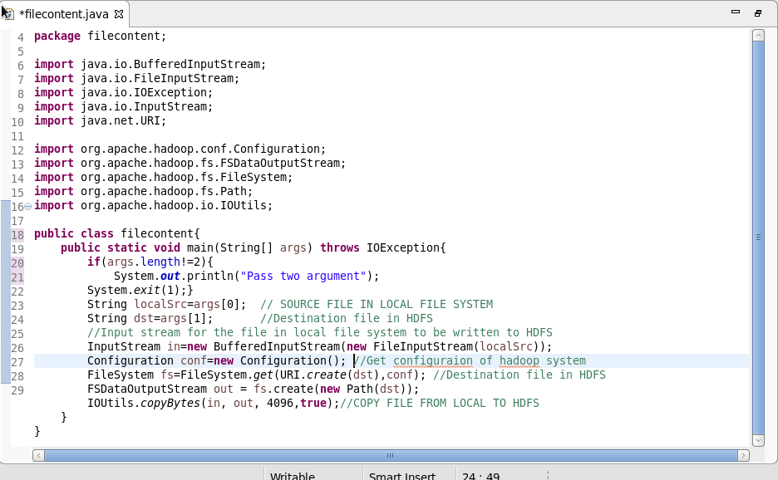

Output:

