**Session 5 - Assignment 3 >**

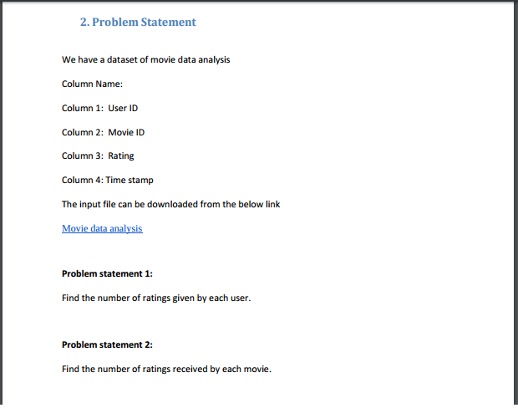

**Problem statement 1 :**

**Code: Driver**

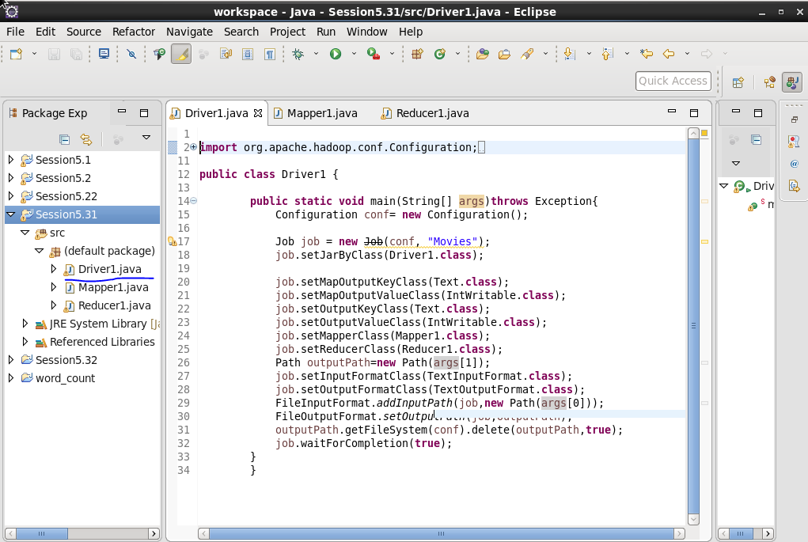

**Code: Mapper**

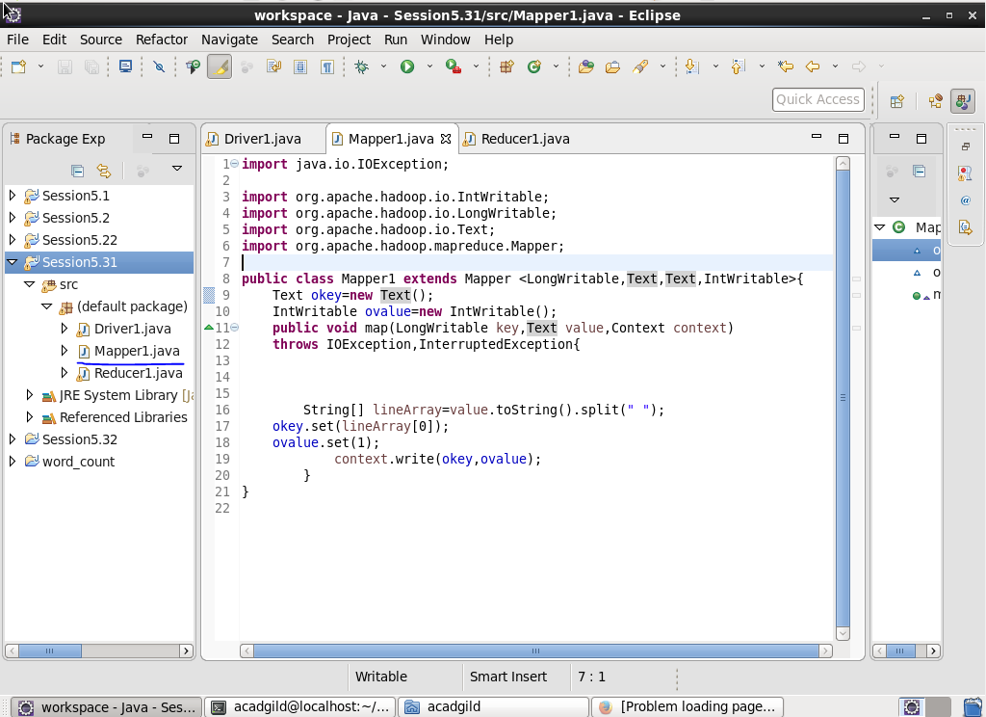

**Code: Reducer**

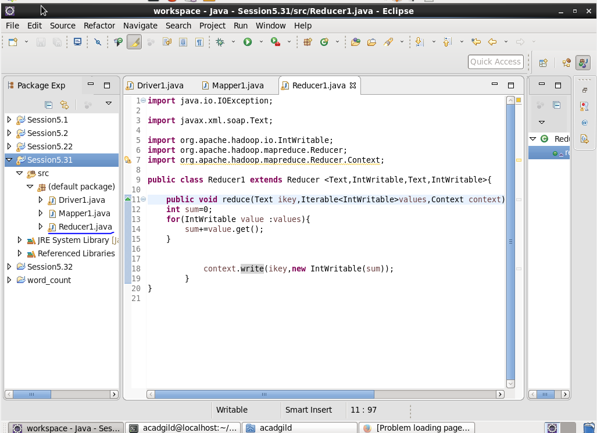

**Input:**

first we need to create a file with he given database, containing with four columns

User ID ,Movie ID , Rating and Time stamp

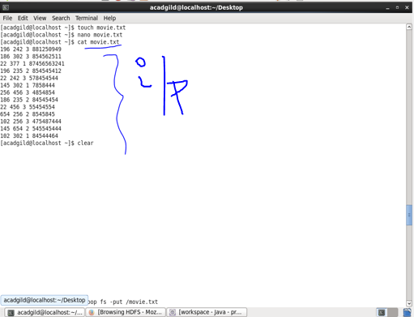

**Output :**

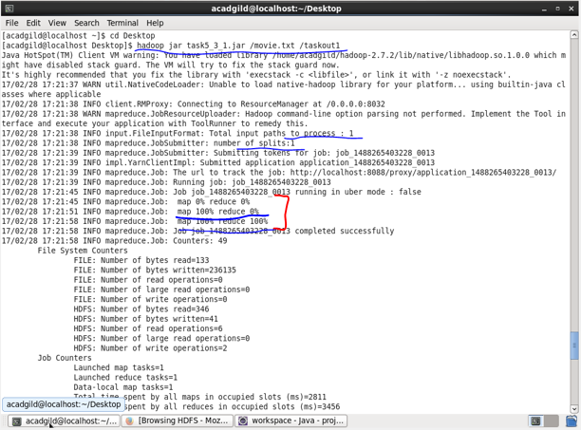

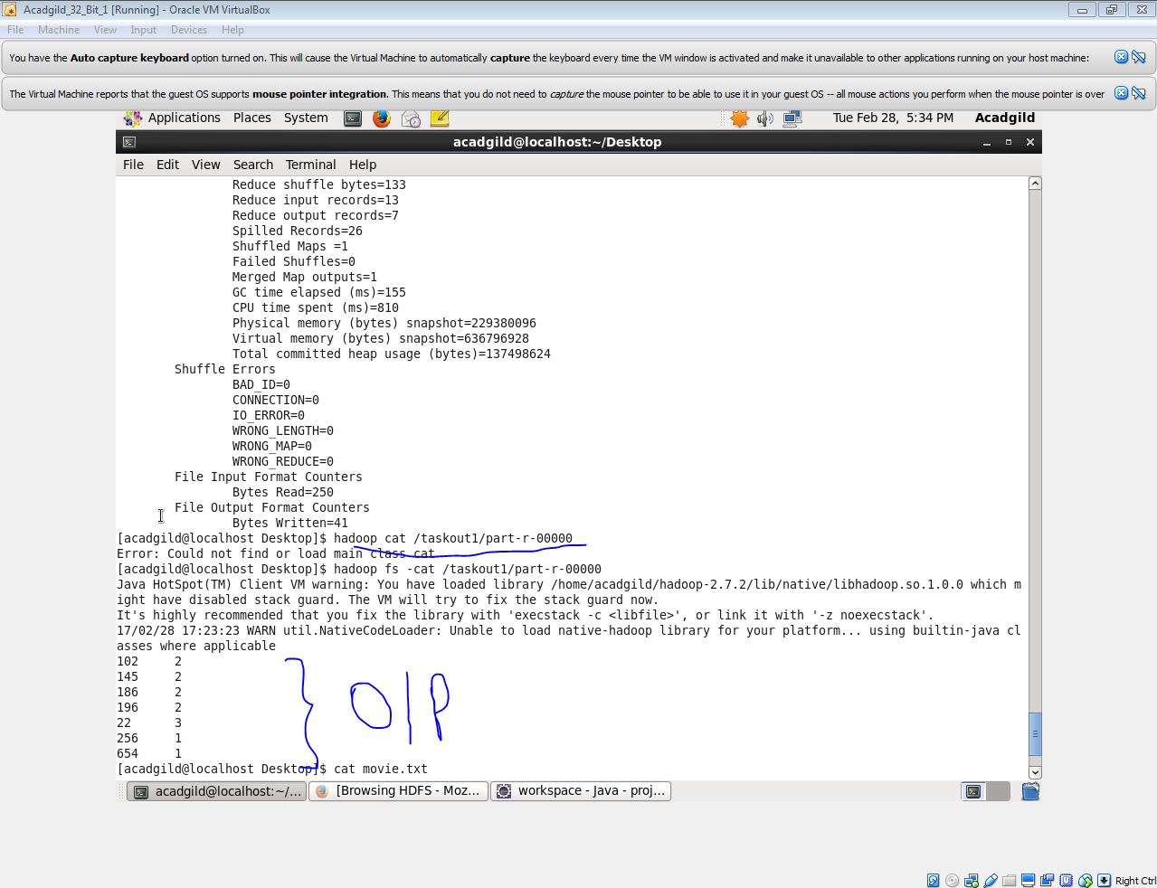

**Problem statement 2 :** Find the number of ratings received by each movie.

**Code: Driver:**

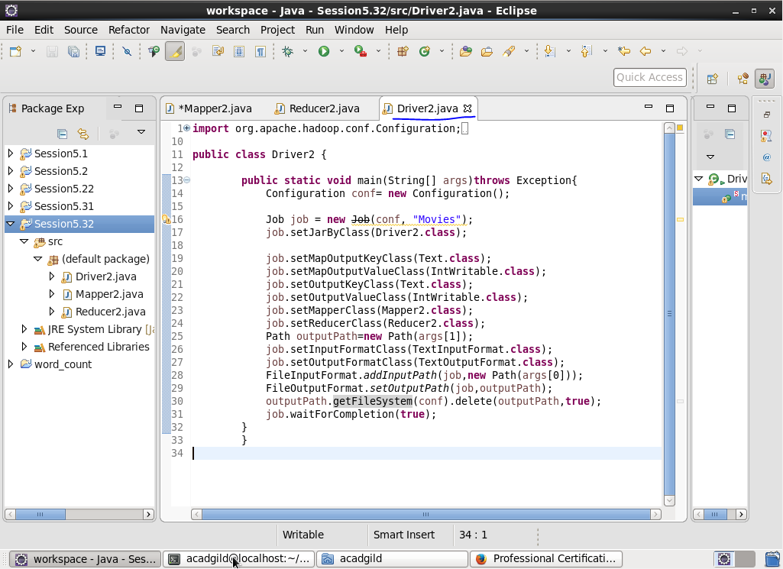

**Code: Mapper:**

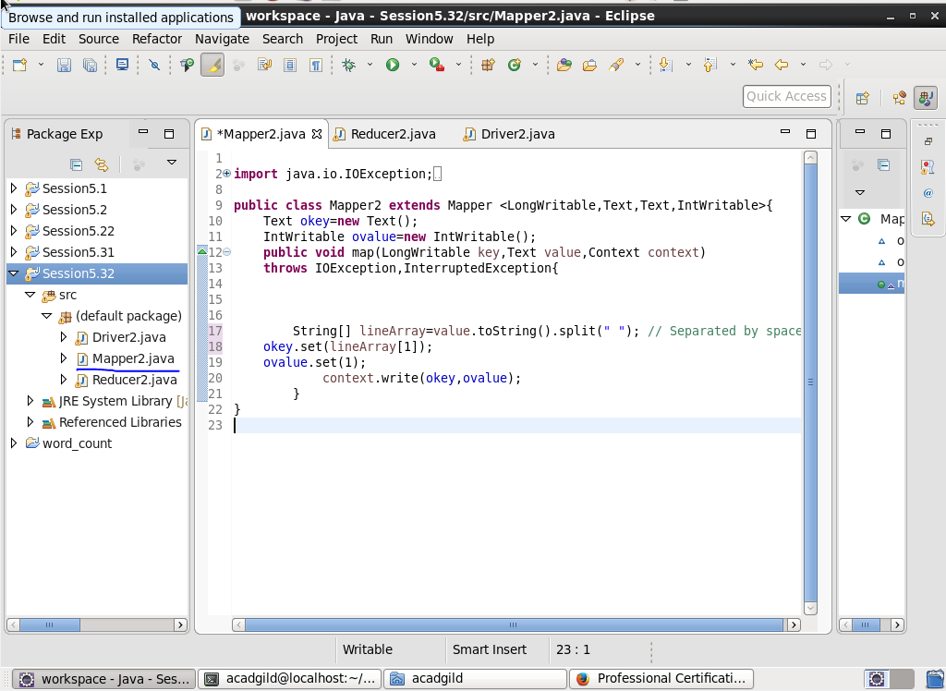

**Code: Reducer:**

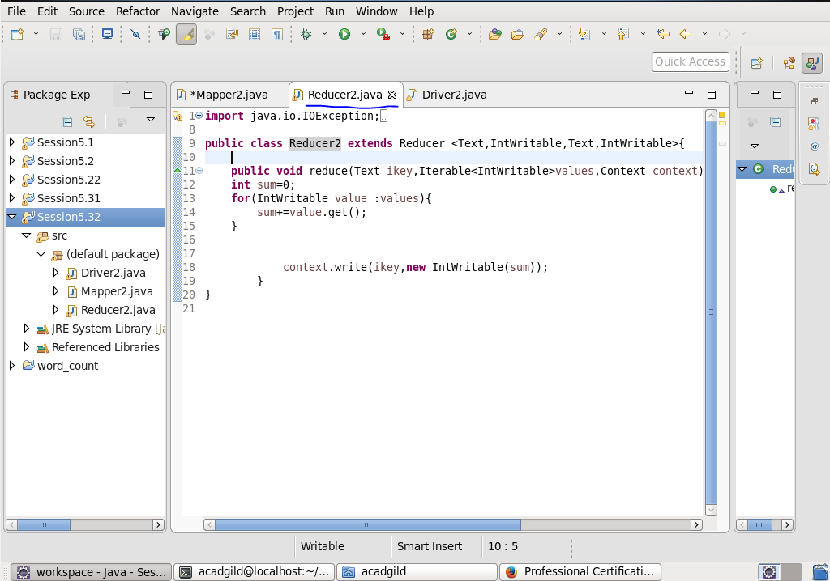

**Input:**

first we need to create a file with he given database, containing with four columns

User ID ,Movie ID , Rating and Time stamp



**Output:**

