**Assignment 9.3**

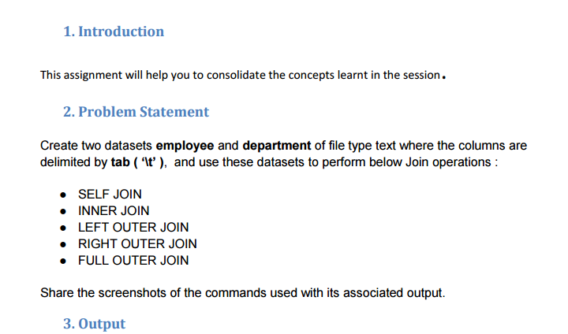

**Input file**

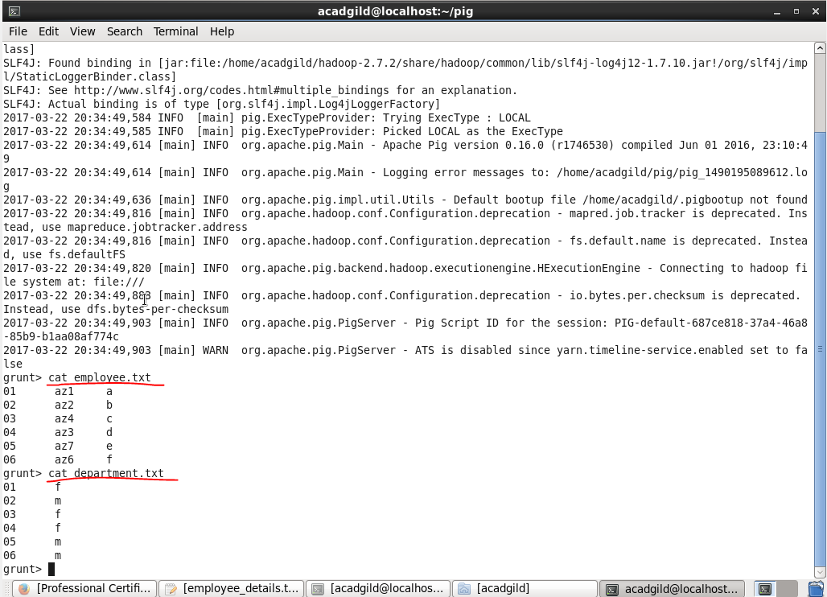

* First we will create two separate text files employee.txt and department.txt
* Then we will insert our data using nano command.

**Starting pig :**

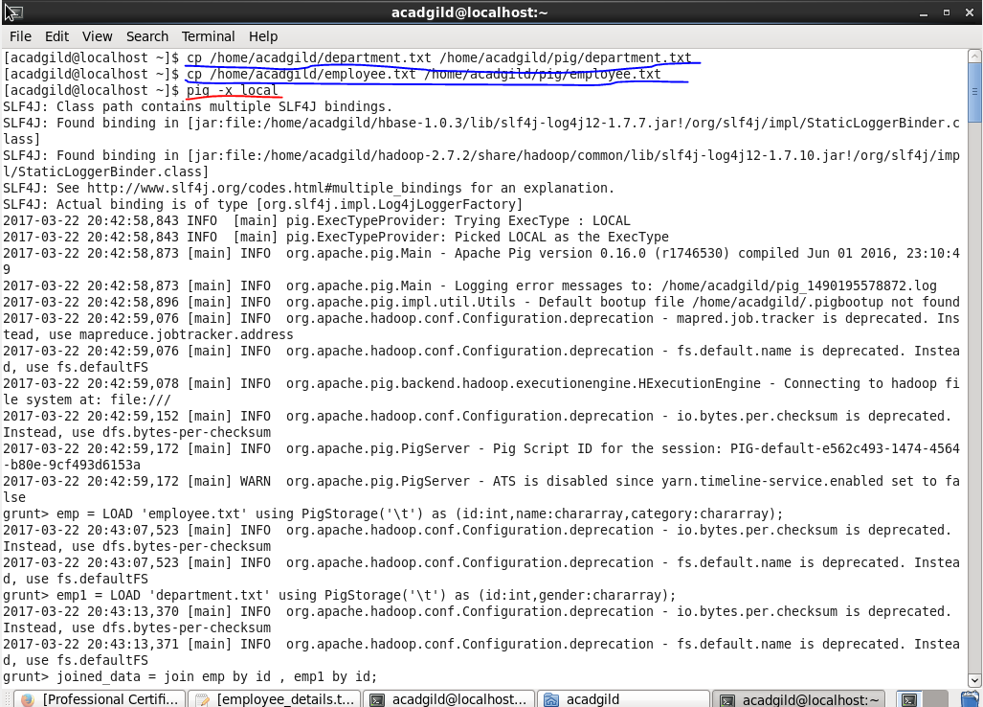

* Before joing two databases,we need to copy our files to our pig directory using cp command as shown.
* Than to start pig we use pig –x local command
* **Self join :**

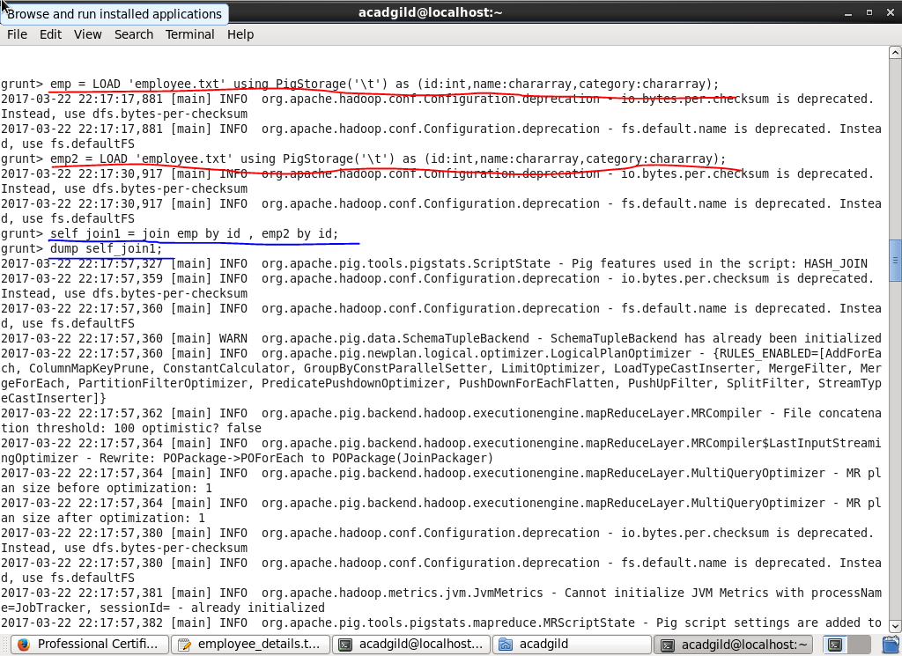

Self join,is joining a database to itself,so this is how we performed self join.

* **Output**

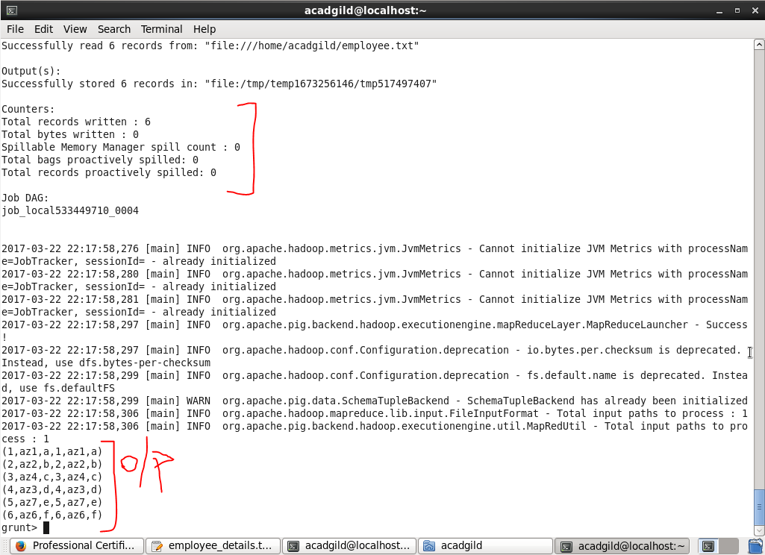

* **Inner join :**

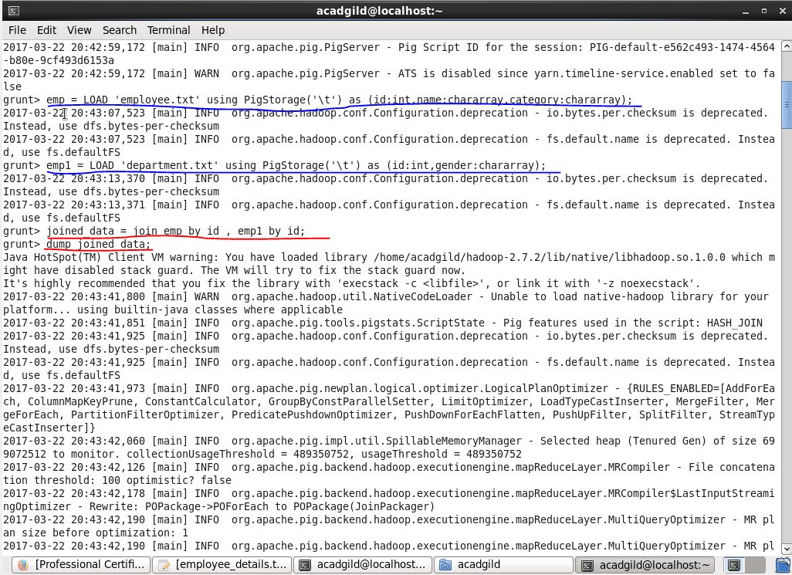

* **Output**

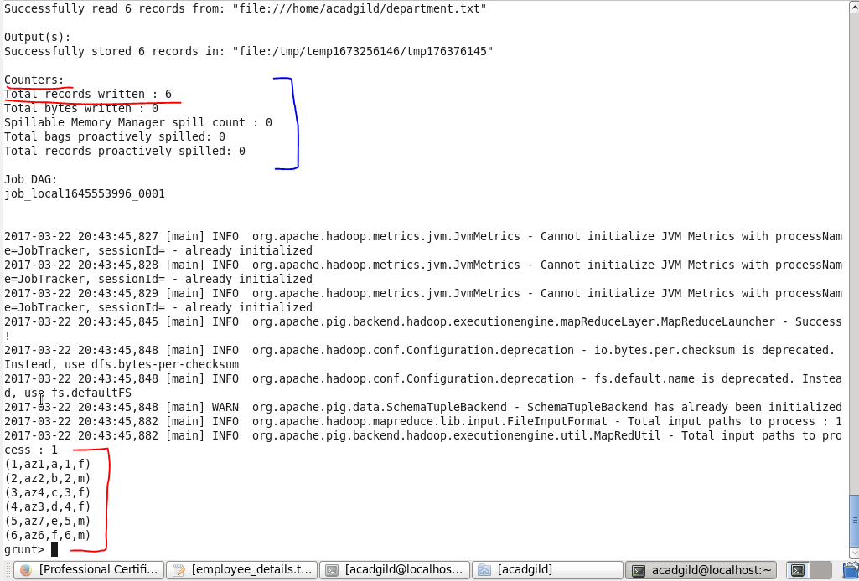

so ,this is how we performed inner join.

**Left outer join**

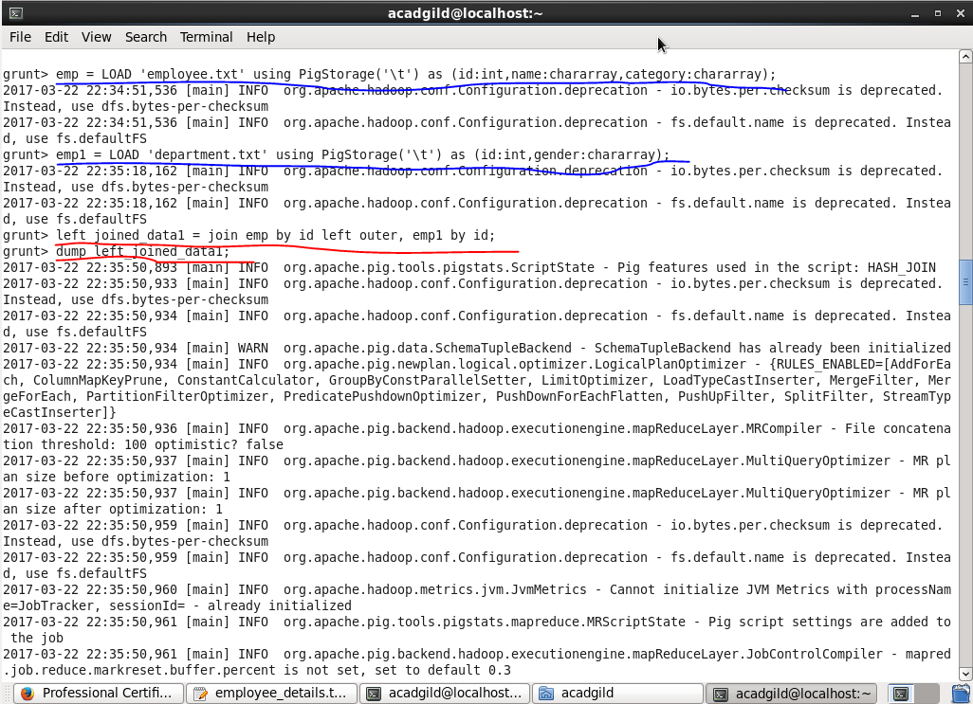

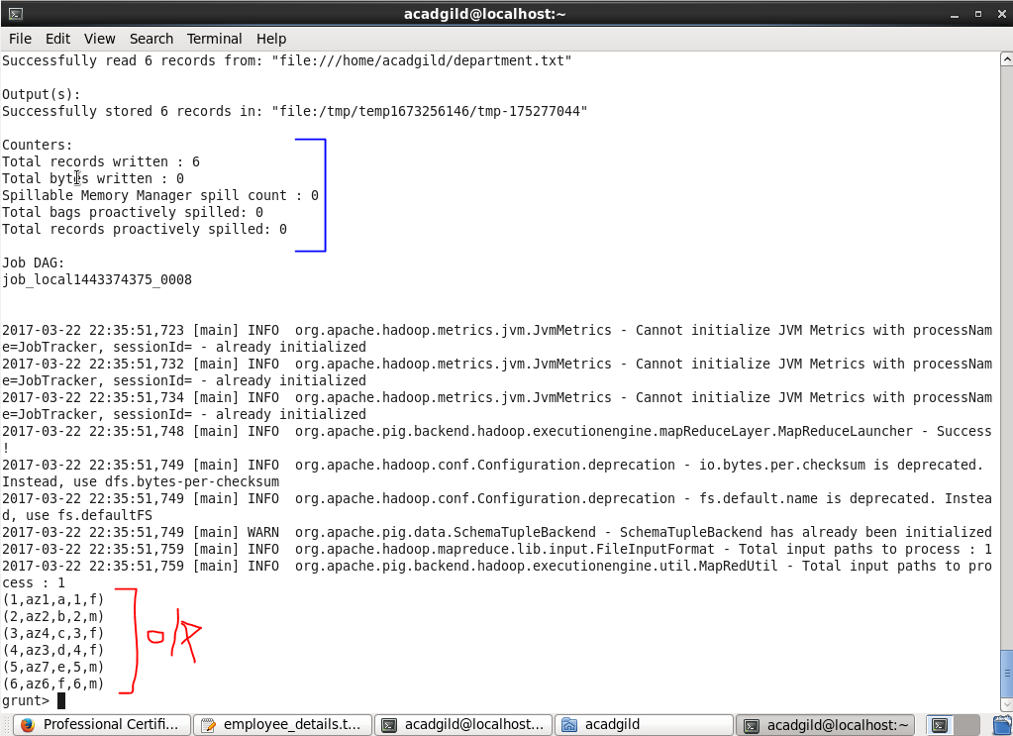

**Right outer join**

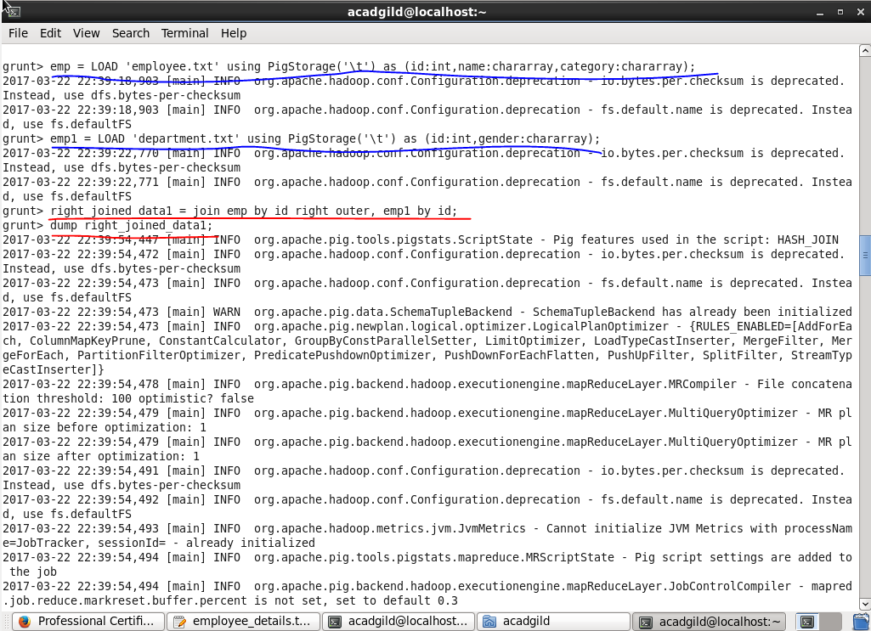

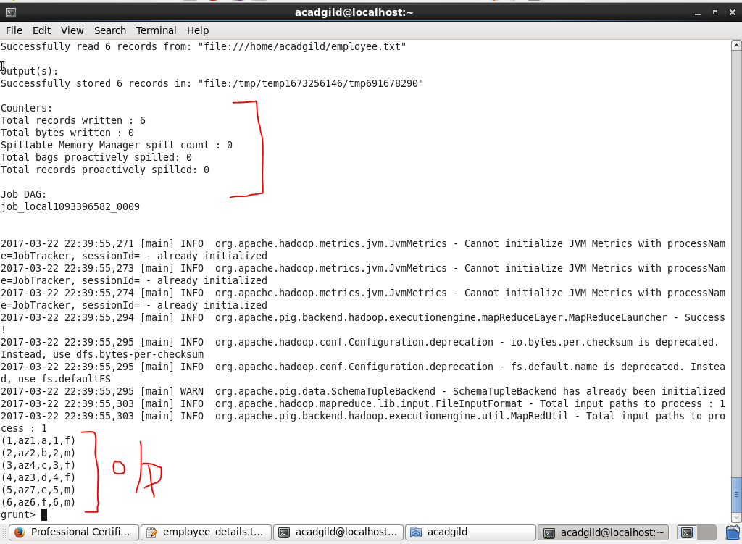

**Full outer join**

