**Assignment 10.4**

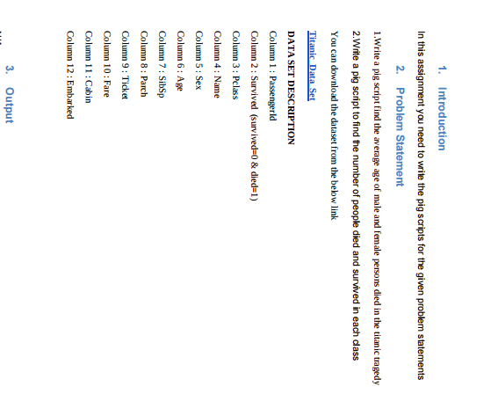

Input:

**Pig commands:**

First we will start local pig using -> pig –x local

* Then we will load our database using LOAD command.
* Then we will filter as we want the average of person died so survived should be 1
* Then we will group by sex i.e male and female
* Then we will generate sex and the average
* Then to show the result we will use DUMP command

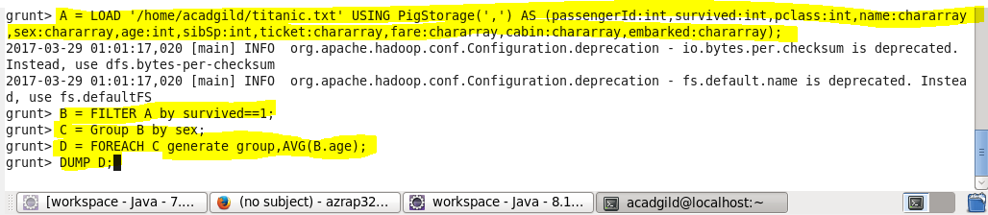

For my data base the output will be :

**OUTPUT :**

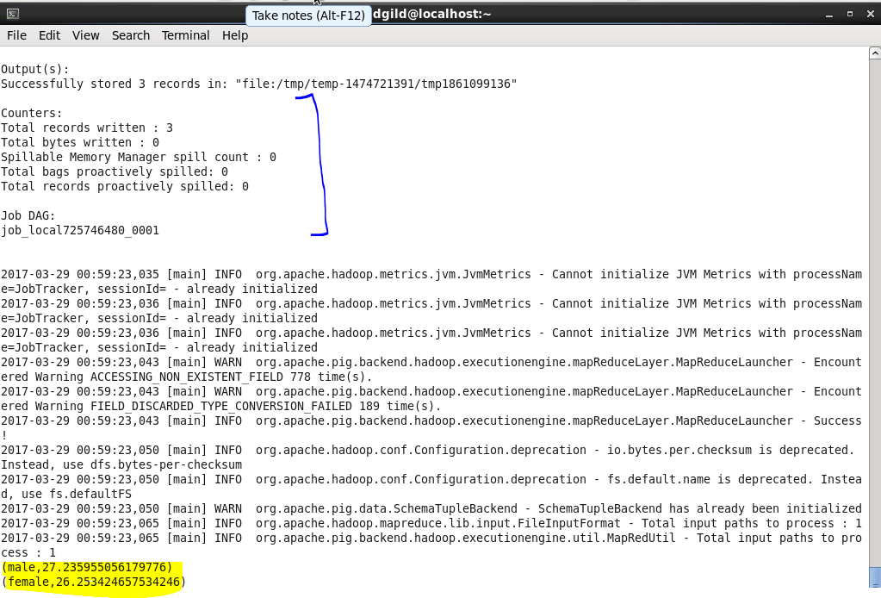

**2.Write a pig script to find the number of people died and survived in each class**

First we will start local pig using -> pig –x local

* Then we will load our database using LOAD command.
* Then we will group by class and the status of survival
* Then we will generate count the number of passengers
* Then to show the result we will use DUMP command

**Pig commands:**

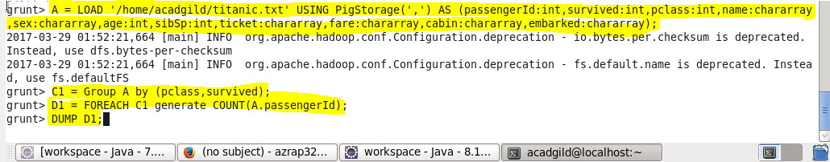

Output:

