**Assignment 25.4**

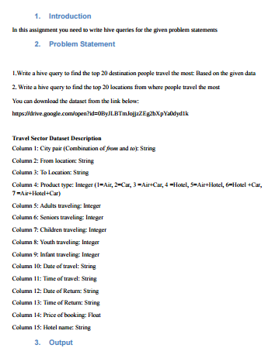

* **First we will create table travel_data using create command**

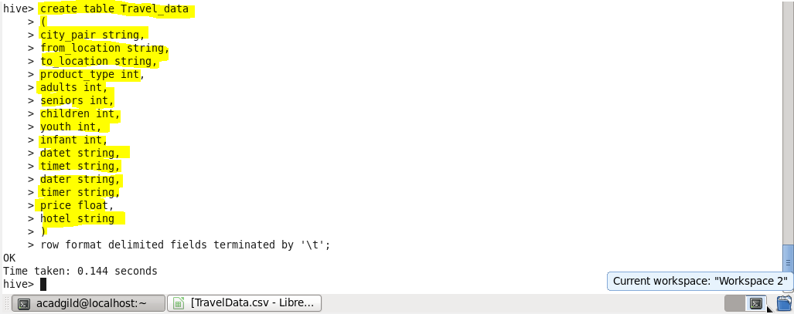

* **Now we load our dataset TravelData.csv to our table travel_data using LOAD**

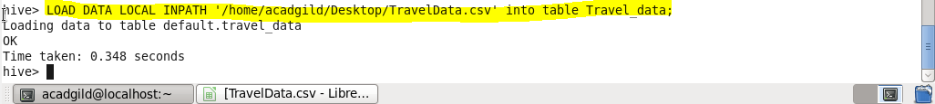

1. **Write a hive query to find the top 20 destination people travel the most: Based on the given data**

* **As we want top 20 destinations for that first we will select the destinations that is to_location in our database and will find out the sum of total visitors for each destination then will sort the result in descending order and will limit our result by 20 number**

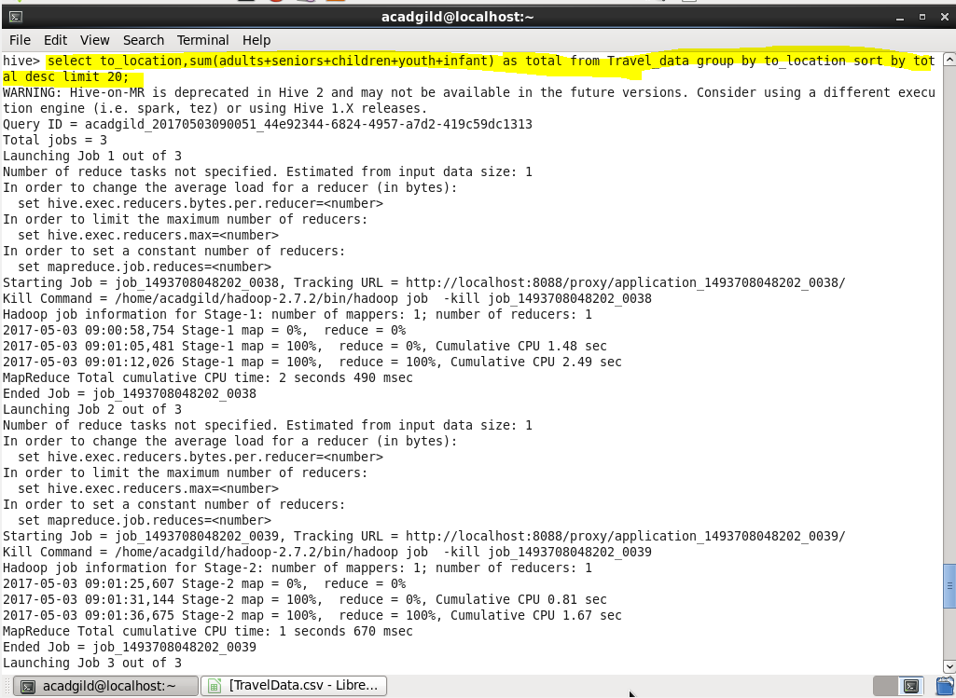

**Output:**

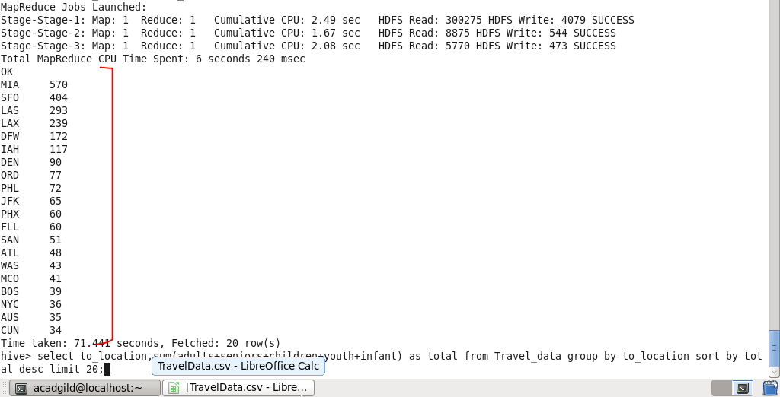

1. **Write a hive query to find the top 20 locations from where people travel the most**

* **As we want top 20 locations froM where people travel most so for that first we will select the locations rom which people travel that is from_location in our database and will find out the sum of total people who travelled from that location for each location then will sort the result in descending order and will limit our result by 20 number**

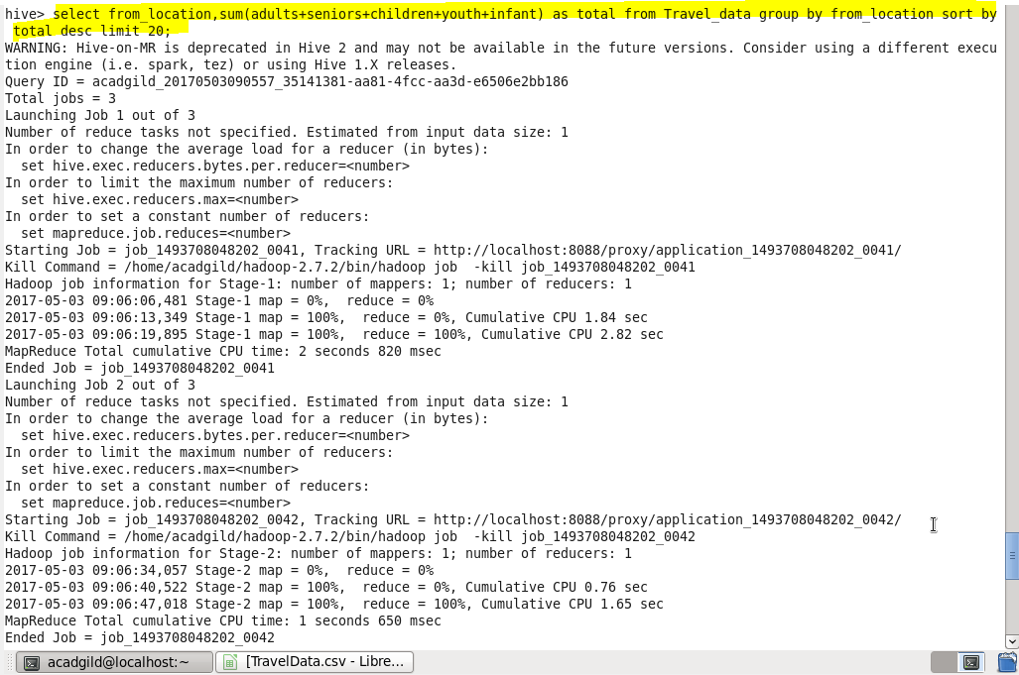

**OUTPUT:**

