Assignment 9.4 :

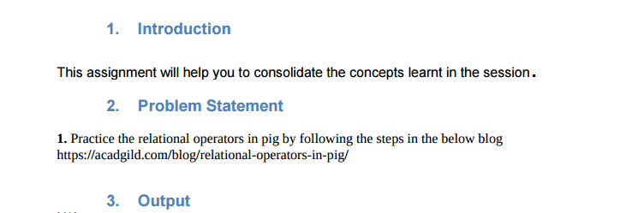

Input Files:

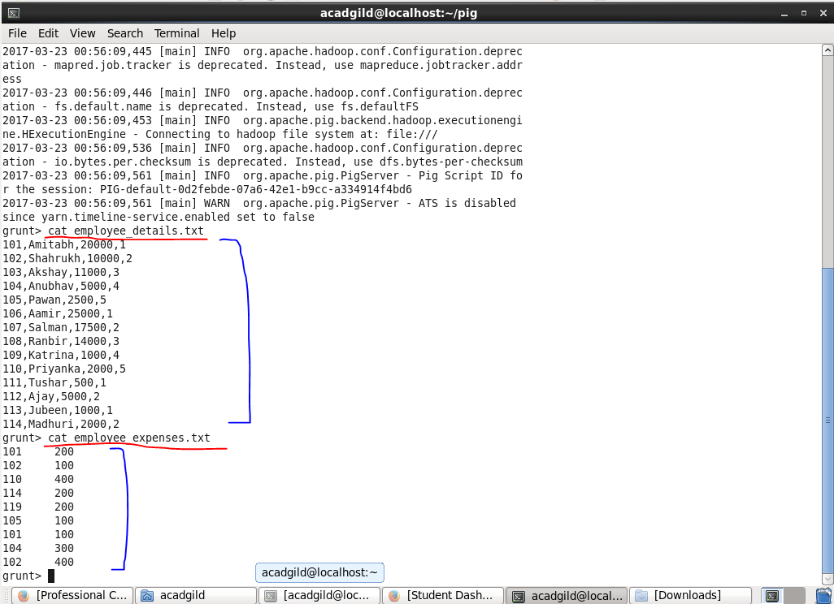

**Load**

The file named employee_details.txt is comma separated file and we are going to load it from local file system.

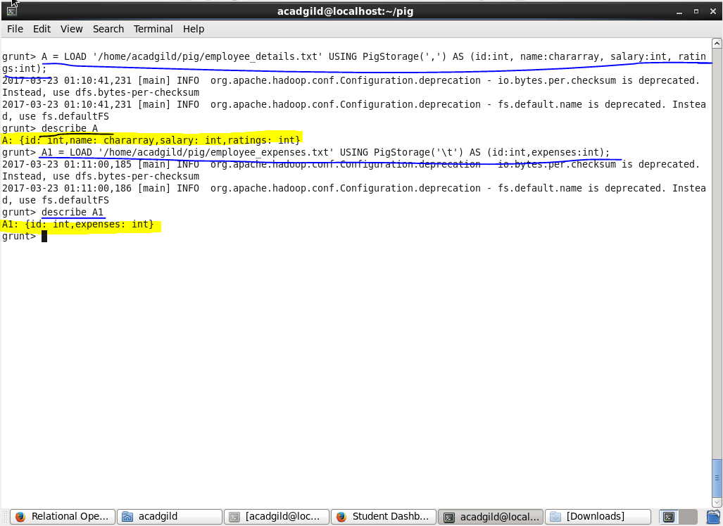

To check the result,we can use DUMP command.

* dump A :

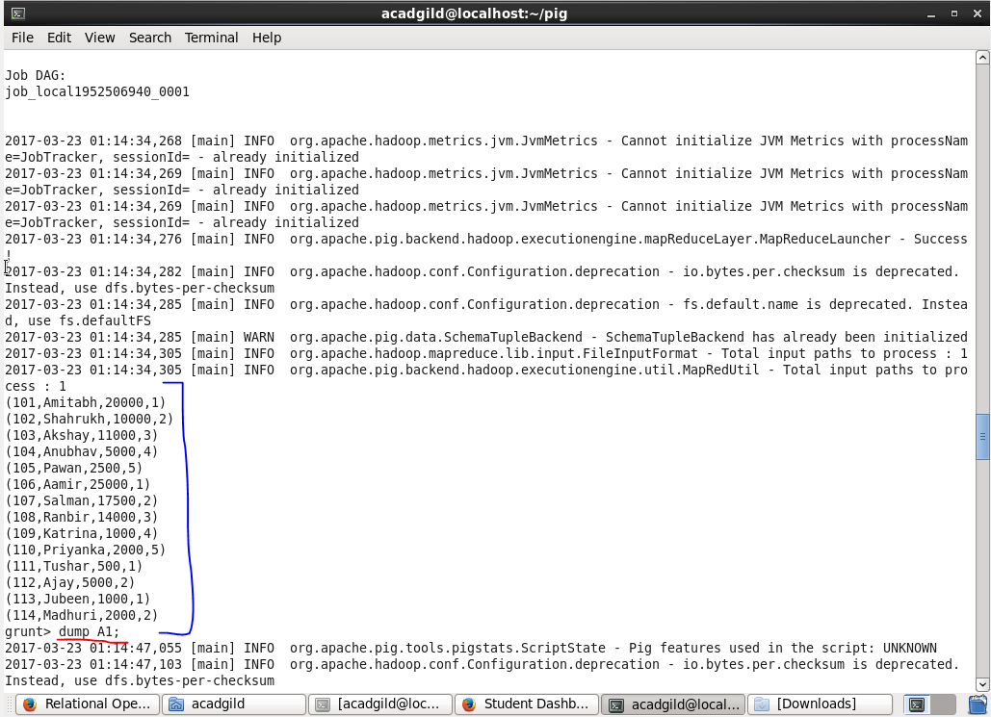

* DUMP A1 :

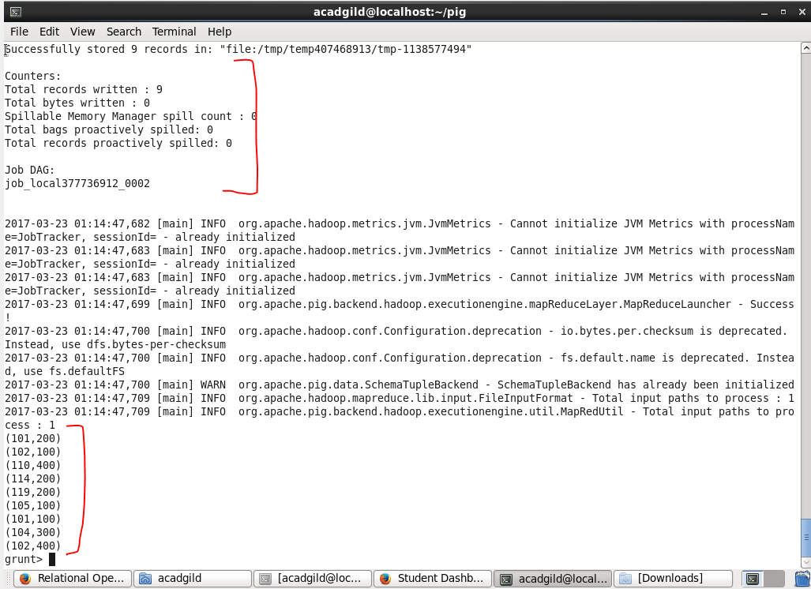

**Limit**

We will be limiting the result of relation A (described above) to 5 :

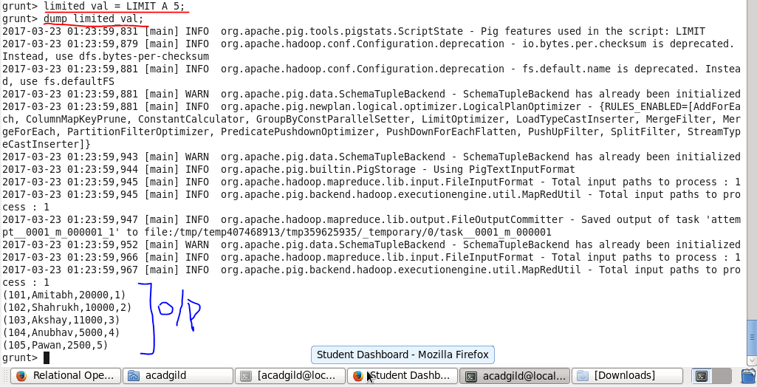

**Order**

We will sort the relation A based on the ratings field and get top 3 employee details with highest ratings.

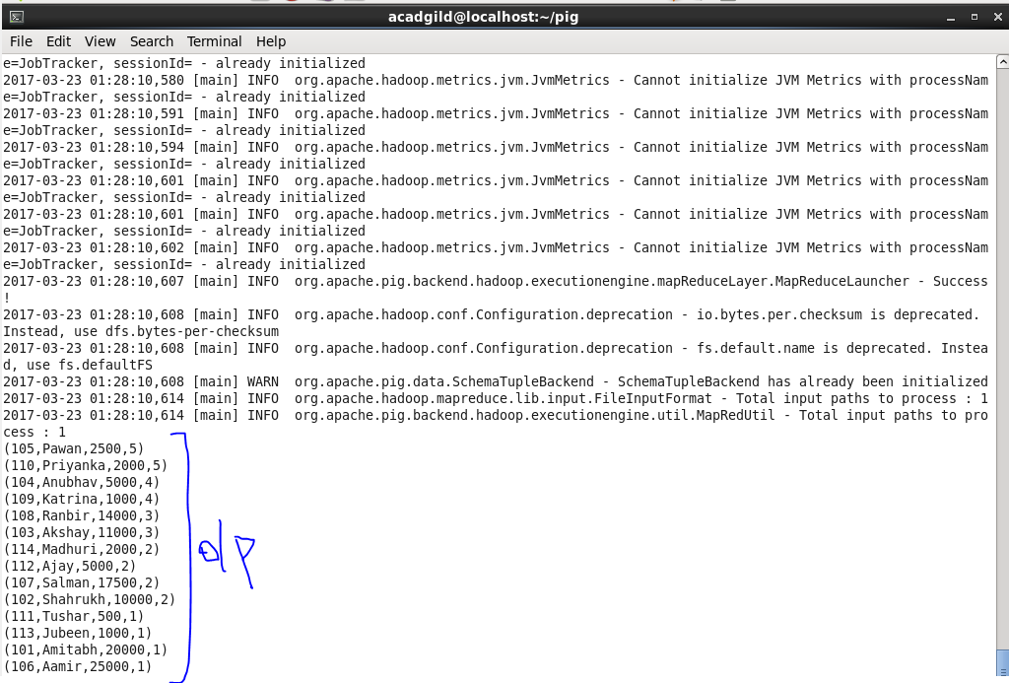

we can also Order the relation based on multiple fields. Let’s order the relation A based on Descending ‘ratings’ and Ascending ‘names’ and generate top 3 result.

Using limit and order both:



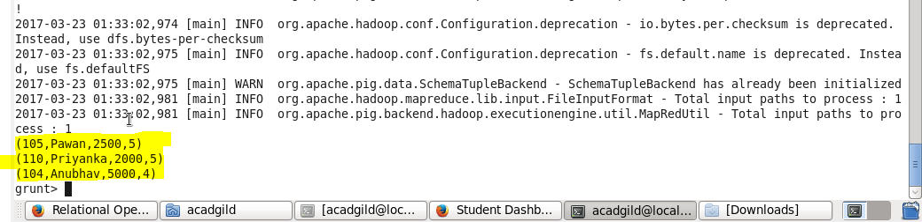

**Group**

now we will group our relation A based on ratings.



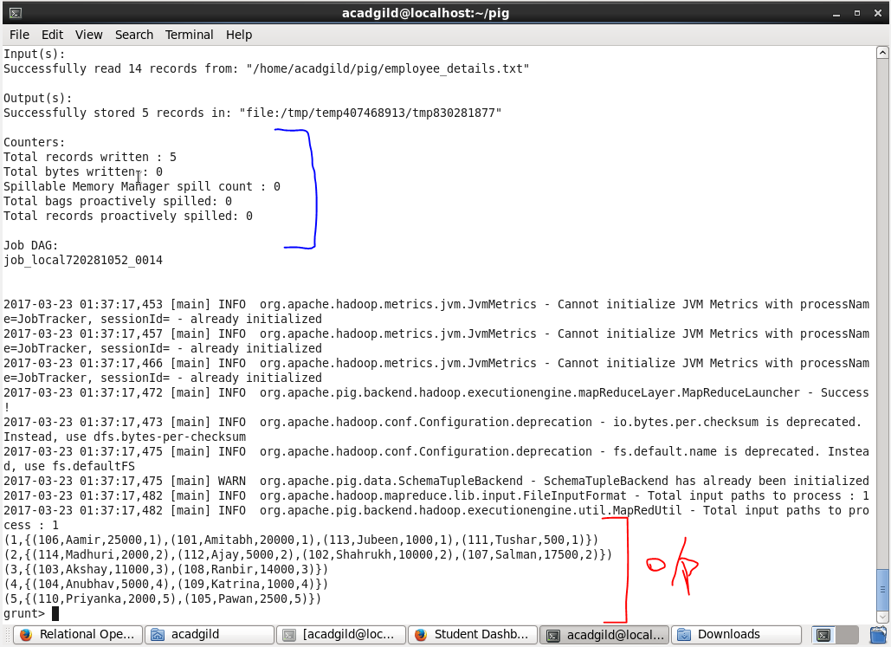

we can also group the data based on more than one fields :



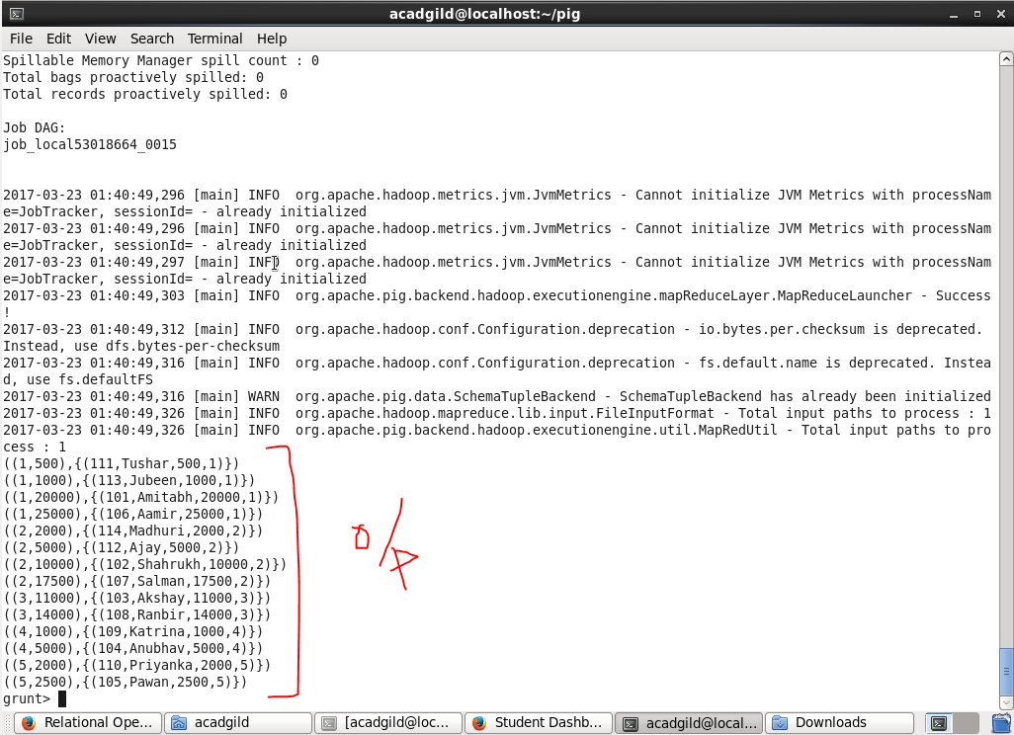

**For Each:**

In our previous example we saw how to group a relation. Now, using FOREACH, we will generate the count of employees belonging to a particular group.



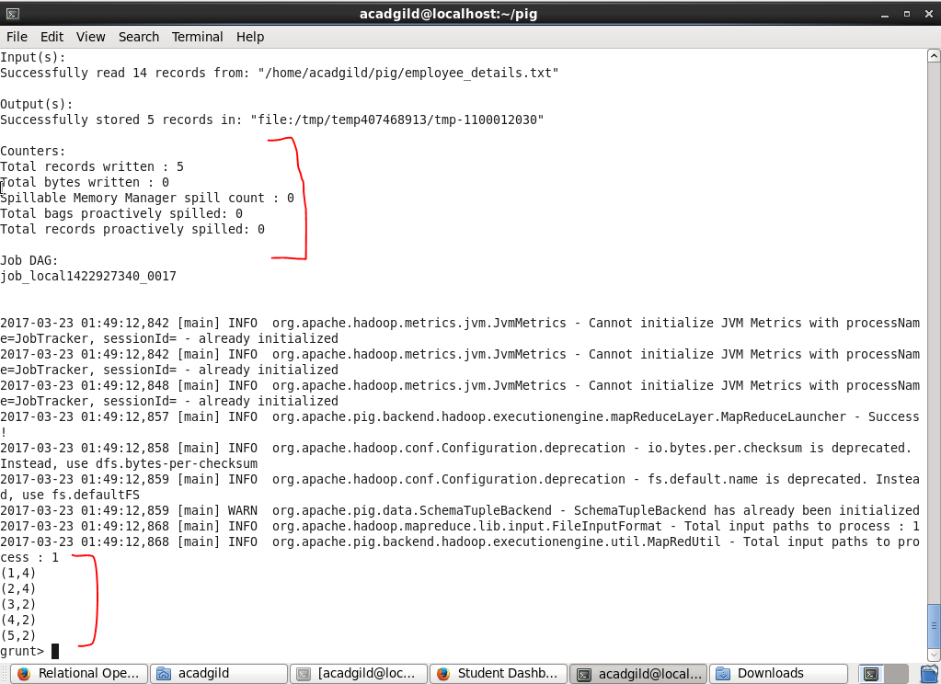

**Filter**

Now we will filter our data (relation A) based on ratings greater than or equal to 4.

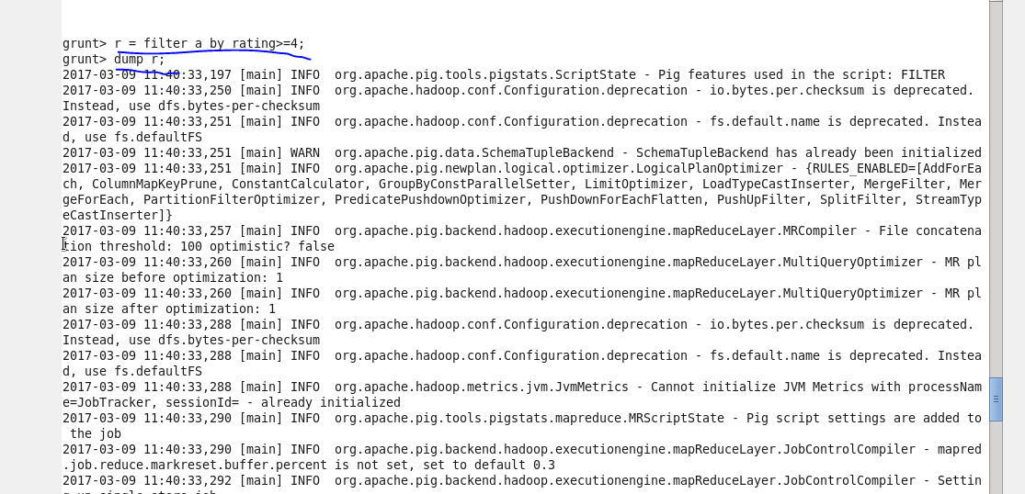

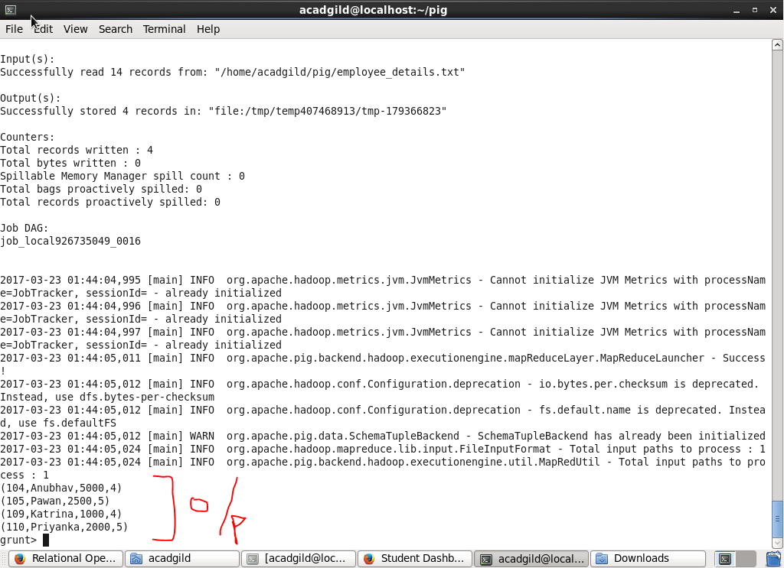

Multi_condition = FILTER A BY (ratings >= 4) AND (salary >1000):

This will produce results that follows in the category of ratings greater than equals 4 and salary greater than 1000.



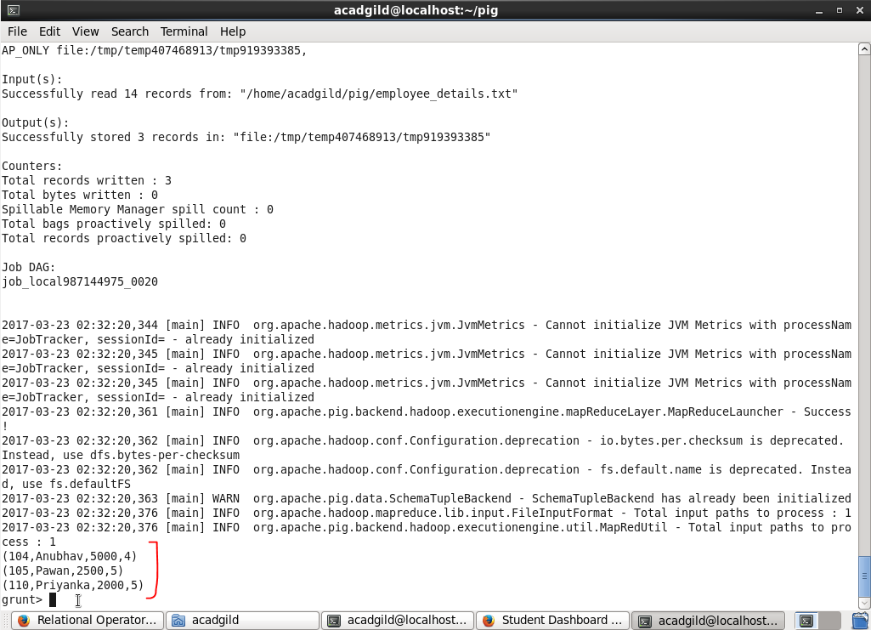

**Store :**

Now we will store our result named “Multi_condition” (achieved in previous operation) into local file system.

