**Assignment 10.5**

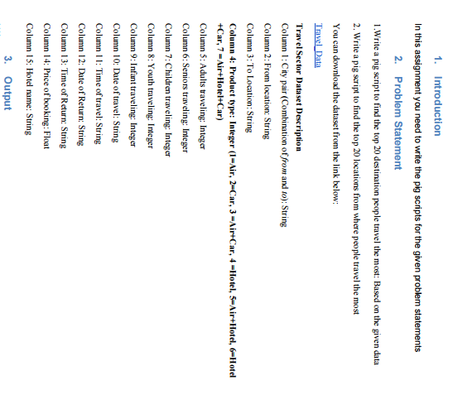

**1 > Top 20 destination people travel the most :**

* First we will load our database, then we will group our data by tolocation that is our destination, then foreach grouped result we will count the number of destinations and then we will order based on the number that is count in descending order then at last as we want top 20 destinations so we will limit the result using LIMIT to 20.

**Pig Script**

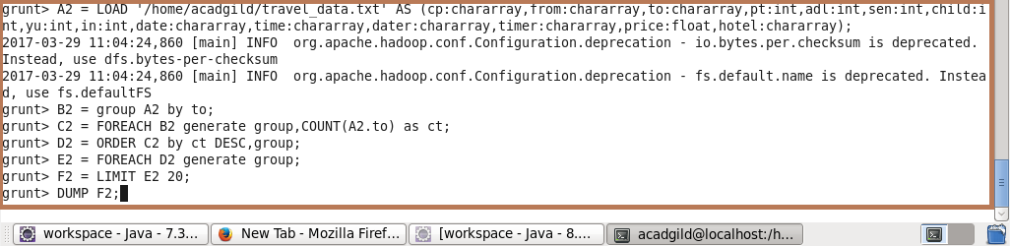

**Output**

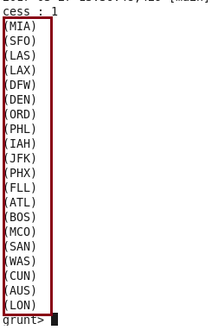

**2 > Top 20 locations from where people travel the most :**

* First we will load our database, then we will group our data by from location that is our location from where people travel, then foreach grouped result we will count the number of destinations and then we will order based on the number that is count in descending order then at last as we want top 20 destinations so we will limit the result using LIMIT to 20.

**Pig script**

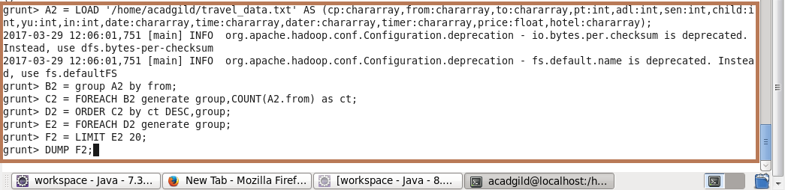

**Output**

