**Assignment – 16.5**

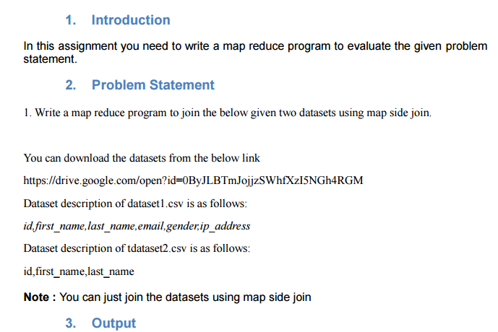

**Driver Class:**

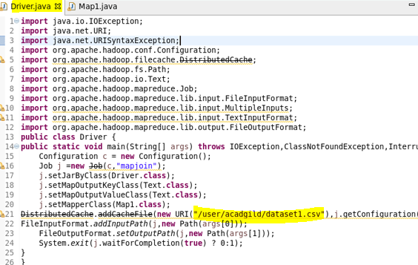

**Mapper Class:**

In the mapper class we are overriding setup method. It is used to get the dataset from distributed cache and then I used hashmap and storing the id as key in hashmap and total line as value.

In map method I’m sending the id as key and joining both values separated by comma.

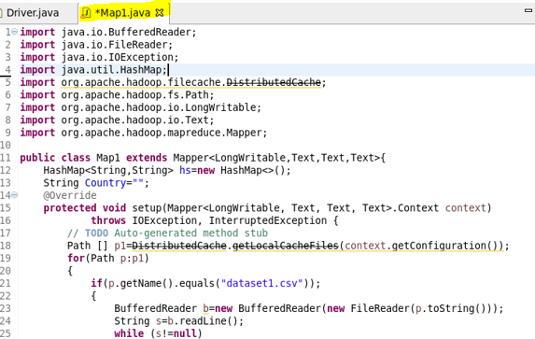

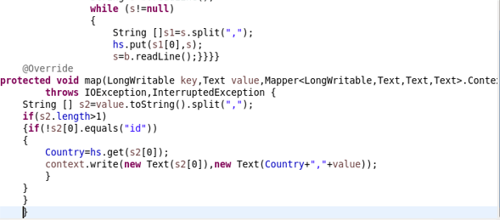

**Running jar file :**

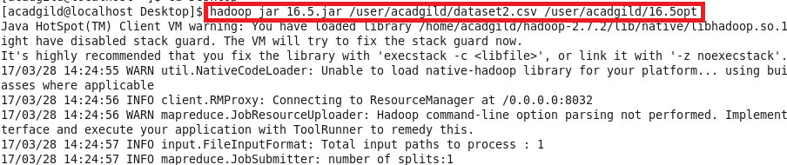

**Using cat command we will print the output.**

