**Assignment 10.6**

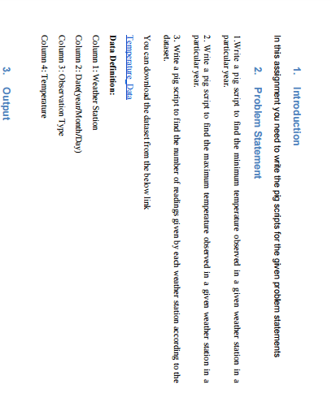

1 > **MINIMUM TEMPERATURE**

* First we will load our Temperature.csv dataset file, then we will group our data by the name of weather station and the particular year we will find out as we used In second command (dividing the date by 10000) then with the use of MIN function we will find out minimum temperature.

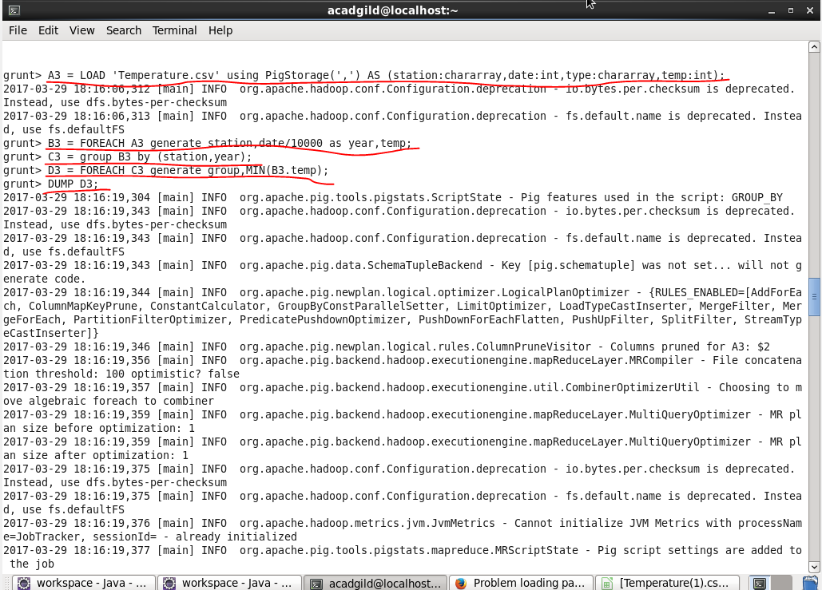

**OUTPUT >**

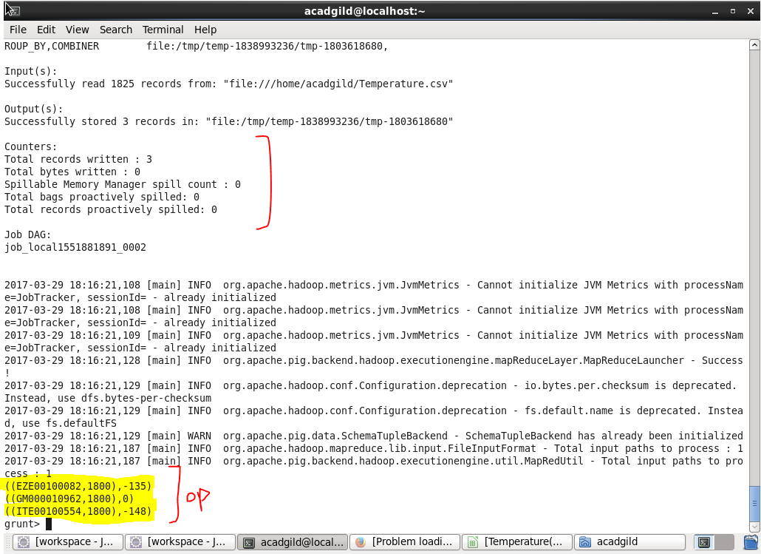

**2. MAXIMUM TEMPERATURE :**

* First we will load our Temperature.csv dataset file then we will group our data by the name of weather station and the particular year we will find out as we used In second command (dividing the date by 10000) then with the use of MAX function we will find out maximum temperature

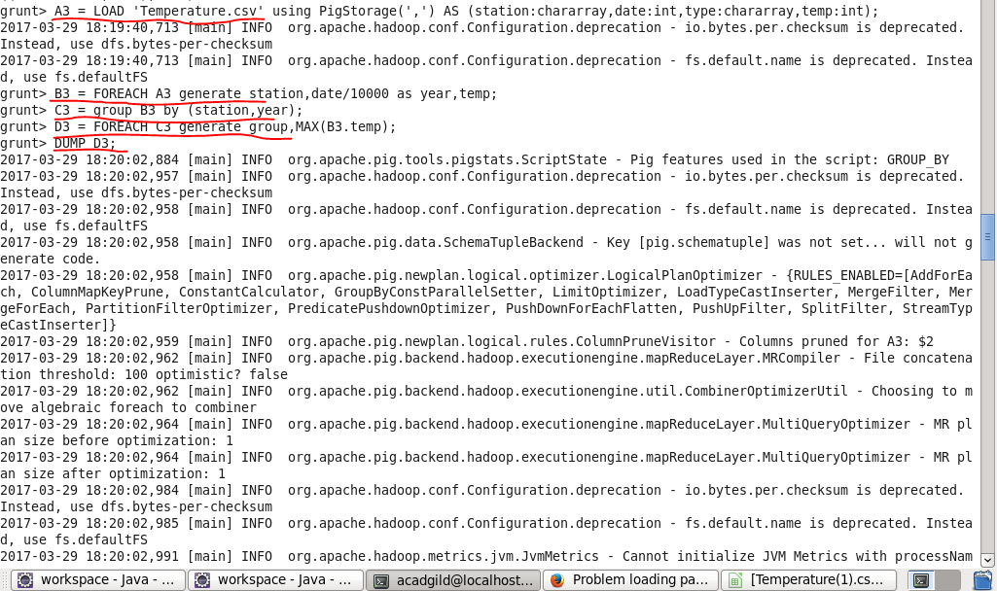

**OUTPUT :**

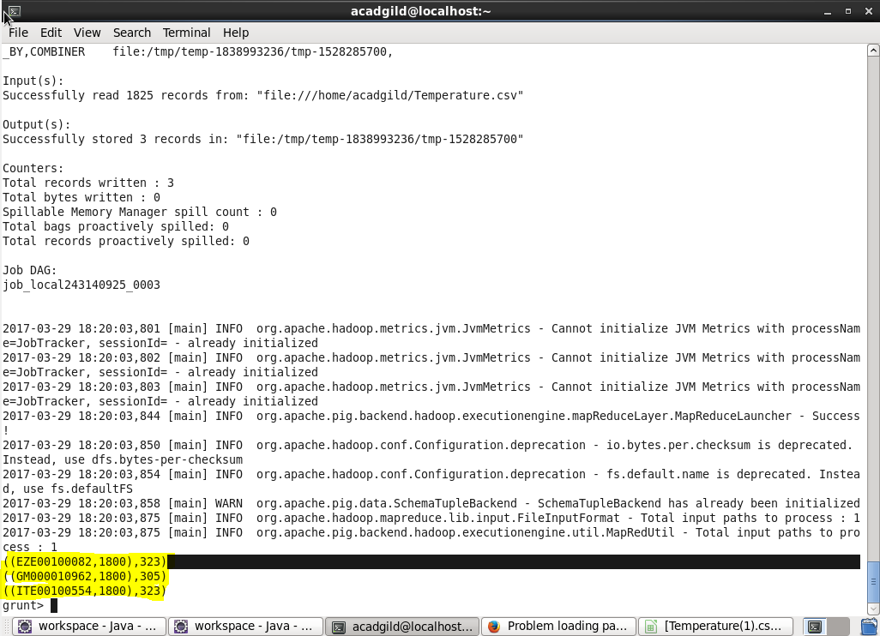

**3. NUMBER OF READINGS**

First we will load our Temperature.csv dataset file, then we will group our data by the name of weather station and the particular year we will find out as we used in second command (dividing the date by 10000) then with the use of COUNT function we will find out the number of readings given by each weather station.

