**Assignment 24.6**

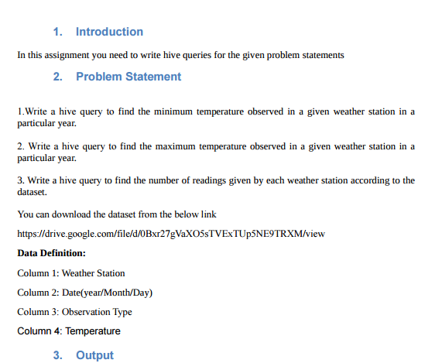

* **First we will create table weather using create command and then using show tables we can check for all the tables.**

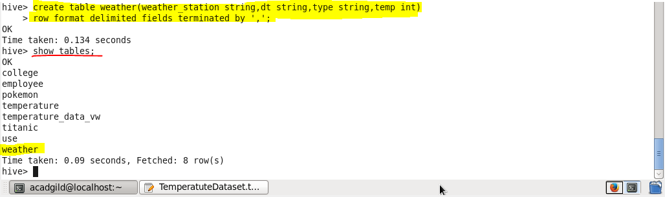

* **Now we will load our dataset temperature.txt to our table weather using LOAD command**

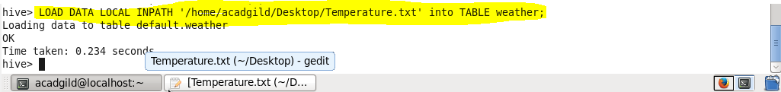

1. **Write a hive query to find the minimum temperature observed in a given weather station in a particular year.**

* **We will use substring method to extract the year from the date.**
* **We will use aggregate function min for finding the minimum temperature in that particular year**
* **Then we will group our result by weather station name and that year**

**Output**

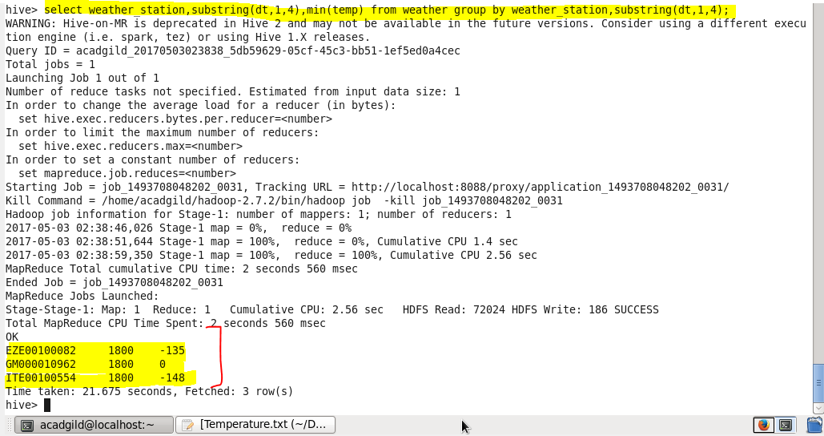

**2. Write a hive query to find the maximum temperature observed in a given weather station in a particular year.**

* **We will use substring method to extract the year from the date.**
* **We will use aggregate function max for finding the maximum temperature in that particular year**
* **Then we will group our result by weather station name and that year**

**Output**

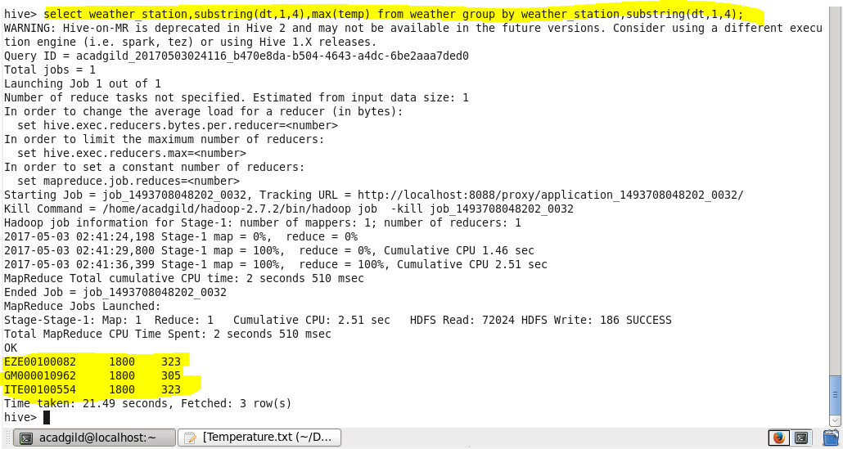

**3. Write a hive query to find the number of readings given by each weather station according to the dataset.**

* **We will select the weather station**
* **For the number of readings we will use count function**
* **And then we will group our result by weather station**

**Output**

