**Assignment 6.4**

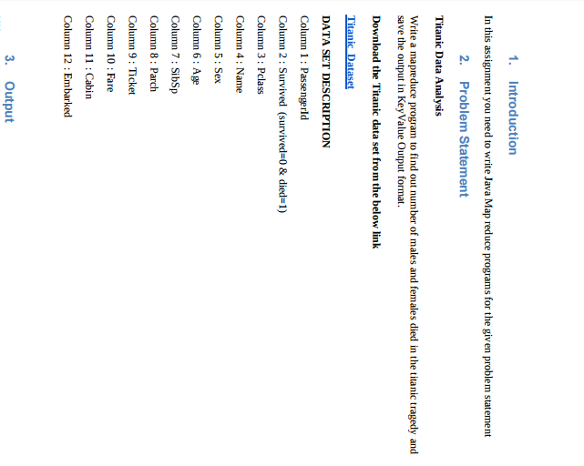

***Code :***

**Driver**

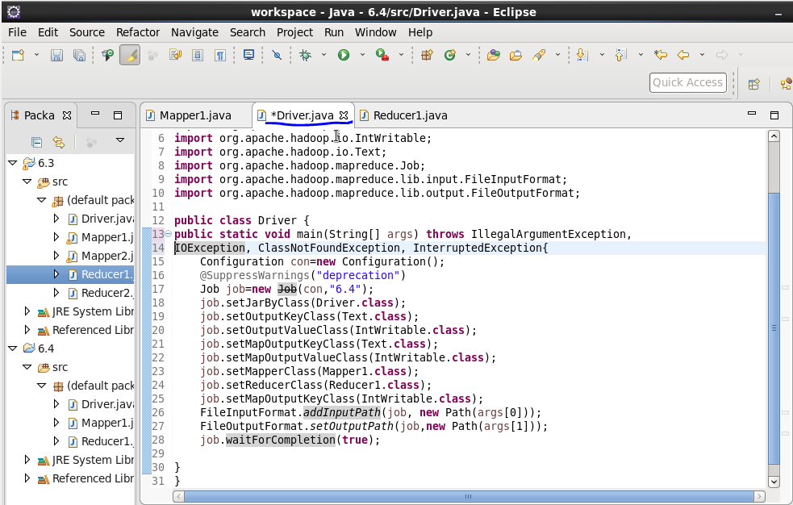

**Mapper**

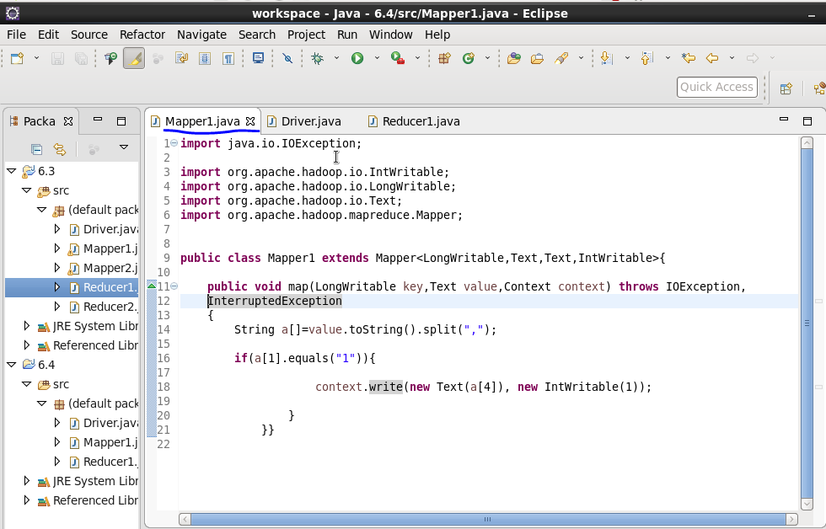

**Reducer**

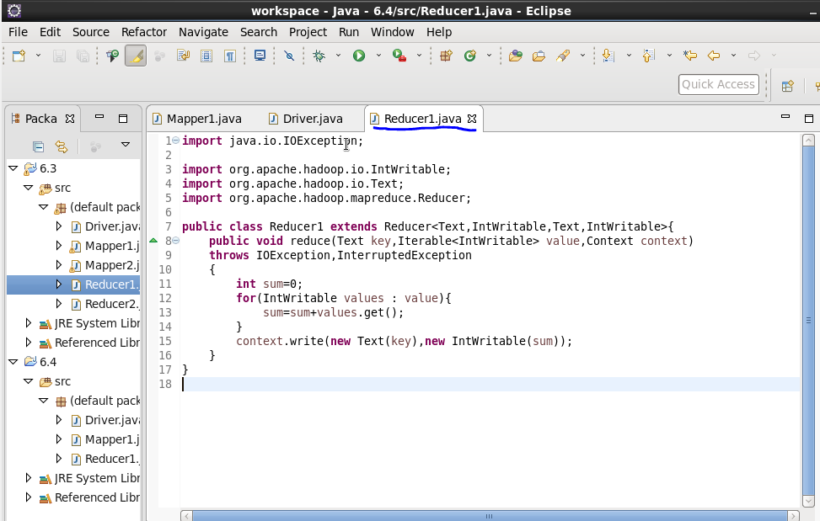

**Output**

**Jar command**



**Output : Command**



**Output**

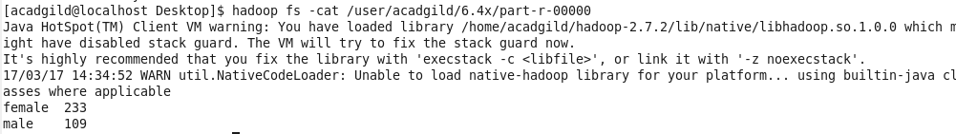

* So,in total 233 females and 109 males died