**Assignment 6.5**

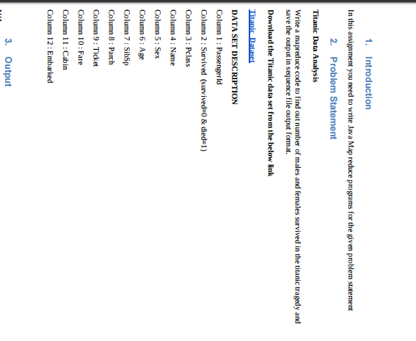

**Code :**

**Driver class**

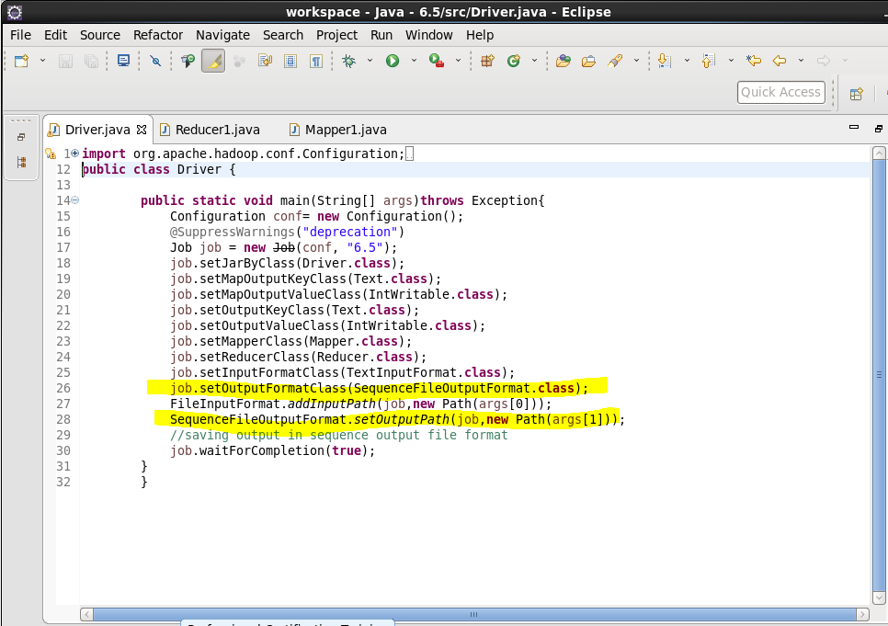

Highlighted code line shows how to save the output in sequence output format.

**Mapper**

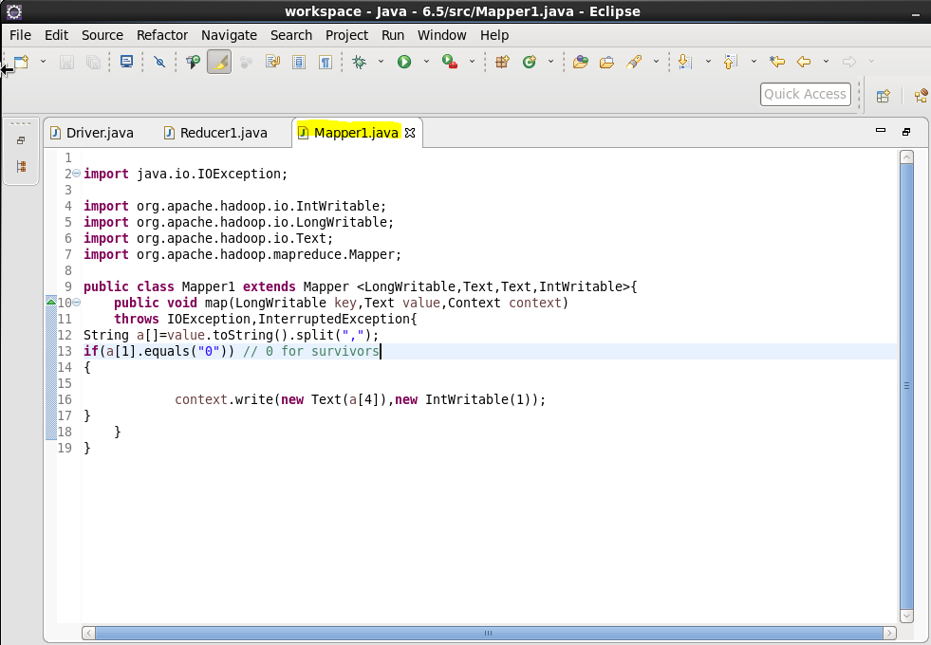

First splitting is to be done using “,” as delimiter after that we will check if passenger is died or not for that we will equate values of column 2 that is survived status if it is 0 that means passenger died.

**Reducer**

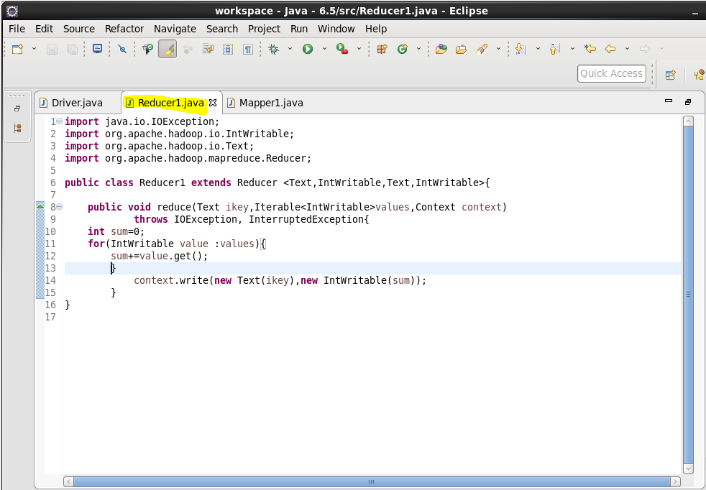

**Jar command**

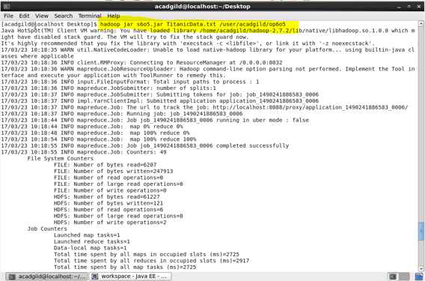

**Output**

