**ASSESSMENT ACADGILD : E-Commerce**

MyCart is an E-Commerce site that sells products. Customer place orders and pay the money

through e Payment mode. They have huge database gathered over years and the management wants

to use the data for better analysis and improvement of business. As the investments are going high,

they want to use a cheaper solution that can be used for better analytics.

They have decided to setup a Hadoop cluster and use Hive as their database for storing data. They

must develop a data model from the existing data model and then transfer the entire data from their

traditional database system (ex. MySQL) to Hive. Consider the table structures given below.

Here is the database design, the E-R diagram, of an ideal E-Commerce firm. You need to design your

MySQL tables accordingly.

**SCHEMA :**



* **Create MySQL tables and insert dummy data into it according to the problem statement**.

1. **Sqoop incremental import needs to implemented to import the data from MySQL table(created earlier) into HDFS incrementally.**

**First we will create a database assessment in mysql in which we will create table required**

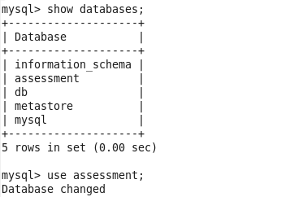

**Now we will create tables and insert values in those**

**Creating Inventory_Item**

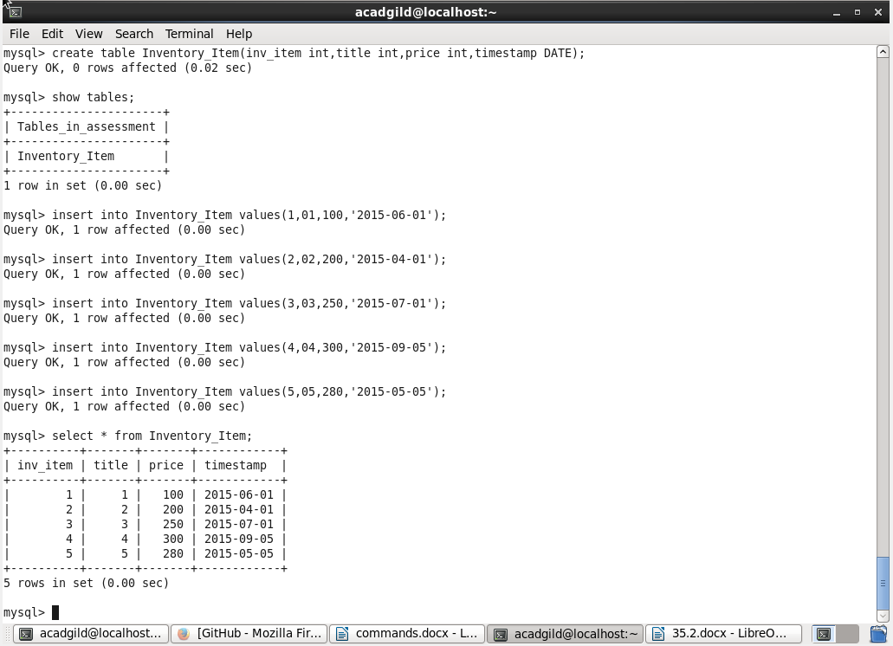

**Adding primary key to table created**



**Showing incremental import of this table from mysql to hdfs**

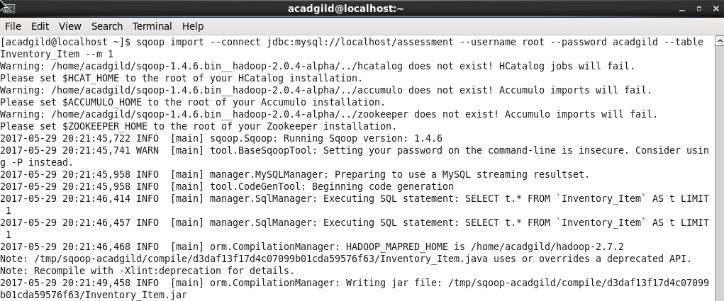

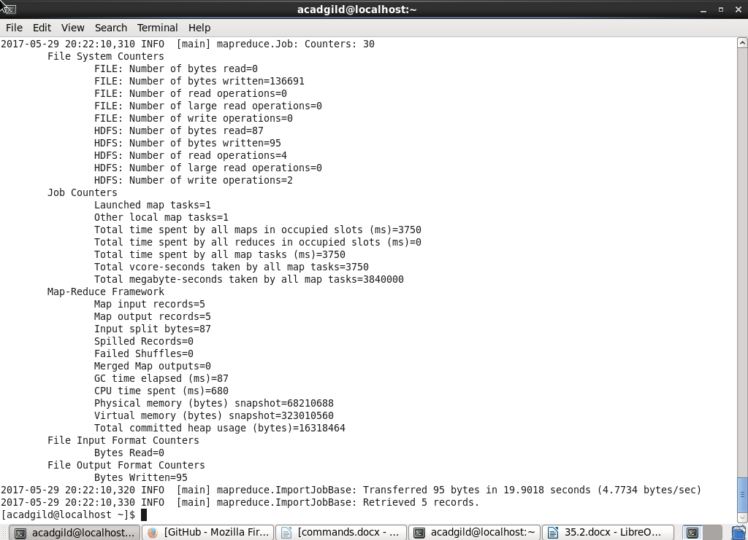

**Using Hadoop fs –ls**

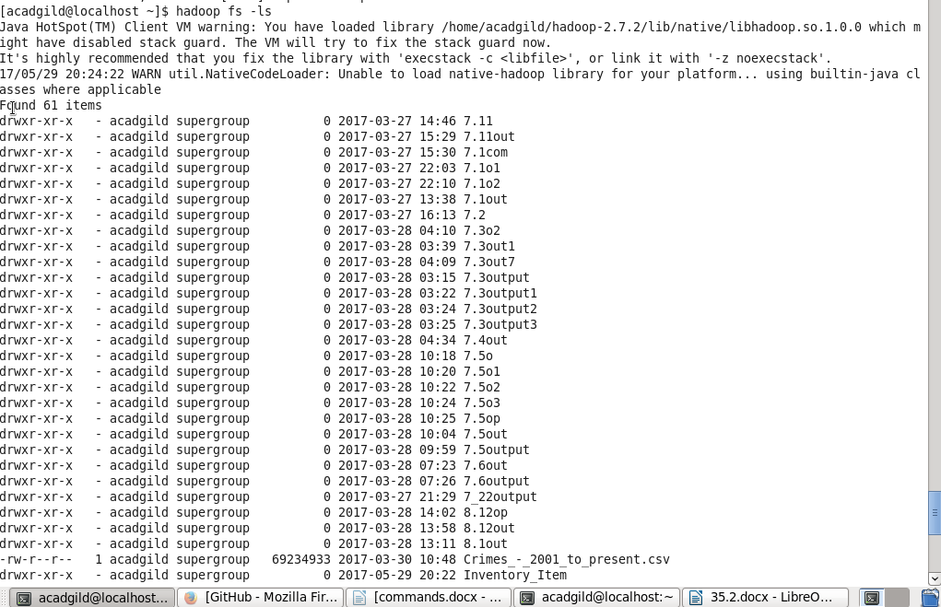

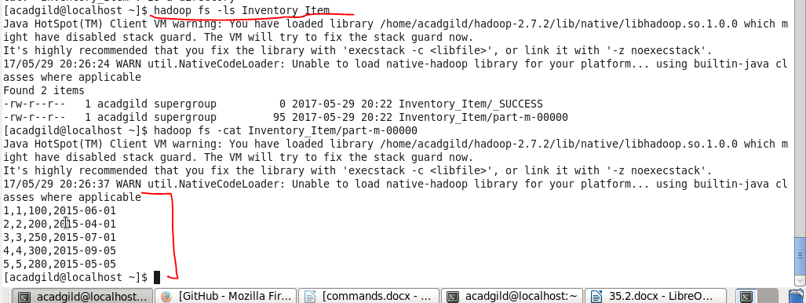

**Now incrementing values :**

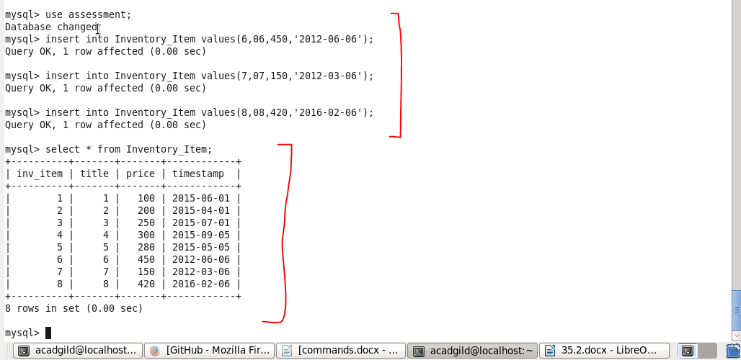

**Incremental import**

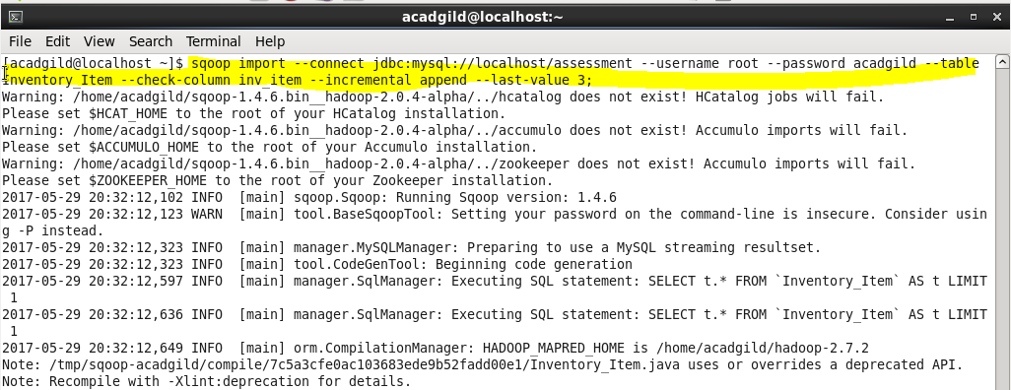

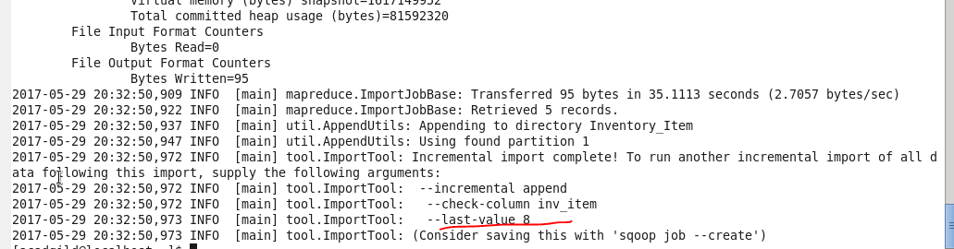

**Checking in hdfs**

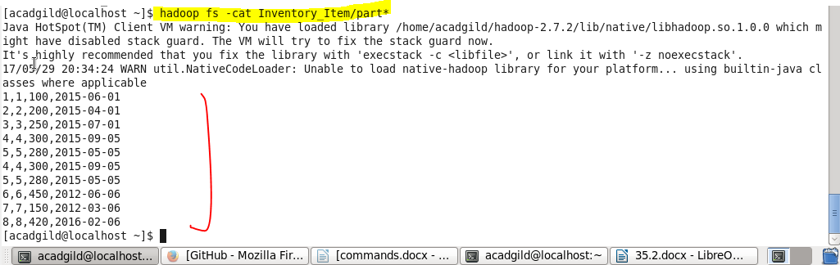

* **So incremental import done**

**2. Find the details of various items purchased by various customers in the quarters '2015-05-01' -'2015-08-31'**

* **Now we will create tables and insert values in those**

**Creating Inventory_Item**



**Adding primary key to table created**



**Creating table Order_Item**

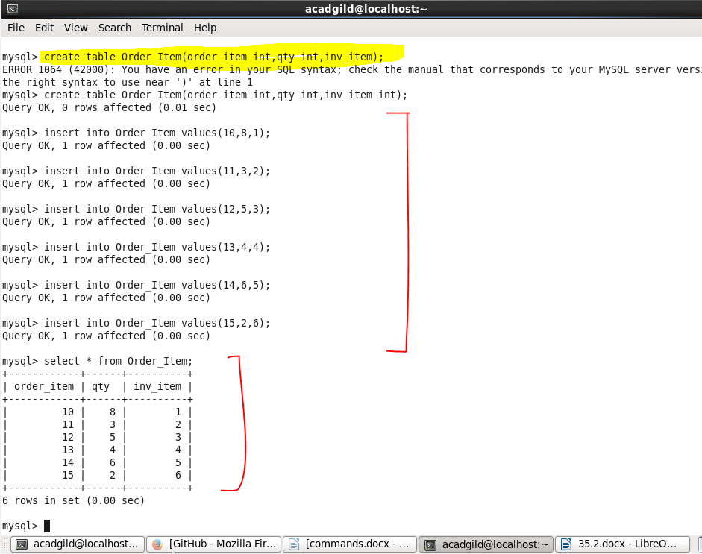

**Creating table order_item_history**

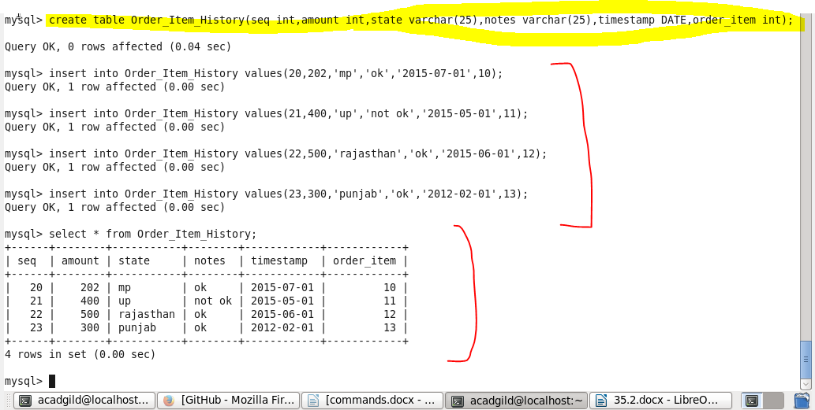

**Create table order_tab**

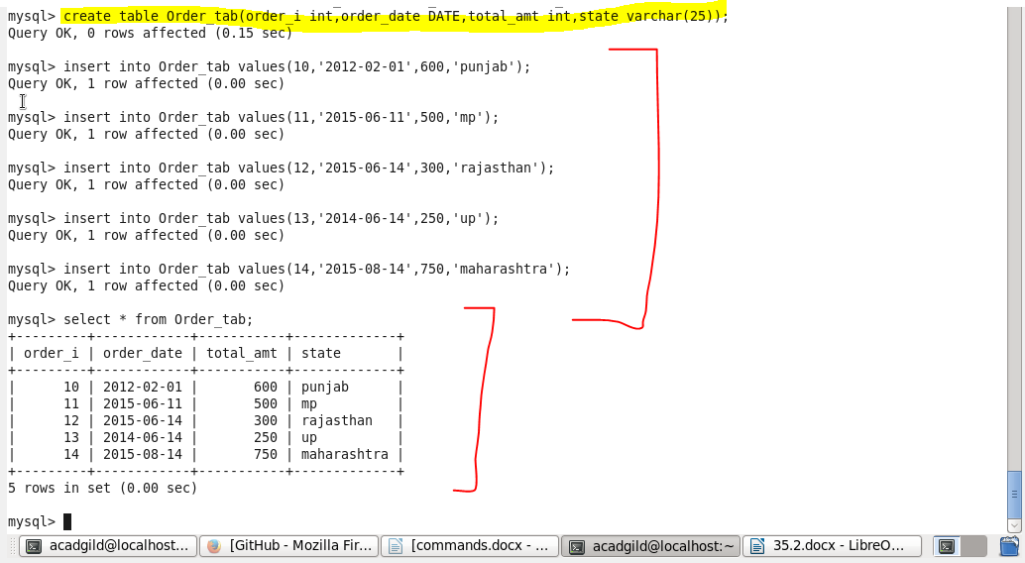

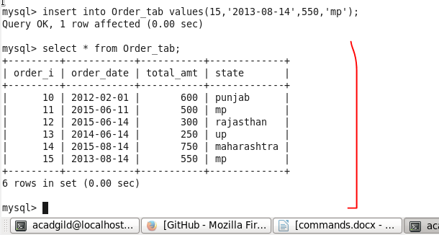

**Create table user_account**

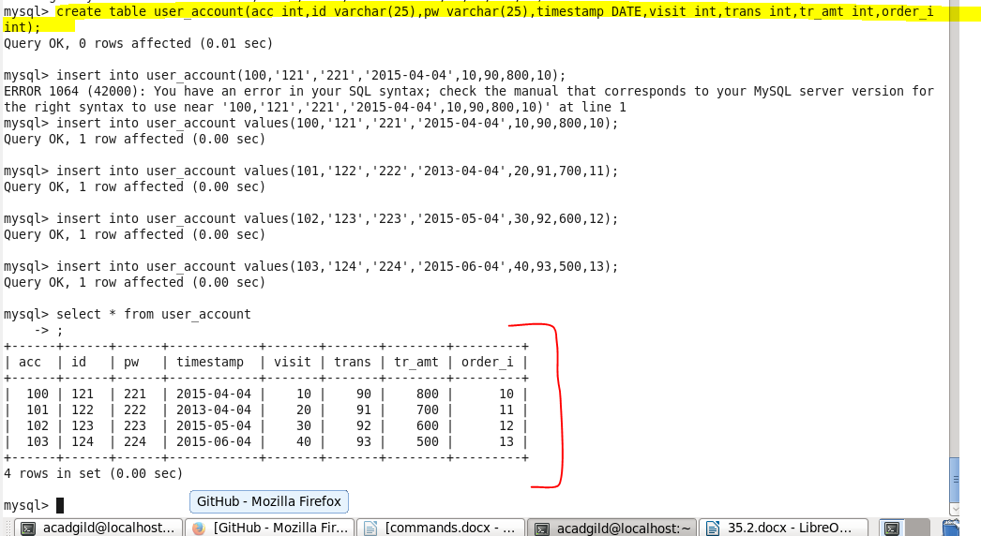

**Create table address**

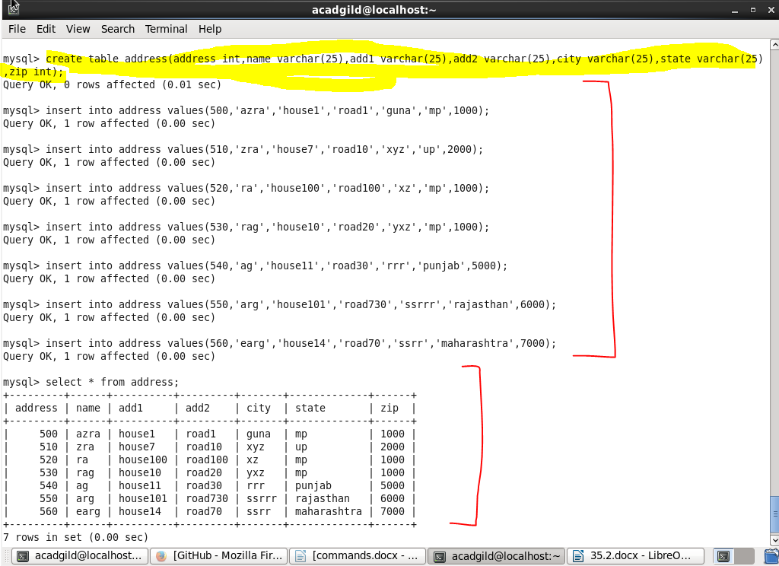

**Now transferring tables from mysql to hive using sqoop**

**Listing all tables**

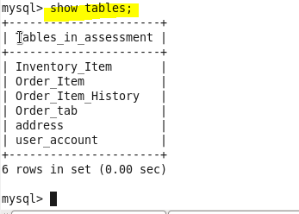

**transferring Inventory_Item table**

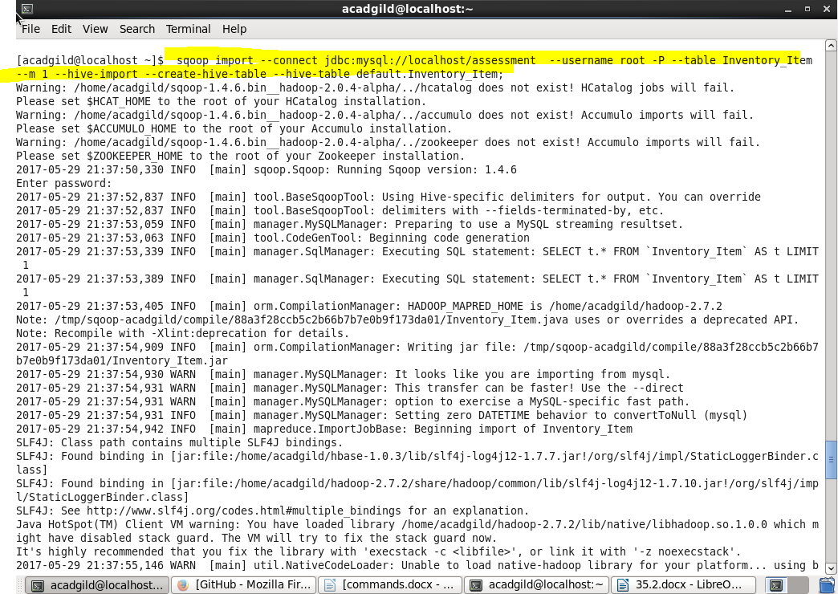

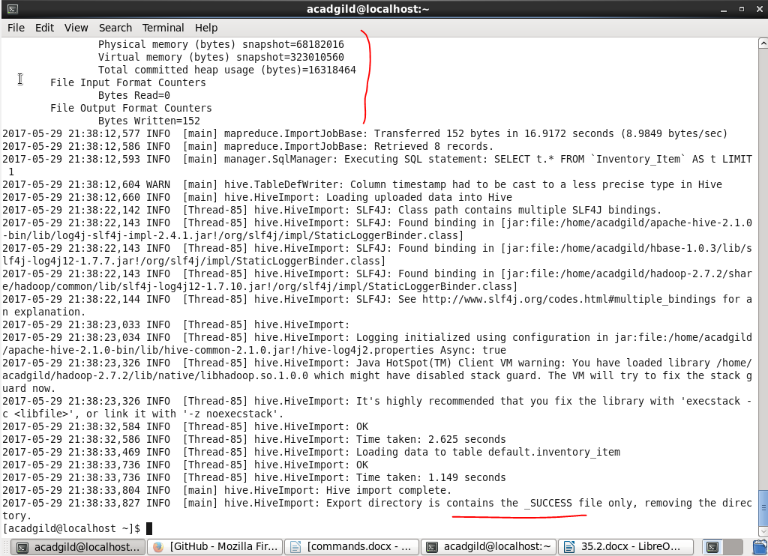

**Shows successfully done same we will do for other tables;**

**transferring Order_Item table**

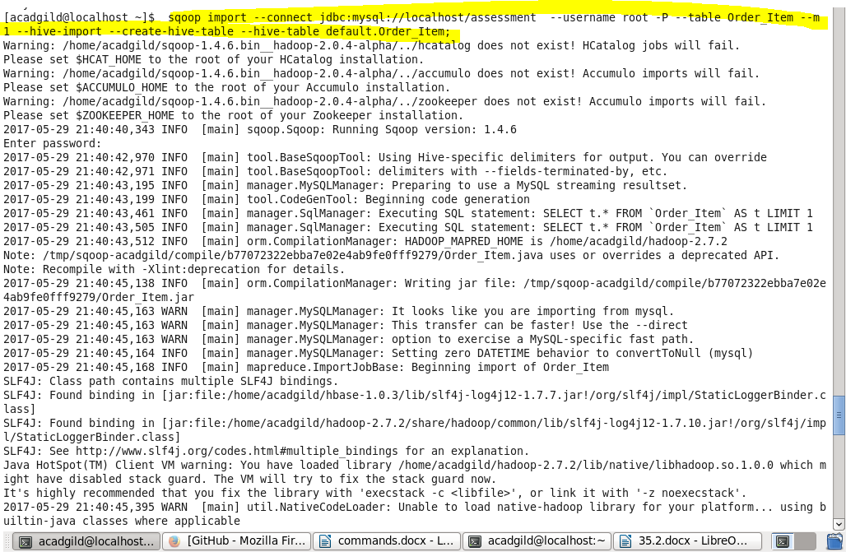

**transferring Order_Item_History table**

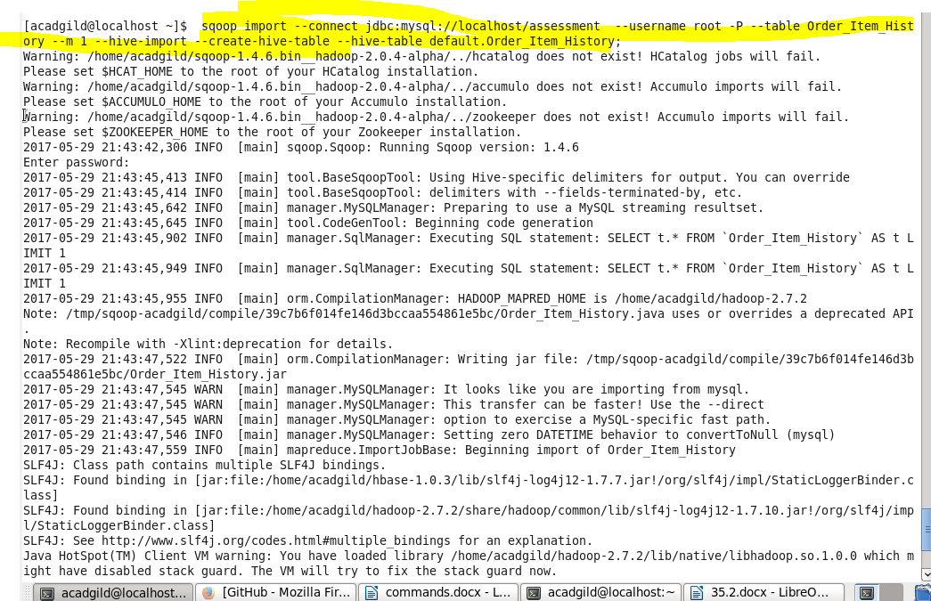

**transferring Order_tab table**

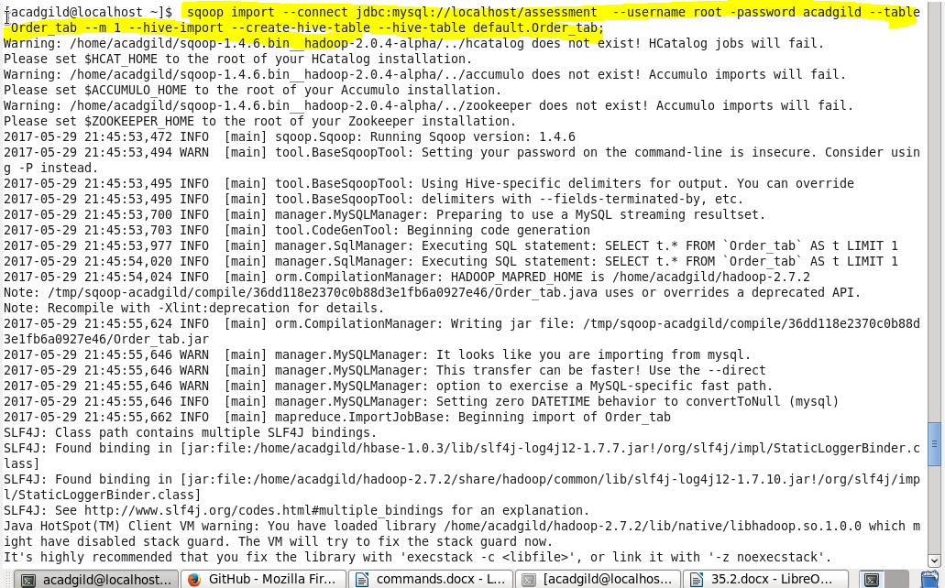

**transferring address table**

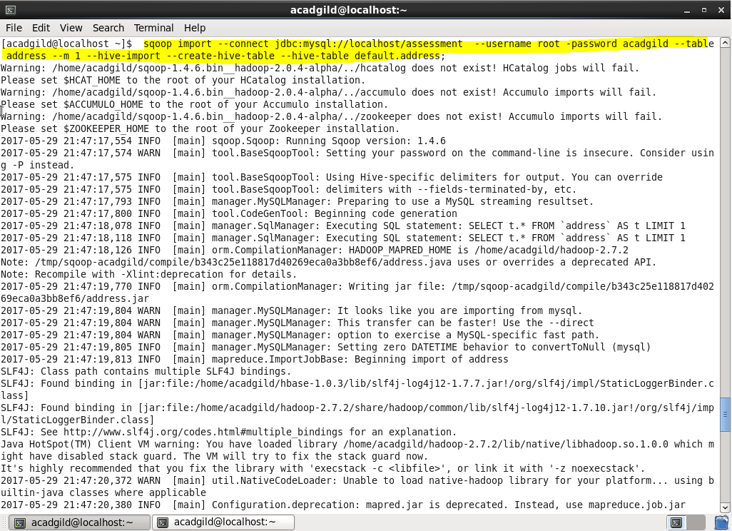

**transferring user_account table**

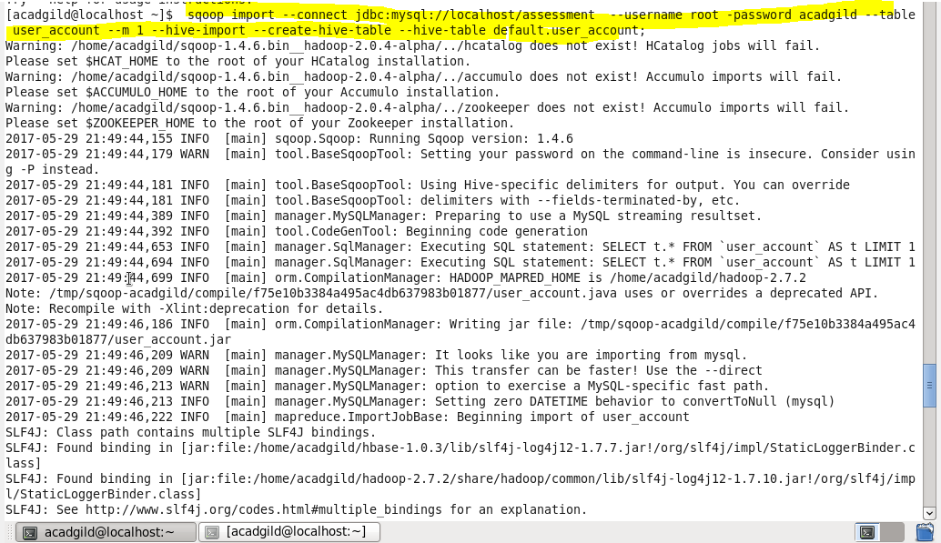

**NOWING GOING TO THE HIVE TERMINAL TO CHECK IFF ALL TABLES ARE THERE OR NOT**

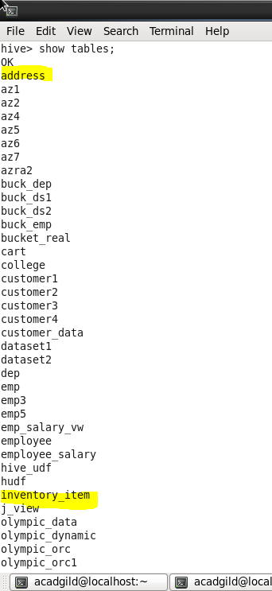 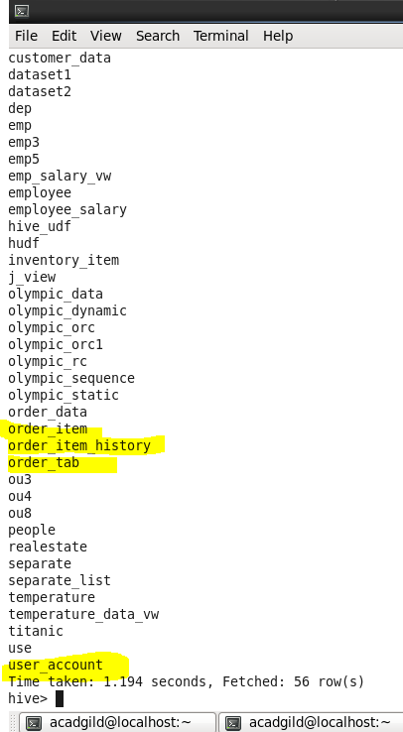

**NOW DOING PROBLEM 2 IN HIVE**

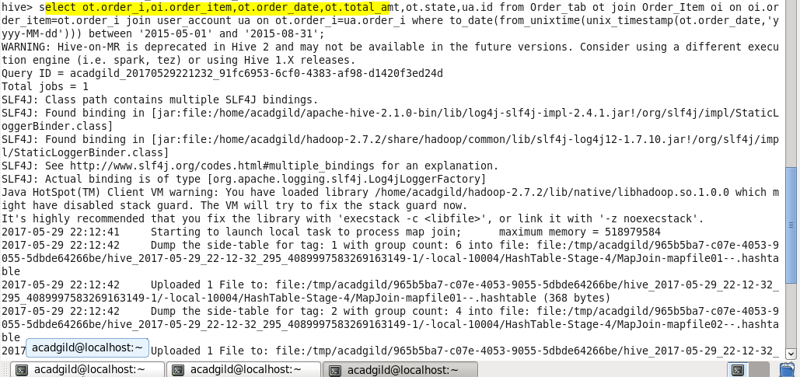

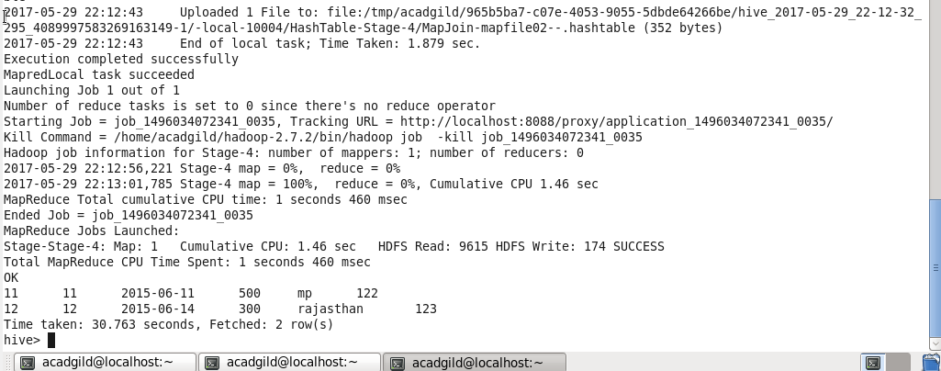

**3. Find which part the world has more number of customers and their total purchases in the past.**

