**Assignment 12.2**

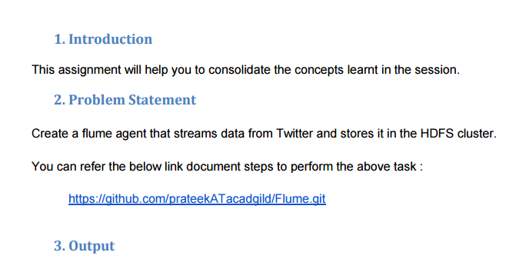

**Twitter Data Stream with FLUME.**

Installed flume via given method on ubuntu .

This is the **flume.conf**

**using shrey chandra’s twitter account** 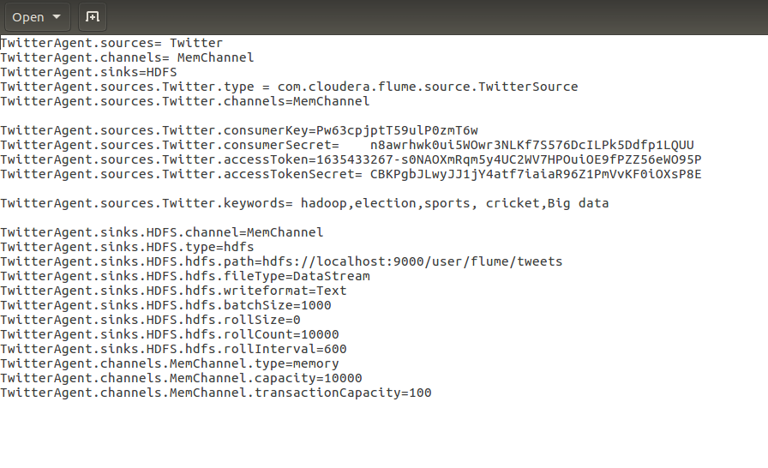

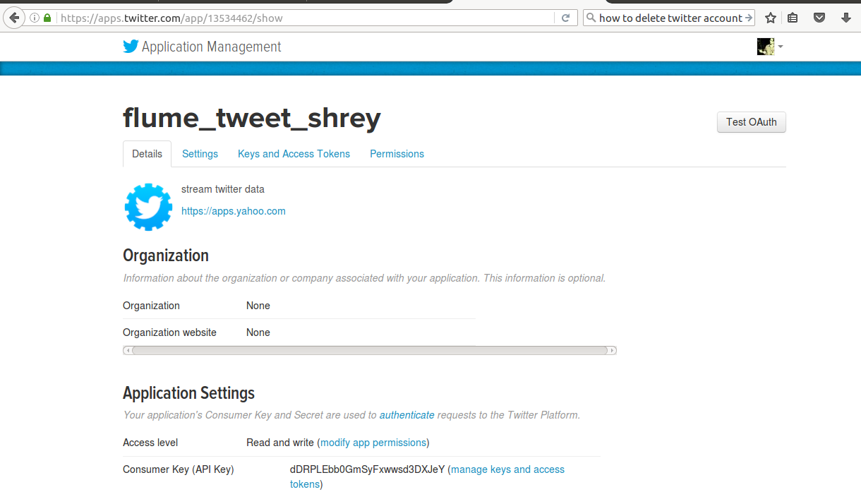

**Running the flume agent :**

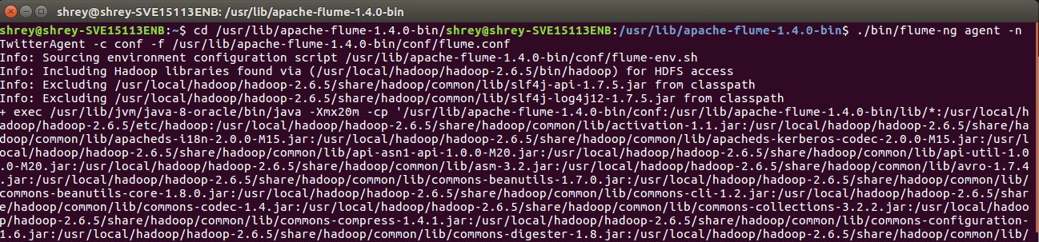

**Checking on HDFS :**

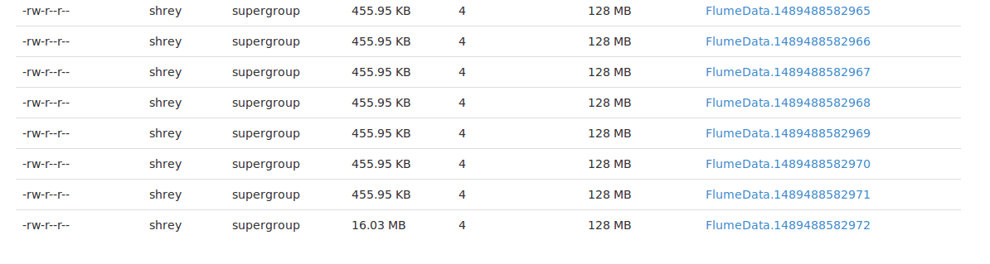

On opening the FlumeData file we can see that DATA STREAMING has started and the keeps on happening until and unless the the streaming is stopped (CTRL + C).

**FlumeData file on HDFS:**

