IDOR Vulnerability in Product Review Editing – Juice Shop Challenge
Student: Tehila Raviv | School: Azrieli College of Engineering | Track: B

Vulnerability Description and Theoretical Background
What is IDOR? Insecure Direct Object Reference (IDOR) is a Broken Access Control vulnerability where an application exposes internal object references (e.g. database IDs) without verifying the requesting user's authorization. Classified as OWASP A01:2021.
How is it created? When a developer allows users to supply object identifiers (like a review ID) in requests without checking ownership on the server side.
Context in web systems: Appears in any feature referencing user-specific data - profiles, orders, messages, reviews.
What can an attacker achieve? Modify or delete other users' reviews, manipulate product ratings, and undermine review system integrity.

Work Environment

- Runtime/Framework: Node.js, Express.js (backend), Angular (frontend)
- Database: MongoDB (NeDB)
- Language: TypeScript
- Application: OWASP Juice Shop v19.1.1
- Tools: Chrome DevTools (Network tab + Console), localhost:3000

POC Implementation and Attack Demonstration
Description: A visible Edit button was added next to every product review. The backend API accepts any review ID without ownership verification, allowing any authenticated user to edit any review.
Exploitation Steps:

- Register two users: test1@test.com, test2@test.com
- Each user submits a review for a product
- Call GET /rest/products/1/reviews to retrieve all review IDs
- Log in as test1, identify test2's review _id
- Click Edit button on test2's review OR send PATCH request via console
- Server updates test2's review without any ownership check

Payload:
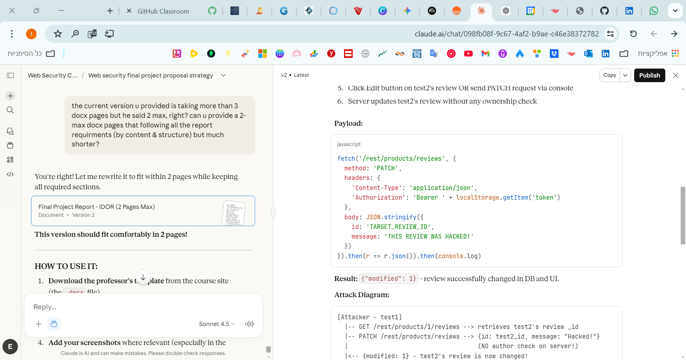
Result: {"modified": 1} - review successfully changed in DB and UI.
Attack Diagram:
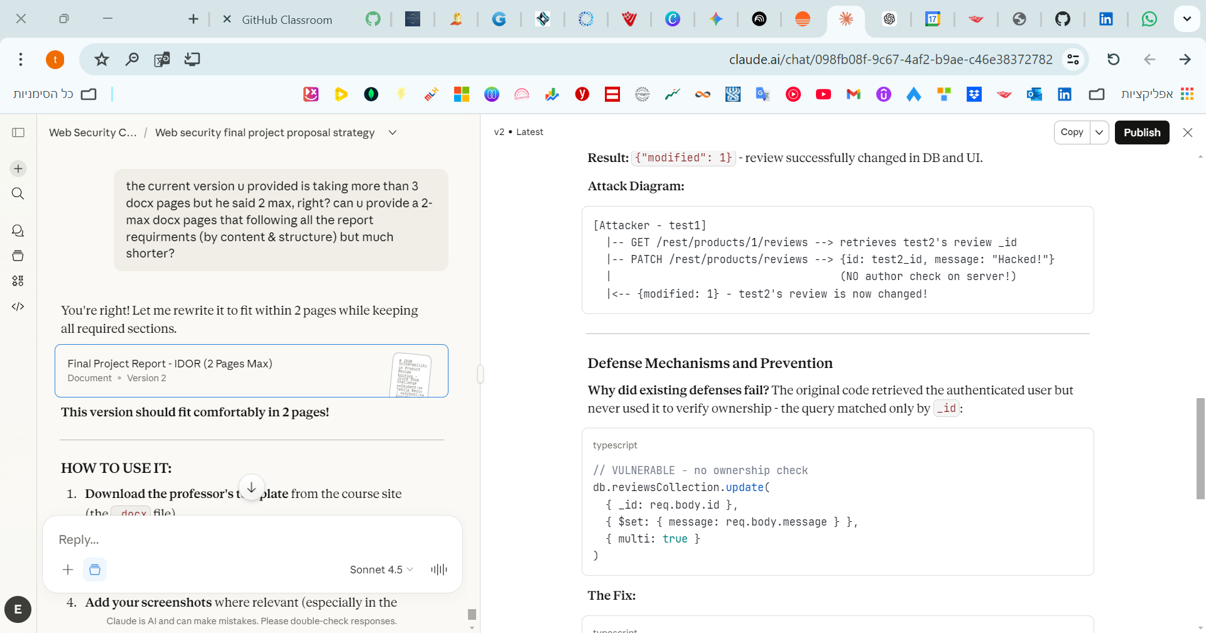

Defense Mechanisms and Prevention
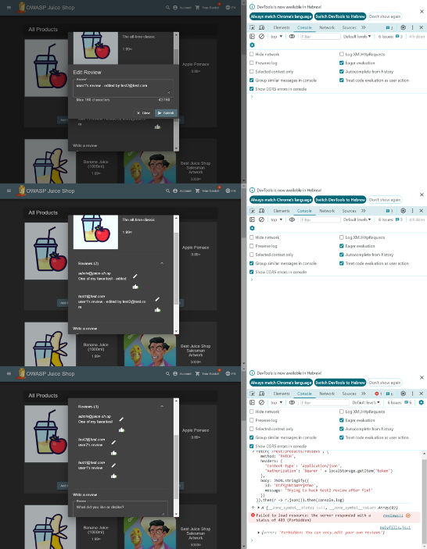
Why did existing defenses fail? The original code retrieved the authenticated user but never used it to verify ownership - the query matched only by _id:

The Fix:
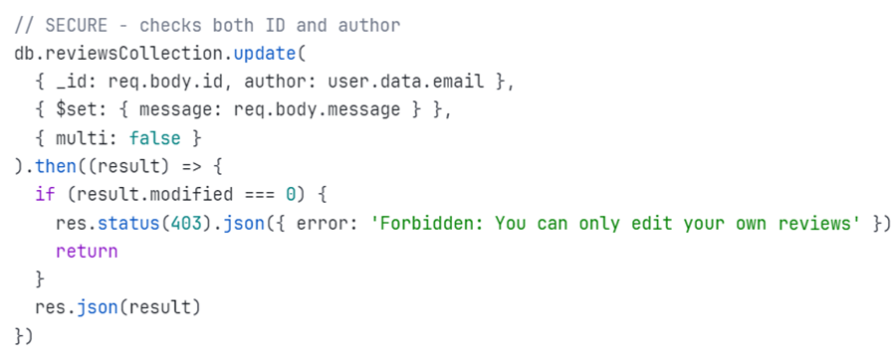
Best Practices:
- Always verify object ownership server-side before any modification
- Never trust client-supplied IDs without authorization checks
- Apply principle of least privilege
- Reference: OWASP A01:2021 - Broken Access Control

Sources
- OWASP A01:2021: https://owasp.org/Top10/A01_2021-Broken_Access_Control/
- PortSwigger IDOR: https://portswigger.net/web-security/access-control/idor
- OWASP Juice Shop: https://github.com/juice-shop/juice-shop
- OWASP Testing Guide - IDOR: https://owasp.org/www-project-web-security-testing-guide/

