|  |  |  |  |  |
| --- | --- | --- | --- | --- |
| **Iteration** | **ex** | **ey** | **ez** | **MAE** |
| 1 | 2.000 | 2.5000 | 3.5714 | 2.6905 |
| 2 | 1.2143 | 1.2619 | 1.5714 | 1.3492 |
| 3 | 0.5667 | 0.6667 | 0.8810 | 0.7048 |
| 4 | 0.3095 | 0.3357 | 0.4333 | 0.3595 |
| 5 | 0.1538 | 0.1754 | 0.2286 | 0.1859 |
| 6 | 0.0808 | 0.0894 | 0.1160 | 0.0954 |
| 7 | 0.0411 | 0.0463 | 0.0602 | 0.0492 |
| 8 | 0.0213 | 0.0237 | 0.0308 | 0.0253 |

**Jacobi Method:**

**Gauss Seidel Method:**

|  |  |  |  |  |
| --- | --- | --- | --- | --- |
| **Iteration** | **ex** | **ey** | **ez** | **MAE** |
| 1 | 2.000 | 1.8333 | 2.1905 | 2.0079 |
| 2 | 0.8048 | 0.0968 | 0.3726 | 0.4247 |
| 3 | 0.0551 | 0.0437 | 0.0361 | 0.0450 |
| 4 | 0.0015 | 0.0065 | 0.0012 | 0.0031 |
| 5 | 0.0011 | 0.0006 | 0.0003 | 0.0006 |
| 6 | 0.0002 | 0.0000 | 0.0001 | 0.0001 |
| 7 | 0.0000 | 0.0000 | 0.0000 | 0.0000 |
| 8 | 0.0000 | 0.0000 | 0.0000 | 0.0000 |

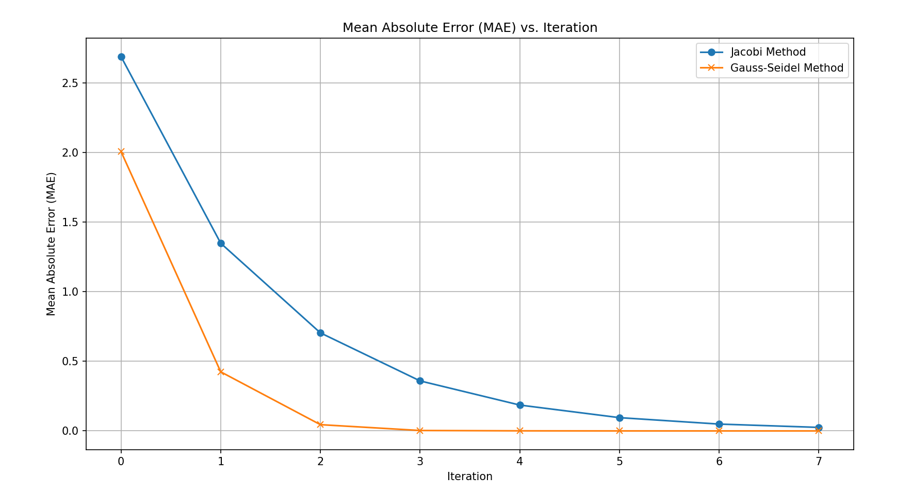

**Jacobi Method:**