Instuctions to Upload the Code:
1 – Add project folder to the Atom Workspace.

Go to File/Add Project Folder

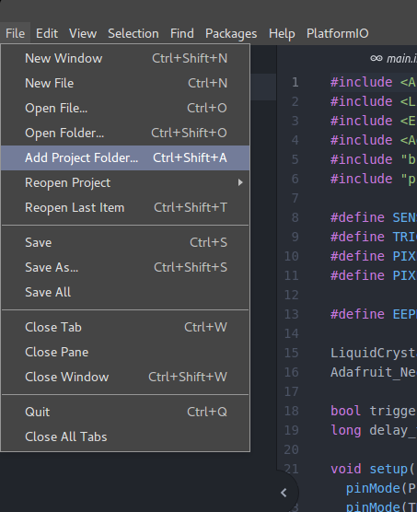

2 – Add the Whole Folder:
Select the whole folder, that means the one named Ring-Folder, that contains the Libs and the Source code
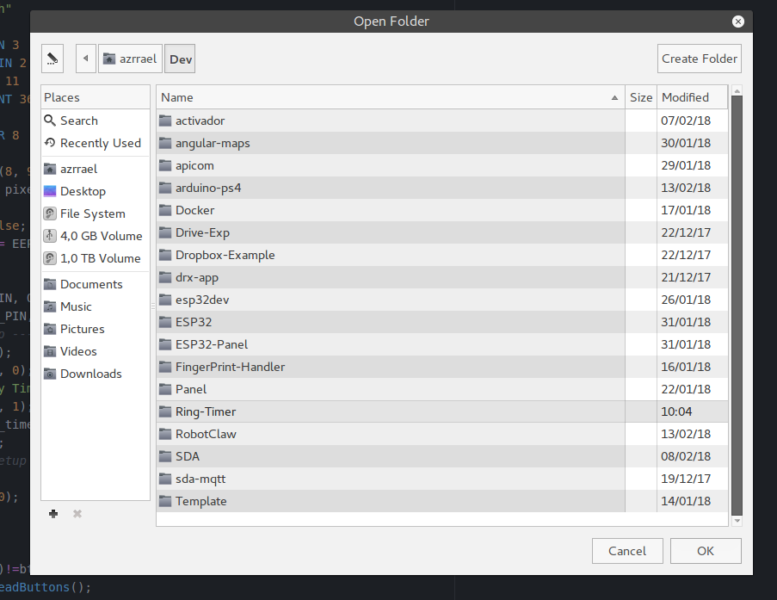

3 – Edit the parameter of the Hardware

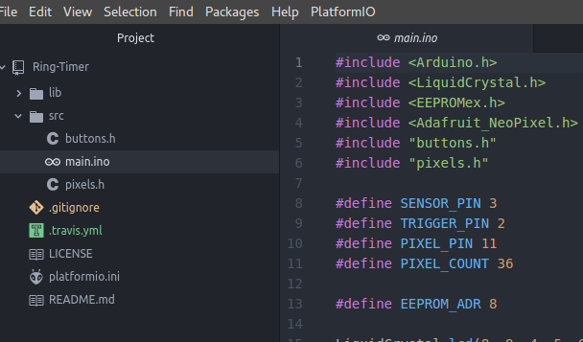
In the left side of the screen navigate the folder tree and open the file:
src/main.ino

In the lines 8 to 11 is contained the configuration of the Hardware, if you need to change any of those is simple. The pixel count automatically change the timer then feel free to modify as much as you need.

4 – Upload the Code

Go to PlatformIO/Upload, the first time it takes a quite long because PlatformIO needs to install the libs and the compiler.
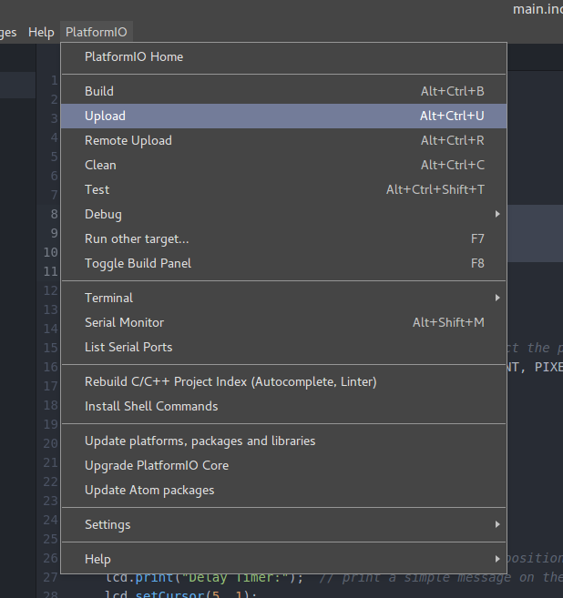

5 – Change the Board (Optional)

I used an Arduino UNO, is cheaper and compact, if you want to use it instead of the Arduino Mega. Got to the file
platformio.ini

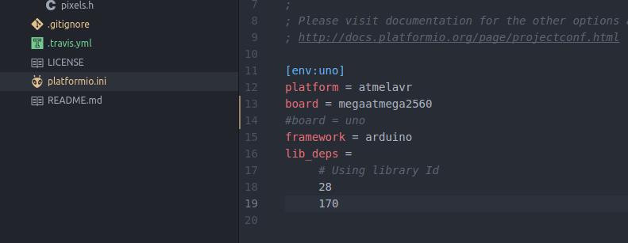

the “#” is used to comment the code, remove it from uno, and put it in the mega line. That is all.

