Adriann Liceralde, Dr. Nathan Moodie, Dr. Brian McPherson

Department of Civil & Environmental Engineering at the University of Utah

May 9, 2020

**Hele Shaw Model Instructions**

**Introduction**

This step-by-step guide shows how to create a 3D model of a Hele-Shaw porous media cell that allows two-dimensional fluid flow. The source images are from Imperial London College. Python will be used to extract the network from these images and Fusion 360 will convert the network to a printable 3D model.

**Materials**

* Windows PowerShell
* Python 3
* Inkscape
* Autodesk Fusion 360

**I. Retrieve Python Codes and MicroCT image**

1. Create a new folder which will now be referred to as the WorkFolder. Take note of the folder’s exact location. For this guide, the location is *C:\Users\user \Desktop\WorkFolder*
2. Go to <https://github.com/Azshian/Hele-Shaw-Model> and download these files to the WorkFolder.
   1. HeleCode.py
   2. HeleCell.stl
3. Go to <https://www.imperial.ac.uk/earth-science/research/research-groups/perm/research/pore-scale-modelling/micro-ct-images-and-networks/>
4. View the different image scans by clicking on the network name. This guide will select **Sand Pack (LV60B)**.
5. Click [**Download image (binary and ASCII)**](http://www3.imperial.ac.uk/pls/portallive/docs/1/46729696.ZIP)which will give a compressed zip file.
6. Extract the zip file and move the .dat file into the WorkFolder. The .raw file is unused.

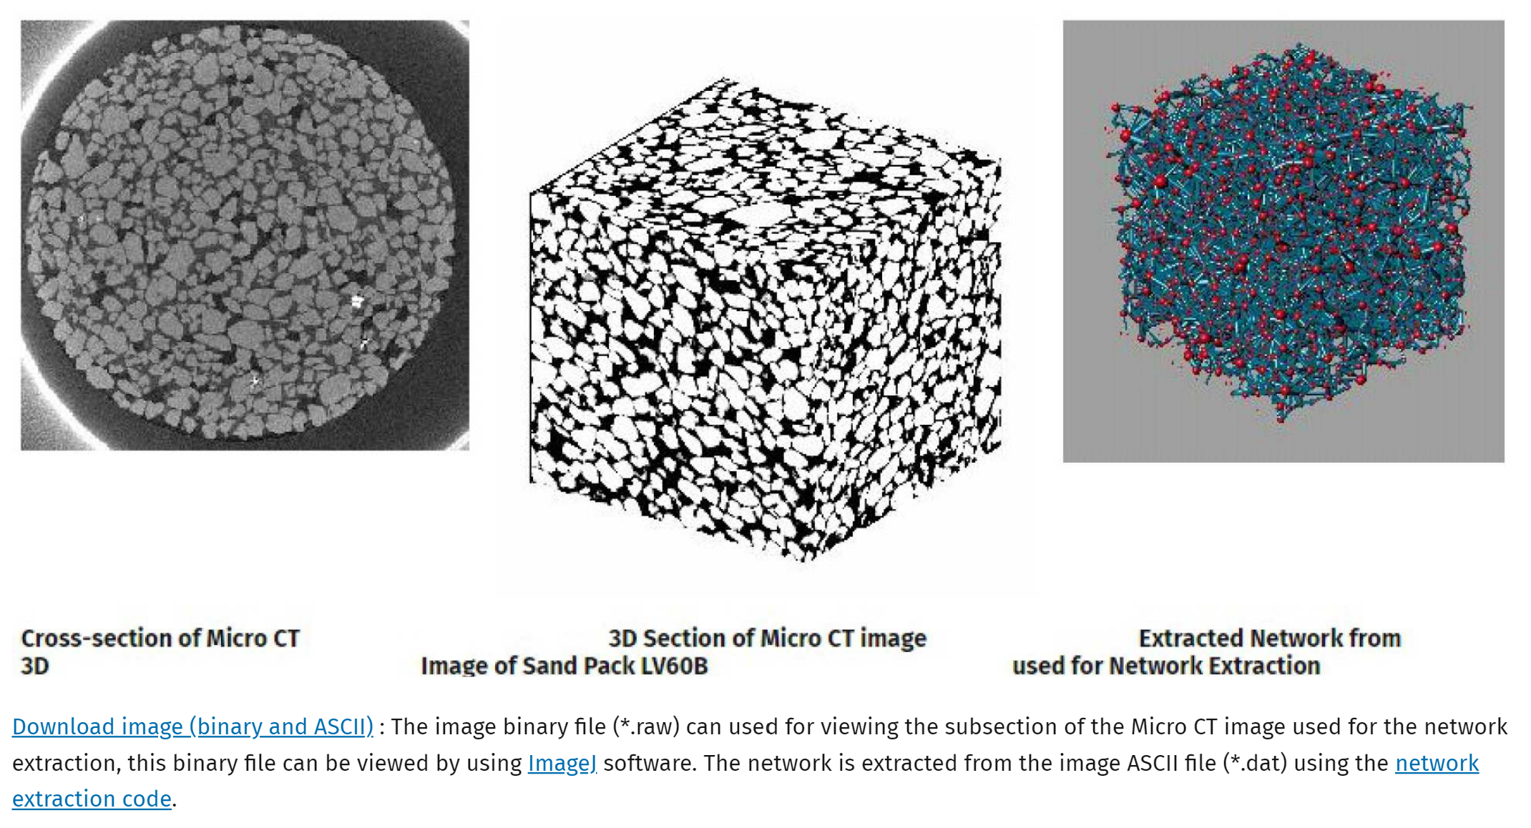

**Figure 1. Screenshot from website from ICT**

**II. Select slice from Pore Network**

1. Open Windows PowerShell and change the directory to the WorkFolder by typing:

*cd “C:\Users\user\Desktop\WorkFolder”*

1. Load the Python code and the image file by typing:

*python HeleCode.py LV60_02.dat*

1. The **Area Selection** GUI will appear, with four sliders and four buttons. Click **Show** to open the image.
   1. The pore network is shown with the filled spaces as yellow and the void spaces as purple.
   2. The red border surrounding the network indicates the area selection.
2. Select the desired network
   1. Use the GUI slider **Y Top, Y Bottom, X Left,** and **X Right** to change the area selection.
   2. Use the **Height** slider to select the height level of the network.
   3. When values are changed, press the **Show** button to update the image
3. Press the **Cut** button to view the selected area.
   1. If more changes are desired, simply press the **Show** button again to view the full network with the red borders.
4. Once the desired area is found, press **Cut**, then press **Save** to save the pore network as a .png file in the Work Folder.

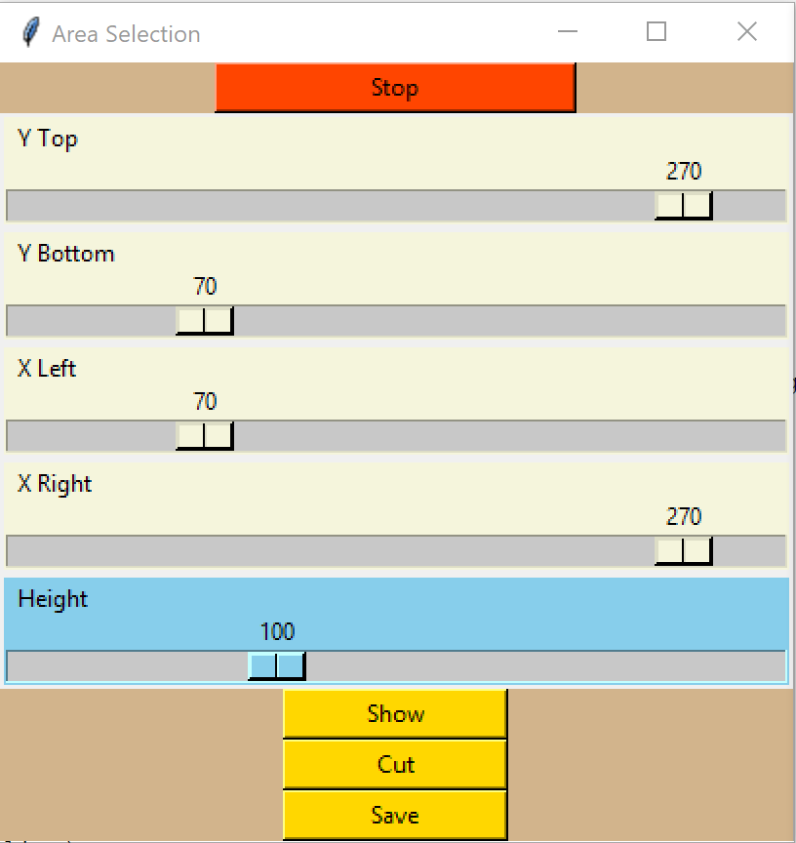

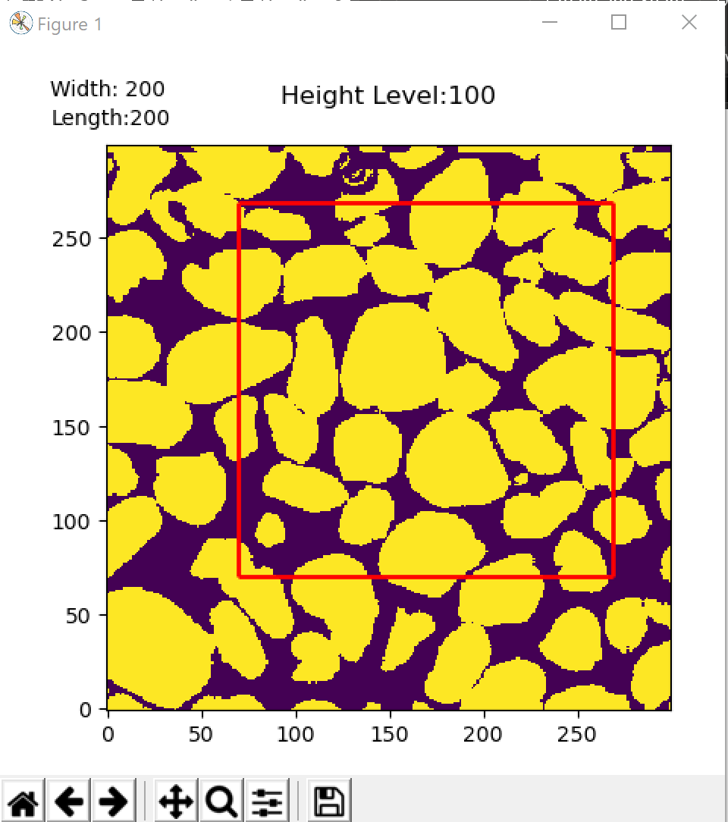

**Figure 2. Slider GUI (left) controlling the Network Image (right)**

**III. Convert PNG to SVG**

1. Open Inkscape. Drag .png file into workspace. Pop-up menu will appear.
   1. Embed. From File. None.
2. Select on the image. Then, on the ribbon, under **Path**, select **Trace Bitmap**. Press OK and close the window.
3. A copy of the image will be produced in a vector format. The smooth vector image is generated right on top of the original pixel image. Drag the vector image out of the way to view the original image and delete the latter.
4. Go to **File** and select **Save as** to save the file as an SVG

**IV. Upload SVG file to Autodesk Fusion 360**

1. Open Fusion 360