Every thing that happened while learning Assembly programming

Got the list of projects from ChatGPT
Initialized the repository in a folder in my dev folder and copied the projects list to the README

Project0: Setup
- googled assembly language programming tutorial on windows
- found one that recommended HLA but saw a note saying its not useful for real world stuff
- Found like nothing useful, so backtracked to pwn.college and looked through the slides for assembly crash course
- Just remembered that i have a linux vm so no need to stress about windows stuff
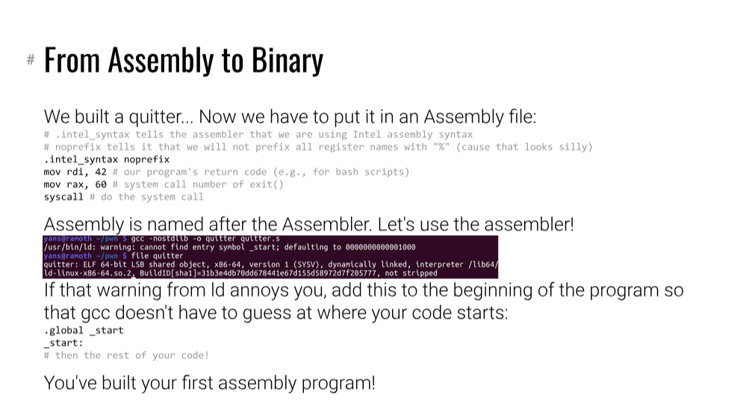
- Found this so have a start point.
- Now time to move over to linux
- PS also found this book, might need in the future http://www.egr.unlv.edu/~ed/assembly64.pdf

