BCSE203E - Web Programming
Digital Assignment – I
Winter Semester 2023 – 2024
Topic: Develop Personal Portfolio

Registration Number – 22BCT0116
Name – Syed Furqaan Lateef
Github Link - https://github.com/Azsriel/Portfolio

Tools:
- VSCode as the code editor
- LibreOffice Writer for the documentation
- Git for version control
- Additional resources from TheOdinProject and GeekForGeeks

Planning:
- Project will be managed using git version control. Documentation will be updated with every commit
The planned website page layouts were as follows:
index.html:
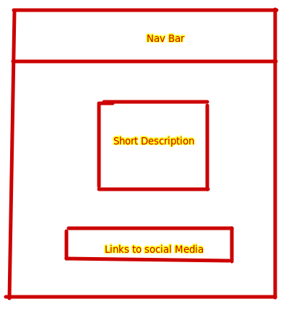

qualifications.html
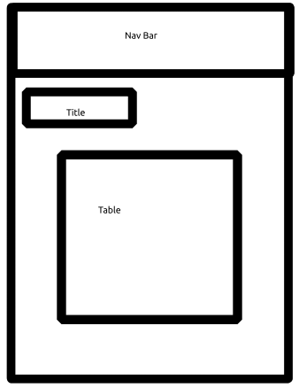

projects.html – list of all projects: Maybe search bar for filtering
lab.html – links to all javascript projects for realtime viewing
contact.html – simple contact me page similar to what was done in lab

Commits:
- Initial Commit with only documentation
- Created About page
- Created Qualifications and Contact pages

