Alec Brandt
CS 210
Prof.
8/20/2025
Project 3: Corner Grocer
Design and Functionality:
My program reads grocery purchases from the provided input file CS210_Project_Three_Input_File.txt. Every line in that file represents a single item bought during the day. The program counts the items, saves the results into a backup file, and then gives the user four menu options to interact with that data.
I built the logic inside a single class called GroceryTracker. This class has one private map that stores each item and its count. It also has public functions to load the file, get the frequency for a single item, print the full list of items with counts, print a histogram, and write the backup file. Using a class made the program easier to organize and keeps main() short and clear.
The data structure I used is std::map<std::string, int> because it automatically sorts the items alphabetically, which makes the printed results easy to read. The map is updated as the input file is read line by line. At startup, the program writes everything to frequency.dat so that there is always a backup copy of the data, just like the instructions require.
The menu has four options:
1. Prompt the user to type in an item and then print its frequency.
2. Print the full list of items and how many times each one appears.
3. Print a histogram that shows each item followed by asterisks representing its count.
4. Exit the program.
For user experience, I added basic input validation, so the program doesn’t crash if the user types something invalid for the menu. I also made item lookups case-insensitive, so that “apple” and “Apple” work the same.
Screenshots:
- Program start and menu display
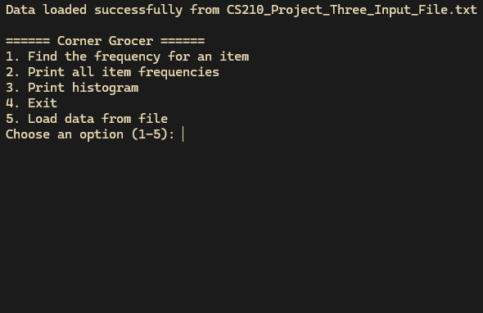
- Example of Option 1 (lookup for a single item)
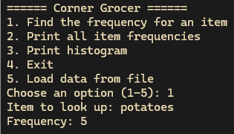
- Example of Option 2 (list of all items with counts)
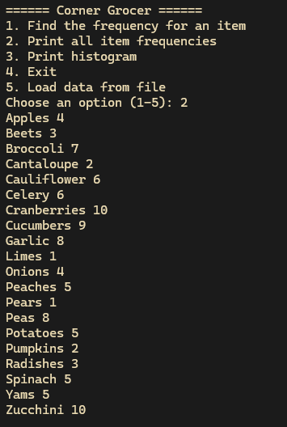
- Example of Option 3 (histogram output)
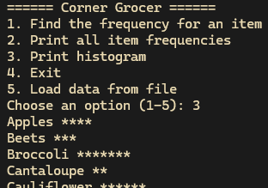
- Opened frequency.dat in a text viewer
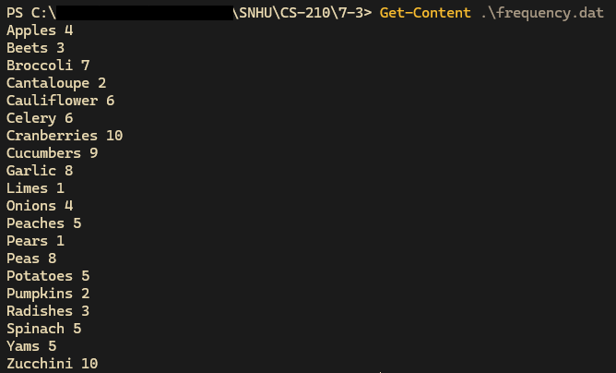

Build and Run:
The program needs CS210_Project_Three_Input_File.txt in the same working directory as the executable. Once compiled, it loads that file, generates frequency.dat, and then waits for menu input. If the file isn’t present or another in the same format is available, it can be loaded by file name if present in the same directory as the executable.

