Devera Austine Lee F.   
A601

Class Schedule

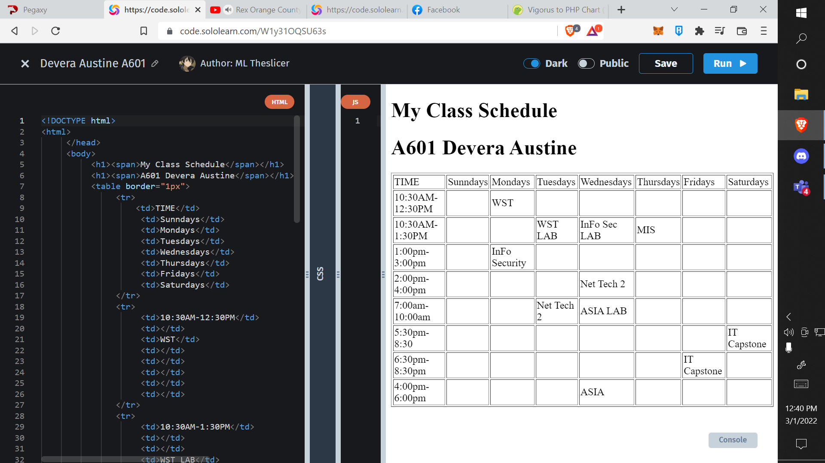  
  
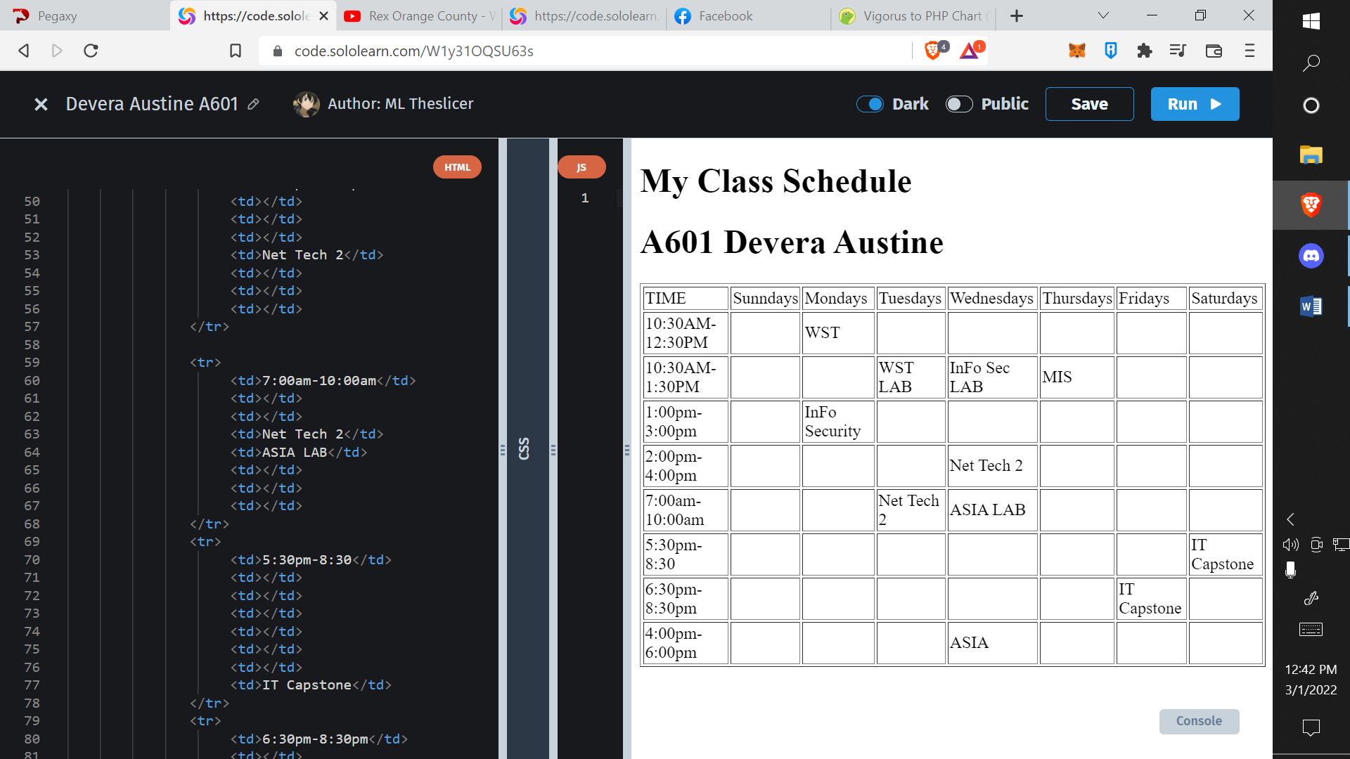  
  
  
  
  
  
  
  
  
Email Registration  
