11/26/2019

HTML1

1. HelloWorld
2. Sitemap / Wireframe
   1. Sitemap – A diagram that contains all the pages for a site and shows how each page relates to the others
   2. Wireframe – A blueprint of a page in your site
3. HTML Elements
   1. Empty Elements === Self Closing Tags
   2. Example, hr and br
4. HTML Attributes
   1. Added info in the opening tag of an element
   2. id="ContentArea" style="color: red;"
5. Whoooaaaa Trippy Stuff
   1. Pi === &#928;
   2. <sup> and <sub>
      1. H<sub>2</sub>O
      2. &#928;r<sup>2</sup>
   3. 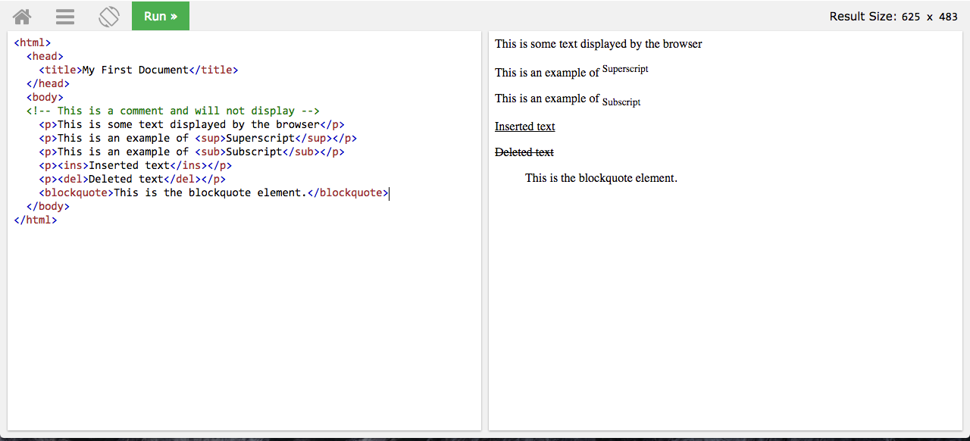

11/27/2019

HTML Block Elements

1. Intro to Block
   1. creates a “block” of content within its parent container that starts with a newline before and after the element making the content appear as a block or box of content on the page. They fill the entire horizontal space of their parent element.
   2. 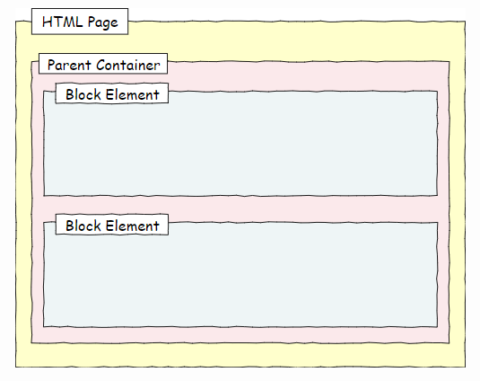
   3. <p></p>
   4. Heading elements (<h2></h2>)
   5. <div></div>
      1. div vs p
         1. div considered a parent container of other elements
         2. div nesting
   6. <header> and <footer>
2. Semantic Elements
   1. List
      1. main: a block that represents the primary section of a page
      2. header: a block at the top of a page
      3. footer: a block at the bottom of a page
      4. nav: a block that includes navigation elements, such as buttons or menus
      5. article: a block that contains nested blocks related to a single topic, like a newspaper article
      6. section: a block that identifies a section of content with a specific purpose, like the section of a newspaper
      7. form: a block that contains the elements of a form
      8. figure: A block that contains an image and information about that image
   2. 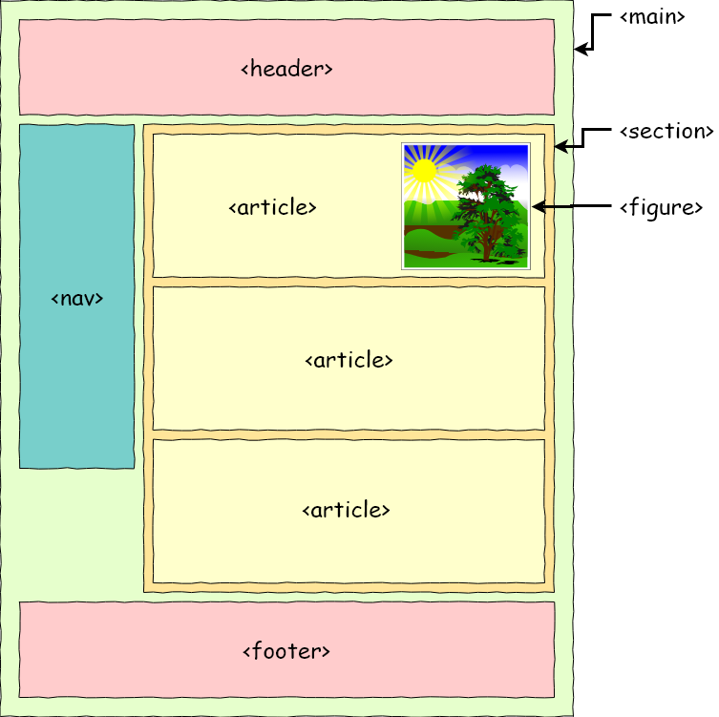

HTML Inline Elements

1. Intro to Inlines
   1. do not start with a new line nor do they fill the entirety of the horizontal space of the parent
   2. In standard practice, inline elements must be nested within a block element, as it cannot stand alone on a page
   3. <span></span>
      1. The <div> equivalent
      2. A very useful tool if you want to apply a specific format to a small amount of text in a block, without formatting the entire block
   4. em and strong
2. Creating Links
   1. Anchor Tag
      1. <a>Clickable content</a>
      2. ATTRIBUTE: href
         1. <a href="https://www.google.com">Google</a>
      3. ATTRIBUTE: target - defines how the linked content will open
         1. _blank will open the link in a new browser tab
         2. _self will open in the same tab, replacing the current page
         3. <a href="https://www.google.com" target="_blank">Google</a>
   2. Targeting Content
      1. 3 types of links
         1. External Link – Open a document on a different web server
            1. website sells computers and you want to give your users a way to open the manufacturer's support pages for those computers
            2. <a href="https://www.google.com" target="_blank">Google</a>
            3. Uses target=”_blank” to open a separate page
         2. Internal (Local) Link – Open a separate document within your website
            1. you might want to provide your users with a link to shipping information from your website
            2. uses relative paths
            3. no need to use target=”_self” (default)
         3. Bookmark Link – Jump to a different section on the same page
            1. common on pages that are very long, making it easy for a user to find specific information in the page without having to scroll too much
            2. Indexes and Single-Page websites
            3. Reference the id

<p><a href="#target">This is the question.</a></p>

<p id="target">This is the target.</p>

* + - * 1. While it is possible to include a target attribute in a bookmark link, it isn't typically recommended unless you really believe that the user would prefer to have a new tab or window open to view that content

Images

1. Breezing through this shiz
2. <img   
   src=<https://cdn.pixabay.com/photo/2017/06/21/00/22/dog-2425528_960_720.jpg>  
   alt="Photo of a puppy and a kitten."   
   style="border: thick red solid; width: 300px;"/>
3. As a general rule, you should specify only height or width in the style property, not both.
   1. Specifying only height or width resizes the image while maintaining the aspect ratio.
4. 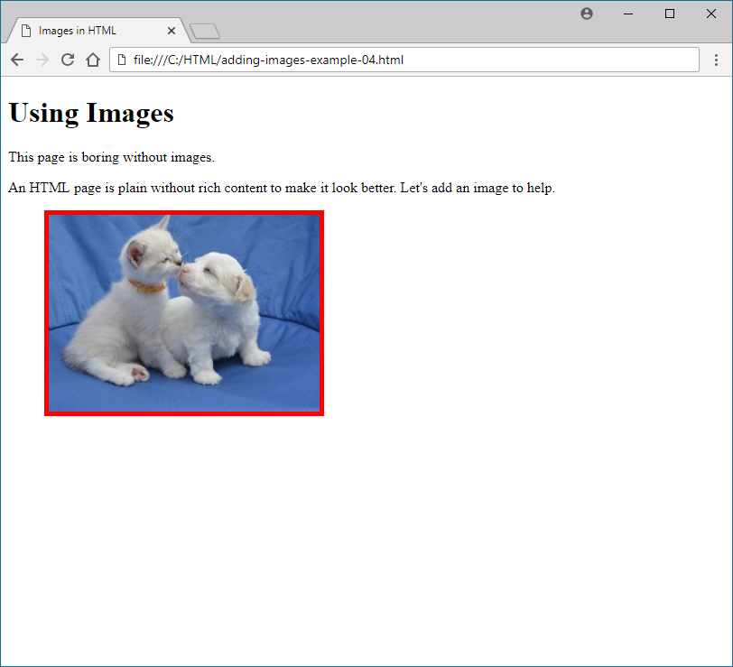
5. Relative vs Absolute Paths

Lists in HTML

1. Breezing through again
   1. Ordered List <ol></ol>
   2. Unordered List <ul></ul>
   3. List items <li></li>
   4. Definition List. See below

<**h2**>Definition Lists</**h2**>

<**dl**>

<**dt**>One</**dt**>

<**dd**>The first positive number in our counting system.</**dd**>

<**dt**>Two</**dt**>

<**dd**>The first whole number greater in value than one.</**dd**>

<**dt**>Three</**dt**> <**dd**>The next whole number in increasing value after two.

</**dd**>

</**dl**>

<**h2**>Definition Lists</**h2**>

<**dl**>

<**dt**>One</**dt**>

<**dd**>The first positive number in our counting system.</**dd**>

<**dt**>Two</**dt**>

<**dd**>The first whole number greater in value than one.</**dd**>

<**dt**>Three</**dt**> <**dd**>The next whole number in increasing value after two.

</**dd**>

</**dl**>

1. TABLES

|  |  |
| --- | --- |
| **Element Name** | **Element Purpose** |
| <table></table> | marks the beginning and end of a table |
| <tr></tr> | table row: marks the beginning and end of a row within a table |
| <th></th> | table header: marks the beginning and end of a cell in a header row |
| <td></td> | table data: marks the beginning and end of a cell in a table row |

* 1. 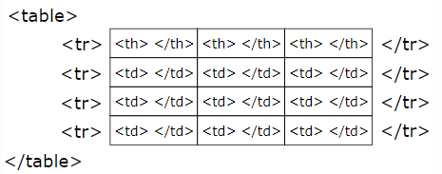
  2. <caption>Contact Information</caption>
  3. Formatting Tables
     1. <table border="1" width="90%">
     2. <tr bgcolor="palegreen">
  4. Cells that Span Multiple Columns/Rows
     1. <th colspan="2">Name</th>
     2. <td rowspan="3">Friends:</td>

1. Forms
   1. Can’t skimp this one – This is crucial!!
   2. Forms are very common – examples include login forms, ordering forms (such as when checking out from a site like Amazon), and Contact Us forms
   3. Form Element
      1. Must have two attributes
         1. Action
            1. specifies the URL where the form data will be submitted
         2. Method
            1. specifies the HTTP method (POST or GET) that should be used to submit the data
            2. GET = included in the URL
            3. POST = data is saved to a server
   4. Input Tag
      1. <input type="type of input" name="name of input" >
      2. Types of Input
         1. Text
            1. Most common
            2. Most forms have at least one text input
            3. Value = data to submit
            4. Put stuff in; non-hidden
         2. Password
            1. Like text, except hidden using *
            2. Value = data to submit
         3. Radio
            1. Collection of two or more display elements that allow you to choose only one at a time
            2. Checked tag to pre-select (recommended)

Not an attribute because no value is set

1. <**input** type="radio" name="answer" value="YES" checked />Yes<**br** />
2. <**input** type="radio" name="answer" value="NO" />No<**br** />
3. <**input** type="radio" name="answer" value="MAYBE" />Maybe<**br** />
4. Submit
   * + - 1. Submits the form
         2. Can use value=”text” to specify text
5. Reset
   * + - 1. Resets the form
         2. Can use value=”text” to specify text
6. CheckBox
   * + - 1. Like radio, except can select multiple
         2. Can check multiple as well

<**input** type="checkbox" name="myChoices" value="Soup" checked/>Soup<**br** />

<**input** type="checkbox" name="myChoices" value="Salad" checked/>Salad<**br** />

<**input** type="checkbox" name="myChoices" value="Fries" checked/>Fries<**br** />

<**input** type="checkbox" name="myChoices" value="Dessert" checked/>Dessert<**br** />

* 1. Select Tag
     1. For dropdown
     2. Value = data to submit

<**select** name="phones">

<**option** value="iPhone6">Mac OS</**option**>

<**option** value="GalaxyS6">Windows</**option**>

<**option** value="Nexus5">Linux</**option**>

</**select**>

* 1. Textarea
     1. Multi-line, resizable text box
  2. Required. Add required tag