**Exploring the Indian Startup Ecosystem: A Data Driven Analysis of Funding Trends and Industry Sectors**

Table of Contents

1. Introduction

2. The Data Journey

3. Unveiling the Insights

4. Investor Perspectives

5. The Road Ahead

6. Conclusion

**Introduction**

Amidst the bustling streets and thriving technology hubs of India, a revolution is taking shape – the rise of a vibrant and dynamic startup ecosystem. This ecosystem, once a mere spark in the distance, has ignited into a blazing inferno, attracting the attention of investors, entrepreneurs, and innovators from across the globe.

As of 2018, India boasted an astonishing 50,000 startups, with an average of 2-3 new tech ventures being born each day. This staggering growth rate of 12-15% annually is a testament to the country's burgeoning entrepreneurial spirit and its commitment to fostering innovation.

In this ever-evolving landscape, data has emerged as a powerful tool, illuminating the paths to success and unveiling the hidden trends that shape the future of this ecosystem. Aditi Gupta, Co-Founder of Zomato once said regarding the hidden gems that data analysis can make available, "The Indian startup ecosystem is brimming with opportunities, and data-driven insights are crucial for navigating this dynamic landscape. Our analysis has unveiled invaluable perspectives that can guide both entrepreneurs and investors towards success."

Through meticulous analysis, we, too, unravel the intricate tapestry of funding patterns, industry dynamics, and market forces that drive the Indian startup revolution.

This article is a culmination of a data-driven odyssey, a journey that delves into the heart of the Indian startup ecosystem, unearthing invaluable insights from a comprehensive analysis of funding datasets spanning the years 2018 to 2021.

As a team of data analysts, our objective is to investigate the Indian startup ecosystem and propose the best course of action for stakeholders using the data regarding funding received by startups in India from 2018 to 2019. The aim of this project is to perform an analysis that will advise stakeholders on investing in ventures with the potential for high profit or income.

To achieve this objective, we will address the following key business questions:

- Which particular sector received the most funding over the time frame?

- What is the distribution of startups across different stages, and the amount of funding allocated to each stage?

- How is funding distributed geographically across different locations in India?

- Which year witnessed the highest number of active investors?

- What are the top three considerations that investors prioritize when evaluating startups for investment?

By answering these questions through our data-driven analysis, we aim to provide stakeholders, especially investors, with actionable insights and recommendations that will guide their investment decisions and enable them to capitalize on the most promising opportunities within the vibrant Indian startup landscape. We fully agree with the statements of Rajan Ananda, Managing Director of Sequoia Capital India, when he shared his views to prospective investors after having completed similar project that required massive investment in time and expertise, "Investing in the right startups is equal parts art and science.” Rightly the data analysis conducted in this project provides the scientific foundation needed to make informed decisions. As reflected in our recommendations, ‘the experience and intuition [of investors] guide the artistic aspects of identifying true gems.’

With an unwavering commitment to unlocking the secrets of this ecosystem, we invite you to join us on this captivating exploration, where data meets innovation, and knowledge becomes the catalyst for empowering the visionaries of tomorrow.

**The Data Journey**

To unravel the mysteries of the Indian startup ecosystem, our quest began with an arduous yet crucial first step – assembling the data that would serve as our compass. From the vast depths of the digital realm, we meticulously gathered funding datasets spanning the years 2018 to 2021, sourced from the hallowed grounds of GitHub and secured remotely from a trusted database.

However, as with any great expedition, challenges awaited us. The datasets, raw and untamed, presented a formidable obstacle – a tangled web of duplicates, misplaced values, and inconsistencies that threatened to derail our journey before it had truly begun.

Undeterred, our team of data explorers embarked on an extensive data cleaning and preprocessing odyssey, armed with the potent tools of Python, Pandas, and NumPy. Like seasoned cartographers, we methodically identified and removed duplicates, rectified misplaced values, and standardized inconsistent variables, ensuring the integrity and reliability of our data.

Null values, those insidious gaps in our knowledge, were handled with the utmost care, employing sophisticated techniques of imputation, removal, and interpolation to preserve the sanctity of our findings. Unnecessary symbols, commas, and full stops were meticulously expunged, leaving behind a pristine canvas upon which our analysis could take shape.

Throughout this arduous process, we adhered to the principles of the esteemed CRISP-DM methodology, a beacon that guided our efforts and ensured a structured, systematic approach to conquering the challenges that lay before us.

Finally, our data stood transformed, a polished and reliable foundation upon which we could construct our exploratory analysis. Armed with the potent technologies of Python, Pandas, NumPy, Matplotlib, Seaborn, and Scikit-learn, we ventured forth, determined to unearth the insights that lay buried within the depths of our meticulously curated datasets.

**Unveiling the Insights**

As we delved into the meticulously curated datasets, our analysis unveiled a treasure trove of insights that directly addressed the key business questions guiding our exploration. We navigated through the intricate patterns and trends, uncovering revelations that shed light on the dynamics of the Indian startup ecosystem.

To this end, let’s now refer back to our original hypothesis, and watch the revelations that our data analysis work has made.

Hypothesis: *The amount of funds a company receive depends on the sector a company belongs to.*

- Null Hypothesis(H_o) - The funds a company receive does not depend on the sector of investment

- Alternate Hypothesis(H_a) - The funds a company receive depends on the sector of investment

Since the p-value = 0.979 after the test is greater than the significance value of 0.05, we fail to reject the Null Hypothesis with an F-statistics of 0.402

Addressing the query of *which sector received the most funding during the 2018-2019* timeframe, our analysis revealed a clear frontrunner – the financial services sector. This burgeoning industry, propelled by the relentless march of innovation and digital transformation, emerged as a beacon of investment, attracting a disproportionate share of funding compared to other sectors.

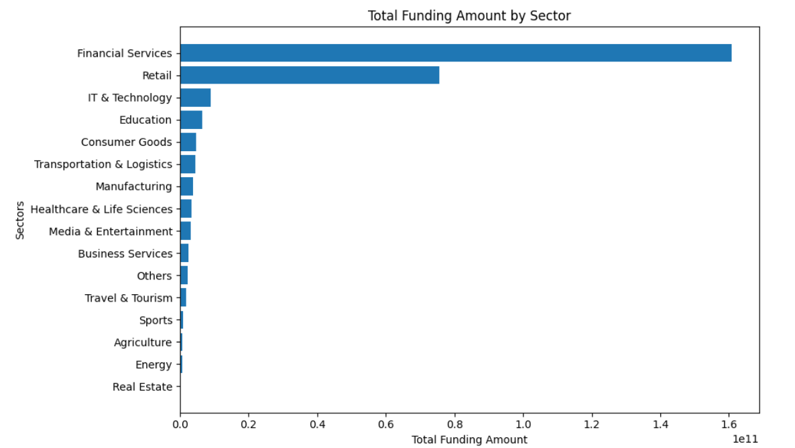The allure of the financial sector lay in its promise of scalability, disruption, and the potential to reshape entire industries. From cutting-edge software solutions to groundbreaking hardware innovations, this sector captivated investors with its boundless possibilities and the allure of being at the forefront of the digital revolution.

Turning our attention to the *distribution of startups across various stages*, our analysis painted a vivid picture of the ecosystem's evolution. Normally one could guess either the early-stage ventures, brimming with ideas and potential, or the established players, brimmed with proven track records and robust business models, should have secured a significant portion of funding, reflecting the appetite for either innovative concepts or for tested and dried ventures. Unfortunately, however, our datasets, due to their tons of missing and mislabeled values, couldn’t allow us deliver concrete answers to this particular business question.

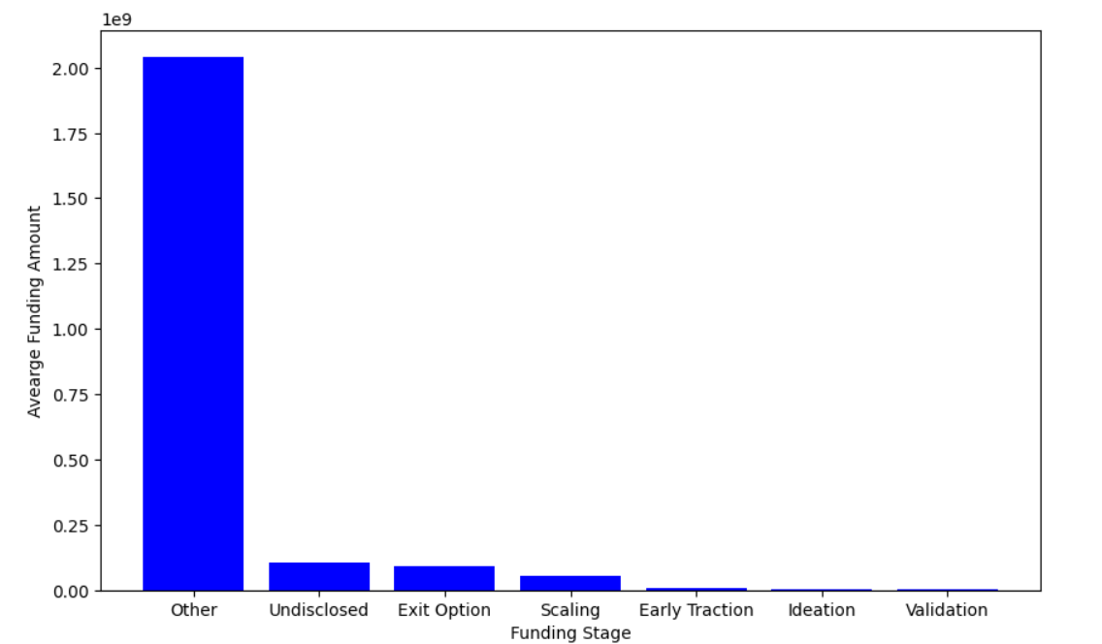

Shifting our gaze to the geographical landscape, our analysis unveiled a tapestry *of disparities in funding distribution across different regions and locations* within India. Metropolitan hubs and tech corridors emerged as magnets for investment, their gravitational pull attracting a disproportionate share of resources and capital.

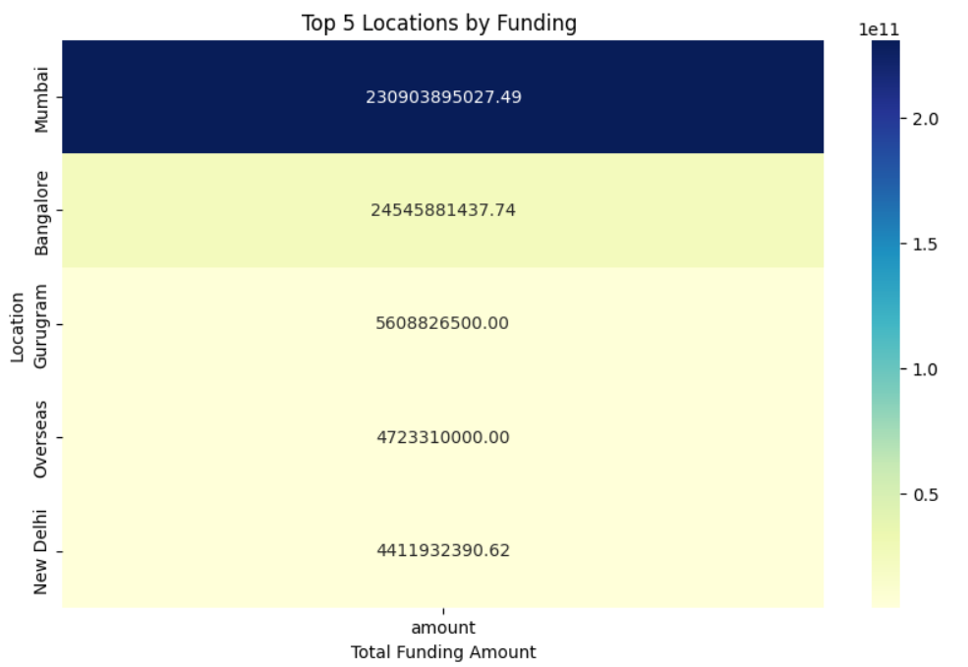 This phenomenon underscored the importance of location in accessing the lifeblood of funding, with startups in these bustling hubs benefiting from proximity to investors, mentors, and a thriving support ecosystem. Conversely, those venturing into the hinterlands often found themselves grappling with limited access to resources, highlighting the need for initiatives that could level the playing field and empower entrepreneurs across the nation.

Through these revelations, we not only addressed the key business questions but also unveiled a deeper understanding of the intricate dynamics that govern the Indian startup ecosystem. Armed with these insights, stakeholders can make informed decisions, prioritize resource allocation, and strategize effectively to navigate the ever-evolving landscape of funding and investment opportunities.

**Investor Perspectives**

As we traversed the ever-evolving landscape of the Indian startup ecosystem, our analysis shed light on the intricate decision-making processes that shape the minds of investors – the gatekeepers of capital. Through our findings, we uncovered the top three considerations that investors prioritize when evaluating startups for potential investment.

First and foremost, market demand emerged as a paramount factor, a beacon that guided investors in their pursuit of viable opportunities. Overall, our analysis has clearly demonstrated that the appetite for investment in the Indian Startup Environment has been very high and increasing at a disproportionate level, as the graph below shows.

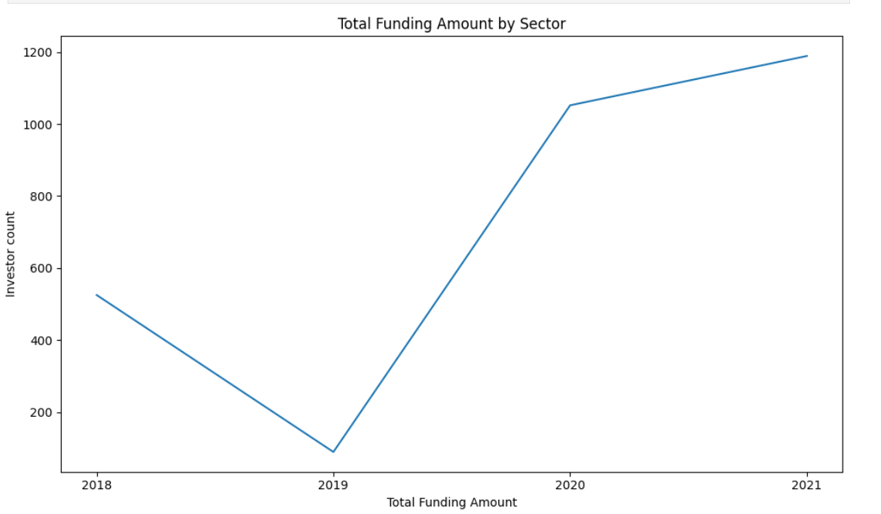

Startups that could demonstrate a deep understanding of their target market, coupled with a scalability, emerged as a siren song that captivated investors with visions of exponential growth and industry dominance. In a world where disruption is the norm, those startups that could seamlessly navigate the treacherous waters of rapid expansion held the keys to unlocking unprecedented returns.

Our analysis revealed that investors favored startups in the financial sector which most definitely supported scalable business models, robust technology infrastructures, and a clear roadmap for sustained growth. Given the size of the Indian population, the definite massive demand for such services, and higher technology adoption rate in the population, this revelation may not as such be a surprise. The allure of ventures with the potential to dominate their respective markets proved irresistible, fueling investment decisions that prioritized scalability as a critical factor.

The third and final consideration, often overlooked but profoundly influential, was the founding or parent company of the startup. The experience, established systems and well developed markets in other parts of the world are definitely key to a startup’s success and subsequent domination of the market in India. Investors sought out startups whose parent companies are already well established and big players somewhere else.

# Hey can you, insert a chart or graph showcasing the correlation between funding amounts and headquarter.

Armed with these insights, startups can tailor their pitches and strategies to resonate with investor priorities. By demonstrating market validation, scalable growth potential, and associating with a well established and well performing parent company, entrepreneurs can increase their chances of securing the coveted investments that propel their dreams towards reality.

As the guardians of capital, investors play a pivotal role in shaping the trajectory of the Indian startup ecosystem. By aligning with their priorities and embracing the data-driven evidence that underpins their decision-making processes, startups can forge a path towards success, fueled by the synergy of innovation and strategic investment.

**The Road Ahead**

As our odyssey through the labyrinth of data and insights reaches its crescendo, we find ourselves at a pivotal juncture – a crossroads where the revelations of our analysis converge with the boundless potential that lies ahead. It is here that we must chart the course for stakeholders, illuminating the path towards seizing the most promising investment opportunities and achieving high profit or income potential within the dynamic Indian startup ecosystem.

Our findings have unveiled a tapestry of sectors that present compelling investment prospects, each weaving its own narrative of growth and disruption. The technology sector, with its relentless drive for innovation and scalability, emerges as a beacon of opportunity, beckoning investors to ride the crest of the digital revolution.

For those seeking to capitalize on this burgeoning domain, we recommend focusing on startups that have demonstrated a deep understanding of their target market, coupled with a robust technology infrastructure primed for exponential growth. By aligning with the investor priorities of market demand and scalability, these ventures hold the key to unlocking unprecedented returns.

However, the allure of the Indian startup ecosystem extends far beyond the realms of technology. The healthcare sector, with its potential to revolutionize patient care and drive advancements in medical innovation, presents a fertile ground for investment. By backing startups that harness cutting-edge technologies and address pressing healthcare challenges, investors can not only reap financial rewards but also contribute to the greater good of society.

For policymakers, we recommend fostering an enabling environment that nurtures entrepreneurship across all sectors and regions. By implementing initiatives that level the playing field and provide equal access to resources, the untapped potential of underserved areas can be unlocked, giving rise to a more inclusive and equitable startup landscape.

Startups, in their relentless pursuit of success, must heed the call of investor priorities. By aligning their pitches and strategies with market validation, scalability, and assembling formidable teams, they can increase their chances of securing the coveted investments that propel their dreams towards reality.

Yet, amidst the boundless opportunities, we must also address the potential risks and challenges that lie ahead. Market volatility, regulatory shifts, and the ever-present threat of disruption by competitors are all factors that stakeholders must be cognizant of.

To mitigate these risks, we recommend a two-pronged approach. First, startups must embrace agility and adaptability, constantly reevaluating their strategies and pivoting when necessary to stay ahead of the curve. Second, investors and policymakers must foster a supportive ecosystem that provides mentorship, resources, and a nurturing environment for innovation to thrive.

By working in tandem, stakeholders can navigate the turbulent waters of the startup world, seizing opportunities while mitigating risks, and ultimately unlocking the full potential of the Indian startup ecosystem to drive economic growth, foster innovation, and achieve sustainable success.

**Conclusion**

As we reach the culmination of our odyssey through the intricate tapestry of the Indian startup ecosystem, we find ourselves armed with a multitude of insights and revelations, each one a testament to the transformative power of data-driven analysis. From the outset, our objective was clear – to investigate this dynamic landscape and propose the best course of action for stakeholders, guiding them towards ventures with the potential for high profit or income.

Through our meticulous analysis, we have unveiled a roadmap that illuminates the path forward for investors, policymakers, and startups alike. For investors seeking to capitalize on the most promising opportunities, our findings have highlighted the allure of sectors such as technology, healthcare, and fintech, where innovation and scalability converge to create a fertile ground for growth and disruption.

We recommend focusing investments on startups that have demonstrated a deep understanding of market demand, coupled with robust scalability plans and well established and well performing parent companies in the developed world. By aligning with these investor priorities, these ventures hold the key to unlocking unprecedented returns and driving sustainable success.

For policymakers, our recommendations emphasize the need to foster an enabling environment that transcends geographical boundaries and industry sectors. By implementing initiatives that level the playing field and provide equal access to resources, the untapped potential of underserved regions can be harnessed, giving rise to a more inclusive and equitable startup ecosystem.

Startups, the beating heart of this vibrant landscape, must heed the call of investor priorities and align their pitches and strategies accordingly. By demonstrating market validation, scalable growth potential, and assembling teams of visionary leaders, they can increase their chances of securing the coveted investments that propel their dreams towards reality.

Throughout our journey, we have witnessed the power of data-driven analysis in unraveling the intricacies of the Indian startup ecosystem. It is through this lens that we have been able to identify lucrative investment opportunities, unveil investor preferences, and chart a course towards sustainable success.

As we bid farewell to this chapter of our odyssey, we leave you with a clarion call – to embrace the revelations unveiled by our analysis, to harness the power of data, and to forge ahead with unwavering determination. For it is in the fusion of knowledge, innovation, and strategic decision-making that the true potential of the Indian startup ecosystem can be unlocked, driving economic growth, fostering entrepreneurship, and propelling our nation towards a future where dreams take flight and boundaries are shattered.