# **Report for Web Authoring Assignment 2**

# **Develop a website using HTML, CSS and JavaScript**

Contents

**Report for Web Authoring Assignment 2** 1

**Develop a website using HTML, CSS and JavaScript** 1

**HTML Markup and Cascading Style Sheets** 2

**File Formats** 2

**Image & Text Processing** 2

**Multimedia Files** 2

**Symbols & Characters** 2

**Scripting Elements in Web Authoring** 2

**Javascript** 2

**Web Production** 3

**Navigation** 3

**Layouts & Design** 3

**SEO** 3

**Colour** 3

**Text / Fonts** 3

**Website Checking** 3

## **HTML Markup and Cascading Style Sheets**

### **File Formats**

.HTML (Hypertext Markup Language), .CSS (Cascading Style Sheet), .JS(JavaScript).& .PHP file formats are suitable for text files.

.PNG (Portable Network Graphics), .JPEG/.JPG (Joint Photographic Expert Group), .ICO (Windows Computer Icons) .GIF (Graphics Interchange Format), are suitable for image files.

.MP3(Moving Picture Experts Group Audio Layer-3) & .OGG file formats are suitable for audio files.

.MP4 (Moving Picture Experts Group Audio Layer-4), WebM (Web Methods Inc), WebVTT (Web Video Text Tracks), & .OGG/OGV file formats are suitable for video files.

PNG is a higher-quality compression format. JPG images are generally of lower quality but are faster to load.

JPEG uses lossy compression algorithm and image may lost some of its data whereas PNG uses lossless compression algorithm, and no image data loss is present in PNG format.

PNG is better for insertion in a webpage if the image is a non-photographic image without a background while JPEG/JPG is better for photographic images with background.

### **Image & Text Processing**

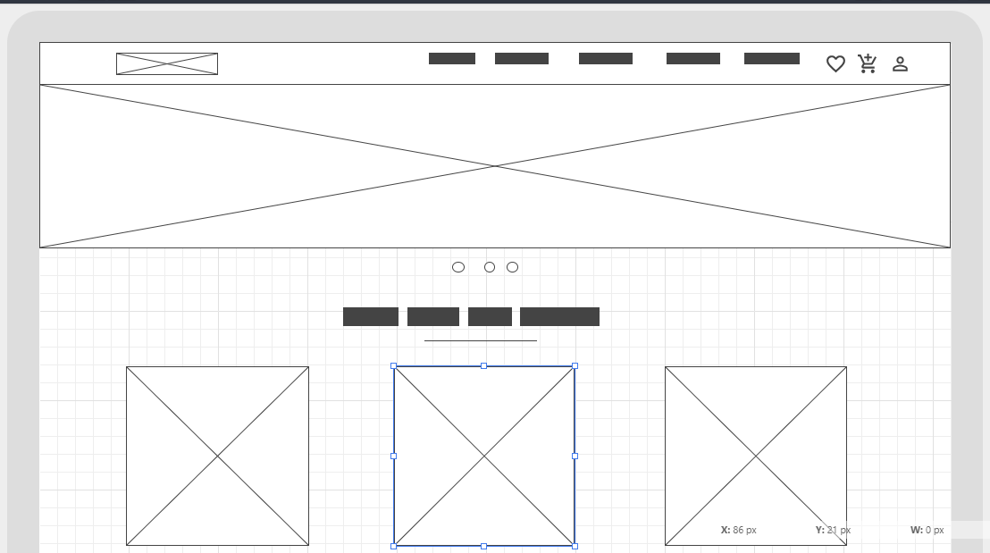

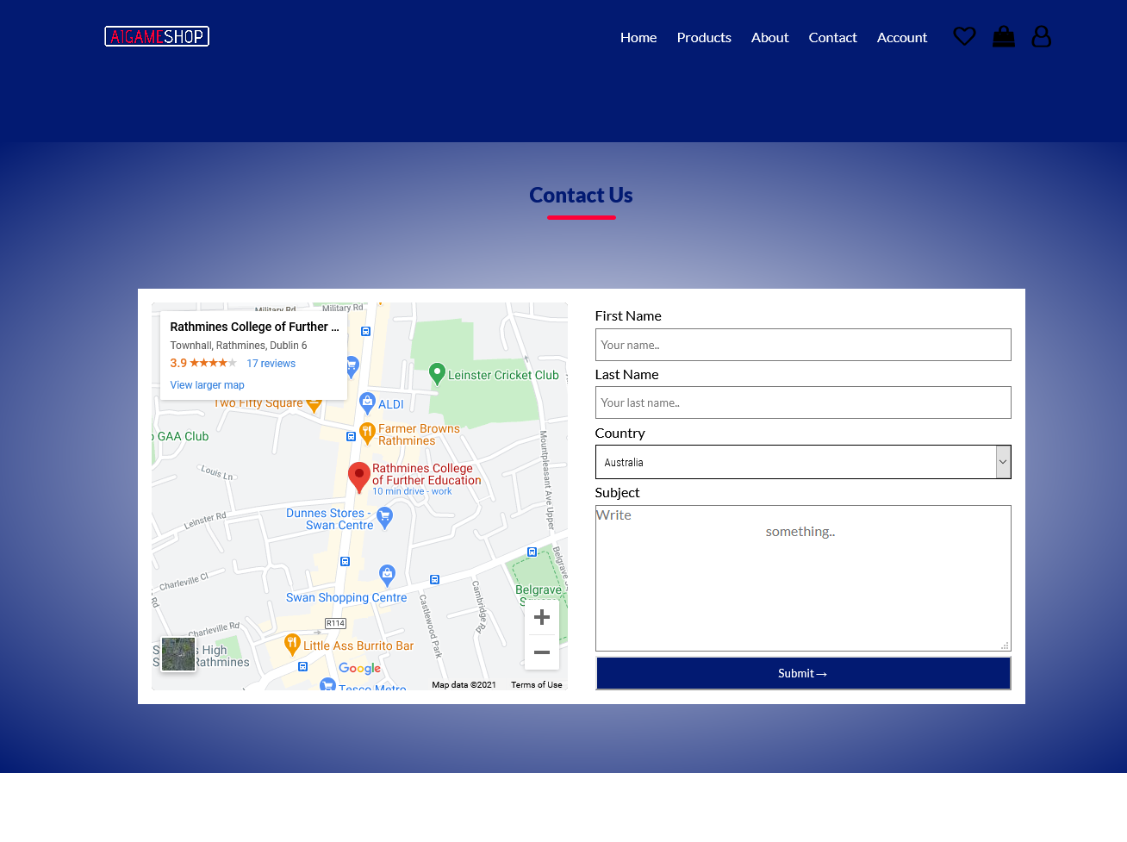

### Contact Page on Mozilla Firefox browser

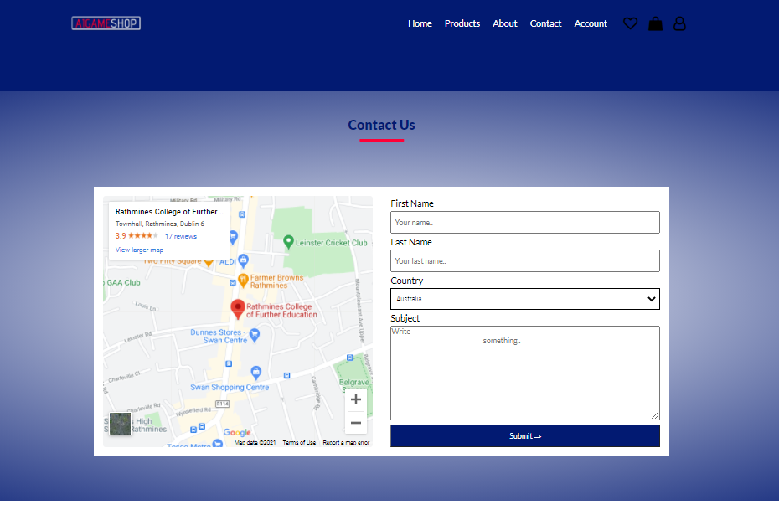

Contact Page on Google Chrome browser

### **TO SHOW HOW TWO DIVS SHARE A EQUAL SPACE IN ANOTHER**

### 

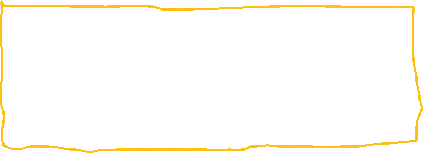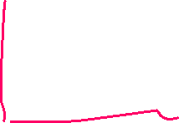

**HTML CODE:**

<div class="offer">

<div class="small_container">

<h2 class="title">Special Offers</h2>

<div class="row">

<div class="col-2">

<img src="./images/switch.png" alt="">

</div>

<div class="col-2">

<p>Exclusively Available on AI GameShop</p>

<h1>Nintendo Switch</h1>

<small>The Nintendo Switch is a video game console developed by Nintendo and released worldwide in most regions on March 3, 2017. The console itself is a tablet that can.</small>

<a href="#" class="btn">Buy Now &#8594</a>

</div>

</div>

</div>

</div>

### **CSS CODE**

### .offer {

### background: radial-gradient (#fff, #021a72); */* This gives the bluish background with a lighter centra area.*

### margin-top: 80px; *This gives the free space on top*

### padding: 30px 0; */* This give the room on top and bottom of the*

### }

### .col-2 offer img {

### padding: 50px;

### }

### .small {

### color: #021a72;

### }

### .btn:hover {

### background: #ff0037; *This gives the buttons it red color on hover.*

### letter-spacing: 10px; *this accounts for the elastic display of the menu item when hovered over*

### }

### IMAGE EXAMPLE: The image on the left-hand side of the screenshot above was designed by placing the image tag inside a col-2 container.



### The col-2 container has a flex-basis of 50% and min-width of 300px. It is sharing the row space co-equally with text area on the right hand side containing a paragraph tag, a h1 tag, a small tag and a button.

### These 4 elements are contained in the right-side container. The right-side container has a flex basis of 50%. This means that they are sharing half of the space contained in the row container.

### The row container is marked with a yellow line. The row container has a Display of flex, align-items of center and a flex-wrap of wrap.

The div container with a class of row is inside another div container with a class of small_container which is in turn inside another container with a class offer. The offer container serves as a section even though it has no section tag. This is because the offer container marks a major integral section of the index page of this website. The offer div has a styling of :

background: radial-gradient (#fff, #021a72); The radial gradient gives the section this beautiful bluish background with a center lighter area.

margin-top: 80px; The margin top 80px gives the larger space on top of the bluish section.

padding: 30px 0; The padding of 30px adds more area to the top and bottom sides of the offer container while the 0 padding means nothing was added to the left and the right side of the offer container.

### This how the part of the website in the screenshot above was created.

TO SHOW CENTERED LINKS, FONTAWESOME AND LETTER SPACING ON FOOTER LINKS

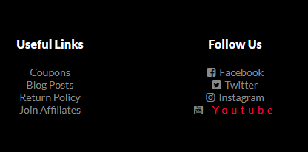

**HTML:**

<div class="footer-col-4">

<h3>Follow Us</h3> Follow us is bigger because it’s wrapped in h3 tag

<ul>

<li><i class="fa fa-facebook-square" aria-hidden="true"></i>

<a href="https://www.facebook.com/">Facebook</a></li>

<li><i class="fa fa-twitter-square" aria-hidden="true"></i><a href="https://www.twitter.com/">Twitter</a></li>

<li><i class="fa fa-instagram" aria-hidden="true"></i><a href="https://www.instagram.com/">Instagram</a></li>

<li><i class="fa fa-youtube-square" aria-hidden="true"></i><a href="https://www.youtube.com/"> Youtube</a></li>

</ul> *<!— The icons with class fa are the fontawesome icons you see before the links -->*

</div>

</div>

**CSS CODE:**

.footer-col-3 a, .footer-col-4 a {

text-decoration: none; */* This removes the underline from the anchor tag element*

color: #8a8a8a; */* This gives the greyish color of this list element*

list-style-type: none;

}

.footer-col-3, .footer-col-4 {

flex-basis: 12%; *This makes sure the links occupy only 12% of the*

text-align: center; *This aligns all the links to the center*

}

.footer-col-3 a:hover, .footer-col-4 a:hover {

color: #ff0037; This gives the red color on the lin Youtube when hovered

letter-spacing: 5px; */* This gives the stretched-out elasticity of Youtube above*

}

.footer-col-3 ul, .footer-col-4 ul {

list-style-type: none; */* This removes the bullet point points from the links*

}

### **TO SHOW WHY THIS IMAGES ARE CIRCULAR IN SHAPE**

|  |  |
| --- | --- |
|  |  |



**HTML CODE**

<div class="col-2">

<a href="http://localhost/shop/cart.html">

<img src="./images/8.jpg" width="100%" id="productImg" alt=""></a>

<div class="small-img-row">

<div class="small-img-col">

<img src="./images/7.jpg" class="small-img" alt="">

</div>

<div class="small-img-col">

<img src="./images/6.jpg" class="small-img" alt="">

</div>

<div class="small-img-col">

<img src="./images/5.jpg" class="small-img" alt="">

</div>

<div class="small-img-col">

<img src="./images/4.jpg" class="small-img" alt="">

</div>

</div>

</div>

**CSS CODE**

.col-4 img,

.col-3 img {

border-radius: 50%; */* This singular piece of codes make all product images on the website to have a circular shape*

text-align: center; around the images to be centered.

}

### **Multimedia Files**

**SOUND FILE**

**<!-- AUDIO -->**

**<div class="landing_audio" style="width: 350; margin: auto;">**

**<audio controls>**

**<source src="./sound/spaceship.ogg" type="audio/ogg">**

**</audio>**

**</div>**

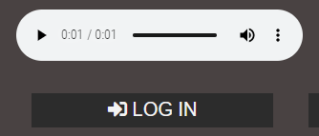

**VIDEO FILE**

**<p>**

**<iframe width="580" height="315" src="https://www.youtube.com/embed/U7dxzKa_s7U?start=18" frameborder="0" allow="accelerometer; autoplay; clipboard-write; encrypted-media; gyroscope; picture-in-picture" allowfullscreen></iframe>**

**</p>**

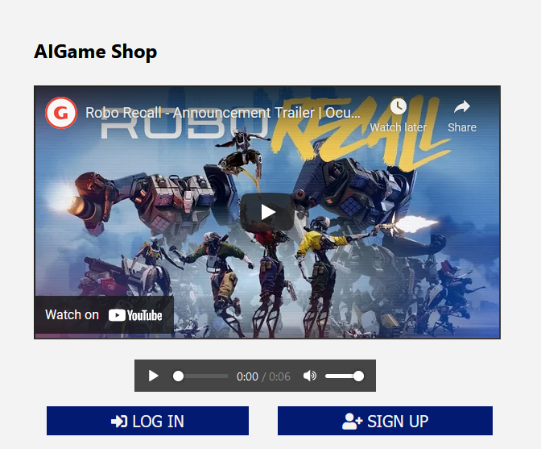

### **Symbols & Characters**

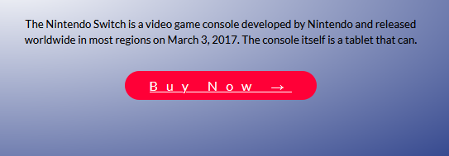

**CODE**

<a href="#" class="btn">Buy Now &#8594</a>

The arrow symbol in the button above was inserted using the cod &#8594

## **Scripting Elements in Web Authoring**

### **Javascript**

|  |  |
| --- | --- |
|  |  |
|  |  |

JAVASCRIPT HIT PAGE COUNTER

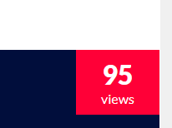

JAVASCRIP STATUS ALERT

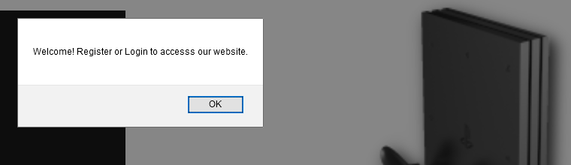

**JAVASCRIPT DARK AND LIGHT THEME**

|  |  |
| --- | --- |
|  |  |

**Web Production**

## **Navigation**

Navigation (LO31 + LO10) – 4 mark

TO SHOW HOW THE THE HEADER ELEMENTS GET THERE SYLING



**HTML CODE**

<!---------------MAIN-NAVIGATION--------------->

<div class="header">

<div class="container">

<div class="navbar">

<div class="logo">

<img src="./images/logo.png" width="125" alt=""> *<-- This piece of code gives the logo its with and Image*

</div>

<nav>

<ul id="MenuItems"> *These are the 4 menu items.*

<li><a href="http://localhost/shop/index.html#">Home</a></li>

<li><a href="http://localhost/shop/products.html">Products</a></li>

<li><a href="http://localhost/shop/contact.html">Contact</a></li>

<li><a href="http://localhost/shop/signup.html">Account</a></li>

</ul>

</nav>

<i class="fa fa-heart-o"></i> *This is fontawesome Icon for the Wish items on the main Navigation*

<i class="fa fa-shopping-bag"></i> *This is the fontawesome icon for the shopping bag*

<i class="fa fa-user-o"></i> *This is the fontawesome icon for the for the user on the main Navigation*

<img src="./images/menu.png" onclick="menutoggle()" class="menu_icon" alt="Menu Icon"> *This is the Responsive menu toggle icon only visible on mobile devices*

</div>

</div>

</div>

**CSS CODE**

.header {

background: #000; */* This is responsible for the black color of the header*

}

HEADER

*/

.navbar {

display: flex; */*This piece of code makes the items in the navbar to stretch in horizontal line*

align-items: center; */* This aligns the navbar items to the center*

padding: 10px; */*This gives a padding of 10px all round to the navbar items*

}

.menu_icon {

width: 40px; */* This gives a width of 40px to the responsive menu icon visible only on mobile devices*

margin-left: 20px; */* This gives it a margin of 20px*

}

nav {

flex: 1;

text-align: right; /* moves the menu items to the right of the header

}

nav ul {

display: inline-block; /* Set the links horizontally

list-style: none;

}

nav ul li {

display: inline-block;

margin-right: 20px; /* Gives a space of 20px on top, bottom,left and right of each menu item

}

nav ul li a {

text-decoration: none; /* Removes underline from menu items

color: #fff; /* Gives the color white to the menu items.

}

nav ul li a:hover {

letter-spacing: 2px; /* Responsible for the elastic behaviour of letter on hover.

color: #ff0037; /* Responsible for red color of menu items on hover

font-size: 16px; /* Gives the font size to the menu items.

.navbar .fa {

color: #fff; /* Responsible for the white color of the icons on the right of menu

font-weight: 100; /* Gives the icons its light weight.

margin: 10px; /* Gives the icons and all round margin of 10px

font-size: 20px; /* Gives the icons a font size of 20px

}

Layouts & Design (LO21 + LO32 + LO27) – 8 Marks

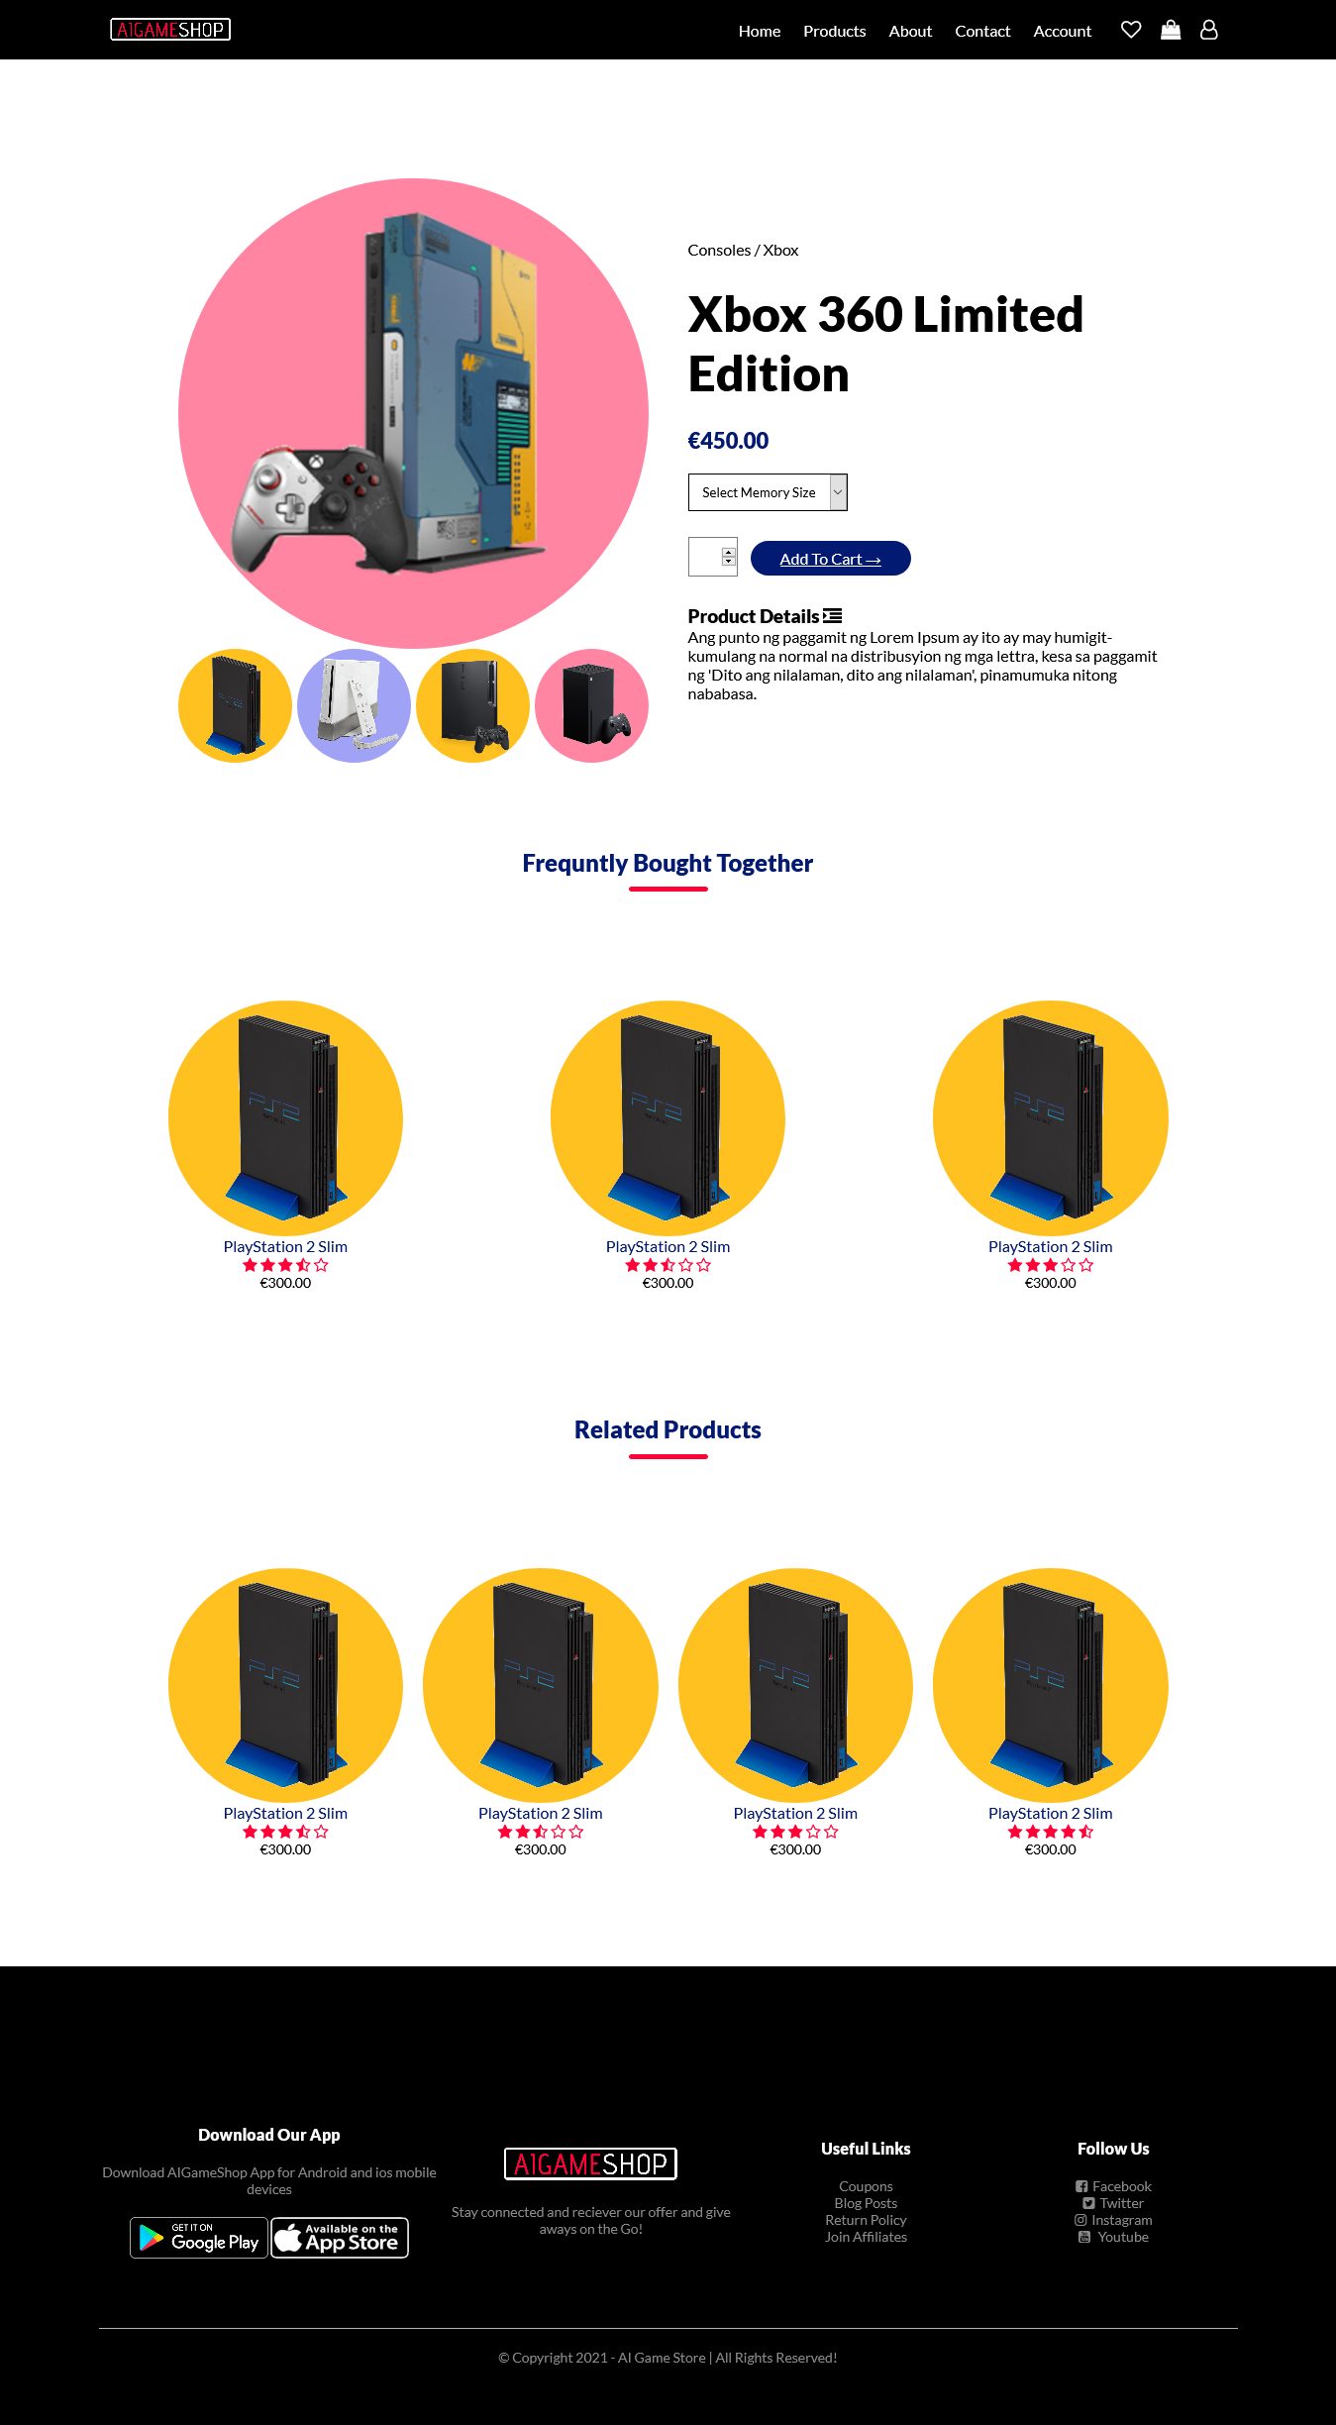

## **Layouts & Design**

### **SEO**

**NOTE all of the below is an example only!!!!!**

**Title and Meta tag changed on the homepage – see below**

<!-- This site is optimized with the Yoast SEO plugin v15.3 - https://yoast.com/wordpress/plugins/seo/ -->

<title>Home Page - Danielle Walsh Ronan Journalism Student</title>

<meta name="description" content="I am journalism student currently studying at Rathmines College in Dublin. I am currently looking for work in the media industry." />

**Title and metatag changed on the about page**

<!-- This site is optimized with the Yoast SEO plugin v15.3 - https://yoast.com/wordpress/plugins/seo/ -->

<title>About - Danielle Walsh Ronan</title>

## **Colour**

**Dark Blue**: **Symbolizes** integrity, knowledge, power, and seriousness. **Blue**: Peace, tranquility, cold, calm, stability, harmony, unity, trust, truth, confidence, conservatism, security, cleanliness, order, loyalty, sky, water, technology, depression, appetite suppressant. Turquoise **symbolizes** calm.

**Light red represents** joy, sexuality, passion, sensitivity, and love. Pink signifies romance, love, and friendship. It denotes feminine qualities and passiveness. Dark **red is** associated with vigor, willpower, rage, anger, leadership, courage, longing, malice, and wrath.

The Meanings of **Yellow**. **Yellow is** the most luminous of all the **colors** of the spectrum. It's the **color** that captures our attention more than any other **color**. ... It's the **color** of happiness, and optimism, of enlightenment and creativity, sunshine and spring.

## **Text / Fonts**

I choose a Serif Type font called Playfair for my main heading. Serif type fonts, in terms of psychology can convey reliability (Hunt, 2019). I choose this font because I want to be known as a reliable journalist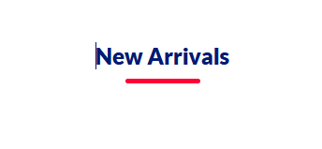

Lato font used on headings

font-family: 'Lato', sans-serif;

Lato

Certainly Lato is my most popular font. It doesn’t mean my other fonts are worse, but Lato is completely free. It's available everywhere now as a web font from many providers. Version 2.0 contains more than 3000 glyphs in 18 styles, everything you need to write whatever you want in latin, cyrillic, greek and IPA scripts. (Dziedzic, n.d.)

*I fall in love with lato font after noticing it’s uniqueness for the first time on Boohoo.com. Then I checked other Ecommerce sites and noticed they used Lato on their main menu. Lato is very beautiful on website navigation. I used it in this project because it always add beauty to design.*

*The screenshot of the heading above shows the beauty of Lato font.*

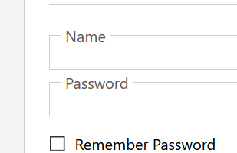

Poppins font used on Sign in form

font-family: "Poppins", "Segoe UI", Tahoma, Geneva, verdana, sans-serif;

**Poppins**

Geometric sans serif typefaces have been a popular design tool ever since these actors took to the world’s stage. Poppins is one of the new comers to this long tradition. With support for the Devanagari and Latin writing systems, it is an internationalist take on the genre. (Lianghai, 2014)

*Poppins font is a favorite font for me. Similar to the Century Gothic font used in this assignment, the poppins font is one of the most beautifuf fonts out there. I chose it because no matter what you are writing, the poppins font will make it look beautiful. It looks beautiful particularly in web-pages.*

## **Website Checking**

|  |
| --- |
| **Landing Page Validation Check** |

|  |
| --- |
| **SignUp Page Validation Check** |

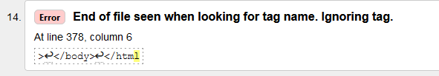

*This error was because the ending html tag closing angle bracket was missing in line 378.*

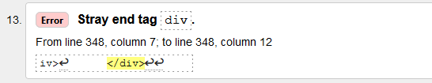

*This error means that there is an ending div tag on line 348 without a corresponding opening div tag*



*This error was because of a stray closing div tag in line 348*

# Bibliography

Lianghai, 2014. *https://fonts.google.com/specimen/Poppins?preview.text_type=custom#about.* [Online]   
Available at: https://fonts.google.com/specimen/Poppins?preview.text_type=custom#about  
[Accessed 16 March 2021].

# Bibliography

Dziedzic, L., 2010. *Lato.* [Online]   
Available at: https://fonts.google.com/specimen/Lato?preview.text_type=custom#about  
[Accessed 16 March 2021].