Impacts of Genetic Variation and Silvicultural Treatments on Loblolly Pine Water Use

By

Azura Liu

Dr. Sari Palmroth, Advisor

Dr. Christopher Maier, Advisor

8/26/2022

Masters project submitted in partial fulfillment of the requirements for the Master of Environmental Management degree in the Nicholas School of the Environment of  
Duke University

**Executive Summary**

Impacts of Genetic Variation and Silvicultural Treatments on Loblolly Pine Water Use

By

Azura Liu

[Date] [Month] 2022

Approved

_____________________________

(MP adviser signature here)

_____________________________

(MP adviser name printed)

___________________________

Date

Approved

_____________________________

(MP adviser signature here)

_____________________________

(MP adviser name printed)

___________________________

Date

Master’s Project submitted in partial fulfillment of the requirements for the Master of Environmental Management Degree in the Nicholas School of the Environment, Duke University May 2020

**Executive Summary**

Loblolly pine (*Pinus taeda,* or *P. taeda*) is of high ecological and economical value in the U.S. for its abundance and rapid growth. *P. taeda* has adapted to a wide range of sites, exhibiting considerable variation in its physiology and morphology. In efforts of understanding such variation, transpiration has become a major study focus for its integral role in tree growth and survival. Past studies have developed methods of quantifying tree transpiration and explored the relationships between transpiration and plastic traits observed in *P. taeda*. Understanding elements that affects transpiration provides an opportunity to explain and model *P. taeda* variation for better forest management.

Transpiration is strongly influenced by crown architecture and environmental variables. In plantations, crown phenotype is developed as a mixed realization of individual crown ideotype and silviculture treatments. Vapor pressure deficit (VPD) determines the strength of the force pulling water into the air while relative extractable water (REW) indicates water available for plants to supply transpiration. Transpiration can be paused temporarily or permanently during drought conditions. This Master’s Project (MP) assessed the variation in *P. taeda* water use concerning genetic variation in crown ideotypes, planting densities, VPD, and REW. With the overall objective of examining variation in *P. taeda* transpiration, three sub questions are explored in this study:

1. Does transpiration differ with genotype and planting density?
2. Does the response of transpiration to VPD vary across genotype and density?
3. Does the response of transpiration to VPD change with seasonal changes in REW?

This study examined sapflux data from an established experiment where four crown ideotypes were planted at 250 trees per acre (TPA) and 750 TPA with four replications. Transpiration responses across eight treatment combinations were compared 1) directly using the analysis of variance (ANOVA), 2) with VPD as a continuous covariate using the analysis of covariance (ANCOVA), 3) with VPD as a continuous covariate and REW as a discrete covariate using ANCOVA.

[Key findings]

[Extension and outlook]

**Table of Contents**

**Introduction 6**

**Material and Methods**

**Results**

**Discussion**

**Conclusion**

**References**

**1 Introduction**

As the most common softwood species in the U.S. and the most commercially important timber species in the South (Brender, Belanger, & Malac, 1981), *P. taeda* contributes over 2 billion tons of annual above-ground biomass (Oswalt et al., 2019) and supports the timber industry generously. Having established through an extensive range of site conditions, the species demonstrates unforeseen elasticity that raises research interests (Samuelson et al., 2013; Shimizu & Sebbenn, 2008). Transpiration has been studied extensively as a quantitative measure evaluating demonstrated traits, with heavy research focuses on growth and productivity (Curtis et al., 2002; Ma et al., 2007; Reichstein et al., 2007; Valentini et al., 2000).

Water moves passively from soil into the atmosphere through tree root, xylem, and shoots, carrying necessary nutrients and supports photosynthesis (Sinha, 2004). Transpiration is defined as the amount of water used in this process (Hanrahan, 2011). Plant transpiration is an integrate part of local and global carbon and hydrological cycle (Jasechko et al., 2013).

Transpiration responds to both biotic and abiotic factors including individual tree crown architecture, planting density, water content in the air, and water availability. Transpiration changes with tree characteristics as the conductance of water flow varies with each tree’s morphology and physiology (Kimball, 2007). Crown architecture, or ideotype, is restricted to consistent morphological expressions such as crown size, density, branching patterns, and angle of leaves relative to each other. (Dickmann, 1985; Martin, Johnsen, & White, 2001). Crown ideotype largely defines leaf area, an important measure of plant growth and productivity as it determines light interception and transpiration (Vose & Allen, 1988; Wright et al., 2004). Although it is innate with a tree’s genetic entry, crown traits can be influenced by environmental factors (Carbaugh, 2015).

Spacing is a common silvicultural practice to meet various management objectives. Spacing regimes affect transpiration by manipulating the interactions between trees. High planting density promotes competition and reduces individual tree sizes (Carlson et al., 2009; Harms, Whitesell, & DeBell, 2000), thus encourages narrow crown development—vice versa for low planting density. Past study has proven that low planting density of *P. taeda* yields greater diameter branches and stem, foliage and branch biomass, leaf area and canopy density, longer-lived crown, lower height to live crown and lower foliage to branch mass ratio comparing to high planting density (Albaugh et al., 2019; Akers et al., 2012).

Because water movement follows a high to low water potential gradient, moving from wet to dry locations, the water potential between shoots and roots becomes the primary driving force of water movements in trees (Freeman, 2014). Strongly and positively related to transpiration, VPD measures ambient air water potential as the difference in water content between ambient air and fully saturated air (Lawrence, 2005). REW is converted from total soil water content that only represents the water available for plants (Granier et al., 1999). VPD and soil moisture together decide the action, rate, and suspension of transpiration by modifying the water potential gradient along the soil-plant-atmosphere continuum. Permanent cavitation of water-transporting xylems can occur when extreme water potential difference breaks the water continuum, resulting in declining water conductance that restricts tree growth and maintenance (Zhang et al., 2016). To avoid xylem cavitation, plants can cope with restricted water supply by closing their stomata to stop transpiring, at the same time pausing photosynthesis (Agurla et al., 2018). Thus, transpiration can behave drastically different with periodic variation in water availability.

Transpiration can be either estimated or directly measured. Gauged watershed method simply subtracts runoff from precipitation to generate transpiration (Hasenmueller & Criss, 2013,); energy balance methods such as the Penman-Monteith Equation considers transpiration as component of an integrated mass-transfer system and estimates transpiration from stomatal conductance (Monteith & Unsworth, 1990); the Eddy covariance and flux gradient method calculates flux by computing the covariance between fluctuations in vertical wind velocity and fluctuations of transferred properties such as heat and moisture (Lee & Law, 2004); there are also various hydrological models for estimating transpiration (Vose & Swank, 1992). On the other hand, direct measurements of individual tree sap flow provide the basis for above methods and generates most reliable results (Vose et al., 2003). Granier (1985) proposed sap flux density as a function thermal conductivity. A thermal sensor with two probes, one electrically heated at upper position and one at ambient temperature at lower position, is inserted into the sapwood of a tree trunk where water transportation occurs (Liu, Urban & Zhao, 2004). The heat dissipated by the upper probe is cooled by water movement within the stem. The temperature differences between the upper and lower probes can therefore be transformed into sap flux density (Fd, g H2O/m-2/s-1), or how quickly water is passing through xylem using the empirical function Fd = 119 *k^1.231, where k is the flow index calculated from the temperature differential between heated and non-heated probes. The point measurements can be scaled up to tree-level and stand-level transpiration using corresponding sapwood area.

**1.1 Goals & Objectives**

This Master’s Project (MP) exists as part of a larger project collaborated between United States Forest Service (USFS), North Carolina State University, Virginia Tech, and Federal University of Santa Catarina, Brazil. The larger study is a long-term silviculture (three planting densities), site (North Carolina Coastal Plain, Virginia Piedmont, and Brazil), and genetic (six genotypes) experiment in efforts to comprehend *P. taeda* physiology. This Master Project focuses on the Virginia site intending to assess the variation in *P. taeda* water use with the overarching goal of better understanding of *P. taeda* transpiration.

To understand how *P. taeda* transpiration is affected by crown architecture and planting density, accounting for variation in VPD and REW, the following hypotheses were developed:

1. Transpiration varies with genotype and planting density.
   1. Under low planting density, transpiration increases as crown ideotypes become broader.
   2. Under high planting density, transpiration increases as crown ideotypes become narrower.
2. Transpiration responds to VPD differently with genotype and planting density.
   1. Under low planting density, transpiration increases more rapidly with each unit of increase in VPD as crown ideotypes become broader.
   2. Under high planting density, transpiration increases more rapidly with each unit of increase in VPD as crown ideotypes become narrower.
3. The responses to VPD vary with REW seasonality between genotypes and planting densities.
   1. Under low planting densities, the sensitivity to soil moisture increases as crown ideotypes become narrower.
   2. Under high planting densities, the sensitivity to soil moisture increases as crown ideotypes become broader.

**2 Material and Methods**

**2.1 Study Area**

Three experimental sites were established in the larger study, including one in the Piedmont (Reynolds Homestead Center, Critz, Virginia, northern edge of *P. taeda* range), one located on the coastal plain (Bladen lakes, NC, a typical *P. taeda* site), and one far away from *P. taeda* range (Paraná, Brazil). The data analyzed in this MP solely came from the Piedmont site in Virginia. Although slightly outside of the northern range of P. taeda, the species has established successfully in the Piedmont.

**2.2 Data Source & Experiment Setup**

The experiment was designed as a block plot with a split-split plot design replicated four times (four blocks). Silviculture is the main plot treatment and spacing and genetic entry are the split plots treatments (Albaugh et al., 2018). Silviculture treatment includes two densities of planting: high density at 750 trees TPA and low density at 250 TPA. Each high density plot measures a total of 404.43 m^2 (18.3 * 22.1 m) and each low density plot measures 134.505 m^2 (18.3 * 7.35 m).

Within each block contains eight plots of different treatment combination (one clone planted at one density). The experiment of the measured block was divided into four systems and was set up as the chart below:

**Table X**. Experimental Setup



Where according to Carbaugh (2015), OP stands for an open-pollinated family and C refers to clones. C3 is considered narrow crown genotype whereas C2 and C4 are considered broad crown genotypes. The narrow crown genotype possesses smaller branch diameter, branch length, and crown volume than the broad crown genotypes. Within the broad crown genotypes, C4 has a slightly larger crown volume than C2. The OP family shares similar branch characteristics to the broad crowned clones with a crown volume in between of broad and narrow crowned clones. Seedlings were planted in 2009.

Sapflux was measured using Granier ‘s thermal probe at stand age 8-9 (2016-2017) for block ?. Briefly, within each treatment plot, eight trees were selected for sapflux measurement. Each tree had a pair of sapflux probes inserted from 0-20 mm (shallow) on the north and south side of the tree. Two of the trees in each plot had an additional probe inserted from 20-40mm (deep). Sapflux was measured every 30 seconds and then averaged over a 15-minute time step.

Tree diameter (cm) was measured for all trees at the beginning and the end of each experimental year.

Volumetric soil moisture (% water per volume soil) was available for block ? for each treatment plot. Additional data related to the weather parameters were obtained from on-site weather station.

For the purpose of this study, the dataset was restricted to growing season (Day 152-173, June-September of 2017) when trees are most active (Lyu et al., 2020).

**2.3 Data Analysis**

The analysis had assigned treatment groups where H and L represents high (750 TPA) and low planting density (250 TPA), and A, B, C, O represents genotype C2, C3, C4, and OP, respectively.

**Data Cleaning**

The 15-minute-interval raw k-values generated from thermal probes were transformed into sap flux density using Granier’s Equation (Fd = 119 *k^1.231). Data was visually presented and checked for erroneous and interesting patterns.

**Gap-filling**

The smallest gaps (<5 entries) in the raw data were interpolated. Relatively small gaps (<48 entries, or half day) of individual probes were filled in with simple linear regression between probes for each 15-minute entry. Gaps larger than 48 entries were gap-filled after calculating daily sums using simple linear regression between probes for each daily sum.

**Sapwood Area**

Daily tree diameters were calculated using the set of equations as:

dbhrel = 1 / (1+(b0*(exp(-b1*DOY))))

DBH = ((DBH1-DBH0)*dbhrel)+DBH0

Where: b0=61.3445, b1=0.0235; dbhrel is an explanatory variable standing for a tree’s relative size (Vastaranta et al., 2011); DOY stands for day of year; DBH is the DBH at any given time; DBH0 and DBH1 stand for DBHs at different time points. The calculated diurnal tree diameters were then transformed into sectioned sapwood area corresponding to probe depths: outer 20mm, 20mm-40mm, and >40mm areas. The total sapwood area of each treatment was calculated.

**Sapflow**

In sapflow calculation, sapflux measurements were multiplied by sapwood area, where the outer probes measure the outer 20mm of sapwood and the inner probe measures the inner 20-40mm. When sapwood depth exceeds 40mm, sapflux of the inner most sapwood area was considered half of the 20-40mm area sapflux.

The transformed sapflux (g H2O/m-2/s-1) of individual data points was scaled up temporally and spatially as sapflow values (L or kg H2O). The 15-minute entries were summed up for each tree across daytime when Photosynthetic Active Radiation (PAR) is above zero, as transpiration is active mostly during daytime. They were also scaled up to stand level transpiration using plot-specific sapwood area, then divided by plot size to generate sapflow per ground area (L/m^3).

**REW**

Volumetric soil moisture was transferred into REW to achieve normalization. REW was calculated as the ratio of the difference between each soil moisture entry and minimum soil moisture during our time of interest, and the difference between maximum soil moisture and minimum soil moisture ((soil moisture-minimum soil moisture)/(maximum soil moisture – minimum soil moisture), Ritchie, 1981).

**Seasonality**

REW was averaged across densities to address density and soil moisture interactions. The REWs of the two planting densities behaved differently during different periods of time. The dataset was broken down into “drying periods” and “wet periods” based on averaged REW behavior. Day 205-223, 231-244, 260-273 were considered drying periods during which the REW was low, and the REW of high density treatment groups changed more drastically than low density treatment groups; day 152-205, 224-230, 245-259 were considered wet periods where REWs of the two densities behaved similarly.

**Figure 1**. Diurnal REW averaged by density during growing season. DOY: Date of year

**Statistical Analysis**

Three linear models were developed to test my three objectives respectively. Whether transpiration vary with genotypes and planting densities or not was tested using a two-way analysis of variance (ANOVA). An analysis of covariance (ANCOVA) was used to assess the relationship between transpiration and VPD under different genotypes and planting densities; VPD was treated as a continuous covariate. ANCOVAs were used again to test the relationship between transpiration and VPD among treatment groups for the entire growing season and for different periods broken down by REW seasonality. REW was treated as a categorical covariate where REW values below 0.4 were categorized as dry soil condition, values between 0.4-0.6 as intermediate soil condition, and values above 0.6 as wet soil condition. The significance level of P<0.05 was used to determine significant effects. All models consider time (Date of the Year) and Block as random effects. All data analysis were performed in Microsoft Excel and RStudio (4.1.3).

**3 Results**

**3.1 Growth**

Low density planting resulted in greater sapwood area increment than high density planting across all genotypes (Table X). In the order of greatest sapwood area increment to the least sapwood area increment, the genotypes were ranked as C, O, B, A under high planting and ranked C, O, A, B under low planting density (Figure X).

**Table X**. Summary of plot level sapwood area.



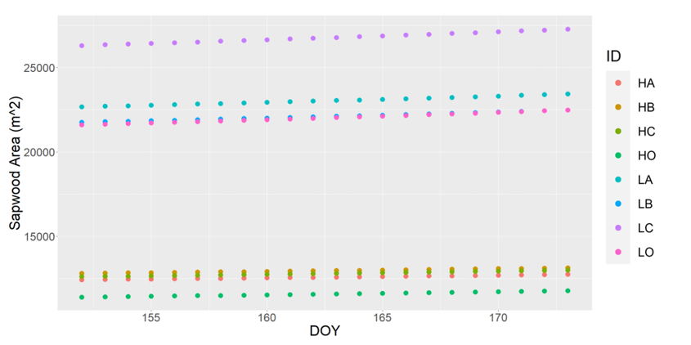

**Figure X**. Sapwood area increment during growing season.

**Figure X**. Sapwood area increment during 2017.

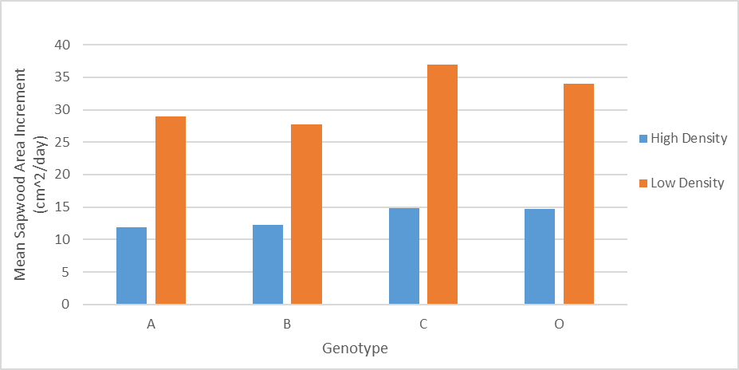

**Figure X**. Average daily sapwood area increment during growing season.

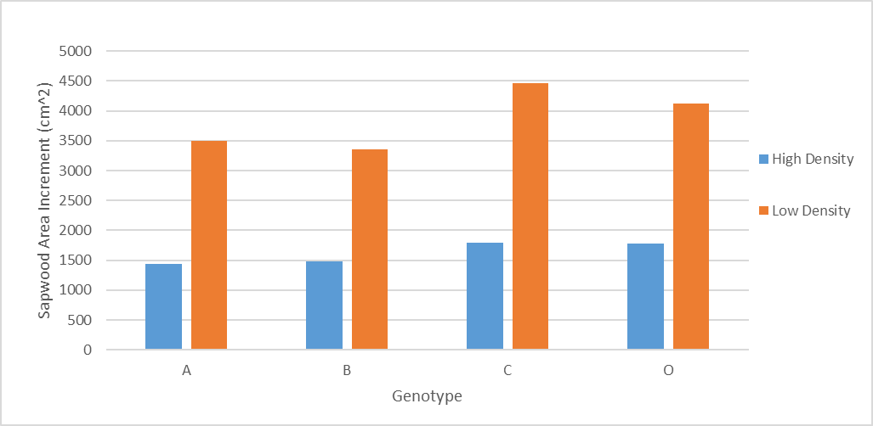

**Figure X**. Total sapwood area increment during growing season.

**3.2 Effect of Genotypes and Planting Densities on *P. taeda* Transpiration**

The two-way ANOVA returned significant P values for density (F = 991.71), genotype (F = 58.11), and their interactions (F = 99.57). Low density planting resulted in an average of 0.75 L decrease in daily sapflow per ground area comparing to high density planting. With density, genotype, and their interactions explaining 19%, 3%, and 6% of the variation respectively, the model explained 28% of total variation in *P. taeda* transpiration.

**Figure X**. Variation of transpiration across genotypes and densities.

**3.3 Transpiration Responses to VPD**

The ANCOVA returned P values below the significance level of 0.5 for density (F = 1486.85), genotype (F = 87.13), their interaction (F = 149.28), and VPD (F = 1946.22). The increase in each kPa of VPD resulted in an average increase of 1.28 L daily sapflow per ground area. The model explained 52% of the variation in sapflow responses with VPD contributing an additional 24% variation explained.

**Figure X**. Variation of transpiration responses to VPD by treatment.

**3.4 Variation in Transpiration Response to VPD with Different Levels of Soil Moisture between Genotypes and Planting Densities**

ANCOVA for the entire study period returned significant P values for density (F = 1791.4), genotype (F = 105), interaction between density and genotype (F = 200.2), VPD (F = 2344.9), REW (F = 197.7), and the interaction between VPD and REW (F = 172.8). With each unit increase in VPD, sapflow per ground area increased by 1.17 L/day. with each increasing level of REW, daily sapflow per ground area decreased by 0.50 L on average. Sapflow per ground area under dry soil condition was significantly higher than wet soil condition by 0.36 L/day. The interactions between REW and VPD produced distinctly different daily sapflow per ground area for dry, intermediate, and soil moisture levels (Figure X).

The model explained 60% of the total variation with REW explaining additional

4% of variation and the interactions between VPD and REW explaining additional 4%. The percentages of variation explained were subjected to rounding.

**Figure X**. Sapflow per ground area mean differences by soil moisture level.

During the drying periods, REW ranged from 0.9%-47% with the mean being 14.7%; REW ranged from 9%-96% with the mean being 46% for wet periods. Wet soil condition was not presented during the drying period. REW, VPD, and their interactions were only significant during the wet periods (Table X). During the drying periods, per unit increase in VPD resulted in 0.98 L addition to daily sapflow per ground area; during the wet periods, per unit increase in VPD resulted in 1.70 L addition to daily sapflow per ground area. All genotype displayed more significant variation during drying periods (Figure X/Table X).

**Table X**. Statistical summary for ANCOVAs of drying and wet periods



**Figure X**. Comparison of *P. taeda* transpiration between drying and wet periods.

**Table X**. Summary of daily mean plot level sapflow per ground area between drying and wet periods



**4 Discussion and Conclusion**

With genotype C2, OP, C4 having similar crown characteristics representing broad crown type, C4 had the broadest crown while C3 had the narrowest crown. Across densities, C4 achieved the greatest sapwood area increment under both density treatments, the lowest sapflow per ground area under high planting density but greatest sapflow per ground area under low planting density, the most drastic response to VPD under low density treatment, the highest sensitivity to REW when planted in high density, and the lowest sensitivity to REW under low planting density. C2 had the smallest sapwood area increment. OP was the least sensitive to VPD under low density planting, the least sensitive to REW under high density planting but the most sensitive to REW under low density planting. C3 had the lowest sapwood increment under low planting density, largest sapflow per ground area under high planting density but lowest sapflow per ground area under low planting density, and the most drastic response to VPD under high density treatment.

-state conclusions regarding hypotheses

**Table X**. Genetic entry comparison. Genotypes were ranked from the highest value to the lowest under each category.



**4.1 Density and genotype**

The interactions between genotypes and densities had a significant impact on transpiration, as the within-genotype differences in transpiration between high and low densities varied across genotypes (Figure X. Variation of transpiration across genotypes and densities).

-low density usually create higher productivity but requires large land, but not always the case.

-genetic manipulation has realized increased productivity.

-clone uniformity vs op variation in forest management practice.

**4.2 VPD**

When VPD increased, genotype C2, C3, and OP transpirations increased more rapidly under high density than low density; within each genotype, the differences in rate of change between densities ranked C2, OP, and C3 from the greatest to the smallest.

For genotype C4, low density treatment group transpired more rapidly with increasing VPD than high density group.

-response to vpd needs to be considered according to site settings.

**4.3 REW**

Under all conditions, transpiration was higher under high density planting except for genotype C where transpiration of high density treatment was lower than that of low density treatment during drying periods (Figure X.). In genotype C2, C3, C4, low density planting exhibited more stable transpiration than high density planting regardless of REW seasonality (Figure X.). Genotype O was inconsistent with other genotypes where it transpired more stably while planted in high density than planted in low density. Genotype O did not contribute to variation in transpiration during the wet periods (P = 0.6), but it became a significant term during the wet periods (P = 2.76E-08).

-climate change & drought & genotype vulnerability/resistance to drought

Drought is the primary factor contributing to reduced productivity and increased mortality (Allen et al., 2010). Zhao and Running (2009) estimated a drought-induced reduction of 0.55 petagram carbon in global net primary productivity from 2000 to 2009.

[Conclusion paragraph]

*P. taeda* exhibits large within-species variation and high responsiveness to silviculture treatments, indicating possibilities of manipulating *P. taeda* for desired traits.

**References**

Agurla, S., Gahir, S., Munemasa, S., Murata, Y., & Raghavendra, A. S. (2018). Mechanism of Stomatal Closure in Plants Exposed to Drought and Cold Stress. *Advances in experimental medicine and biology, 1081*, 215–232. https://doi.org/10.1007/978-981-13-1244-1_12

Akers, M., Kane, M., Teskey, R., Daniels, R., Zhao, D., & Subedi, S. (2012). The effects of planting density and cultural intensity on loblolly pine crown characteristics at age twelve. In *Biennial Southern Silvicultural Research Conference* (p. 1).

Albaugh, T. J., Maier, C. A., Campoe, O. C., Yáñez, M. A., Carbaugh, E. D., Carter, D. R., ... & Fox, T. R. (2020). Crown architecture, crown leaf area distribution, and individual tree growth efficiency vary across site, genetic entry, and planting density. *Trees*, *34*(1), 73-88.

Allen, C. D., Macalady, A. K., Chenchouni, H., Bachelet, D., McDowell, N., Vennetier, M., ... & Cobb, N. (2010). A global overview of drought and heat-induced tree mortality reveals emerging climate change risks for forests. *Forest ecology and management*, *259*(4), 660-684.

Carlson, C. A., Fox, T. R., Creighton, J., Dougherty, P. M., & Johnson, J. R. (2009). Nine-year growth responses to planting density manipulation and repeated early fertilization in a loblolly pine stand in the Virginia Piedmont. *Southern Journal of Applied Forestry*, *33*(3), 109-114.

de Oliveira, R. K., Higa, A. R., Silva, L. D., Silva, I. C., & Gonçalves, M. D. P. M. (2018). Emergy-based sustainability assessment of a loblolly pine (Pinus taeda) production system in southern Brazil. *Ecological Indicators*, *93*, 481-489.

Dickmann, D. I. (1985). The ideotype concept applied to forest trees. *Attributes of trees as crop plants*, 89-101.

Freeman, S. (2014). *Biological science*. United States of America: Pearson. pp. 765–766. ISBN 978-0-321-74367-1.

Granier A, Bréda N, Biron P, Villette S (1999) A lumped water balance model to evaluate duration and intensity of drought constraints in forest stands. Ecol Model 116:269–283. https://doi.org/10.1016/ S0304-3800(98)00205-1

Granier, A. (1985). Une nouvelle méthode pour la mesure du flux de sève brute dans le tronc des arbres. In *Annales des Sciences forestières* (Vol. 42, No. 2, pp. 193-200). EDP Sciences.

Hanrahan, G. (2011). *Key concepts in environmental chemistry*. Academic Press.

Hasenmueller, E. A. , & Criss, R. E. (2013). Water Balance Estimates of Evapotranspiration Rates in Areas with Varying Land Use. In (Ed.), Evapotranspiration - An Overview. IntechOpen. https://doi.org/10.5772/52811

Hubbard, R. M., Hakemada, R., & Ferraz, S. (2015, December). Effects of Planting Density on Transpiration, Stem Flow and Interception for Two Clones Differing in Drought Tolerance in a High Productivity Eucalyptus Plantation in Brazil. In *AGU Fall Meeting Abstracts* (Vol. 2015, pp. H11G-1430).

Jasechko, S., Sharp, Z. D., Gibson, J. J., Birks, S. J., Yi, Y., & Fawcett, P. J. (2013). Terrestrial water fluxes dominated by transpiration. *Nature*, *496*(7445), 347-350.

Lawrence, M. G. (2005). The relationship between relative humidity and the dewpoint temperature in moist air: A simple conversion and applications. *Bulletin of the American Meteorological Society*, *86*(2), 225-234.

Lee, X., Massman, W., & Law, B. (Eds.). (2004). *Handbook of micrometeorology: a guide for surface flux measurement and analysis* (Vol. 29). Springer Science & Business Media.

Lu, P., Urban, L., & Zhao, P. (2004). Granier's thermal dissipation probe (TDP) method for measuring sap flow in trees: theory and practice*. ACTA BOTANICA SINICA-ENGLISH EDITION-, 46*(6), 631-646.

Lyu, J., He, QY., Yang, J. *et al.* Sap flow characteristics in growing and non-growing seasons in three tree species in the semiarid Loess Plateau region of China. *Trees* **34**, 943–955 (2020). https://doi.org/10.1007/s00468-020-01972-1

Martin, T. A., Johnsen, K. H., & White, T. L. (2001). Ideotype development in southern pines: rationale and strategies for overcoming scale-related obstacles. *Forest Science*, *47*(1), 21-28.

Monteith, J., & Unsworth, M. (2013). *Principles of environmental physics: plants, animals, and the atmosphere*. Academic Press.

Ritchie, J. T. (1981). SOIL WATER AVAILABILITY. *Plant and Soil*, *58*(1/3), 327–338. http://www.jstor.org/stable/42933793

Sinha, R. K. (2004). *Modern Plant Physiology*. Alpha science international Ltd.

Souza, B. M., de Aguiar, A. V., Dambrat, H. M., Galucha, S. C., Tambarussi, E. V., da Silva Sestrem, M. S. C., ... & Longui, E. L. (2022). Effects of previous land use on genotype-by-environment interactions in two loblolly pine progeny tests. *Forest Ecology and Management*, *503*, 119762.

Vose, J. M., & Allen, H. L. (1988). Leaf area, stemwood growth, and nutrition relationships in loblolly pine. *Forest science*, *34*(3), 547-563.

Vose, J. M., Harvey, G. J., Elliott, K. J., & Clinton, B. D. (2003). Measuring and modeling tree and stand level transpiration. *Phytoremediation: transformation and control of contaminants*, 263-282.

Wright, I. J., Reich, P. B., Westoby, M., Ackerly, D. D., Baruch, Z., Bongers, F., ... & Villar, R. (2004). The worldwide leaf economics spectrum. *Nature*, *428*(6985), 821-827.

Zhang, Y. J., Rockwell, F. E., Graham, A. C., Alexander, T., & Holbrook, N. M. (2016). Reversible leaf xylem collapse: a potential “circuit breaker” against cavitation. *Plant Physiology*, *172*(4), 2261-2274.