**This website is part of our continuous assessment for Web Development & Deployment 2 module.**

**Authors:**

Jelo Salomon C14429822

Dylan Butler x

**Description:** Sticky Notes Website !

This website will allow users to create their very own sticky notes profile! Users creates a profile which allows them to create their own web page and create sticky notes on their wall. Users can also see other user’s sticky notes profile using the search mechanism.

The system will prompt the user to register a username and a password, this information will be stored inside a database. Users can use this registered information to create and delete their own sticky notes. The system will prompt users to create a sticky note or delete a stickynote.

If users create a sticky note this information will be stored inside a MySQL database. If users delete their own sticky note this information will be deleted from the database.

Users can also log out of their profile.

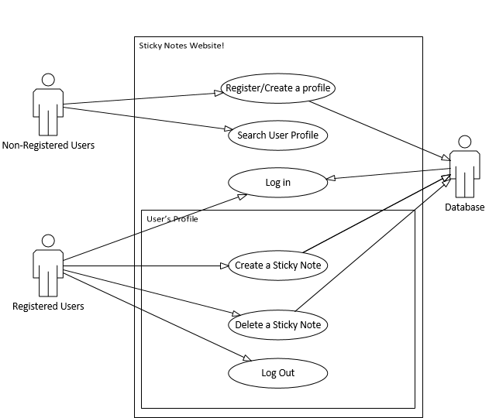

**Main Flow of Use Case 1:** Register/Create a Profile

**1.1:** System brings user to landing page to Log in /Create a Profile/ Search profiles

**1.2:** System asks the user to input in their register details: Name, E-mail, Password.

**1.3:** System stores the Name, E-mail and Password into the database to create a profile for the user.

**1.4:** System tells the user that their profile has been successfully created.

**Main Flow of Use Case 2:** Search User Profiles

**2.1:** System brings user to landing page to Log in /Create a Profile/ Search profiles

**2.2:** System takes user input and searches for profiles using Name.

**2.3:** System renders user’s sticky notes – no permission to create or delete.

**Main Flow of Use Case 3:** Log in

**3.1:** System brings user to landing page to Log in /Create a Profile/ Search profiles

**3.2:** System asks user to Name and Password.

**3.3:** System checks if the user is valid.

**3.4:** System brings user to their profile with privileges to create and delete.

**Main Flow of Use Case 4:** Create a Sticky Note

**4.1:** System brings user to their profile.

**4.2:** User clicks on “Add Sticky Note”

**4.3:** System creates sticky note overlay where user puts information into the sticky note.

**4.4**: System puts the information into the database.

**4.5:** System renders the sticky notes associated to user’s profile

**Main Flow of Use Case 5:** Delete a Sticky Note

**5.1:** System brings user to their profile.

**5.2:** User clicks on “Delete this Sticky Note”

**5.3:** System prompts user “Are You Sure?”

**5.4:** System deletes information from database.

**5.5:** System renders the sticky notes associated to user’s profile

**Main Flow of Use Case 6:** Log Out

**6.1:** System brings user to their profile.

**6.2:** User clicks on “Log out Button”

**6.3:**  System prompts user “Are you sure?”

**6.4:** System brings user to landing page.

**Analysis Class for Sticky Notes Web Site**

For Un-Registered user’s the system will render the landing page where the unregistered user can search for profiles, log in and register. Users who have already logged in will be rendered a profile page where the system renders their sticky from the can create a sticky, delete a sticky and log out.

The database will allow all these features to be implemented. By storing user’s login information when they register, store the sticky information when they are created by the registered user, delete the sticky notes info when user wants it to be deleted, check if the user is valid when the user logs in and sends information to the user’s profile so that the sticky notes will be rendered.

