# Azure Data Factory Data Flow Transformations

## Surrogate Key Transformation

Use the Surrogate Key Transformation to add an incrementing non-business arbitrary key value to your data flow rowset. This is useful when designing dimension tables in a star schema analytical data model where each member in your dimension tables needs to have a unique key that is a non-business key, part of the Kimball DW methodology.

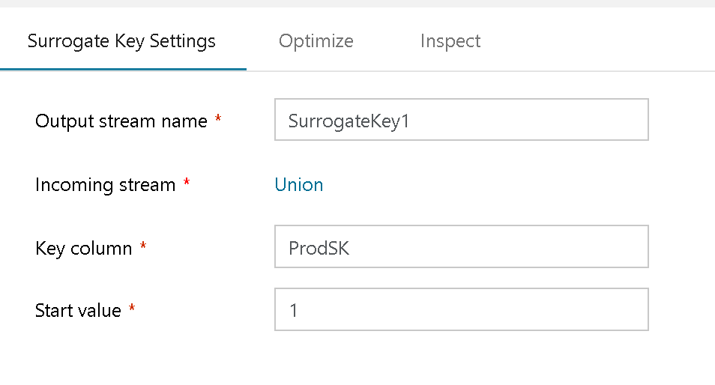

Surrogate Key Transform

“Key Column” is the name that you will give to your new surrogate key column.

“Start Value” is the beginning point of the incremental value.