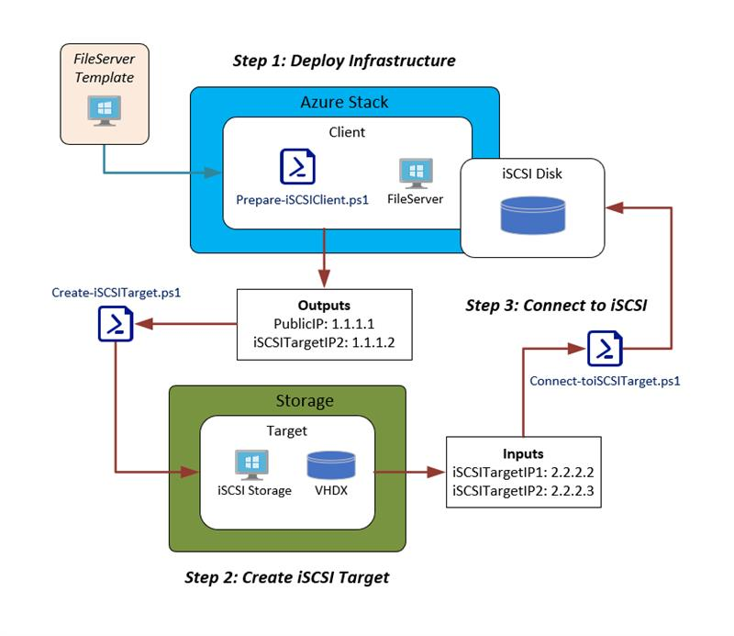

**Deploying the Template:**

1. Go To <https://github.com/lucidqdreams/azure-intelligent-edge-patterns/tree/master/storage-iSCSI> and click download then Download ZIP to download the template and dsc files an save to the machine you will perform the install from.
2. Extract Files from downloaded .zip.
3. Open a browser to the Azure Stack Portal Site ( <https://portal.xxx.xxx.xx.xx>). Then login with an that access to your Azure Stack subscription.
4. Click on Create a resource then Template deployment.
5. Click on Edit template.

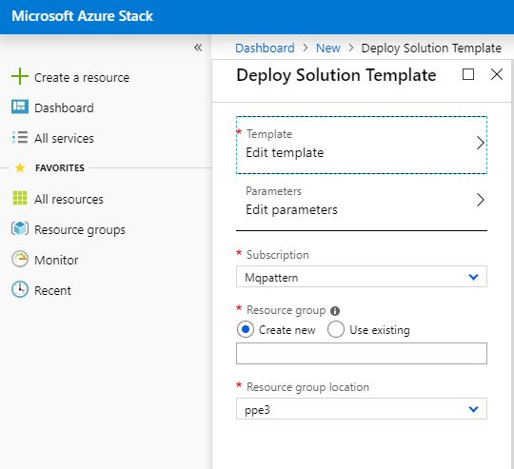

1. Click on Load Files and navigate to where your extracted template is located. Click on azuredeploy.json then click Save.

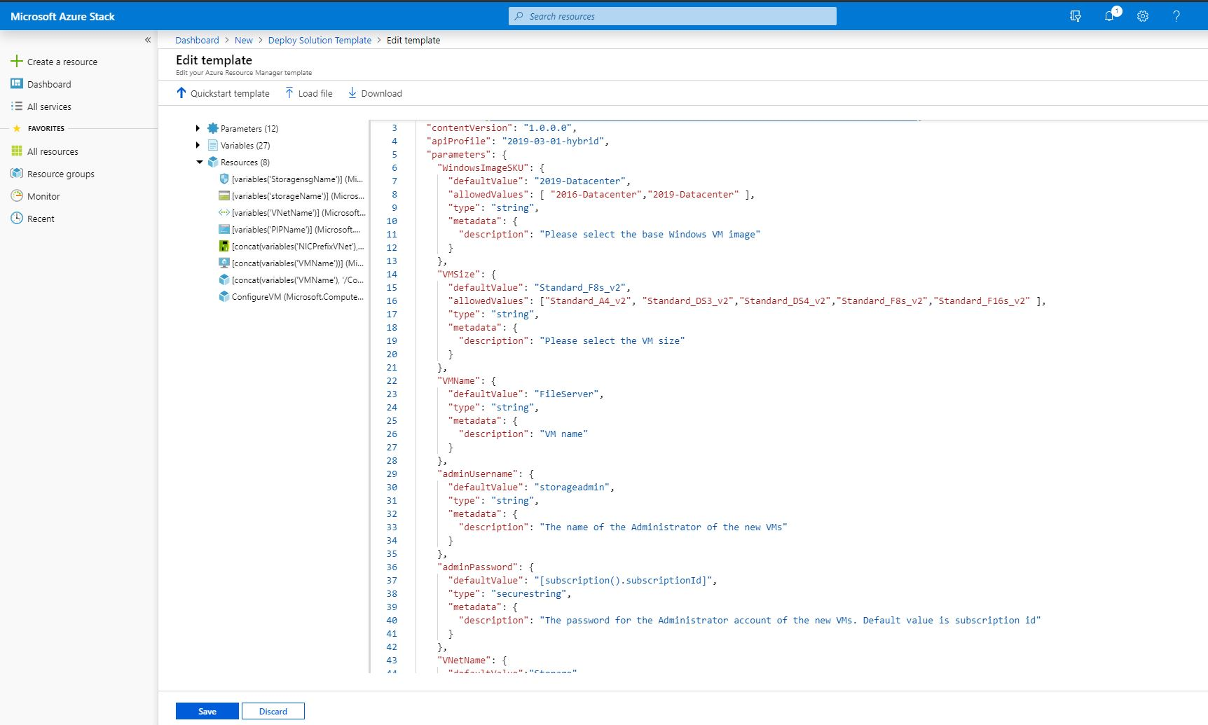

1. Click Parameters and you will see the parameters and will see the list of parameters below. Fill in the required information and click **OK**.

**Note:** If this is for a test environment you can just fill in the ADMINPASSWORD parameter and the rest of the defaults will work.

**WINDOWSIMAGESKU:** This is the SKU that will be used for the vm deployed on Azure stack as the iSCSI initiator.

**VMSIZE:** Select the size you want to use for the Azure stack iSCSI initiator vm.

**VMNAME:** Enter the name you want to use for the Azure stack iSCSI initiator vm.

**ADMINUSERNAME:** This will be the name of the Administrator for the Azure stack iSCSI initiator vm.

**ADMINSPASSWORD:** The password for the Administrator account of the new VM. Default value is subscription id.

**VNETNAME:** The name of VNet. This will be used to label the resources installed in VNet.

**VNETADDRESSSPACE:** Theaddress space that will be used for VNet.

**VNETINTERNALSUBNETNAME:** The name that will be uses for the internal Subnet.

**VNETNTERNALSUBNETRANGE:** Address Range for Internal Subnet.

**INTERNALVNETIP:** Static Address for the internal IP of the File Server.

**ARTIFACTSLOCATION:** The location of resources, such as templates and DSC modules, that the template depends on.

**ARTIFACTSLOCATIONSASTOKEN:** Auto-generated token to access _ARTIFACTSLOCATION. NOTE: This can be blank if no SAS token is required.

1. Next, select or create a resource group where the iSCSI initiator deployment will reside.
2. Once you are happy with your parameters and resource group click Create and the deployment will start.

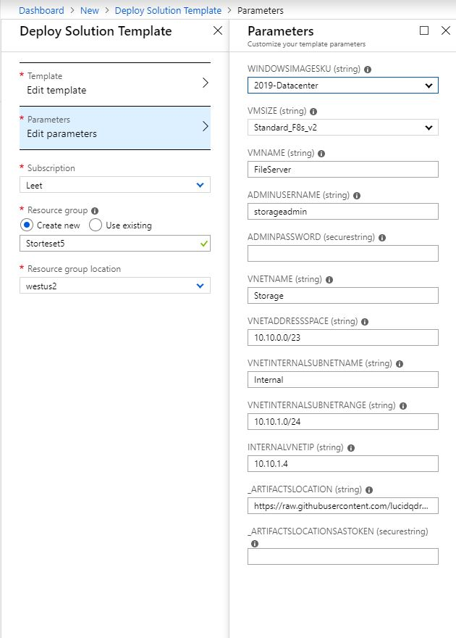

1. Once the Deployment has succeeded you can move on to preparing the iSCSI target vm.

**Preparing iSCSI Target:**

1. Open a browser to the Azure Stack Portal Site ( <https://portal.xxx.xxx.xx.xx>). Then login with an that access to your Azure Stack subscription.
2. Go to the resource group where installed the iSCSI initiator and click on **Deployments**.

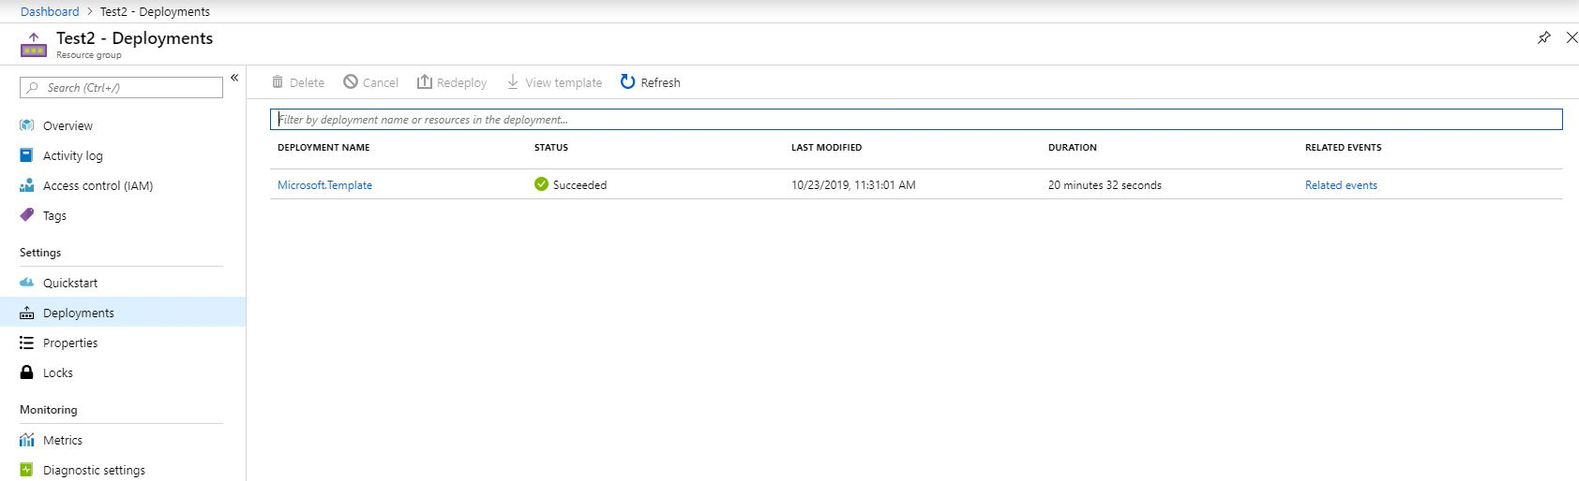

1. Click on the deployment then click on Outputs.
2. Take note of the PUBLICENDPOINT output. This will be the public IP address of the iSCSI initiator vm.

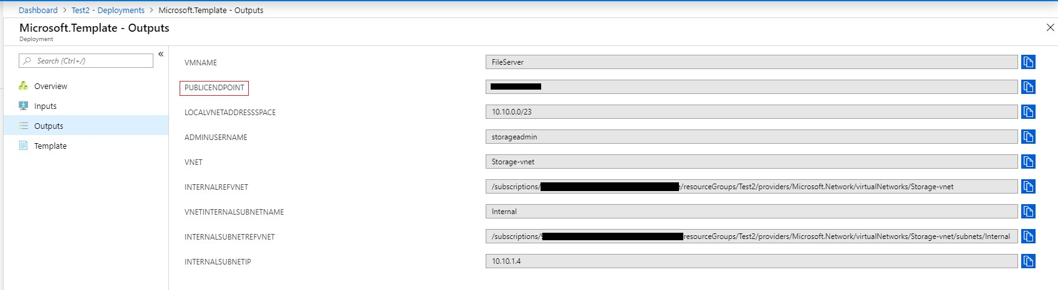

1. Login to the machine that you want to use as the iSCSI target.
2. Go to Start and open up **Windows Defender Firewall**.
3. Click on **Allow an app or feature through Windows Defender Firewall**.
4. Scroll down to iSCSI Service and check all three of the checkboxes for the App, Private and Public then click OK to apply.

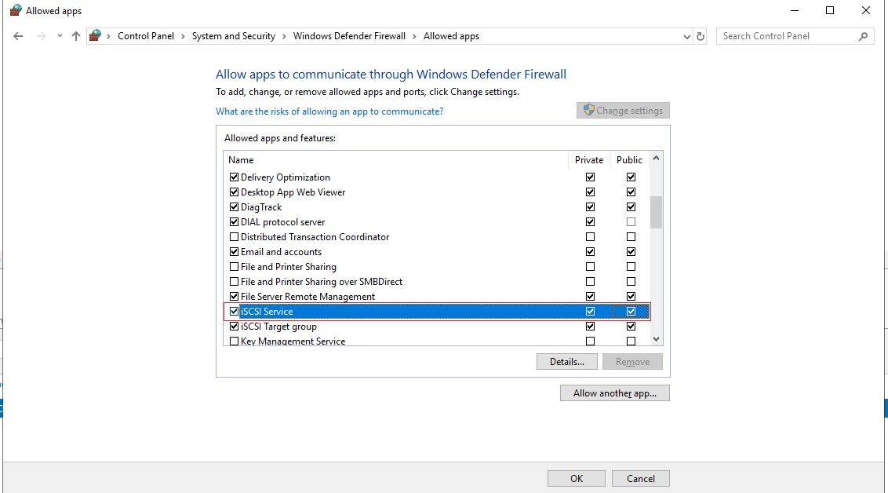

1. Now open up the create-iSCSItarget.ps1 script in the PowerShell ISE.
2. Go to the $DiskSize Parameter and adjust the disk size to the size you need. The default is 10GB.
3. Take the PublicENDPOINT ip you captured earlier and replace the IP in the $RemoteServerIPs Parameter in your script. Then press F5 and run the script. **NOTE:** When the script is complete it will reboot the machine.
4. Once the machine has rebooted you can take a look to make sure everything has been deployed. You should see an iSCSI virtual disk and an iSCSI target.

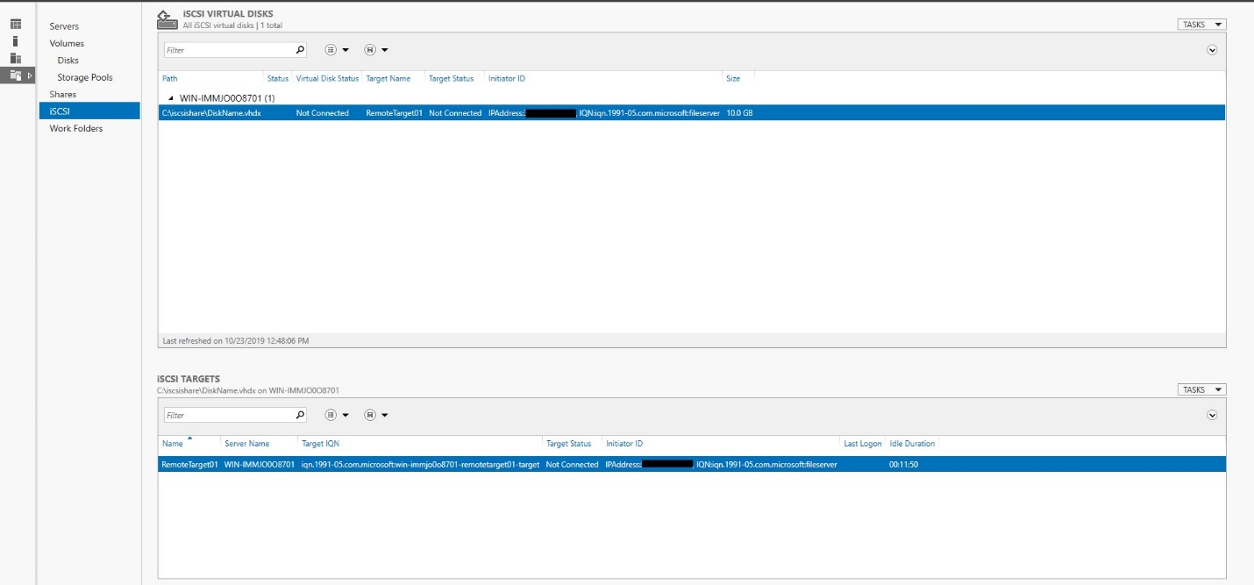

**Connecting iSCSI :**

1. Open a browser to the Azure Stack Portal Site ( <https://portal.xxx.xxx.xx.xx>). Then login with an that access to your Azure Stack subscription.
2. Go to the resource group you deployed earlier, click on the virtual machine and click on **Connect,** then Download RDP File. Then login to your virtual machine.
3. Once your RDP file has downloaded click Connect and login.
4. Copy **the Connect-toiSCSITarget.ps1** file over to your virtual machine and open it in PowerShell.
5. Go to the param block in the script and change the $TargetPortalAddresses to be the IP address of the iSCSI target you created earlier.

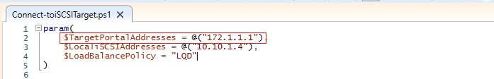

1. Then go the $LocaliSCSIAddresses and enter the IP of the iSCSI initiator vm you are logged into now. **NOTE**: If you used the defaults in the template this does not need to be changed.

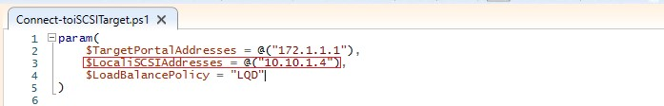

1. Once these changes are made you can hit F5 to run the script.
2. After the script completes go to Server Manager\Tools\iSCSI Initiator.
3. On the Targets screen under Discovered Targets you should have one remote target with a status of Connected.

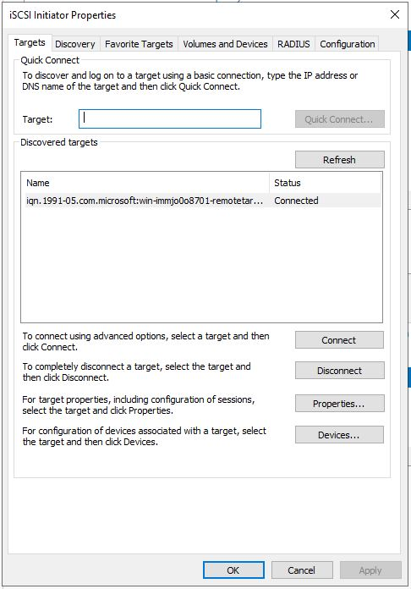

1. You can verify this from the Target side by logging in to your target server. Then go to Server Manager and click iSCSI.
2. The status for the iSCSI virtual Disks and iSCSI targets should now show as Connected. NOTE: you may need to refresh for these to show up if you previously had this view open.

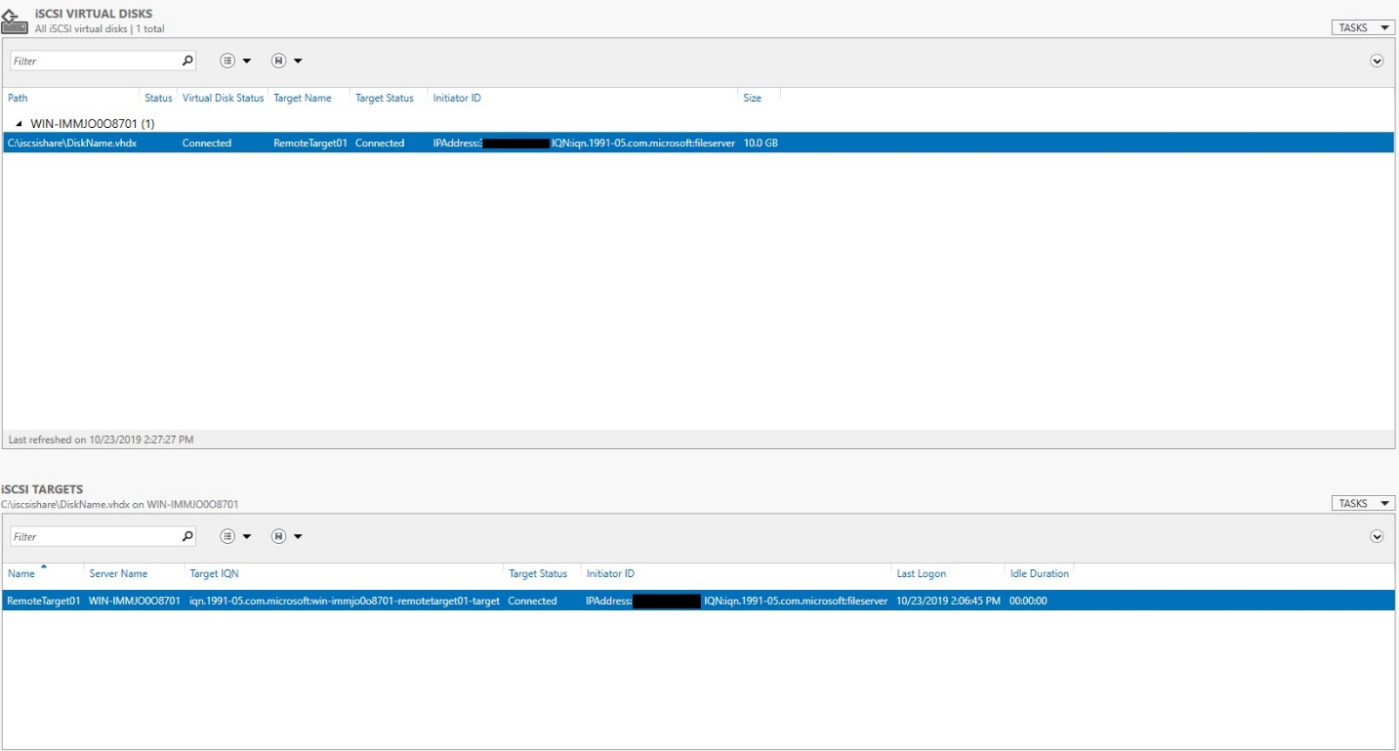

1. asdf