Different roles in Azure portal

Classic subscription administrator roles
Azure role-based access control (RBAC) roles
Azure Active Directory (Azure AD) administrator roles

When Azure was initially released, access to resources was managed with just three administrator roles: Account Administrator, Service Administrator, and Co-Administrator. Later, role-based access control (RBAC) for Azure resources was added. Azure RBAC is a newer authorization system that provides fine-grained access management to Azure resources. RBAC includes many built-in roles, can be assigned at different scopes, and allows you to create your own custom roles. To manage resources in Azure AD, such as users, groups, and domains, there are several Azure AD administrator roles.
The following diagram is a high-level view of how the classic subscription administrator roles, Azure RBAC roles, and Azure AD administrator roles are related.
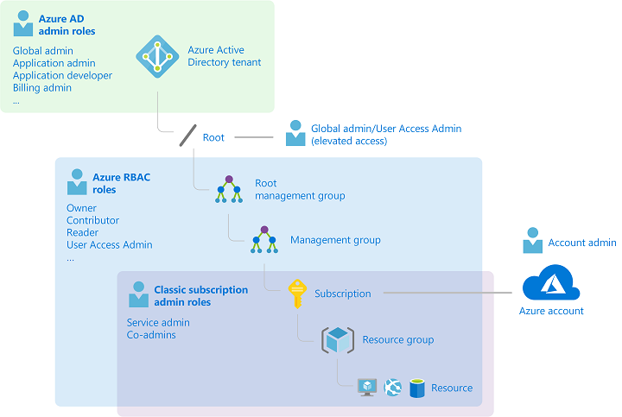
Classic subscription administrator roles

Account Administrator, Service Administrator, and Co-Administrator are the three classic subscription administrator roles in Azure. Classic subscription administrators have full access to the Azure subscription. They can manage resources using the Azure portal, Azure Resource Manager APIs, and the classic deployment model APIs. The account that is used to sign up for Azure is automatically set as both the Account Administrator and Service Administrator. Then, additional Co-Administrators can be added. The Service Administrator and the Co-Administrators have the equivalent access of users who have been assigned the Owner role (an Azure RBAC role) at the subscription scope. The following table describes the differences between these three classic subscription administrative roles.
Classic subscription administrator | Limit | Permissions | Notes
Account Administrator | 1 per Azure account | - Access the Azure Account Center  - Manage all subscriptions in an account  - Create new subscriptions  - Cancel subscriptions  - Change the billing for a subscription  - Change the Service Administrator | Conceptually, the billing owner of the subscription.  The Account Administrator has no access to the Azure portal.
Service Administrator | 1 per Azure subscription | - Manage services in the Azure portal  - Assign users to the Co-Administrator role | By default, for a new subscription, the Account Administrator is also the Service Administrator.  The Service Administrator has the equivalent access of a user who is assigned the Owner role at the subscription scope.  The Service Administrator has full access to the Azure portal.
Co-Administrator | 200 per subscription | - Same access privileges as the Service Administrator, but can’t change the association of subscriptions to Azure directories  - Assign users to the Co-Administrator role, but cannot change the Service Administrator | The Co-Administrator has the equivalent access of a user who is assigned the Owner role at the subscription scope.

Azure RBAC roles
Azure RBAC is an authorization system built on Azure Resource Manager that provides fine-grained access management to Azure resources, such as compute and storage. Azure RBAC includes over 70 built-in roles. There are four fundamental RBAC roles. The first three apply to all resource types.

Azure RBAC role | Permissions | Notes
Owner | - Full access to all resources  - Delegate access to others | The Service Administrator and Co-Administrators are assigned the Owner role at the subscription scope  Applies to all resource types.
Contributor | - Create and manage all of types of Azure resources  - Cannot grant access to others | Applies to all resource types.
Reader | - View Azure resources | Applies to all resource types.
User Access Administrator | - Manage user access to Azure resources

The rest of the built-in roles allow management of specific Azure resources. For example, the Virtual Machine Contributor role allows the user to create and manage virtual machines. For a list of all the built-in roles, see Built-in roles for Azure resources.
Only the Azure portal and the Azure Resource Manager APIs support RBAC. Users, groups, and applications that are assigned RBAC roles cannot use the Azure classic deployment model APIs.

Azure AD administrator roles
Azure AD administrator roles are used to manage Azure AD resources in a directory such as create or edit users, assign administrative roles to others, reset user passwords, manage user licenses, and manage domains. The following table describes a few of the more important Azure AD administrator roles.
Azure AD administrator role | Permissions | Notes
Global Administrator | - Manage access to all administrative features in Azure Active Directory, as well as services that federate to Azure Active Directory  - Assign administrator roles to others  - Reset the password for any user and all other administrators | The person who signs up for the Azure Active Directory tenant becomes a Global Administrator.
User Administrator | - Create and manage all aspects of users and groups  - Manage support tickets  - Monitor service health  - Change passwords for users, Helpdesk administrators, and other User Administrators
Billing Administrator | - Make purchases  - Manage subscriptions  - Manage support tickets  - Monitors service health

Differences between Azure RBAC roles and Azure AD administrator roles

At a high level, Azure RBAC roles control permissions to manage Azure resources, while Azure AD administrator roles control permissions to manage Azure Active Directory resources. The following table compares some of the differences.
Azure RBAC roles | Azure AD administrator roles
Manage access to Azure resources | Manage access to Azure Active Directory resources
Supports custom roles | Cannot create your own roles
Scope can be specified at multiple levels (management group, subscription, resource group, resource) | Scope is at the tenant level
Role information can be accessed in Azure portal, Azure CLI, Azure PowerShell, Azure Resource Manager templates, REST API | Role information can be accessed in Azure admin portal, Microsoft 365 admin center, Microsoft Graph, AzureAD PowerShell

