Azure Media Player Video Editor (AMVE) Usage Guide

# Terms

There following terms will be used throughout the remainder of the document:

## Mark-In

This is the desired beginning point for the clip.

## Mark-Out

This is the desired end point for the clip.

## Mode

The mode determines what type of clip is created. For a full description of the modes, please see the Modes section.

## Scrubber

The control used to navigate the timeline of the stream using your computers pointer device:



# Creating a Clip

Creating a clip is fairly straight forward however the actions required and accuracy vary slightly between the different modes. This section will demonstrate how to create a clip for the Virtual and Rendered modes. The actions for Trim is basically the same as Virtual and Rendered except that you will not be setting a mark out point. For Trim mode, the mark out point is the end of the stream. For a full description of the modes, please see the Modes section.

## Setting a Mark-In Point

Once your stream has loaded, you can create the mark-in point by using the scrubber to scrub, playback to play to or rewind/forward to rewind/forward to the desired time and then tapping/clicking on the set in button:

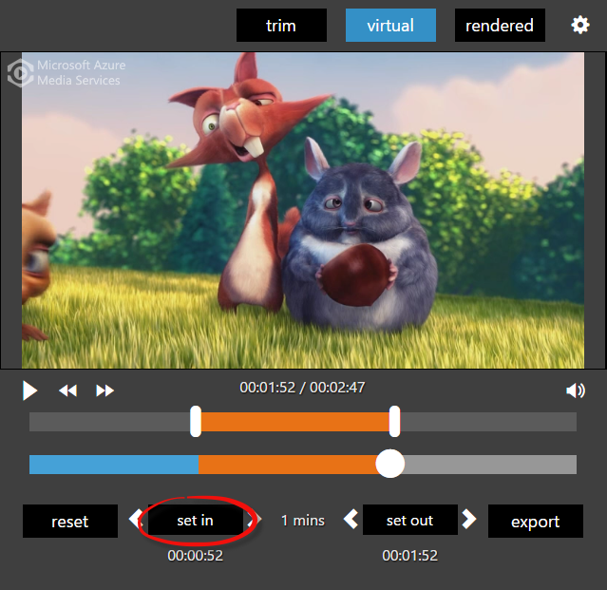

## Setting a Mark-Out Point

Once your stream has loaded, you can create the mark-in point by using the scrubber to scrub, playback to play to or rewind/forward to rewind/forward to the desired time and then tapping/clicking on the set out button:

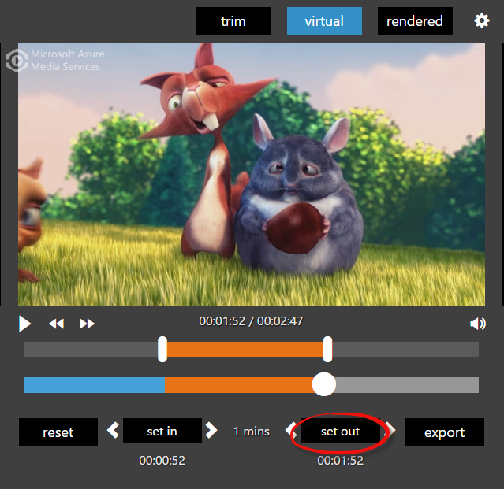

## Changing Mark Points

There are two ways to change the mark-in and mark-out points:

### Mark Bar

The mark bar sits above the scrubber and shows both the mark-in and mark-out points as a handle on the bar. The mark bar’s scale is the same as the scrubber and its length represents the timeline of the stream. To change the mark-in and/or mark-out pint using the mark bar, simply tap/click on the handle and drag to the desired point and release:

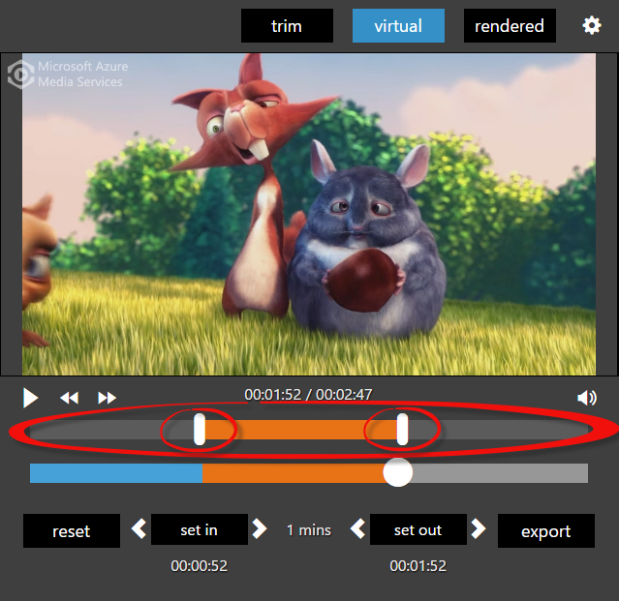

### Mark Arrows

On either side of the set in and set out buttons you’ll see arrows. Clicking on the left arrow moves the target mark point back one segment boundary (GOP) for Trim and Virtual Modes or one frame for Rendered Mode. Clicking on the right arrow moves the target mark point forward one segment boundary (GOP) for Trim and Virtual Modes or one frame for Rendered Mode:

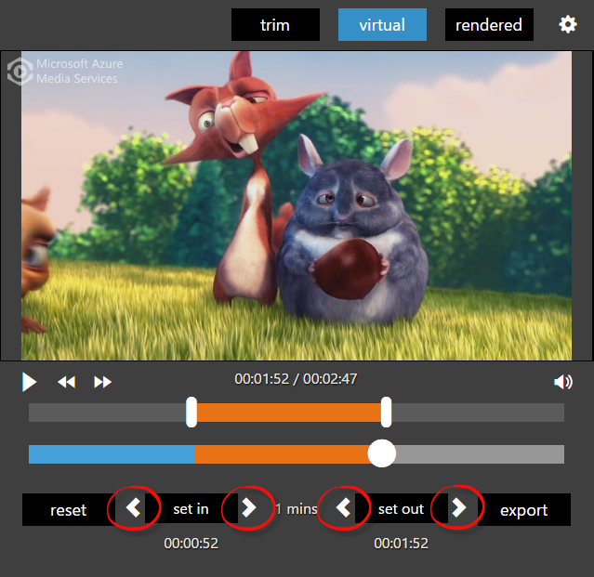

## Export a Clip

With mark-in and mark-out points set (mark-out not required for Trim mode), the export button will be enabled and you can export your clip data. Clicking on export will open the submit dialog. When the submit dialog first opens, you’ll see a loading indicator which will be present until the thumbnails are generated. After the thumbnails are generated, you can select a thumbnail, set a title, set a description and also set other metadata depending on whether or not the provider has added custom form fields. With the thumbnail chosen and the metadata set, you can export the data by tapping/clicking on submit. After exporting the clip data, the provider’s application will process the data accordingly.

|  |  |
| --- | --- |
|  |  |
|  |  |

## Settings

To open the settings dialog tap/click on the settings icon at the top right corner of the editor:

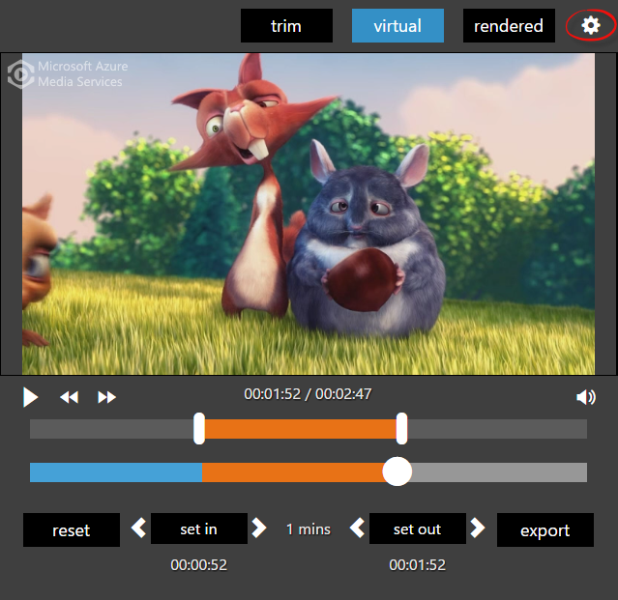

There are two settings that you can modify to change the behavior of AMVE, frame rate and # of thumbnails:

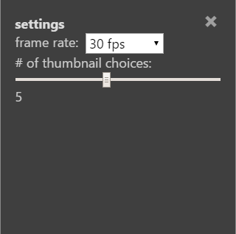

Frame rate should be set to the frame rate of the target stream (supported frame rates are 23.976 fps, 25 fps, 29.976, 30 fps and 60 fps. The frame rate setting will be used to find the frames in the stream.

The # of thumbnails setting determines how many thumbnail choices are generated in the submission dialog.

## Reset

You can clear out the mark points and reset the stream to the beginning by tapping/clicking on the reset button:

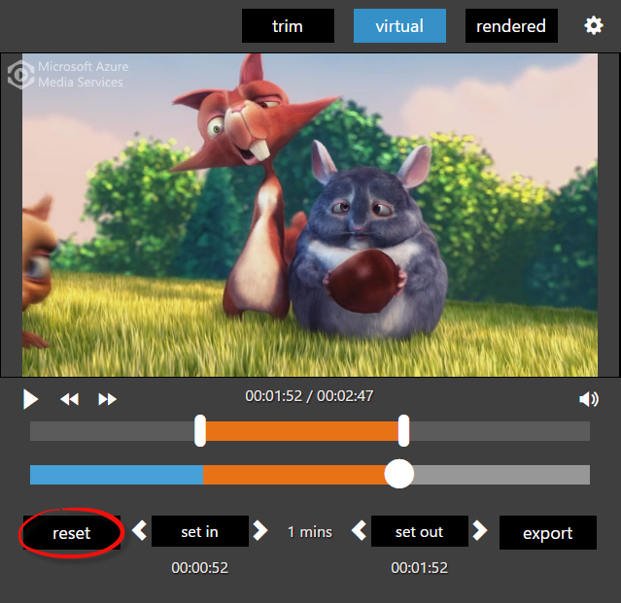

# Supported Modes

There are three modes that AMVE supports:

## Trim

Trim mode is segment boundary (GOP) accurate creates a clip starting from the segment boundary (GOP) closest to the mark-in point and ending at the end of the stream.

## Virtual

Virtual mode is segment boundary (GOP) accurate and creates a clip starting with the segment boundary (GOP) that is closest to the mark-in point and ending with the segment boundary (GOP) that is closest to the mark-out point.

## Rendered

Rendered mode creates a clip starting with the frame that is closest to the mark-in point and ending with the frame that is closest to the mark-out point. Frames are calculated based on the frame rate which can be set in the AMVE settings.