*Margie’s Travel Presents…*

London

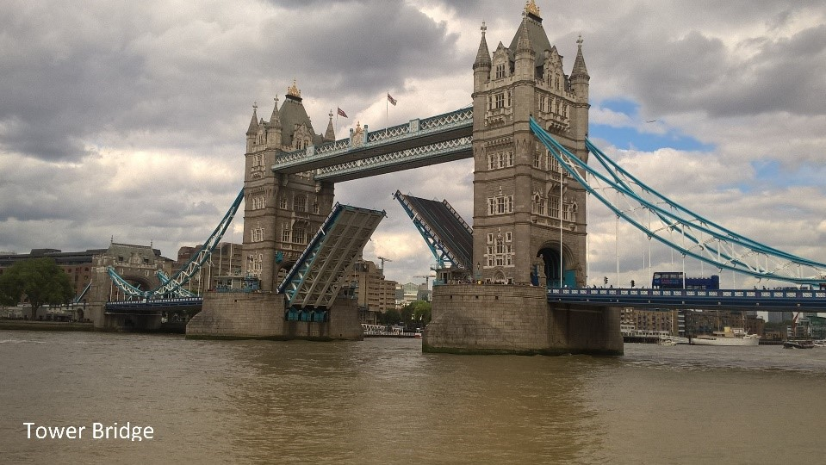London is the capital and most populous city of England and the United Kingdom. Standing on the River Thames in the south east of the island of Great Britain, London has been a major settlement for two millennia. It was founded by the Romans, who named it Londinium.

London's ancient core, the City of London, largely retains its 1.12-square- mile medieval boundaries.

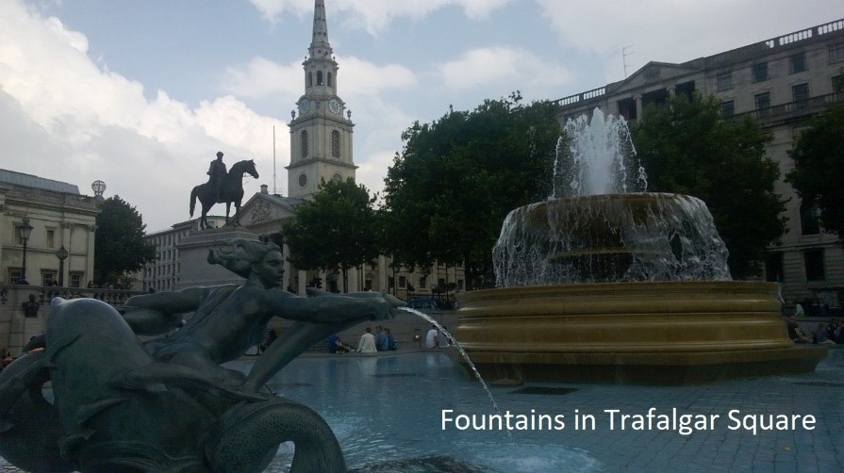Since at least the 19th century, London has also referred to the metropolis around this core, historically split between Middlesex, Essex, Surrey, Kent, and Hertfordshire, which today largely makes up Greater London, governed by the Mayor of London and the London Assembly.

# Mostly popular for:

Leisure, Outdoors, Historical, Arts & Culture

# Best time to visit:

Jun-Aug

Averag Precipitation: 1.9 in Average Temperature: 56-67°F

**London Hotels**

Margie’s Travel offers the following accommodation options in London:

# The Buckingham Hotel

Comfortable hotel close to major sights like Buckingham Palace, Regent’s Park, and Trafalgar Square.

# The City Hotel

Luxury rooms in the city, within walking distance of Tower Bridge and the Tower of London..

# The Kensington Hotel

Budget accommodation near Earl’s Court.

To book your trip to London, visit [www.margiestravel.com](http://www.margiestravel.com/)

|  |  |
| --- | --- |
| **Category** | **Information** |
| Country | United Kingdom |
| Capital Of | England |
| Currency | Pound Sterling (GBP) |
| Population (2021 census) | Approximately 8.8 million |
| Famous For | Historical landmarks, museums, cultural diversity |