**__________________________________________________________________________________________________**

**Letter of Authorization – Manual / Bulk Number Acquisition **

**__________________________________________________________________________________________________**

I hereby authorize Azure Communication Services or its designated agent to assist me in acquiring numbers in bulk for my Azure Communication Services account. I also provide authorization for charging me the amounts mentioned below (and any additional charges for usage that will be over and above the number acquisition charges).

Please fill out the following information and send it to us at [acstnrequest@microsoft.com](mailto:acstnrequest@microsoft.com); **Please ensure that your email subject line begins with "ACS Number Request:"**

**Customer Name and Azure Details**

Customer name: Click or tap here to enter text.

Email Address: Click or tap here to enter text.

Reason for Acquisition: Click or tap here to enter text.

Azure ID (See screenshot below): Click or tap here to enter text.

Azure Immutable ID (See screenshot below): Click or tap here to enter text.

*TIP: To find the required Azure details, navigate to your Azure resource and click on JSON view on the top right*

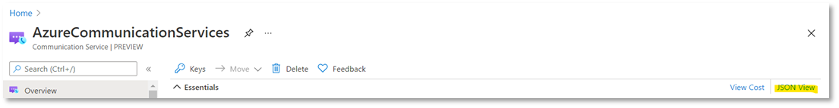

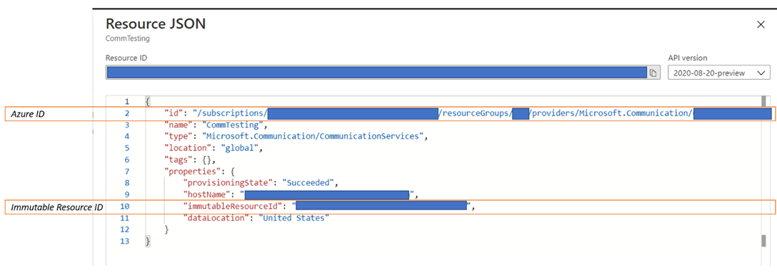

**Number Details**

Which country phone number you need

United States

United Kingdom

Canada

Denmark

Use case

An application will be making calls or sending SMS messages

A person will be making calls or sending SMS messages

Type of Number

Toll-free

Geographic

*You can check the pricing for number leasing* [*here*](https://docs.microsoft.com/en-us/azure/communication-services/concepts/pstn-pricing)

Capabilities Requested

Inbound Calling Receive SMS (US, CA Toll-Free Only)

Outbound Calling Send SMS (US, CA Toll-Free Only)

Quantity of Numbers: Click or tap here to enter text.

Desired Area Code – Priority 1: Click or tap here to enter text.

Desired Area Code – Priority 2: Click or tap here to enter text.

*(****Note:*** *We cannot guarantee that we can provide numbers in a particular area code)*

**Signature and Date**

Authorized signature: Click or tap here to enter text.

Authorizing name: Click or tap here to enter text.

Date: Click or tap here to enter text.