

Software for Open Networking in the Cloud (SONiC) Architecture

Table of Contents

1 Abstract 4

2 High Level Architecture 4

3 Definitions 5

3.1 Switch Hardware 5

3.2 Platform Adaptation Services (PAS) 5

3.3 Switch Abstraction Interface (SAI) 6

3.4 SAI Host Adapter 6

3.5 Network Applications 6

4 SONiC Object Library 6

5 Platform Abstraction Service (PAS) 6

5.1.1 System Device Interface (SDI) 7

6 Switch State Service (SwSS) – Switch control 8

6.1 Architecture Overview 8

6.1.1 Overview 8

6.1.2 Key value database 9

6.1.3 Network applications 9

6.1.4 Orchestration Agent 10

6.1.5 syncd 10

6.2 Database Implementation 10

6.2.1 Table Operations 10

6.2.2 Transactions 10

6.3 Switch Data Service Database Schema 11

6.3.1 Overview 11

6.3.2 Schema 11

6.3.3 Database 1 – ASIC_DB 11

6.4 Switch state service Layer 3 Implementation 12

6.4.1 L3 Route learning example 12

7 Network Abstraction Services (NAS) Switch Control 12

7.1 Networking Features 13

7.2 Supported Networking Features 13

7.3 Layer 3 Features 15

7.4 Object Model 15

8 Porting New Hardware to SONiC 15

9 Appendix 16

10 References 16

# Abstract

Software for Open Networking in the Cloud (SONiC) is a collection of software packages installed on Linux running on a network hardware switch which make it a complete, functional router in Azure or any data center network.

# High Level Architecture

The following picture presents the target SONiC Architecture.

On the left side of the picture focuses on supporting platform related concepts including:

* Fans
* Power supplies
* Media/Transceivers

On the right hand side of the picture focuses on the networking components including:

* SAI
* ASIC Control Software



Figure 1 – Target SONiC High Level Software Design

As mentioned earlier, the diagram presents the target SONiC Architecture. The current SONiC project implements Switch State Service as it’s ASIC control software. NAS is a new ASIC control software that is in the process of being integrated with SWSS into a single component.

Each one of these will be described in sections below but a high level picture of both architectures is shown below.



Figure 2- NAS and SWSS merge

# Definitions

## Switch Hardware

Switch hardware refers to all the physical components inside the network switch enclosure (chassis). This includes fans, power supplies, status LEDs and network transceivers. In SONiC terminology, these are called “system devices”.

## Platform Adaptation Services (PAS)

The platform abstraction layer is an interface to network switch hardware peripherals such as transceivers, fans, power supplies and leds. SONiC exposes these details via the platform abstraction services.

The PAS uses an abstract low-level platform-independent abstraction for all types of system devices, called System Device Interface (SDI) API. Therefore, only system device drivers (either user space or kernel device drivers) which implement the SDI API are hardware-specific, while the API itself is hardware-independent.

## Switch Abstraction Interface (SAI)

The switch abstraction interface is a standardized C API to the switching ASIC. This API is normally implemented by an SDK specific to the Switch ASIC. More information on SAI is available at the [SAI GitHub](https://github.com/opencomputeproject/SAI) repository.

## SAI Host Adapter

The SAI Host Adapter’s role is to provide a mechanism for storing and synchronizing network switch data with the Switch ASIC. This includes initialization, configuration and current status of the switch ASIC.

## Network Applications

Network applications, such as a BGP routing protocol, may use the Object Libraries API’s to get and set the state of the SONiC SAI Host Adapter.

# SONiC Object Library

As of this writing, the object library is being updated as PAS and NAS are integrated into the project. As this occurs, this document will be updated. A high level description of the Object library follows.

The SONiC Object Library (Object Library) mediates interactions between SONiC applications and external applications. The Object Library infrastructure defines two types of application roles: clients and servers. Client applications execute create, set, get, and delete operations on objects. Server applications execute operations requested by clients.

In addition, the Object Library infrastructure supports a publisher/subscriber model. Server applications publish relevant events; client applications can subscribe (register) for specific events and objects. Client applications can register for events generated when objects are created, modified, or deleted.

The publisher/subscriber approach and object-centric operations allow for the completely independent operation of client and server applications.

Custom-written applications use the Object Library API to communicate with the SONiC components.

# Platform Abstraction Service (PAS)

The PAS provides a higher-level abstraction and aggregation of the functionality provided by the System Device Interface (SDI) component, described below. In addition, the PAS implements the object models associated with system devices.

The PAS monitors the status of system devices and reports (publishes) status changes or faults as events. It also allows user applications to retrieve current status information and set the control variables of system devices.

For example, the PAS Object API allows user applications to:

* Read current temperature values reported by temperature sensors.
* Get and set fan speed values.
* Set a LED state.
* Read power levels reported by PSUs.
* Get system inventory and EEPROM information.
* Set transceiver module state (for example, Tx laser on/off) and get module information.

The PAS detects:

* Common field replaceable units (FRUs), such as PSUs and fans, and insertion and removal events.
* Over-temperature events for pre-defined temperature thresholds.
* Transceiver insertion on physical ports.

### System Device Interface (SDI)

A system device refers to a hardware component, such as:

* Fans/cooling devices
* Power supplies
* Temperature sensors
* LEDs
* EEPROM
* Programmable devices.
* Transceivers

All hardware components except for NPUs are abstracted as system devices.

The SDI API defines a low-level platform-independent abstraction for all types of system devices. Only system device drivers that implement the SDI API are hardware-specific; the API itself is hardware-independent.

The implementation of the SDI API can use any approach suitable for a given platform or vendor:

* 'sysfs' access to Linux kernel device drivers
* user space devices drivers using UIO or other methods
* new vendor specific kernel modules, accessible through sysfs, netlink or ioctl calls
* combination of any of the above methods

In general, other approaches not mentioned above are also possible, as long as the implementation supports the SDI API.

An application will use the PAS Object model through the Object Library. The PAS service will use the SDI (System Device Interface) to access the drivers which will (as an option) communicate with the Sysfs file system which in turn communicates with the actual hardware device drivers.



# Switch State Service (SwSS) – Switch control

## Architecture Overview

### Overview

The Switch State Service (SwSS) is a collection of software that provides a database interface for communication with and state representation of network applications and network switch hardware.

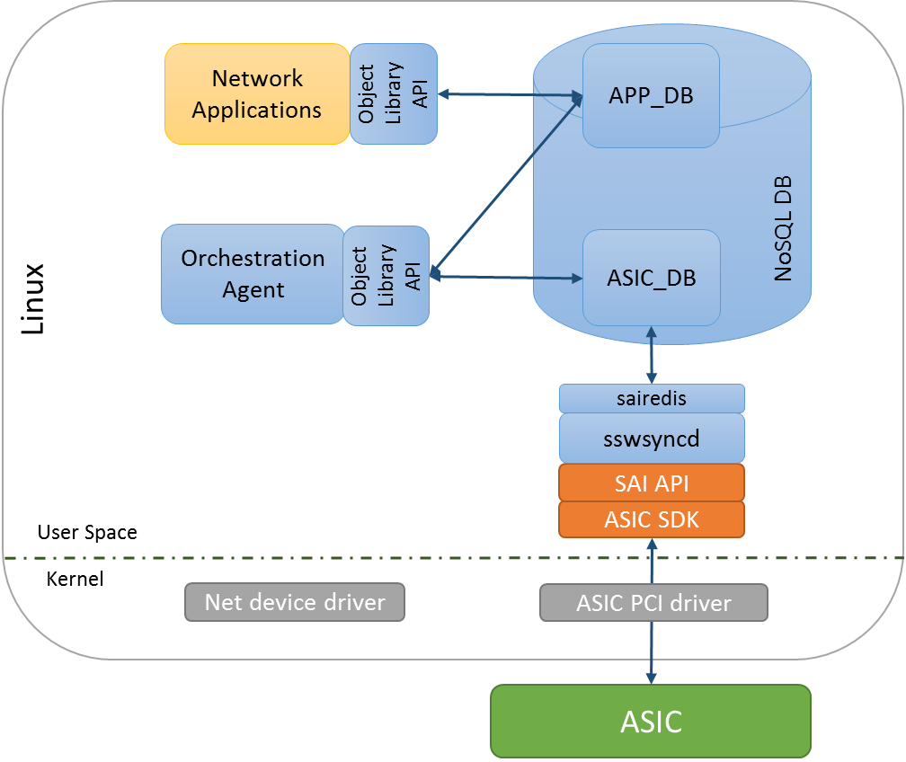

Figure 3 – Switch State Service High Level Design

Network applications read and write to APP_DB. Example applications include a netlink route syncer, quagga FPM route syncer, access control list (ACL) control, QoS control, load balancer, telemetry control and so on.

The Orchestration agent reads and writes data between APP and ASIC databases. The Orchestration agent is responsible for any necessary logic to verify and transform the data into SAI objects which can be processed by syncd.

The syncd process reads and writes SAI objects between the ASIC_DB and the SAI SDK.

### Key value database

A key value database was chosen to provide a language independent interface, a method for data persistence, replication and multi-process communication. An API wrapper is implemented in swss/common which implements transactions, convenience methods and allows the database storage engine to be changed in the future if necessary. Redis was chosen as the underlying database engine, but this could be changed in the future.

### Network applications

Using the SwSS API, SONiC network applications are written to be entirely independent of the lower layer communication details to the hardware. Applications subscribe only to the data views they require and avoid implementation details that are not specific for their functionality. Examples of applications that intended to interface with SwSS include: Layer 3 routing, Layer 2 bridging, Access control lists (packet filtering), Quality of service, Telemetry streaming, tunneling, link aggregation, load balancing and policy based routing to name a few.

### Orchestration Agent

This process contains logic for transforming and copying data between the APP tables and the ASIC tables.

There must only be one producer for each ASIC table. Currently there is just one orchestration agent, although others could be added over time.

Only a single Orchestration Agent may write to an ASIC_DB table.

### syncd

The switch sync daemon syncd copies data between the ASIC_DB tables and a SAI compliant ASIC SDK. There must only be one syncd process per SAI SDK instance.

## Database Implementation

SwSS implements the concept of a table in redis by naming keys with prefixes. A producer / consumer design is implemented to ensure integrity of data.

APP_ tables are designed for each use case. For example, ROUTE_TABLE and NEIGH_TABLE.

ASIC_ tables are created from the SAI header files. For example ASIC_sai_unicast_route_entry_t and ASIC_sai_neighbor_entry_t.

### Table Operations

[TODO: link to github, .h files, API’s for common table operations]

Producer

SET – insert or update a key -> fields and values.

DEL – deletes a key

Consumer

POP – get a table change notification, the key name and the key->fields and values and operation [SET, DEL].

SELECT – check if a table notification exists.

[TODO: Elad to add examples]

### Transactions

SwSS implements transactions internally so producers and consumers can to stay in sync with the database using a queue-like method.

For each ‘TABLE’, there are QUEUE keys used for internal implementation of notifications. Here is an example of how it works.

The intfsyncd process performs a SET to the APP.INTF_TABLE using the swss producer API. The producer API SETs the key/value in the TABLE and SETs an equivalent entry for each of the QUEUE keys.

The orchestration agent (OA) is a CONSUMER of the APP.INTF_TABLE. OA will receive a notification from the swss consumer API that there is a data change on APP.INTF_TABLE. The consumer API will POP the KEY, VALUE and OP from the QUEUE keys. The data the intfsyncd wrote to the APP.INTF_TABLE remains untouched.

See the code for more details.

Tablename+”_KEY_QUEUE”

Tablename+”_VALUE_QUEUE”

Tablename+”_OP_QUEUE”

## Switch Data Service Database Schema

### Overview

Two databases are defined, APP and ASIC. Applications outside of SwSS are expected to store data by adding keys with well-defined names into the APP database. The ASIC database stores data used by hardware sync agents. Keys in the ASIC database are expected named strictly following SAI attributes.

Keys must be prefixed with a string that looks like a table name. The allowed keys are “[a-z][A-Z][0-9]_” and end with “_TABLE:”

In redis, databases are only defined my numbers:

Database 0 = APP_DB

Database 1 = ASIC_DB

Database 7 = TEST (used for unit testing)

### Schema

The SwSS schema is defined at: https://github.com/Azure/sonic-swss/blob/master/doc/swss-schema.md

### Database 1 – ASIC_DB

The ASIC database stores data used by hardware sync agents. Keys in the ASIC database are named strictly following SAI attributes. See <https://github.com/opencomputeproject/SAI>

## Switch state service Layer 3 Implementation

### L3 Route learning example

This section provides an example of how a BGP route is learned and propagated to the ASIC. Quagga is used as an example, but other routing applications could be used.

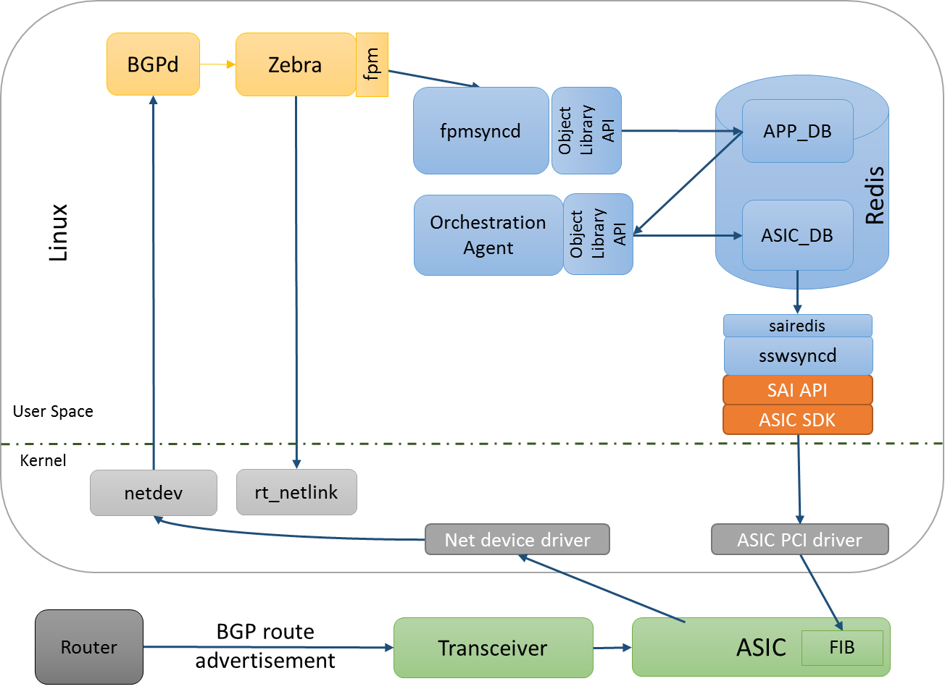

Figure 4 – Learn bgp route

# Network Abstraction Services (NAS) Switch Control

The Network Adaptation Service (NAS) manages the high level network processor (NPU) abstraction and adaptation. The NAS abstracts and aggregates the core functionality required for networking access at Layer 1 (physical layer), Layer 2 (VLAN, link aggregation), Layer 3 (routing), ACL, QoS and network monitoring. The NAS enables adaptation of the low level switch abstraction provided by the Switch Abstraction Interface to:

* Standard Linux networking APIs and Linux Interfaces
* SONiC specific Object Library API functionality.

In addition, the NAS is responsible for providing packet I/O services, using the Linux kernel IP stack.

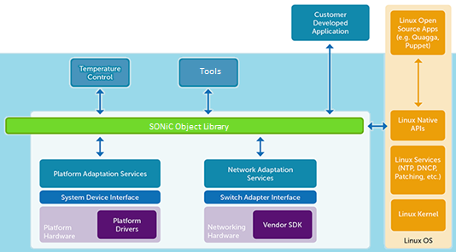

## Networking Features

The SONiC NAS Host-adapter allows you to model and configure various networking features in the network processing unit (NPU) using two methods: Linux commands and SONiC Object Library APIs. See the [Application Programming guide](https://azure.github.io/SONiC/) for the SONiC NAS Host Adapter for a description of the SONiC Object Library framework.

The Network Adaptation Service (NAS) handles networking functionality. The NAS daemon accepts commands from the object library and listens to netlink events for Layer 2 and Layer 3 configurations, and programs the NPU.

## Supported Networking Features

| **Networking Feature** | **Configure with Linux Commands/**  **Linux Native APIs** | **Configure with SONiC Library API** |
| --- | --- | --- |
| **Interfaces** | | |
| Physical | Yes | Yes |
| Link Aggregation | Yes (Bond) | Yes |
| VLAN | Yes | Yes |
| Fanout (4x10G) | No | Yes (script) |
| **Layer 2 Bridging** | | |
| LLDP | Yes | Yes |
| MAC Address Table | No | Yes |
| STP | Yes | Yes |
| VLAN | Yes | Yes |
| **Layer 3 Routing** | | |
| ECMP | Yes | Yes |
| IPv4 | Yes | Yes |
| IPv6 | Yes | Yes |
| Unicast Routing | Yes | Yes |
| **QoS** | No | Yes |
| **ACL** | No | Yes |
| **Monitoring** | | |
| Port Mirroring | No | Yes |
| sFlow | No | Yes |
| Port and VLAN statistics | No | Yes |

## Layer 3 Features

The SONiC NAS Host-Adaptor supports unicast routing over Linux interfaces using routes in the Linux kernel routing table. Applications can also use the SONiC Object Library API to configure routes.

The SONiC NAS Host-Adaptor routing subsystem manages the forwarding information base (FIB). The routing subsystem programs routes with resolved next hops using ARP/Neighbor table entries received from the Linux kernel.

Both IPv4 and IPv6 are supported. Adding routes can be done via the Linux “ip” command or through the Object Library. See the SONiC NAS documentation for more details.

## Object Model

[Object model definitions](https://github.com/Azure/sonic-object-model-schema) are used to generate C header files included by client and server applications. The SONiC C/C++ representation of objects and their attributes is designed to ensure compatibility between multiple versions of the object model.

SONiC provides both C/C++ and Python programming interfaces for the Object Library.

# Porting New Hardware to SONiC

Porting new hardware to SONiC is very important to support and much thought has gone into making it as simple as possible.

There are two main components required to port SONiC to a new hardware platform.

* Hardware drivers
* SAI implementation for the target hardware



The SONiC PAS architecture through the SDI layer can be adapted to any possible driver interface and has been designed to be as generic as possible in order to support as many platforms as possible but we recommend the use of the sysfs interface. The SONiC platform will provide a plug-in interface that will simplify integration of a sysfs to the SDI interface.

Here are the devices that are currently supported by the SONiC Platform

* Fans/cooling devices
* Power supplies
* Temperature sensors
* LEDs
* EEPROM
* Programmable devices (PLD)
* Transceivers

# Appendix

# References