Sharing Capacity Reservation Group across Subscriptions under same AAD-Private Preview v1.0

IMPORTANT: **Sharing Capacity Reservation Group** is currently in PREVIEW. See the [Supplemental Terms of Use for Microsoft Azure Previews](https://azure.microsoft.com/en-us/support/legal/preview-supplemental-terms/)  for legal terms that apply to Azure features that are in beta, preview, or otherwise not yet released into general availability.

Overview:

Sharing of deployed resources across subscriptions is a new area for Compute that would allow Capacity Reservation Group to be shared across subscriptions. This would allow customers to create and manage Capacity Reservation for subscriptions within the same AAD.

For example, if Sub A created a CRG X and shared with Sub B and gave read/deploy rights to subscription B (under same AAD as subscription A), subscription B will be able to deploy VM R in CRG X given it is within the same VM SKU and region/zone:

Due to Azure limitations and funding constraints, we will take a crawl, walk and run approach. For v1, Azure will provide basic functionality that supports the key scenarios some of which are summarized below:

* **Scenarios:**

1. **Resource Reuse:**

Customers can maximize utilization even during scale-in of primary apps. Customers with ODCR for DR will now have the ability to use reservations for lower priority workloads including non-production, test and run-to-completion jobs hosted in separate subscriptions.

1. **Centralized Capacity:**

Customers can have the same persona to manage both quota and reserved capacity across subscriptions for the app environments they support.

1. **Scaling/Sharding:**

At-scale customers using multiple subscriptions for a single application environment can have a single group of reserved capacity.

1. **ISV customer isolation:**

SaaS providers that host VMs for specific customers can manage supporting resources more centrally while keeping their customers isolated in their own subscriptions. Resources include quota and reserved capacity. Customers get streamlined access in a more dynamic way that better fits their customer usage patterns.

* **Capacity Reservation Group sharing requirements:**

Capacity Reservation Groups (CRGs) can be shared between subscriptions under the same Azure Active Directory tenant. The deployed VMs must match one of the Capacity Reservations in the Capacity Reservation groups on SKU, location, and zone if applicable.

Consider the example represented by the diagram:

* Ava creates and manages Capacity Reservation Groups in Subscription A.
* Bob creates and deploys Virtual Machines in Subscription B. Sal performs the same actions in Subscription Dev.
* The goal is for Ava to share CRG X with Subscription B such that Bob can deploy VMs using CRG X.

Step 1: share CRG X

1. A rights administrator in Subscription B must grant Ava CRG write permissions to Subscription B. The specific access required is Microsoft.Compute/capacityReservationGroups/write.
2. Ava must then update the “sharing profile” of CRG X to include Subscription B.

At this point, CRG X and all member Capacity Reservations are visible to Subscription B.

Step 2: grant user access to CRG X

1. A rights administrator in Subscription A must grant Bob read and deploy rights to CRG X.

The specific access rights are Microsoft.Compute/capacityReservationGroups/read and Microsoft.Compute/capacityReservationGroups/deploy.

1. Bob can now add CRG X as the capacityReservationGroup property on Virtual Machines. The usual rules on the VM matching a Capacity Reservation apply. From the diagram, VM R must match either CR Y or CR Z.

Note that Bob was not granted write permissions to CRG X. Bob is not allowed to create more reservations in CRG X, change reserved quantities, or make any other changes to the definition of CRG X.

* **Usage patterns:**

1. Grant access to specific Capacity Reservation Groups – this was accomplished in the example above
2. Grant access to all Capacity Reservation Groups in a subscription – follow the same steps, except instead of granting Bob rights to just CRG X, create a custom role for the CRG read and deploy rights. In Subscription A, add Bob to the custom role.
3. Grant access to all subscriptions in a management group – for the initial release of sharing across subscriptions, this is best accomplished using Azure Template Specs to set permissions and update the CRG sharing profiles. See <https://learn.microsoft.com/en-us/azure/azure-resource-manager/bicep/template-specs>.

* **Summary of key design considerations:**
  + Usage Control: Customer has control over sharing of CRG
  + Discoverability: Customer using shared objects must be able to find them (For Private Preview customers customers can only use ARM deployment template for creating CRG with sharing profile. Portal aspect will be ready by the time we do Public Preview/GA. API to get all CRGs inlcuding shared for a given subscription will be available by Public Preview)
  + Manageability: Customers have the option to set an object’s share policy and then it operates automatically as their object set changes
  + At scale: System can manage large set of objects in a streamlined way

**Customer experience of CRG sharing:**

* **CRG creation with sharing profile**:
* User Ava needs to have Microsoft.Compute/capacityReservationGroups/write permission to be able to share CRG with Sub B
* User Ava will populate CRG X with Subscription B in “sharingProfile”

* **Shared CRG usage:**

User Bob has to have read and deploy rights to be able to deploy VM A in shared CRG X

* **Deletion of CRG:**
* Only CRG owners have ability to delete the CRs and CRG if no VMs associated to CRs
* A shared CRG cannot be deleted if there are VMs using or referencing it from any subscription
* Un sharing with Sub B will happen as part of shared CRG deletion process

* **Billing:**

If a shared VM is deployed to CRG/CR, the VM usage will be emitted to billing with the associated CR. The billing engine will behave as it does today– bill the subscription hosting the VM for the usage and deduct the usage from the corresponding CR based on the compute usage stream associating the VM and CR.

CRG owner subscription pays: unused CR

VM owner subscription pays: $VM+$storage+$network

VMs deployed in shared reservation are eligible for RIs owned by subscription that created the CRG if the RI is for entire enrollment. Scoped RIs won’t apply if the subscription deploying VM is in a target outside of the RI scope as part of Private Preview. If subscription deploying VM has an RI, the billing engine would behave as it does today.

* **Quota:**

If the contributor subscription (Sub B) is deploying VM in shared CRG owned by Sub A, quota will be deducted from both subscriptions.

For example if sub A created a CR of DS1_v2 with 1 instance, quota will be deducted by 1 vCore from Sub A. If Sub B is deploying a VM of DS1_v2 to the CR of Sub A, quota will be deducted from Sub B by 1 vCore.

**Enable Preview Access**

To participate in private preview, your subscription has to be registered with afec for sharing listed. To ensure your subscription is registered to enable the feature, please fill in the Private Preview Sign up form: [CRG Sharing Private Preview Sign Up Form](https://forms.office.com/Pages/ResponsePage.aspx?id=v4j5cvGGr0GRqy180BHbR5P8Ebc4Hg5DnPLwjgZ9SlVUQlA1SjcxTU5NOFZGMFFEVlhXWFA0U1JPMy4u)

**Limitations/Restrictions for sharing:**

Private preview limitations:

* The feature enabled only for few regions.
* Each subscription used in testing must be enabled by Microsoft. A minimum of 2 subscriptions (CRG creation and CRG sharing target) will be needed.
* Only the REST API and Azure templates are supported. SDK and Azure Portal support will come later.
* Only single VM deployments from the subscriptions in the sharing profile can be made using a shared CRG. VMSS Uniform and Flex will be added before release.
* Sharing is only allowed to subscriptions within same Azure Active Directory tenant. The ability to share across AAD tenants will be added in a later release.

Known issues:

* Resource move scenarios are not supported. Attempting a resource move may cause errors on future resource updates.
* API to get list of all CRG IDs (local and shared) for a given subscription is not available during Private Preview. Support will be available during Public Preview.
* Reserved Instance discounts are still applied based on the context of the Virtual Machine. If the VM using a shared CRG is from a subscription outside RI scope, then RI discounts will not be applied. This will be addressed in a future release. If needed, a workaround is to test with two subscriptions in the same management group and then use management group scope for the Reserved Instances.
* The CRG administrator is granted “CRG write” permissions to target subscriptions of the sharing (see user Ava granted this permission to Subscription B in the example). This may not be desirable since user Ava can then create CRG objects in Subscription B. At public preview, this requirement will change to using a new “CRG share” permission instead of “CRG write.” This design change will require updates to access rights configuration.

Limitations by design:

* Sharing works with an explicit list of target subscriptions. Azure does not support wildcard or tenant level sharing.
* Maximum number of subscriptions a CRG can be shared with is 100
* Sharing is per Capacity Reservation Group which grants access to all member Capacity Reservations. Individual Capacity Reservations cannot be shared.

**Customer guidance for using Sharing CRG feature:**

* Create CRG with sharing profile:

**RBAC access:**

Before a CRG can be shared with a subscription, the CRG owner needs to have “Microsoft.Compute/capacityReservationGroups/write” permission to be able to share CRG with cross Subscription.

You can create a custom role to add this permission to the user or give owner/contributor rights for example:

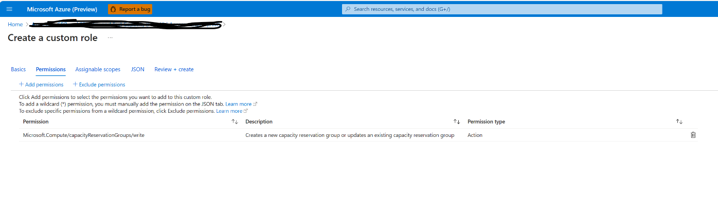

Please refer to Azure RBAC links below for more information related to role assignment:

[Azure RBAC documentation | Microsoft Learn](https://learn.microsoft.com/en-us/azure/role-based-access-control/)

[Steps to assign an Azure role - Azure RBAC | Microsoft Learn](https://learn.microsoft.com/en-us/azure/role-based-access-control/role-assignments-steps)

Once Sub A CRG owner has CRG/write permission, he/she can create CRG with sharing profile.

**Creating Shared CRG using Template:**

* Go to: [Home - Microsoft Azure](https://ms.portal.azure.com/#home)
* Search for “Deploy a Custom Template”
* Click “Build your own template in Editor”
* Copy paste Template format given in links below for regional and zonal CRG
* Edit the values of CRG Name, Region and Subscription IDs in “Sharing Profile” section of template

**Create Regional Shared CRG:**

[Create Regional Shared CRG Template](https://github.com/Azure/capacityreservationsharing/blob/main/SharedCRG_Regional_Template.json)

**Create Zonal Shared CRG:**

[Create Zonal Shared CRG Template](https://github.com/Azure/capacityreservationsharing/blob/main/CRG_Zones_SharingProfileTemplate.json)

To check the zone mapping for the subscriptions using sharing feature use below link to identify physical and logical zones for the subscriptions:

[Subscriptions - List Locations - REST API (Azure Resource Management) | Microsoft Learn](https://learn.microsoft.com/en-us/rest/api/resources/subscriptions/list-locations?view=rest-resources-2022-12-01&tabs=HTTP#code-try-0)

For example, sub A has created CR in physical zone PAZ2 has logical zone as L1. If Sub B has a VM in PAZ1 (corresponding L1 is logical zone), VM cannot be associated with CR (as shown below) unless CR and VM match the same Physical zone.

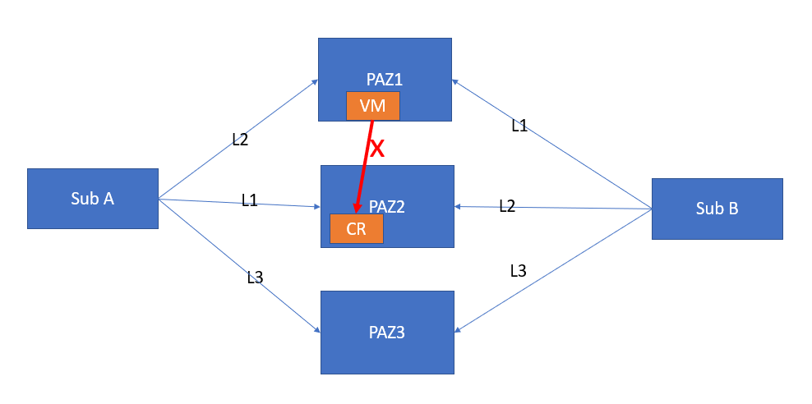

CR and VM has to be in same Physical zone (PAz2 in this example as below) for VM to be associated with CR.

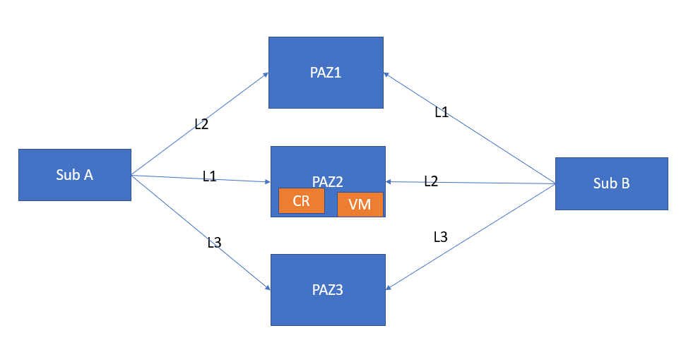

**Adding subscriptions to sharing profile:**

To add a new subscription to share to sharing profile, the previous shared subscriptions need also be passed in the new subscription add request. If the request has any of subscriptions removed, it would mean customer would like to unshare CRG with the removed subscription.

* Unsharing CRG with a subscription from Sharing Profile:

To un share CRG with a subscription from Sharing profile, the subscription has to be removed from sharing profile.

For example, if you have shared with 2 subscriptions as below (just showing properties section for example):

"properties": {

"sharingProfile" :

{

"subscriptionIds" : [

{

"id": "/subscriptions/SubscriptionID1"

},

{

"id": "/subscriptions/SubscriptionID2"

}

]

}

}

To remove sub ID2 in above example, sharing profile would look like below:

"properties": {

"sharingProfile" :

{

"subscriptionIds" : [

{

"id": "/subscriptions/SubscriptionID1"

} ]

}

}

Un-sharing of CRG with cross subscription ID will be allowed while a VM or VMSS from cross subscriptions remain associated with CRG. Once un-sharing happens, any VM or VMSS previously associated to CRG would fail to associate on deallocation or reallocation.

Using shared CRG:

As part of Private Preview only single VMs can be deployed in shared CRG. Support for VMSS Uniform and Flex will be available in Q1 2024 (tentative).

For cross subscription to be able deploy VMs in shared CRG, user needs to be given read/deploy rights by CRG Subscription. RBAC role example: owner, contributor etc. Please refer to below RBAC documentation for guidance:

[Azure RBAC documentation | Microsoft Learn](https://learn.microsoft.com/en-us/azure/role-based-access-control/)

[Steps to assign an Azure role - Azure RBAC | Microsoft Learn](https://learn.microsoft.com/en-us/azure/role-based-access-control/role-assignments-steps)

Once user has been granted read/deploy right, VMs can be created in shared CRG by cross subscription.

**Associate or create a single VM with shared CRG:**

Single VM can be deployed in shared CRG using ARM template/Posh/CLI/API. Please refer to[Associate a virtual machine to a Capacity Reservation group - Azure Virtual Machines | Microsoft Learn](https://learn.microsoft.com/en-us/azure/virtual-machines/capacity-reservation-associate-vm?tabs=powershell1%2Capi2%2Capi3)

Portal option is not available for association with shared CRG

**Remove VM from Shared CRG:**

Can be deployed using ARM template/Posh/CLI/API. Please refer to[Remove a virtual machine association from a Capacity Reservation group - Azure Virtual Machines | Microsoft Learn](https://learn.microsoft.com/en-us/azure/virtual-machines/capacity-reservation-remove-vm?tabs=api1%2Capi2)

* **View shared CRG usage:**

Capacity Reservation Group and Capacity Reservation usage can be viewed using below link:

[Capacity Reservation Groups - Get - REST API (Azure Compute) | Microsoft Learn](https://learn.microsoft.com/en-us/rest/api/compute/capacity-reservation-groups/get?view=rest-compute-2023-07-01&tabs=HTTP)

[Capacity Reservations - Get - REST API (Azure Compute) | Microsoft Learn](https://learn.microsoft.com/en-us/rest/api/compute/capacity-reservations/get?view=rest-compute-2023-07-01&tabs=HTTP&tryIt=true&source=docs#code-try-0)

[Create a Capacity Reservation in Azure - Azure Virtual Machines | Microsoft Learn](https://learn.microsoft.com/en-us/azure/virtual-machines/capacity-reservation-create?tabs=portal1%2Capi1%2Capi2)

In the GET CRG, we will see the same subscription ids being populated in both sharing profile and goal state. The subscription id in “sharingProfile” means goal state and “sharedSubscriptionIds” says the CRG was successfully shared with this subscription.

In this scenario, we were able to successfully share this capacitation group with this specific subscription.

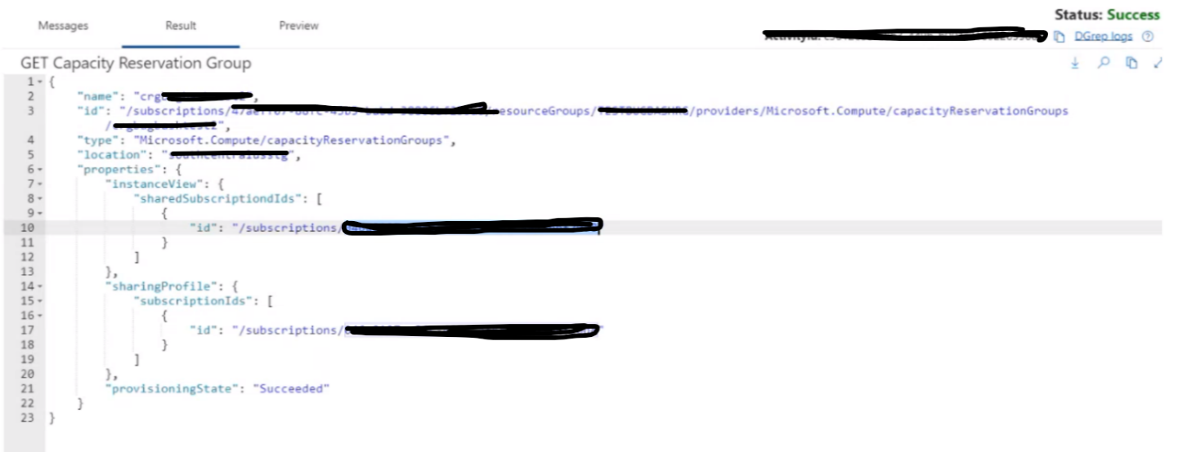

* **Deleting CRG**

Deletion of CRG will cause unsharing the CRG with shared subscriptions.

Deletion of shared CRG will fail if:

* VMs associated to CRG
* CRs in CRG have not been deleted

**Feature timeline**

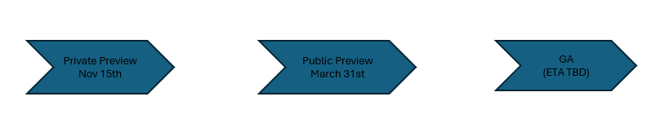

|  |  |  |  |
| --- | --- | --- | --- |
| **Definition** | **Reservation Sharing Private Preview** | **Reservation Sharing Public Preview** | **Reservation Sharing GA** |
| Scope | * Enable cross subscription CRG sharing within same AAD * Rollout of code changes to first few regions and enable flag:   Canary, US West Central, UK South, Europe North, US South Central   * Customer’s subscription will need to be allow listed to participate in Private Preview * Support deployment of single VMs only in shared CRG | * Rollout of code changes across all Public regions (afec strategy TBD) * Commerce scoped RI integration * Portal readiness * Support Private Preview for VMSS Uniform and Flex deployment in shared * REST/CLI/PowerShell changes readiness * Cross AAD sharing (TBD) * Support for API for CRG IDs(shared and local) for a given subscription * Known bug fixes * New CRG share permission * Built in role for sharing (TBD) | * Rollout of code changes across all Public regions with no afec |

**Feedback & Reporting Issues**

For reporting issues and feedback, please reach out to Tarannum Ferdous (tferdous@microsoft.com)