OVERVIEW
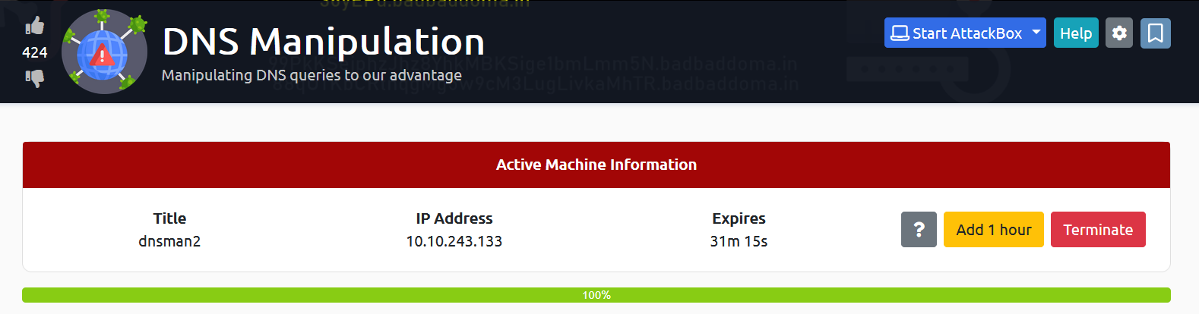

TASK1 : INTRODUCTION
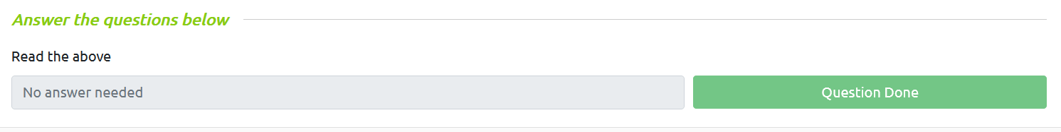

TASK2 : INSTALLATION
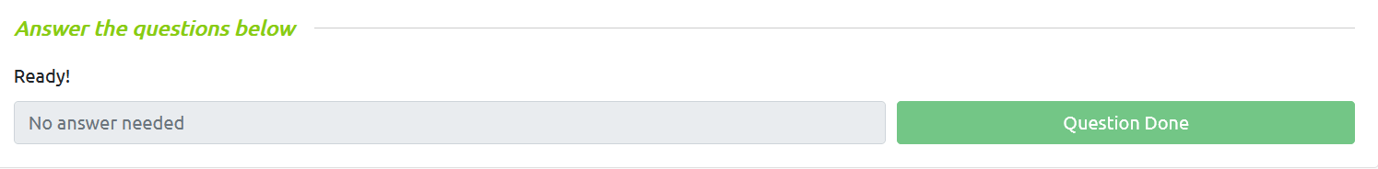

TASK3 : CUSTOM PUBLIC DNS SERVER
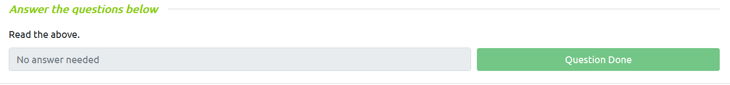

TASK4 : WHAT IS DNS
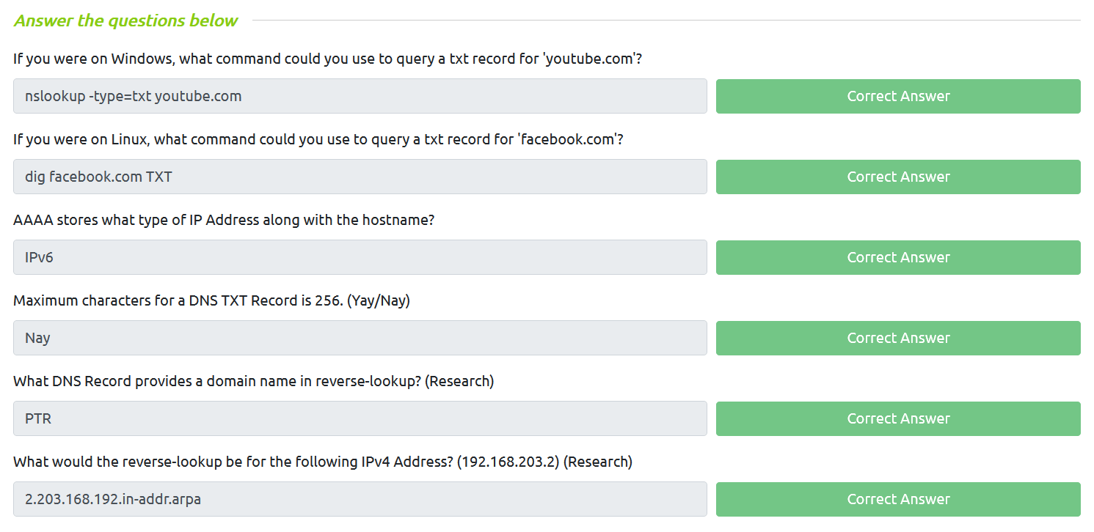

TASK5 : WHAT IS DNS EXFILTRATION
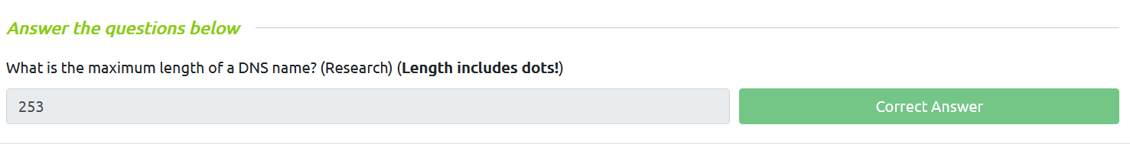

TASK6 : DNS EXFILTRATION DEMO
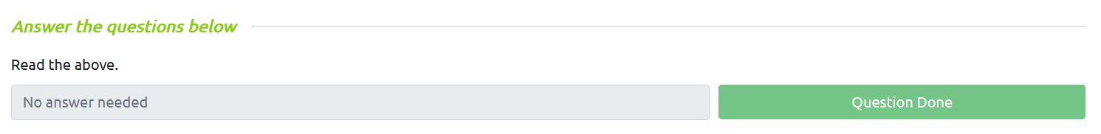

TASK7 : DNS EXFILTRATION PRACTICE
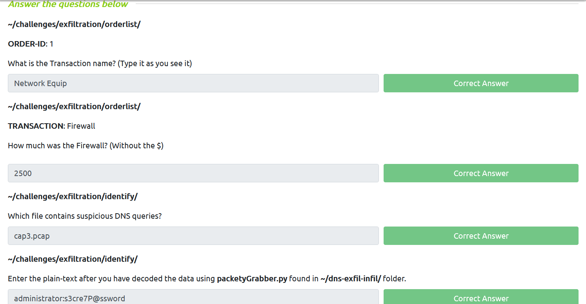

TASK8 : WHAT IS DNS INFILTRATION
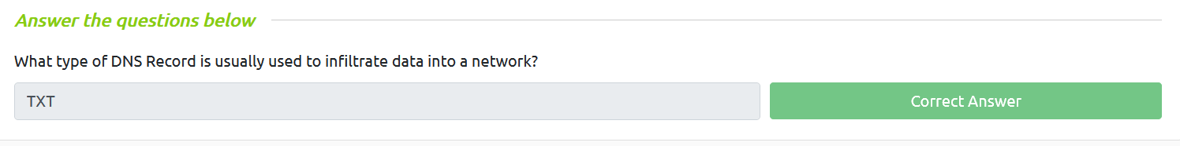

TASK9 : DNS INFILTRATION DEMO
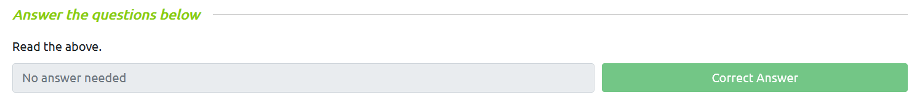
TASK10 : DNS INFILTRATION PRATICE
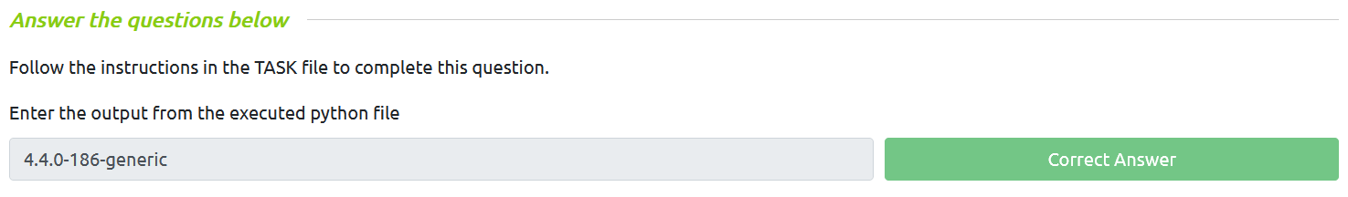
TASK11 : DNS TUNNELING
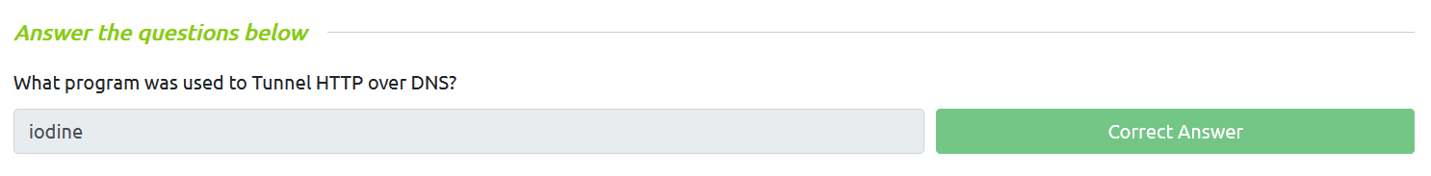
TASK12 : THE END
